Polls on Attitudes to Genetically Engineered Foods

The Council of Canada
Environics Poll on Canadian Consumer Attitudes to Genetically Engineered Foods
March 31, 2000

Environics Research Group was commissioned by The Council of Canadians to conduct a national poll on consumer attitudes to genetically engineered foods. The telephone poll, which surveyed 902 Canadians between December 22, 1999 and January 16, 2000, is accurate within 3.3 percentage points, 19 times out of 20.
The following questions were asked of people who said they were somewhat or very familiar with "genetically engineered" or "genetically modified" foods:
- Q 1. Do you strongly agree, somewhat agree, somewhat disagree or strongly disagree with each of the following statements:
  - I worry about the safety of genetically engineered foods
48% Strongly agree
27% Somewhat agree
75% TOTAL AGREE
13% Somewhat disagree
11% Strongly disagree
24% TOTAL DISAGREE
  - Genetically engineered foods should always be labelled as such.
87% Strongly agree
8% Somewhat agree
95% TOTAL AGREE
2% Somewhat disagree
2% Strongly disagree
4% TOTAL DISAGREE
  - Consumers should be able to buy food that is not genetically engineered.
80% Strongly agree
15% Somewhat agree
95% TOTAL AGREE
3% Somewhat disagree
1% Strongly disagree
4% TOTAL DISAGREE
  - I would prefer to buy non-genetically engineered foods, even if they were slightly more expensive.
45% Strongly agree
26% Somewhat agree
71% TOTAL AGREE
15% Somewhat disagree
11% Strongly disagree
26% TOTAL DISAGREE
- Q 2. How confident are you in the federal government's ability to protect the safety and health of Canadians when it comes to genetically engineered food? Are you…?
11% Very confident
33% Somewhat confident
44% TOTAL CONFIDENT
33% Not very confident
23% Not at all confident
56% TOTAL NOT CONFIDENT
- Q 3. Do you strongly agree, somewhat agree, somewhat disagree, or strongly disagree that Canada should be able to refuse to import genetically engineered foods from other countries if there are concerns about health or environmental safety?
84% Strongly agree
10% Somewhat agree
94% TOTAL AGREE
2% Somewhat disagree
4% Strongly disagree
6% TOTAL DISAGREE
_____________________________________________

Pew Research Center
Survey of Public and Scientists Views on Science and Society
January 29, 2015
Attitudes and Beliefs on Science and Technology Topics
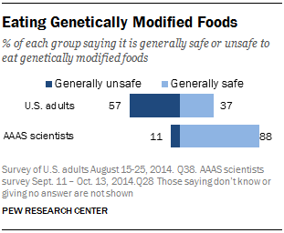
Citizens and scientists often see science-related topics issues through different sets of eyes. This is hardly a new reality, but there are particularly stark differences across the board in these surveys.
The largest differences are found in beliefs about the safety of eating genetically modified foods. Fully 88% of AAAS scientists say it is generally safe to eat genetically modified (GM) foods compared with 37% of the general public who say the same, a gap of 51 percentage points.
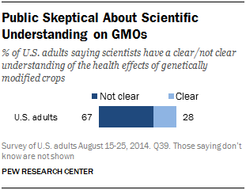
The general public also tends to be skeptical about the scientific understanding of GMO effects. A minority of adults (28%) say they think scientists have a clear understanding of the health effects of genetically modified crops while 67% say their view is that scientists do not clearly understand this.
Patterns Among the General Public
Among the general public, those with a college degree are closely divided over whether eating genetically modified foods is safe: 49% of those with college degrees say it is generally safe, while 47% say it is generally unsafe. Those with a college degree are still substantially less likely than AAAS scientists to consider GM foods safe to eat, however (49% compared with 88%).
Fewer women (28%) than men (47%) believe eating GM foods is safe. Opinions also tend to vary by race and ethnicity with fewer blacks (24%) and Hispanics (32%) than whites (41%) saying that GM foods are safe to eat. Views about GMOs are roughly the same among both younger (ages 18 to 49) and older (50 and older) adults.
About half of U.S. adults report that they always (25%) or sometimes (25%) look to see if products are genetically modified when they are food shopping. Some 31% say they never look for such labels and 17% say they do not often look.
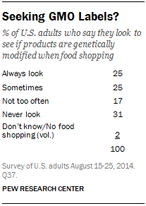
Not surprisingly, those who consider GM foods unsafe tend to check for GM food labels more often: 35% of this group always looks to see if products are genetically modified, compared with 9% among those who consider such foods generally safe to eat.

