Selectively Breeding Sheep
Teacher Resources

Summary
In this standards-aligned, 5-E lesson plan, students will explore a real-world application of genetics and Punnett Squares to help them understand how selective breeding impacts the health of livestock.

Grade Level
9-12

Content addresses the following Next Generation Science Standards
- HS-LS3-1. Ask questions to clarify relationships about the role of DNA and chromosomes in coding the instructions for characteristic traits passed from parents to offspring.
- HS-LS3-3. Apply concepts of statistics and probability to explain the variation and distribution of expressed traits in a population.

Authors
Diana Webber, Albemarle High School, Charlottesville, Virginia
Dr. Ron Lewis, Department of Animal Science, University of Nebraska-Lincoln
Erin Ingram, Curriculum Development Specialist, University of Nebraska-Lincoln, IANR Science Literacy
Molly Brandt, Graduate Research Assistant, University of Nebraska-Lincoln, IANR Science Literacy

Background

Standards
Next Generation Science Standards
- HS-LS3-1. Ask questions to clarify relationships about the role of DNA and chromosomes in coding the instructions for characteristic traits passed from parents to offspring.
- HS-LS3-3. Apply concepts of statistics and probability to explain the variation and distribution of expressed traits in a population.
Common Core
CCSS.ELA-Literacy.RST.9-10.4
- Determine the meaning of symbols, key terms, and other domain-specific words and phrases as they are used in a specific scientific or technical context relevant to grades 9-10 texts and topics.
CCSS.ELA-Literacy.RST.9-10.7
- Translate quantitative or technical information expressed in words in a text into visual form (e.g., a table or chart) and translate information expressed visually or mathematically (e.g., in an equation) into words.
CCSS.Math.Content.HSS.IC.A.2
- Decide if a specified model is consistent with results from a given data-generating process, e.g., using simulation.
CCSS.Math.Content.HSS.MD.B.7
- Analyze decisions and strategies using probability concepts

Estimated Time
One 60-minute class period

Student Materials
- Computer with internet access
- Student worksheet

Vocabulary
- gene: a segment of DNA or RNA that determines a certain trait
- allele: the alternate form of a gene
- dominant trait: traits you will see at any time they are present
- recessive trait: traits that are only visible when paired with another recessive allele
- genotype: complete heritable genetic identify
- phenotype: description of your actual physical characteristics
- homozygous: having two paired alleles of the same case (NN or nn)
- heterozygous: having two pair alleles of different case (Nn)
- Punnett Square - a diagram that is used to predict an outcome of a particular cross or breeding experiment
- selective breeding: the intentional mating of two animals in an attempt to produce offspring with desirable characteristics
- ram: an uncastrated male sheep
- ewe: a female sheep

Key STEM Ideas
All plants, animals, and humans are born with a different, but specific set of chromosomes which contain DNA. DNA stands for deoxyribonucleic acid. It is special, because it holds the code for every cell in your body. Every cell in your body uses DNA as an instruction manual to control the specific makeup of an organism. Within each string of DNA are sets of instructions called genes. A gene tells a cell how to make a specific protein. The proteins are used by the cell to perform certain functions, to grow, and to survive.

Inheritance is a biological process in which parents pass genes onto their children or offspring. Every offspring inherits genes from both of their biological parents and these genes in turn express specific traits. Some of these traits may be physical for example hair and eye color and skin color etc. On the other hand some genes may also carry the risk of certain diseases and disorders that may pass on from parents to their offspring.

Students’ Prior Knowledge
Students should have a good understanding of basic inheritance and how genes are passed on from parent to offspring. Students should have basic skills in statistics and probability. Students do not need to have any knowledge of sheep. The lesson includes a quick overview of Mendelian inheritance, Punnett squares, and sheep.

Connections to Agriculture
Sheep are ruminant animals raised for meat and wool. According to the American Sheep Industry Association (2015), there are 5.28 million head of sheep in the United States. There are over 200 breeds of sheep that are selectively bred to serve specific purposes.

While sheep are bred for desirable traits, occasionally, other genetic diseases or disorders may be passed along to offspring as well. Spider Lamb Syndrome (SLS) in sheep is a recessive genetic disorder. It causes skeletal deformities including bent limbs and twisted spines. It is difficult for sheep breeders to eliminate the risk of SLS in a flock because parents of SLS lambs do not exhibit any symptoms. This is a recessive disorder, so both parents must carry a recessive allele in order for the lamb to be affected.

Sheep producers have the difficult task of using a combination of selective breeding techniques and DNA tests to eliminate this genetic trait from their animals. DNA tests can be expensive, so instead of purchasing DNA tests for an entire flock, breeders can test certain sheep and use Punnett Squares to predict the probability of other sheep in the flock of carrying the recessive allele.

For more information: Purdue University Fact Sheet on Spider Lamb Syndrome: http://ag.ansc.purdue.edu/sheep/ANSC442/Semprojs/spider/spider.html

Essential Links
- Wet vs. dry ear wax inheritance: https://www.youtube.com/watch?v=CBezq1fFUEA
- Inheritance of blood type: https://www.youtube.com/watch?v=NR3779ef9yQ
- Natural selection vs. selective breeding: http://learn.genetics.utah.edu/content/selection/artificial/
- Example of SLS (Gitta): https://www.youtube.com/watch?v=b8tkOPAY56g

Sources/Credits
Pictures on slides retrieved from:
- http://www.raisingsheep.net/suffolk.html
- http://solwaybanksuffolks.co.uk/index.php?route=product/product&product_id=1052
- http://www.woadfarm.co.uk/
- http://gastonsfarm.com/wallop-flock/
- http://www.uwyo.edu/vetsci/undergraduates/courses/patb_4110/2009_lectures/31_genetic_disease/html/class_notes.htm
- http://www.independent.ie/business/farming/out-of-877-births-lambs-ranged-in-from-a-hefty-82kg-single-down-to-a-15kg-quad-30163205.html
- http://learn.genetics.utah.edu/content/inheritance/patterns/
- http://www.vmsherp.com/LCGenetics101.htm
- http://www.pged.org/personal-genetics-101/what-is-genotype-what-is-phenotype/

Lesson Procedures
Engage
- Begin lesson by asking students if they are able to roll their tongue. Let them pair up with a partner to decide if they are able to roll their tongues. Record how many students in the class can and can’t roll their tongues on the board. 70% of people in the world can roll their tongue. Students will fill in blanks on worksheet.
- Ask students why some people are able to roll their tongue while others aren’t.
- Students might mention genetics, parent’s ability to roll tongue, practice, etc.
- Explain that it was once believed that tongue rolling was a recessive Mendelian trait. Introduce the idea of a Mendelian trait in which one gene is responsible for a trait being expressed. Explain when a single dominant allele (or variant of a gene) is present, the dominant trait will be expressed. In order for a recessive trait to be expressed, both alleles must be recessive.
- Review Punnett Squares with slides 3 & 4. Explain that Punnett Squares are simple tables used by geneticists to determine the outcome of various combinations of alleles. Show students how to fill in a sample Punnett square. Discuss differences between genotype and phenotype to reinforce vocabulary and understanding (Genotype isn’t something we can see. Phenotype is observable.) Repeat Punnett squares as necessary until students understand the concept.
- Have students read about the crossing of two tongue-rolling parents and calculate the probability of having a child who can NOT roll his or her tongue. The probability is 0%.
- If the child is later able to roll her tongue, this must mean that tongue rolling is NOT a true Mendelian trait. However, having dry or wet ear wax is a Mendelian trait meaning it is controlled by a single gene. Have students watch the YouTube video (https://www.youtube.com/watch?v=CBezq1fFUEA) on slide 5 for a better understanding of topic.
- For a basic review of Mendelian inheritance vocabulary, have students watch the YouTube video on slide 6. Basic inheritance vocabulary can also be reviewed with slide 7. Spend as much time as you feel necessary for your students to feel comfortable with the terms. Once students are comfortable with terminology, you can continue on with the rest of the lesson.
Explore and Explain
- Facilitate class discussion about inheritance and its connection to other animals using slide 8.
How do the parents’ genes impact or affect possible offspring?
Offspring will inherit traits from their parents and be similar to their parents.
Why is it important to predict the phenotype of future offspring?
If a parent possesses an undesirable Mendelian trait, you can see what the chances are that the offspring will also possess this undesirable characteristic.
- Using slide 9, introduce sheep as an important managed livestock in the U.S. Explain that over 200 different sheep breeds exist. This diversity is the result of both natural selection and selective breeding.
- Using slide 10, explain the difference between natural and selective breeding. Have students watch the video (http://learn.genetics.utah.edu/content/selection/artificial/) and answer the questions in Activity #2 on the worksheet.
- Watch the following YouTube video. https://www.youtube.com/watch?v=b8tkOPAY56g (3 minutes) Instruct students to focus on the lamb’s ability to move and the physical characteristics instead of subtitles.
- Facilitate a Think, Pair, Share activity. Have students discuss the following questions on slide 12.
- What did you notice about Gitta?
Gitta has troubles moving. She does not walk normally. Her legs are long and bent.
- How does this impact the lamb?
Gitta struggles getting around. She does not move like a normal lamb. It’s difficult for her to do basic activities.
- How does this impact the sheep breeder?
Gitta may not live as long as the average sheep. She will not be able to be used for breeding.
- Use slide 13 to give students a brief description of SLS.
- Remind students that SLS is a recessive disorder using slide 14. They must understand this in order to continue with lesson.
- Review basic sheep terminology on slide 15. This is needed to complete lesson.
- Have students begin activity #3 on the worksheet. Slide 16 has question #1.
- Review answers to question #1 using slide 17.
- Question #2 is on slide 18. Have students complete Punnett square.
- Answers for question #2 are on slide 19. Have students answer additional questions.
- Have students use their understanding of SLS and Punnett squares to answer question #3 on slide 20.
- Answers for question #3 are on slide 21.
Extend & Evaluate
- Slide 22 shows information about the genetic test for SLS. The image of the gel electrophoresis shows that you can see the difference in the DNA bands for the different genotypes. It also has a screenshot of the UC Davis’s website about various tests that are done on sheep.
- Ask students if you have a large flock and a limited budget, which sheep would they select for testing and why?
- Help students understand that it would be the best idea to test the rams since a single ram will breed with multiple ewes. Students will record explanation on worksheet.

Selectively Breeding Sheep: Answer Key
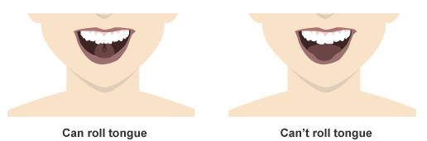
Activity #1: Introduction to Punnett Squares

With a partner sitting next to you, determine if you possess this talent!
Are you able to roll your tongue? YES NO
Was your partner able to roll their tongue? YES NO

How many kids in your class were able to roll their tongue? ____________
How many kids in your class weren’t able to roll their tongue? ____________

Why do you think some people can roll their tongue while others can’t?
_________________________________________________________________________________________________ _________________________________________________________________________________________________
If a trait is determined by a single gene, it is known as a Mendelian trait. It was once believed that tongue rolling was a recessive Mendelian trait, meaning two recessive alleles (nn) needed to be present for this trait to be expressed. Imagine a child is born to two tongue-rolling parents, one is a dominant homozygote (NN) and the other is a heterozygote (Nn). If tongue-rolling is a Mendelian trait, what is the probability that the child will be born with the tongue-rolling trait?
 | N | N
N
n
It is later determined that the child is able to roll her tongue.
Is tongue rolling a true Mendelian trait? YES NO

Activity #2: Natural Selection and Selective Breeding
What is natural selection?
Natural selection is also known as natural breeding. Animals/plants have free choice in who to breed/reproduce with.
What is selective breeding?
Selective breeding is also known as artificial selection or unnatural selection. It is the process by which humans breed plants and animals for particular traits.
What are the advantages of selective breeding?
Breeders get to select which traits they want in their livestock.
Give an example of selective breeding and describe what trait might be selected for by the breeder.
Answers will vary. A rabbit breeder chooses to breed the rabbits that have the best markings.

Activity #2: Using Punnett Squares in Sheep Breeding
Imagine you are a sheep farmer and there is a strange disease that is affecting the lambs that are born in your flock. The parent sheep are healthy, but the lambs have bent limbs and twisted spines. Many of them are dying, which will drastically reduce your income to the farm and the longevity of your flock. How can you make wise mating decisions to prevent the births of these sick lambs?

Spider Lamb Syndrome (SLS) in sheep is a recessive genetic disorder. It causes skeletal deformities including bent limbs and twisted spines. It is difficult for sheep breeders to eliminate the risk of SLS in a flock because parents of SLS lambs do not exhibit any symptoms. This is a recessive disorder, so both parents must carry a recessive allele in order for the lamb to be affected.

Breeders have the difficult task of using a combination of selective breeding techniques and DNA tests to ensure healthy lambs. DNA tests can be expensive, so instead of purchasing DNA test for an entire flock, breeders can test certain sheep and use Punnett Squares to predict the probability of other sheep in the flock of carrying recessive alleles.

- You mate two sheep that are carriers for SLS, which means both the ram and the ewe have one dominant allele and one recessive allele. Fill out the Punnett Square.
 | N | n
N | NN | Nn
n | Nn | nn
Possible Combinations
NN= Healthy Sheep
Nn= Healthy Sheep, but a “carrier” of the SLS gene
nn= Lamb with SLS

What is the probability that the offspring will have SLS?
There is a 25% chance the offspring will have SLS.
What is the probability that the offspring will be carriers?
There is a 50% chance the offspring will carry the SLS allele.
Do you think that breeders should mate two SLS carriers? Why or why not?
Answers will vary.

- You mate a sheep that does not carry a recessive spider allele with a carrier sheep. Fill out the Punnett Square.
 | N | N
N | NN | NN
n | Nn | Nn

What is the probability that the offspring will have SLS?
There is a 0% chance the offspring will have SLS.
What is the probability that the offspring will be carriers?
There is a 50% chance the offspring will be carriers.
Do you think that breeders should mate a RR sheep with a carrier? Why or why not?
Answers will vary.

- You buy a healthy ram from a neighboring farm, and you do not know his genotype. You mate him with a SLS carrier and the lamb is born with SLS.
Fill in the Punnett Square with the genotype of the ram and his offspring.
 | Ram
 | __N___ | __n___
N | NN | Nn
n | Nn | nn

- A relatively simple genetic test is available for SLS. According to the information below, how much would it costs to test an animal for SLS? If you have a large flock and a limited budget, which sheep (rams or ewes) do you think you should select for testing and why?

The cost of a test is $20. Testing rams should be tested because they will be mated with multiple ewes and pass their genes off to more offspring than a single ewe. This is a more cost effective strategy.
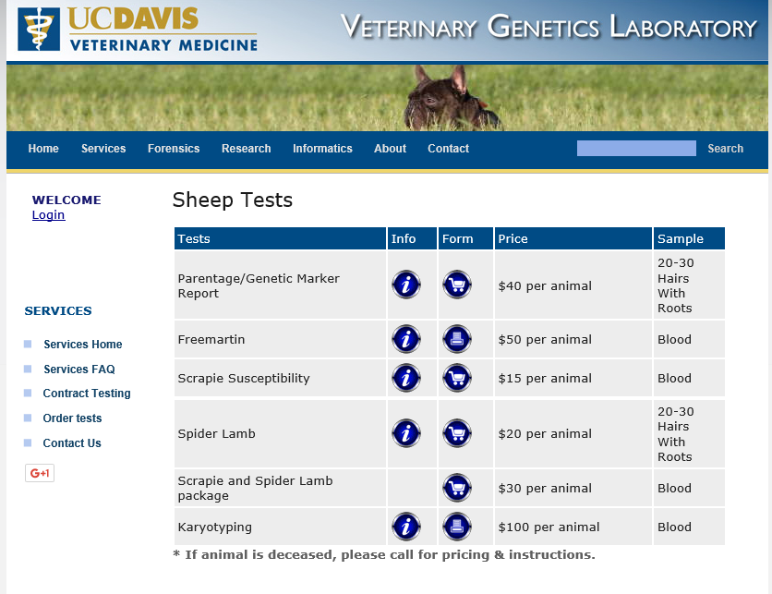
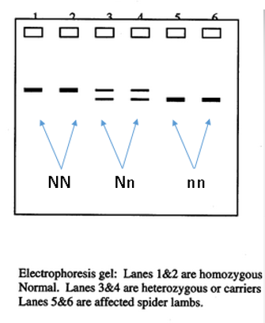
A gel electrophoresis showing DNA bands for homozygous Normal (NN), heterozygous carriers (Nn), and homozygous SLS (nn) sheep.
Costs associated with genetic tests available from University of California-Davis Veterinary Genetics Laboratory.

