Selectively Breeding Sheep
Student Name _________________________________________

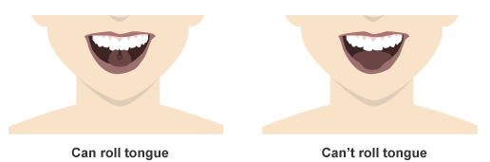
Activity #1: Introduction to Punnett Squares
Working with a partner sitting next to you, determine if you possess the ability to roll your tongue.
Are you able to roll your tongue? YES NO
Was your partner able to roll their tongue? YES NO

How many kids in your class were able to roll their tongue? ____________
How many kids in your class weren’t able to roll their tongue? ____________

Why do you think some people can roll their tongue while others can’t?
_________________________________________________________________________________________________ _________________________________________________________________________________________________

If a trait is determined by a single gene, it is known as a Mendelian trait. It was once believed that tongue rolling was a recessive Mendelian trait, meaning two recessive alleles (nn) needed to be present for this trait to be expressed. Imagine a child is born to two tongue-rolling parents, one is a dominant homozygote (NN) and the other is a heterozygote (Nn). If tongue-rolling is a Mendelian trait, what is the probability that the child will be born with the tongue-rolling trait?
 | N | N
N
n
It is later determined that the child is able to roll her tongue.
Is tongue rolling a true Mendelian trait? YES NO

Activity #2: Natural Selection and Selective Breeding
Watch the animation found here: http://learn.genetics.utah.edu/content/selection/artificial/ and answer the following questions:

What is natural selection?
__________________________________________________________________________________________________________________________________________________________________________________________________________________________________
What is selective breeding?
__________________________________________________________________________________________________________________________________________________________________________________________________________________________________
What are the advantages of selective breeding?
__________________________________________________________________________________________________________________________________________________________________________________________________________________________________
Give an example of selective breeding and describe what trait might be selected for by the breeder.
___________________________________________________________________________________________________________________________________________________________________________________________________________________________________________________________________________________________________________________________________________________

Activity #3: Using Punnett Squares in Sheep Breeding
Imagine you are a sheep farmer and there is a strange disorder that is affecting the lambs that are born in your flock. The parent sheep are healthy, but the lambs have bent limbs and twisted spines. Many of them are dying, which will drastically reduce your income to the farm and the longevity of your flock. How can you make wise mating decisions to prevent the births of these sick lambs?

Spider Lamb Syndrome (SLS) in sheep is a recessive genetic disorder. It causes skeletal deformities including bent limbs and twisted spines. It is difficult for sheep breeders to eliminate the risk of SLS in a flock because parents of SLS lambs do not exhibit any symptoms. This is a recessive disorder, so both parents must carry a recessive allele in order for the lamb to be affected.

Breeders have the difficult task of using a combination of selective breeding techniques and DNA tests to ensure healthy lambs. DNA tests can be expensive, so instead of purchasing DNA tests for an entire flock, breeders can test certain sheep and use Punnett Squares to predict the probability of other sheep in the flock of carrying recessive alleles.

- You mate two sheep that are carriers for SLS, which means both the ram and the ewe have one dominant allele and one recessive allele. Fill out the Punnett Square.
 | N | n
N
n
Possible Combinations
NN= Healthy Sheep
Nn=Healthy Sheep, but a “carrier” of the SLS gene
nn= Lamb with SLS

What is the probability that the offspring will have SLS?
What is the probability that the offspring will be carriers?
Do you think that breeders should mate two SLS carriers? Why or why not?

- You mate a sheep that does not carry a recessive spider allele with a carrier sheep. Fill out the Punnett Square.
 | N | N
N
n

What is the probability that the offspring will have SLS?
What is the probability that the offspring will be carriers?
Do you think that breeders should mate a RR sheep with a carrier? Why or why not?

- You buy a healthy ram from a neighboring farm, and you do not know his genotype. You mate him with a SLS carrier and the lamb is born with SLS.
Fill in the Punnett Square with the genotype of the ram and his offspring.
 | Ram
 | _____ | _____
N
n

- A relatively simple genetic test is available for SLS. According to the information below, how much would it cost to test an animal for SLS? If you have a large flock and a limited budget, which sheep (rams or ewes) do you think you should select for testing and why?
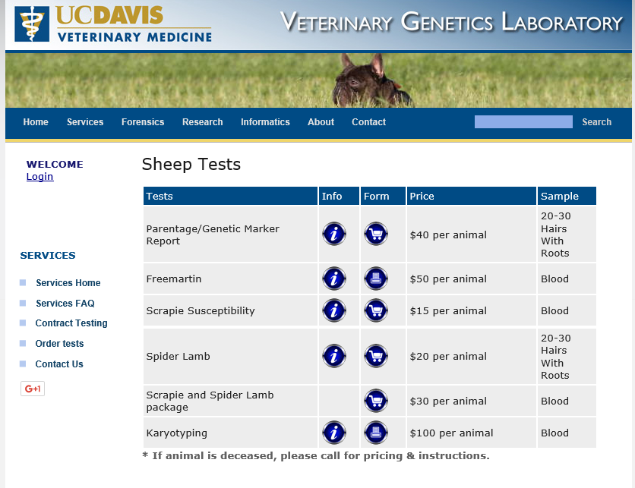
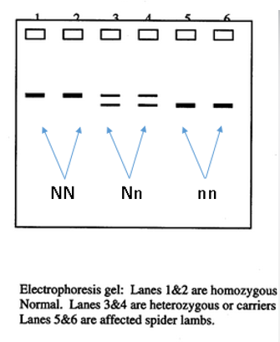
____________________________________________________________________________________________________________________________________________________________________________________________________________________________________________________________________________________________________________________________________________________________________________________________________________________________________________________________________
Costs associated with genetic tests available from University of California-Davis Veterinary Genetics Laboratory.

A gel electrophoresis showing DNA bands for homozygous Normal (NN), heterozygous carriers (Nn), and homozygous SLS (nn) sheep.

