Pollinators in the Biology Classroom
Student Resources

Student Name ___________________________________________

Contents
Lesson 1 | Good Taste: Forager Food Preference 2
Lesson 2 | Fermentation of Honey 12
Lesson 3 | Preservation Power of Honey 19
Lesson 4 | Honey as a Biomolecule 24
Lesson 5 | Imported Food Safety 28

Authors
Burke Morrow, Biology and Earth Science Teacher, Lincoln East High School, Lincoln, Nebraska
Erin Ingram, Curriculum Development Specialist, University of Nebraska-Lincoln, IANR Science Literacy

Lesson 1 | Good Taste: Forager Food Preference

Student Name ___________________________________________

Activity 1: What determines a worker bee’s role in the hive?
A hive is in constant need of materials such as pollen, water, and nectar. Worker bees forage to supply the hive with these materials. As the colony’s needs change, so do the resources that are collected. Pollen serves as a protein source and is needed in greater abundance when the colony has young offspring. Nectar is a carbohydrate which serves as an energy source. Water is brought back and evaporated to keep the colony cool on a hot day.
Figure 1: Worker bee with plastic numbered tag
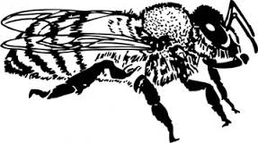
A student wondered if worker bees shared equally in bringing each type of material to the hive or if there was a division of labor where workers were specialized for different materials. To determine which was correct, the student set up an experiment. To monitor the behavior of specific bees, the student glued plastic, numbered tags to 50 worker bees. She monitored foraging activity at the hive entrance. The student recorded which resources each numbered bee brought back to the nest in her field notes.
17

What is the student’s research question?

Form a hypothesis for the research question.

Use the researcher’s data in the field notes to complete the data table.
Table 1:
Bee number | Time Point 1 | Time Point 2 | Time Point 3 | Time Point 4

Categorize the bees by their number into two groups. Why did you group them in this manner?

Does this data suggest that there is a division of labor in the hive? Explain.

At what point in the day was water was returned to the hive? Suggest a reason.

Bees #26, 34, and 44 returned empty on at least one of their foraging trips. Do you think this is related to the time of day that bees foraged? Explain.

Suggest a reason why Bees 26, 34, and 44 might have returned to the hive without a resource.

From the previous data, you should have concluded that there are two strains of bees: those that forage for nectar and those that forage for pollen and water.

Why might worker bees be divided into two strains? Discuss and list 3 possible reasons.

Activity 2: Learning about the Proboscis Extension Response (PER)
The student wonders if a honey bee’s foraging behavior is related to their ability to detect sugar. The student hypothesizes if a bee is a nectar collector, then that bee is more likely to be able to detect high concentrations of sugar. Conversely, if a bee is a pollen or water collector, then that bee is more likely to respond to a lower concentration of sugar. Scientists measure a bee’s ability to detect sugar using the proboscis extension response (PER). Watch this video to see a researcher perform a PER test: https://youtu.be/-_cXqda1BZA

A bee’s antenna is a sensory organ that smells and tastes substances for the bee. When the antenna contacts a solution, the bee can assess the sugar concentration. If the bee detects a sufficient concentration of sugar, the bee’s proboscis (tongue) reflexively extends. By varying the concentrations of sugar solutions, one can determine the point at which a bee can detect sugar. The threshold is the minimum concentration of sugar needed to elicit the PER.

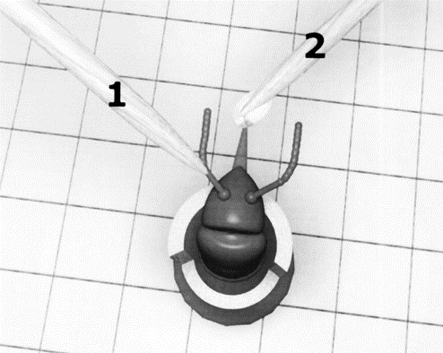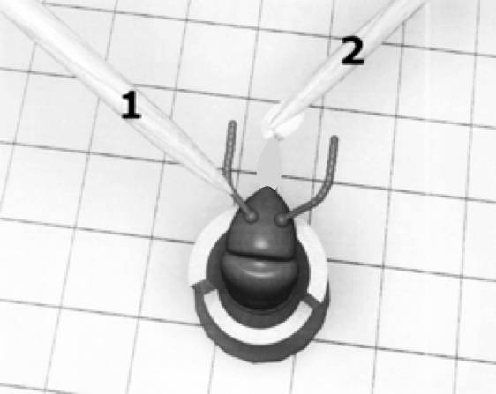
Positive response:
Notice the extended proboscis.
Negative response:
Notice the proboscis is not extended.

If a bee’s proboscis extends at a low concentration of sugar, we conclude that the bee has high ability to detect sugar. In other words, these bees think a relatively low concentration of sugar is worth collecting. If a bee has a high PER threshold, it will take a high concentration of sugar to elicit the PER. These bees are like people with a sweet tooth. If it isn’t really sweet, they don’t want it.

Make a prediction about a bee’s ability to detect sugar and their foraging habits by filling in the table.

Sugar concentration needed to elicit response  (low or high) | Ability to detect sugar  (low or high) | PER threshold  (low or high) | Predicted foraging behavior  (nectar or pollen)
Low
High

The student decides to use the bees from experiment 1 and test their ability to detect sugar using the PER method. Refer back to question 3 in Activity 1 for the two groups of bees.

Which numbered bees do you predict would have high PER thresholds?

Which numbered bees would have low PER thresholds?

Examine graph 1 to evaluate your earlier prediction and the student’s hypothesis for the PER experiment.

Graph 1:

Pollen collectors (Bee 10, 17, 37, 42)
Nectar collectors (Bee 23, 26, 34, 44)
10 %
30 %
50 %
Concentration of sucrose solution
Proportion of bees responding

Does the evidence in the graph support the student’s hypothesis? Explain.
(Recall the student’s hypothesis: If a bee is a nectar collector, then that bee is more likely to be able to detect high concentrations of sugar. Conversely, if a bee is a pollen or water collector, then that bee is more likely to respond to a lower concentration of sugar.)

Activity 3: Could genes determine a bee’s foraging behavior?
We have learned that bees vary in their threshold response to sugar. Could there be a genetic component to explain this difference in ability to perceive sweetness?

To test this idea, you will learn the process of DNA fingerprinting and analyze DNA from a practice case. Next, you will analyze the DNA from a pollen collector and a nectar collector to determine if there is a difference in their genes. You will then use DNA analysis to classify unknown bees as pollen or nectar collectors.

The Process of Gel Electrophoresis and DNA Fingerprinting Analysis
Gel electrophoresis is a process where DNA fragments of different sizes are separated and analyzed. Before analyzing DNA from your bees, you will learn the steps of DNA fingerprinting from the simulation “The Case of the Licked Lollipop”

Use the link below to describe the purpose of each step of DNA fingerprinting as well as to solve the case.
http://www.pbslearningmedia.org/asset/tdc02_int_creatednafp2/

Step | Purpose
Pour restriction enzymes into DNA | Ex) Enzymes act like scissors cutting DNA at specific places in the DNA code
Pour agarose gel into tray
Pour DNA into tray
** Note: DNA is typically loaded into a slot in the agarose using a pipet
Begin electrophoresis
Place nylon membrane on gel
Add probes to nylon membrane
Place x-ray film on top of nylon film
Develop film and analyze

Who is the culprit in the case of the Licked Lollipop? ________________________________

Activity 4: Analyzing the DNA from known bees
While the genes responsible for pollen collecting and nectar collecting are still being researched, the following activity simulates how DNA testing might one day be used to visualize the genetic differences between these two strains. In this simulation, you have been given DNA from a pollen collector, a nectar collector, and a sample of DNA showing the action of the restriction enzyme, BamHI. BamHI binds at the recognition sequence 5'-GGATCC-3', and cleaves these sequences just after the 5'-guanine on each strand.
G | T | A | G | G | A | T | C | C | T
C | A | T | C | C | T | A | G | G | A
A DNA sample cut is shown here:

Cut the DNA segments from the pollen and nectar collectors in the same manner as shown in the sample by drawing lines in the appropriate places. Each line represents a cut in the DNA.

DNA Sample of pollen collector:
A | G | G | A | T | C | C | G | A | G | G | A | T | C | C | T | T | A | G | G | A | T | C | C
T | C | C | T | A | G | G | C | T | C | C | T | A | G | G | A | A | T | C | C | T | A | G | G

DNA Sample of nectar collector:
A | A | G | A | T | C | A | G | A | G | G | A | T | C | C | T | T | A | C | G | A | T | C | A
T | T | C | T | A | G | T | C | T | C | C | T | A | G | G | A | A | T | G | C | T | A | G | T

Fill in the table based on the cuts above.
 | Pollen collector | Nectar collector
Number of cuts in DNA
Number of segments of DNA

- How does the number of cuts in the pollen collector’s DNA compare to the nectar collector’s DNA?

- How will this affect the number of fragments formed on the gel electrophoresis?

Activity 5: Using a gel electrophoresis simulation to identify unknown bees
Materials:
- gel electrophoresis card
- small bowl
- water
- 0.5 tsp washing soda
- plastic spoon to stir

The card represents a gel tray from the DNA electrophoresis of four unknown bees. Your task is to analyze the DNA from bees 1-4 and determine which bees are pollen collectors and which bees are nectar collectors by comparing the results to the known bees from Activity 4.

Procedure:
- Fill bowl approximately 1/2 full with water, add 0.5 tsp of washing soda solution. Mix with spoon.
- Dip card into solution until pink dots become visible and quickly remove it.
- Briefly sketch your results into the data table.

Data:
positive
negative
Bee 1
Bee 2
Bee 3
Bee 4
800
600
400
200
100
50
Standard

- Why do the various segments of DNA separate out along the tray?

- Large pieces of DNA would be found toward which end of the gel tray? Why?

- Using the DNA samples from Activity 4, identify which bees from your gel electrophoresis would be…
  - Pollen collectors _______________________

  - Nectar collectors _______________________

Reflection and Application to Agriculture

- How might a bee’s foraging behavior impact their pollination or honey production potential?

- Genetics are partially responsible for bees’ foraging preference. How might the beekeeping industry use this to their advantage?

Activity 1: Field notes
Experiment 1 |  |  | Field Notes: Foraging Behavior
Time point 1 |  | 8:00am
Weather: Overcast, 66ºF, wind speed 12 mph
Bee # | Resource collected
17 | Pollen
34 | None
42 | Pollen
44 | Nectar
Time point 2 |  | 11:00am
Weather: Sunny, 75ºF, wind speed 8 mph
Bee # | Resource collected
10 | Pollen
17 | Pollen
23 | Nectar
26 | Nectar
34 | None
37 | Pollen
42 | Pollen
44 | None

Experiment 1 |  |  | Field Notes: Foraging Behavior
Time point 3 |  | 2:00pm
Weather: Sunny, 98ºF, wind speed 5 mph
Bee # | Resource collected
10 | Water
17 | Water
23 | Nectar
26 | Nectar
34 | Nectar
37 | Water
44 | None
Time point 4 |  | 5:00pm
Weather: Sunny, 88ºF, wind speed 8 mph
Bee # | Resource collected
10 | Water
17 | Water
23 | Nectar
26 | None
34 | Nectar
37 | Water
44 | Nectar

Lesson 2 | Fermentation of Honey

Student Name ___________________________________________

Cellular Respiration (Aerobic Respiration)
All living organisms need energy to support activities necessary to survive. They obtain this energy from food molecules which contain chemical energy that is released when chemical bonds are broken. In the presence of oxygen, aerobic respiration occurs. Glucose is an energy source for the cell but it must be converted into ATP which is the energy source that the cell can use. The equation for cellular respiration is shown.

C₆H₁₂O₆ + 6 O₂ → 6 CO₂ + 6 H₂O + ATP
Glucose + Oxygen → Carbon Dioxide + Water + ATP

Glycolysis is the first stage where glucose in broken into two pyruvate molecules. The next stage depends on the presence of oxygen. If oxygen is present, the 2 pyruvates enter the Kreb’s Cycle where two more ATP are formed. The final step is the electron transport chain where 34 ATP are produced. Each glucose yields a total of 38 ATP through aerobic respiration.

The diagram below summarizes the stages of aerobic respiration. Notice that ATP are produced in 3 different stages.
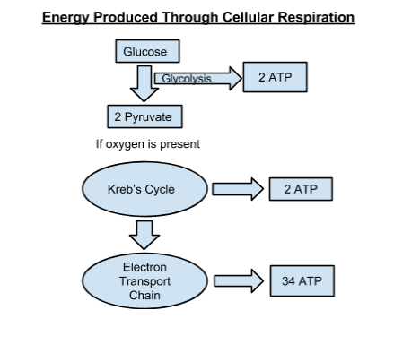

Fermentation (Anaerobic Respiration)
In the absence of oxygen, organisms can still obtain the energy they need to survive through the process of fermentation. One type of fermentation, lactic acid fermentation, occurs in the muscle of animals. You may experience lactic acid fermentation when you do short bursts of hard exercise such as lifting weights or running up stairs. A second type of fermentation called alcoholic fermentation occurs in yeast and other microorganisms. This type of fermentation is important in the food science industry for baking bread or brewing beer and wine.

It is also important in the biofuels industry as the alcohol ethanol is produced as a byproduct. Although fermentation is necessary when energy is needed and oxygen is not available, it has disadvantages. Fermentation only produces 2 ATP per glucose while aerobic respiration produces a total of 38 ATP per glucose. Also, the byproducts of anaerobic respiration are toxic to cells.

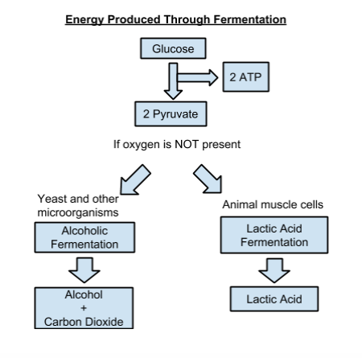

Part 1: How does the concentration of sugar affect the rate yeast produces CO₂?
Materials needed:
- Sugar
- Warm water
- 4, 100mL beakers
- ‘Rapid rise’ activated dry yeast
- 4, 50mL beakers per group
- 4, respirometers per group (made of 5cc syringe, graduated pipette, and plastic tubing)
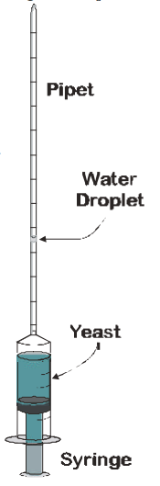
- 1 timer or clock per group

Student lab procedures:
- Gather materials needed for lab.
- Measure out 10 ml of the 1% sugar solution and place the solution into a 50 mL beaker.
- Measure out 10 ml of the yeast solution and add it to the 50 mL beaker with the sugar solution.
- Allow the yeast and sugar mixture to incubate for 5 minutes occasionally swirling the beaker.
Image source: http://www.cur.org/assets/1/7/ystferm.pdf

- Draw 3 mL of the yeast and sugar mixture into the syringe.
- Continue drawing the syringe until it has 1 mL of air on top of the sugar-yeast mixture.
- Add a drop of water into the bottom of the pipette and attach the pipette to the top of the syringe with plastic tubing.
- Begin timing when the drop of water reaches 0 on the graduated pipette.
- Record the amount of CO₂ produced every 2 minutes in the data table.
- Repeat the procedure with the other concentrations of sugar.

Record the data: Note how far the water droplet has moved up the pipette every 2 minutes.

 | 1% sugar | 5% sugar | 30% sugar | 50% sugar
2 minutes
4 minutes
6 minutes
8 minutes
10 minutes

- After 10 minutes, which concentration of sugar produced the greatest amount of carbon dioxide?

- If you were trying to maintain a yeast population, which concentration of sugar would you want to feed the yeast? Why?

- After 10 minutes, which concentration of sugar produced carbon dioxide at the fastest rate?

Part 2: Predicting fermentation in honey
In addition to table sugar, other foods may provide organisms with the glucose needed for energy. The glucose in honey can be transformed into usable energy (ATP) for living organisms. Let’s review the process of how honey is made.

Honey bees gather nectar from flowers as a source of sugar. However, nectar has a high water content. Bees evaporate water from nectar by fanning their wings thus increasing the concentration of sugar in the honey. In addition to removing water, bees add enzymes to the nectar. The enzyme invertase is responsible for breaking down sucrose, a disaccharide into its component monosaccharides, glucose and fructose. Glucose can be used in the cellular respiration process of bees to produce ATP for energy.
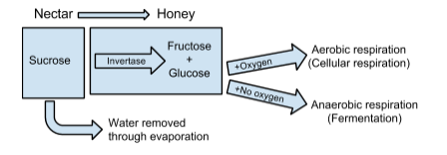
However, microorganisms such as bacteria and yeast compete with other living organisms such as bees for the same food source. They may hijack the carbohydrates for their own energy needs through fermentation or aerobic respiration sometimes producing unwanted results. Using what you learned from Part 1, answer the following questions to predict how successful yeast would be at using the glucose in honey as a source of carbohydrates for energy production.

- Honey is a rich source of carbohydrates including glucose. If the water content of ripened honey is 16%, what is the percent of sugar found in ripened honey?

- Graph the data for all sugar concentrations from Part 1 at 10 minutes on the graph below. Now add the sugar concentration of ripened honey to your graph. Predict the amount of CO₂ produced.

- Based on the trend of CO₂ production, would you predict yeast to be successful in producing energy in ripened honey?

Part 3: Honey gone haywire!

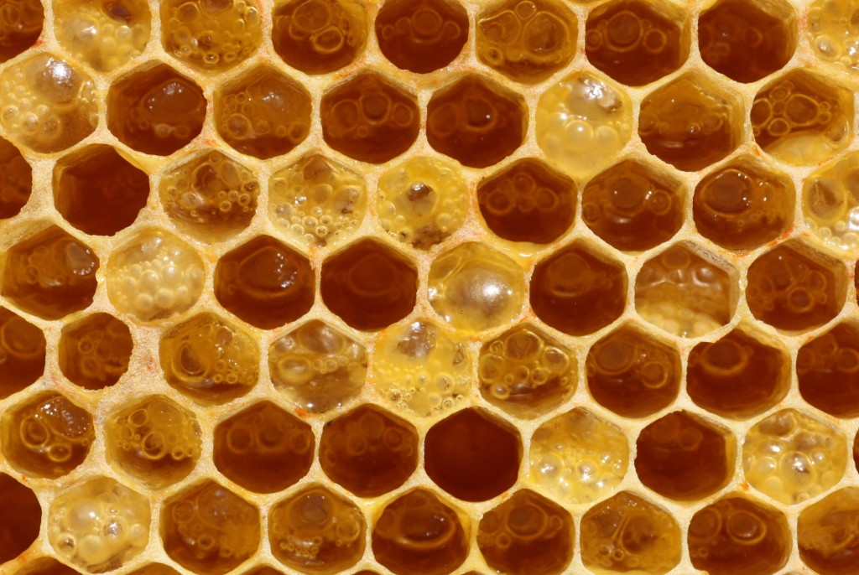
Honey is a good source of energy for bees. It’s also a valuable food product for humans. In 2014, U.S. beekeepers sold over 178 million pounds of honey worth nearly $400 million. In order to produce a high quality honey crop worth the highest market value possible, beekeepers are always on the lookout for contaminants that might compromise the safety or taste of their honey.
Image source: http://www.honeybeesuite.com/uncapped-honey-fermenting-in-the-comb/

Suppose you are a beekeeper. Looking at the honey in the honeycomb, answer the following questions on your own.

- Where did the bubbles come from in this honey?

- What undesirable components would be found in the honey?

- What process formed these two products?

- What are the risks of selling this honey product as it is?

Lesson 3 | Preservation Power of Honey

Student Name ___________________________________________

Introduction
Food Preservation Methods
How do people prevent the following foods from spoiling?

 | My prediction | Post class discussion
Beef jerky

Bread

Milk

Pickles

Raw steak

Cucumber

Cup cake

Croutons

Twinkie

Honey bee societies like human societies have to manage logistics such as adequate space, shelter, and a safe year round food supply. Bees rely on plants that flower during summer months to provide nectar a carbohydrate and pollen a protein source to last throughout the year. Bees need to safely store their food during times when flowering plants are not available.

Listen to the audio clip: Why Honey Doesn’t Spoil? (2:30)
http://indianapublicmedia.org/amomentofscience/honey-spoil/

- Do bees use any of the same methods to preserve their food supply? If so, which ones?

Part 1: Does honey inhibit the growth of bacteria in the lab?
Researchers interested in the use of honey as an antibacterial set up the following experiment.

- Bacteria commonly found in milk was evenly applied to growth medium in a petri dish.
- Five concentrations of honey (5, 10, 15, 20, and 25%) and water (as a control) were applied to antibacterial discs.
- All six (6) discs were placed in the petri dish and labelled with letters A-F.
- The petri dish was incubated at 36ºC for 24 hours to allow bacteria to grow.

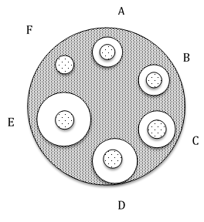
Using a ruler, measure the zone of inhibition for each disc and record in the data table.

Disc | Concentration (mg/ml) of honey used | Diameter (mm) of zone of inhibition
A | 5 | 10.3
B | 10 | 10.6
C | 15 | 12.6
D | 20 | 15.6
E | 25 | 18.6
F | Water only | 6.4

- What is the relationship between the concentration of honey and the size of the zone of inhibition caused by the honey?

- Suggest a reason for this relationship.

Listen to the audio clip: Honey: Food for Yeast or a Natural Preservative? (2:02)
http://indianapublicmedia.org/amomentofscience/honey-food-yeast-natural-preservative/

- Honey is more expensive than sugar, $2.00 per pound versus $0.34 per pound. Do you think a concentrated sugar solution could be used as a more cost effective antibacterial preservative?

Part 2: Does concentrated sugar inhibit the growth of bacteria in the lab?
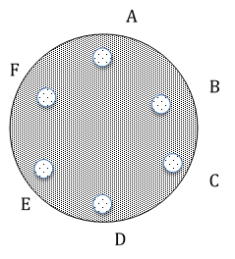
The researchers were encouraged by their finding about the antibacterial property of honey in Part 1 and decided to test if the same concentrations of sugar rather than honey could similarly inhibit the growth of bacteria commonly found in milk. The same experimental set up was used from part 1, except the discs were treated with various concentrations of sugar (fructose) rather than honey.
Disc | Concentration (mg/ml) of sugar used | Diameter (mm) of zone of inhibition
A | 5
B | 10
C | 15
D | 20
E | 25
F | Water only

- Compare the fructose data to the honey data. Do you agree that sugar would be a more cost effective alternative for food preservation? Explain.

Is honey “just” a concentrated sugar solution? Do bees add anything special to the mix? To answer these questions, we will need to understand how honey is made.

Bees need a source of sugar for energy. Some plants attract bees by providing the sugar in the form of nectar. During the course of collecting the nectar, bees transfer pollen from plant to plant. The foraging bees carry the nectar back to the hive. Upon returning to the hive, the forager unloads the nectar to a receiver bee. The receiver bee modifies the nectar by repeatedly using her tongue to expose the nectar to air which decreases the water content. During this process, two important enzymes are added. The enzyme invertase is responsible for breaking down sucrose, a disaccharide into its component monosaccharides glucose and fructose. The second important enzyme is glucose oxidase which breaks down some of the glucose into hydrogen peroxide (H₂O₂) and acid.
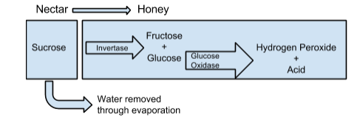

- Examine the diagram of honey. Which parts of the honey do you think inhibit the growth of bacteria?

Part 3: Can honey inhibit the growth of bacteria in food products?
Milk and dairy products are an important part of a healthy diet providing an inexpensive source of protein, vitamins, and minerals. Spoilage of milk is a major limitation in providing this valuable food source to people who do not have access to refrigeration. Can the preservation power of honey prevent spoilage in milk?
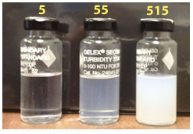
To test this hypothesis, researchers tested samples of milk divided into two groups, milk with honey added and milk without honey. After six days, milk was tested for bacterial content using turbidity.

Turbidity is the measure of relative clarity of a liquid and can be used as an indicator of bacterial content. Presence of bacteria increases the cloudiness and therefore turbidity of the milk.

Image source: http://water.usgs.gov/edu/turbidity.html

- What is the relationship between cloudiness and the turbidity value of the vials in the image?

Use the data in the table to calculate the percent difference in inhibition of growth.
No. of days of storage | Turbidity of milk with honey | Turbidity of milk without honey | Percent difference in inhibition of growth $\frac{\left|with honey - without honey\right|}{\frac{with honey + without honey}{2}} x 100\%$
0 | 0.62 | 0.75 | $\frac{\left|0.62-0.75\right|}{\frac{0.62+0.75}{2}}$ = $\frac{0.13}{0.685}$ = 0.189 x 100% = 18.9%
3 | 0.78 | 1.41
4 | 0.82 | 1.56
5 | 0.89 | 1.73
6 | 0.94 | 1.84

- Is honey an effective preservative for milk? Explain.

- One quarter of the world’s population does not have access to electricity. Without refrigeration, it can be difficult or impossible for people to gain access to a consistent or safe supply of milk. Do you believe adding honey to milk as a preservative is a feasible solution to this challenge? Why or why not?

Lesson 4 | Honey as a Biomolecule

Student Name ___________________________________________

Part 1: Introduction
In order to stay healthy, people need to eat a variety of nutritious foods. Food contains six nutrients that are necessary for good health. These nutrients include carbohydrates, proteins, lipids, minerals, vitamins, and water.

Carbohydrates, lipids, and proteins are called organic molecules. These molecules are called organic molecules because they are carbon based and should not be confused with certified organic products. The USDA defines organic agriculture as using methods that preserve the environment and avoid most synthetic material as pesticides and antibiotics.

Read each statement and check the appropriate box indicating if you think that the statement is true or false.
True | False | Statement
 |  | A teaspoon of honey and a teaspoon of sugar have the same number of calories.
 |  | A teaspoon of honey and a teaspoon of sugar have the same number of carbohydrates.
 |  | A teaspoon of honey and a teaspoon of sugar have the same effect on a person’s glycemic index (GI). GI is a measure of how carbohydrates affect a person’s blood sugar level. High GI foods “spike” a person’s blood sugar level which may increase a person’s risk of coronary heart disease and Type 2 diabetes.
 |  | Honey is added to certain baked goods to extend shelf life.
 |  | Honey is not recommended for infants under one year of age.

Divide into groups of 2-3 students. Read the following articles. Discuss with your group if you learned anything new about honey or table sugar.
- Carbohydrates and the Sweetness of Honey
http://www.honey.com/images/downloads/carb.pdf
- Is Honey the Same as Sugar?
http://extension.arizona.edu/sites/extension.arizona.edu/files/pubs/az1577.pdf

Part 2: Comparing Carbs
Carbohydrates are the main source of energy for living organisms. Glucose, fructose, and galactose are the three monosaccharides or single sugar molecules. Disaccharides are formed by two monosaccharides bonded together and include sucrose, also known as table sugar, and lactose, the sugar found in milk. Polysaccharides are large molecules formed by many monosaccharides bonded together. Animals store carbohydrates in the polysaccharide glycogen. Plants store carbohydrates in polysaccharides, starch and cellulose, the latter of which is used for structure and support. Whether simple or complex, all carbohydrates are made of sugar, but not all sugars are equally sweet.

Food scientists have rated the relative sweetness of carbohydrates as seen in the table.

Relative Sweetness Scale
Carbohydrate | Rating
Glucose | 70-80
Galactose | 35
Fructose | 140
Sucrose (glucose + fructose) | 100
Lactose (glucose + galactose) | 20
High Fructose Corn Syrup | 120-160

- Which monosaccharide is the sweetest?

When a disaccharide breaks down into its component monosaccharides, the sweetness changes as well. The resulting sweetness can be determined by averaging the sweetness of the two monosaccharides.

Lactose is the disaccharide found in milk. Before lactose can be used by the body, it must be broken down into monosaccharides. The enzyme, lactase, breaks down lactose into the monosaccharides, glucose and galactose. When lactose is digested its sweetness changes too. The new sweetness can be calculated by averaging the sweetness rating of the two monosaccharides; glucose (75) and galactose (35). Note: The average value for glucose is used in the example.

Example: $\frac{75+35}{2}=\frac{110}{2}=55$

- How does the sweetness of milk compare to the sweetness of milk that has been digested by lactase?

- Sucrose or table sugar is also a disaccharide. What two monosaccharides compose sucrose?

- Using the average value for glucose, calculate the sweetness of sucrose after it has been broken down into its component monosaccharides.

- How does the sweetness of sucrose compare to the sweetness of sucrose that has been digested by enzymes?

- Breaking down disaccharides into monosaccharides is necessary for digestion but food scientists see another benefit. Of what advantage is producing sucrose that has already been broken down by enzymes?

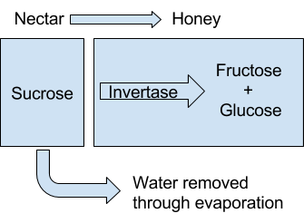
Bees make honey by gathering nectar from certain flowering plants. Nectar is sucrose. Foraging bees carry the nectar to their hive where receiving bees unload the nectar load and begin to process the nectar into honey. During the processing, bees add invertase, an enzyme that breaks down sucrose.

- How do you think sweetness of honey compares to the sweetness of nectar? Explain your thinking.

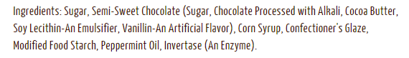
Examine the ingredients on the label for Junior Mints to answer the questions below.
- What carbohydrates have been used?

- What enzyme has been added and how will that affect the sweetness of the carbohydrates?

Part 3: Developing a Food Product with Honey

Food scientists use their knowledge of biology, chemistry, and chemical engineering to better understand food processes and to improve food products for consumers. Imagine you are a food scientist developing a new food product using honey as an ingredient.

What is the name of your product?

Who is the core audience for your product?

What will your packaging look like?

What ingredients will be used in your product?

Draw a quick sketch of what your product will look like?

List three reasons why a food scientist might use honey instead of sugar in this recipe.

Lesson 5 | Imported Food Safety

Student Name ___________________________________________

Activity 1: Where does your food come from?
With a partner, examine the food items. Discuss the following questions.

- Where do these foods come from?

- Where did you find this information?

- Who makes sure that foods in the U.S. are safe to eat?

Activity 2: Global Food Trade Webquest
In our increasingly global economy, agricultural products are regularly imported and exported between countries. To ensure the safety of food products in the U.S., several government agencies play a role with the process of food safety. Go to the web address: http://www.foodsafety.gov/about/federal/index.html and answer the following questions about how our food supply is kept safe.

- What are three federal government agencies responsible for protecting our food supply and what are their duties regarding food safety?

- Which agency would be responsible for ensuring the safety of the following food items?
  - A carton of eggs _______________________________________________
  - Bananas _____________________________________________________
  - A burrito from a fast food restaurant _______________________________
  - A steak purchased at the grocery store ______________________________
  - A hamburger from the school cafeteria _____________________________
  - Honey ______________________________________________________
  - Baby formula _________________________________________________

Read the fact sheet “Boost to Food Safety Funding Would Benefit Public Health and Food Producers” (http://www.pewtrusts.org/en/research-and-analysis/fact-sheets/2015/03/boost-to-food-safety-funding-would-benefit-public-health-and-food-producers) from The Pew Charitable Trusts, March 20, 2015.

- The FDA is asking for how much additional federal funding to enact legislation that will help protect our food supply?

- What are the top three ways the FDA proposes to spent this increase in funding?

- What is the name of the legislation?

Read the article “New Rules Make Companies Do More to Police Imported Food” (http://nyti.ms/1kTdpsf) from the New York Times, November 13, 2015.
- What do the new rules require from food importers?

- How does the FDA propose that food importers meet the new requirements?

- What percent of the American food supply is imported?

- The produce rule includes requirements for what four aspects of growing, harvesting, packing, and storing produce?

Activity 3: Safety Challenges of Importing Food
Read the statements below. Mark an X if you believe the statement is true or false.
True | False | Statement
 |  | Honey is included in many items I eat on a regular basis.
 |  | Consumers in the U.S. consume approximately 2 million pounds of honey each year.
 |  | All honey in the U.S. is produced by domestic beekeepers.
 |  | Bread, cookies, energy bars, and snack pastries are regularly made with honey.
 |  | All countries require producers, packers, and food processing companies to follow strict regulations regarding the buying and selling of honey.

Read the article “Food Detectives on a Tough Case” (http://nyti.ms/1ujIb1r) from the New York Times, January 19, 2015.

Answer the following questions and discuss with a partner.

- What federal agency is working to test the make-up and country of origin of honey?

- How much honey in the U.S. is imported from other countries?

- What is a tariff? Why is there a tariff on Chinese honey being imported into the U.S.?

- Why was Chinese honey being relabeled as coming from other countries prior to being imported?

- How accurate have the lab’s tests been in determining the country of origin?

- Give a brief description of how the lab is currently testing the honey’s country of origin.

- Protecting the safety of our nation’s food supply is an important societal concern. Do you think the new safety legislation and improved laboratory techniques to detect unsafe aspects of our food supply will help to protect our nation’s food supply? Why or why not?

- Should something more be done? If yes, what do you propose? If no, how does the current system address food safety concerns?

