Genetic Engineering: Journey of a Gene
Student Resources

Student Name ___________________________________________

Contents
Lesson 1 | Designing a Genetically Engineered Organism 2
Lesson 2 | Gene Insertion 11
Lesson 3 | Flower Anatomy and Plant Breeding 14
Lesson 4 | Backcross Breeding with Transgenic Plants 18

Authors
Caitlin Falcone, Life Science Teacher, Lourdes Central Catholic School, Nebraska City, Nebraska
Dr. Don Lee, Professor of Agronomy and Horticulture, University of Nebraska-Lincoln
Erin Ingram, Curriculum Development Specialist, University of Nebraska-Lincoln, IANR Science Literacy
Molly Brandt, Graduate Research Assistant, University of Nebraska-Lincoln, IANR Science Literacy

Lesson 1 | Designing a Genetically Engineered Organism

Student Name ___________________________________________

Part 1: Introduction to Genetic Engineering
Discuss each of the questions below with a partner and provide your answer.
- What is genetic engineering?

- What organisms can you think of that have been genetically engineered?

- What do you think is the goal of genetic engineering?

Steps in the Process of Crop Genetic Engineering
View the interactive module “Overview of Crop Genetic Engineering” (http://passel.unl.edu/pages/animation.php?a=overview_genetic_engineering.swf&b=990818777) As you click through the module, focus on understanding the overall process of genetic engineering. You will not need to understand the specifics or details of each step yet. Answer the follow-up questions.

- What are the five basic steps in the process of genetically engineering a crop?

1.
3
4
5
2.
3.
4.
5.
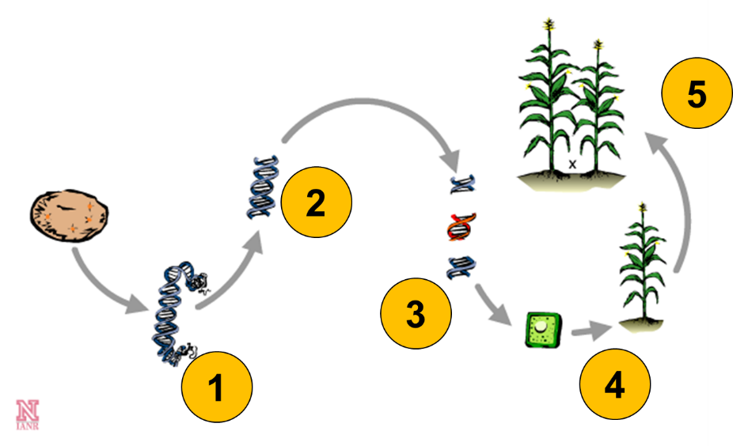
- How are genes, proteins, and traits related?

- What action is taken after the single gene that codes for the desired protein is located and copied out of all the DNA?

- How is the desired gene cut into pieces?

- What is recombinant DNA?

- What two methods can be used to insert the new gene (also called the transgene) into a single plant cell?

- How does the transgene become incorporated into all of the cells of the transgenic plant?

- Why is backcross breeding necessary?

Exploring Early Steps in Crop Genetic Engineering
You have learned that genetic engineering is the process of manually adding new DNA to an organism. The purpose of this process is to add one or more new traits that are not already found in that organism.

This lesson will focus on the first three steps of the genetic engineering process:
Step 1: Identifying an organism with the desired trait and extracting its DNA.
Step 2: Locating the gene responsible for the desired trait and cloning (or copying) that gene.
Step 3: Modifying the gene to express in a particular way in the engineered plant.

Step 1: Identifying an Organism with a Desired Trait and Extracting the DNA
Once a scientist has identified an organism with a desirable trait, the DNA of that organism needs to be extracted. DNA carries the genetic code for all living organisms. Each cell in a plant or animal has a nucleus with multiple chromosomes. Each chromosome is made up of DNA. Genes are short segments of this DNA that code for proteins resulting in the organism’s traits. We will practice extracting DNA from a common food crop (strawberries); however, DNA could be extracted from cells from any organism from bacteria to humans.

Materials Needed
- 1 strawberry
- mortar and pestle
- 10 mL (2 tsp) dish detergent
- 125 mL (1/2 cup) water
- 5 g (1 tsp) salt (non-iodized)
- rubber band
- coffee filter
- 2 plastic cups
- tray of ice
- masking tape and marker for labeling
- 91% cold isopropanol (rubbing alcohol)
- popsicle stick or coffee stir stick

Lab Procedures
- Place one strawberry into the mortar and grind it with the pestle.
- In a cup, mix the water, dish detergent, and salt. Add the solution to the strawberry in the mortar. Continue to grind the mixture.
- Label a second cup with your name. Place a coffee filter inside the cup and use a rubber band to hold it in place.
- Pour the strawberry mixture into the filter and place the cup in the tray of ice. It’s important to keep the mixture COLD while it slowly filters. Wait several minutes for the mixture to filter.
- After the mixture has filtered, SAVE the filtered liquid (which contains the DNA) in the cup. Discard the coffee filter and strawberry remains in the trash.
- Gently add an amount of isopropanol (rubbing alcohol) equal to the amount of filtered liquid to the cup. Remember to layer the isopropanol on top of the clear liquid rather than mixing the two layers together. Watch and wait. Bubbles will begin to form and a white stringy substance will become visible. This precipitate (the solid that forms when a chemical is added to a solution) is the DNA!
- Place the cup back into the ice tray and check on it in 10 minutes. If you don’t stir the layers, a large “glob” of strawberry DNA will form. (Leave the cup on ice for as long as possible.)
- Pick up the DNA using a popsicle stick or coffee stir stick.

Lab Reflection
- Why did you have to crush up the strawberry to get out the DNA?

- Why did you need to add dish detergent and salt?

- What did you observe when you added alcohol to the filtered liquid?

- What did the DNA look like?

- If you would have cut your strawberry in half and performed two separate DNA extractions with each half, would the resulting DNA be the same in both extractions? Explain. (Hint: Remember that strawberry started out as one fertilized cell.)

Lab Extension
- The next step in genetic engineering is to locate the gene responsible for the trait and clone (or copy) them. Predict what might happen if you skipped this step and simply inserted all of the DNA from the strawberry into a new plant.

Step 2: Gene Cloning
Developing a genetically engineered crop variety, or transgenic, is a long and complicated process.
The first step in this process involves a genetic engineer identifying an organism with a desirable trait. Some traits might be especially valuable to a farmer such as a plant being able to defend itself against an insect pest or tolerate poor environmental conditions such as drought or flooding. Other traits might be selected for their value to a consumer, such as a long shelf-life or added nutritional value.

Next, the genetic engineer extracts DNA from the organism with the desired trait. Then, the engineer locates the specific gene responsible for the wanted trait and makes copies of the gene. This step is known as gene cloning.

To learn more about gene cloning, view the animation found here: http://passel.unl.edu/pages/animation.php?a=genecloning.swf&b=990819293
- In the animation example, the desired trait was found in what organism?

- What is a restriction enzyme? How is it used?

- Bacterial plasmids are small circles of DNA in bacterial cells that are naturally present in addition to the bacteria’s other DNA. A plasmid is capable of storing and transporting cloned DNA segments. What happens to the cut plasmids and gene-sized pieces of DNA when they are mixed together?

- How are recombinant plasmids inserted into bacterial cells?

- The transformed bacteria are placed on a media that contains an antibiotic. Why is this done?

- Will all bacterial cells that are grown on the antibiotic plates have the desired gene (the gene of interest)? Why or why not?

Step 3: Understanding Gene Regions and Modifying the Gene
Once a gene has been located and cloned, the genetic engineer can modify or replace regions of the gene to make it express in a particular way in the plant.
To learn more about the regions of a gene and what functions they perform, view the animation found here: http://passel.unl.edu/pages/animation.php?a=GeneRegions.swf&b=1011727433.
- What are three regions that make up a gene and what do they do?

- What is a codon and what does it do?

- How are amino acids related to which protein is produced by a gene?

Part 2: Designing a Transgene
According to the United States Department of Agriculture’s Economic Research Service (USDA ERS), corn accounts for more than 95% of total feed grain production in the U.S. Feed grain is used to feed livestock. It is also made into a variety of food and industrial products and is used to produce ethanol for fuel.
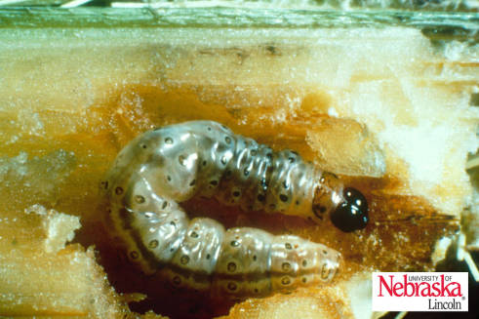
In order to protect this valuable agricultural crop, growers must minimize damage from pests, pathogens, and parasites. A major pest of corn is a moth known as the European corn borer, (ECB). During the larval stage, it feeds on various parts of the corn plant including the leaves, stalk, and ears of corn. Feeding damage results in poor ear development, broken stalks, and dropped ears. Yield losses and control expenses associated with European corn borer cost farmers in the U.S. more than 1 billion dollars.
European corn borer larva feeding on corn stalk

Plant breeders can use genetic engineering to develop improved lines of corn that incorporate desirable traits, such as resistance to pests like the European corn borer. Imagine you are a plant breeder. You are responsible for designing a transgene to combat European corn borer damage of corn. Use the information provided below to accomplish your task.

Select and circle your choice of promoter, coding region, and termination sequence from the choices in the table.
Gene Region Choices
Promoter | Coding Region | Termination Sequence
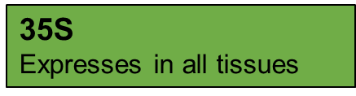 | 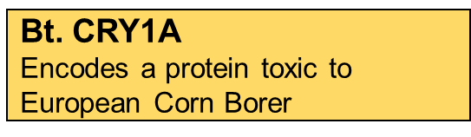 | 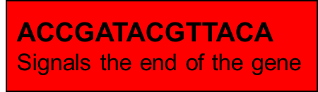
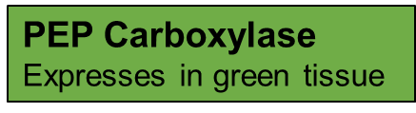 | 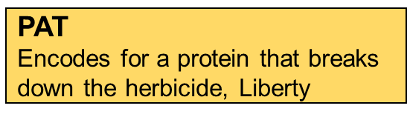
 | 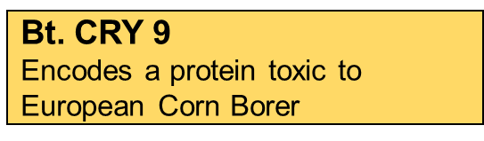
 | 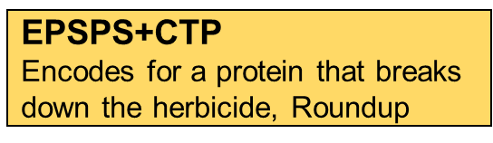

What trait will your transgenic corn plant have?

Part 3: Designing Transgenes to Solve Real-World Issues
Instructions: Read each of the four real-world issue scenarios provided. Examine the list of promotors and coding regions in the tables on pages 5 and 6. Select one promoter and one coding region to potentially solve each scenario. Using scissors, cut apart the promoters and coding regions. Paste your selected promoter and coding region with the corresponding scenario.

Scenario #1
Although rice plants naturally produce beta-carotene (Vitamin A), none is present in the endosperm, the part of the plant that is consumed. In many countries where rice is a staple food, people are vitamin A deficient, which may lead to blindness or susceptibility to other diseases.

By increasing the nutritional value of rice, scientists hope to prevent millions from suffering these afflictions.

Promoter:
Photo source: www.goldenrice.org

Coding Region:

Scenario #2
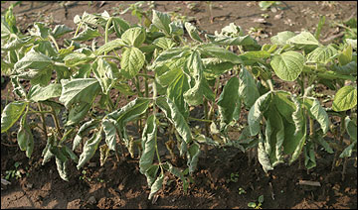
The herbicide, Roundup, can stop enzyme productivity in plants which halts the plant’s growth and development. The plant eventually dies from starvation. Agrobacteria, a naturally occurring soil bacteria, has a resistance to Roundup and can function in its presence.

By creating soybean plants that can tolerate being sprayed with Roundup herbicide, plant breeders hope to improve soybean production by reducing competition with weeds.
Photo source: extension.missouri.edu
Promoter:

Coding Region:

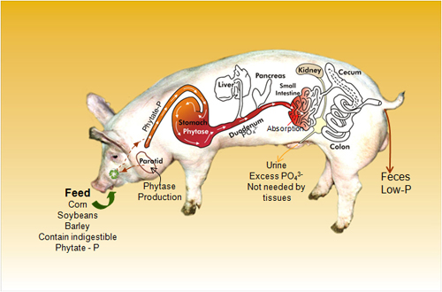
Scenario #3
Pigs are unable to digest 50-75% of the phosphorous in their food. In areas of swine production, the soil builds up phosphorous content. After heavy rains, the phosphorus leaches into freshwater ponds, streams, and rivers. This causes algae blooms which result in fish deaths due to low dissolved oxygen content and reduced water quality.

By creating a transgenic pig capable of digesting phosphorous, breeders hope to avoid the problem of phosphorous impacting quality of freshwater ponds, streams, and rivers.
Photo source: http://www.uoguelph.ca/enviropig

Promoter:

Coding Region:

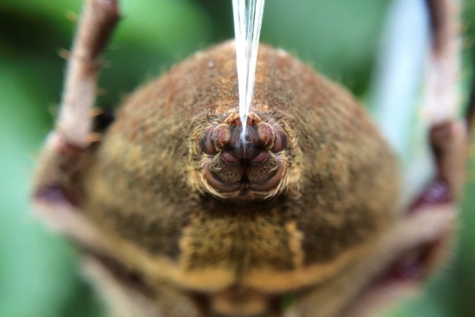
Scenario #4
Spiders produce silk that has long impressed engineers as it is stronger than steel yet thinner than a human hair. If scientists could use this silk in technology we could revolutionize bridges, medical sutures, car bodies, and Kevlar. However, spider silk production is time-consuming and expensive due to spiders’ small size and the complexity of the process. Initially attempts were made to use bacteria to produce the silk proteins. These efforts failed; however, it has been found that goats have very similar mammary glands to spiders’ silk glands.

Promoter:
Photo source: en.wikipedia.org

Coding Region:

Lesson 2 | Gene Insertion

Student Name ___________________________________________

Introduction: Identifying an Agricultural Problem: Sudden Death Syndrome (SDS) in Soybeans
Watch the video found here: https://ge.unl.edu/journey-of-a-gene/ (video length: 2:37). Answer the following questions.
- What happens to soybean fields afflicted with Sudden Death Syndrome (SDS)?

- In the video, one scientist indicates that developing a genetically engineered variety of soybean plants resistant to SDS in a lab is a good option. Why isn’t traditional breeding considered a viable solution?

- What are three criteria scientists might consider to be important when creating a new soybean plant through genetic engineering? Why?

Part 1: Practice Inserting a Gene
Genetic engineering enables scientists to modify the DNA of living organisms by transferring a transgene - or modified gene - into a target organism. The genetically engineered organism is then called a transgenic. What steps are involved in the insertion of a transgene into an organism? Let’s find out.
Working either individually or in pairs:
- Go to passel.unl.edu/ge/
- Click on “Step 2: Transformation”
- Read the Learning Objectives and watch the video “Constructing a Plasmid”, found under Gene Delivery (video length: 2:47).
- Define the following terms from the video:
  - Agrobacterium –

  - Plasmid –

  - Sticky ends –

  - Transgene –

- Under the tab, Practice Inserting a Gene, visit the PBS interactive animation called “Engineer a Crop”. Practice dragging and dropping the steps in the right order in order to insert a Bt transgene into a tomato plant in order to create a transgenic tomato plant resistant to certain insect pests.
- Complete the table below with the eight steps of engineering the crop from the animation. In one column, list the physical action you must take for each step and in the next column describe WHY you are doing that action – what do you hope to get out of it?

Step # | Physical Action | Goal/Result
1
2
3
4
5
6
7
8
- Answer the following questions based on what you learned from the animation.
  - What is Bt?

  - How does the Bt gene get into the plant’s genome?

  - What is technically incorrect about Step 6?

  - How can you tell if you were successful in inserting the transgene?

- Spend a few minutes reviewing the steps involved in engineering a plant. When you feel you understand the steps in the process, go to your instructor's desk. Eight cards representing the above steps will be available. Arrange the cards in the correct order AND explain why the cards are placed in that particular order. If you are successful, you can move on to the next task. No notes are allowed for this step.

If you can’t put them in the right order or explain it yet, your instructor will tell you to come back to this practice exercise to hone your skills before you try again.

Part 2: Testing for Successful Gene Insertion
Watch the video located under the tab entitled, Marker Genes (video length: 4:05).
- What three genes are inserted into the plant in the example shown and what is their purpose?

- In your own words, describe how antibiotics and herbicide are used by scientists to ensure successful insertion of the transgene into the plant.

Part 3: Using Gene Insertion in Research
Watch the video located under the tab entitled, In the Lab (video length: 6:44).
- After the seeds have germinated on the growth medium, what does, Shirley, the scientist do to the plant? Why is this done?

- How long is the agrobacterium given to incorporate the transgene into the cotyledon?

- True or False: Scientists have control over where the transgene is inserted in plant’s genome when using agrobacterium.

- What steps might scientists take after the plant is transformed in the lab and grown in a greenhouse?

Lesson 3 | Flower Anatomy and Plant Breeding

Student Name ___________________________________________

Activity 1: Structure and Function of a Flower
Plant breeding requires the plant breeder to manipulate a flower to control a cross. In doing this, a breeder needs to have a good understanding of flower parts. As a review of flower anatomy, you will dissect a flower, separate the parts of the flowers, group them by similar structure, and predict their function for the plant.

Materials needed
- One flower blossom
- Microscope or hand lens (5x–10x)
- Assortment of dissecting tools (probes, tweezers, scalpel)
- Double-sided tape
- 2 pieces of paper (one for sketching, one for attaching flower parts)

Procedures
- Draw a sketch of the flower.
- Gather dissection materials.
- Begin carefully dissecting the flower.
- As you gently remove parts of the flower, group them with similar parts.
- When all parts of the flower have been taken apart, use double-sided tape to attach the parts to a piece of paper.
- Make observations about the flower structures based on what you can see, smell, and touch.
- Write your prediction of what function each part serves in the plant.

Post-Activity Reflection
- The parts of this flower make up what functional system for the plant?

- What observations did you make about the flower petals? How do you think the petals contribute to plant reproduction?

- What characteristics did you notice about pollen? Why do you think pollen is well-suited for moving genetic material between plants?

- What did you observe about the stigma of the flower? How does this characteristic help the stigma to function?

Activity 2: Flowering Plant vs. Human Reproduction
Now that you have explored the parts of a flower, it is time to compare and contrast flowering plant reproduction with human reproduction. Create a table that lists similarities and differences between these reproductive systems.

Similarities | Differences
Ex) Both require fertilization of the egg by male genetic material. | Ex) The male genetic material is sperm in humans and pollen in plants.

Watch the video “Plant Reproduction in Angiosperms” from the Ameoba Sisters (https://youtu.be/HLYPm2idSTE). Answer the following questions.
- According to the video, squash and green beans are considered fruit. Why is this?

- Why are pollinators important for plant reproduction?

- What is the purpose of fruit development in plant reproduction?

Activity 3: Controlling Plant Reproduction in Agriculture
Watch the video “How to cross soybeans” (https://vimeo.com/82420755) and answer the following questions.

- What was one difference you noticed about the size of soybean flowers compared to the flower you dissected in activity 1?

- Explain, in detail, what a plant breeder must do to pollinate a soybean plant.

- What is the benefit of a plant breeder pollinating soybeans by hand rather than relying on an insect pollinator to move the genetic material from one plant to another?

- Why might a breeder want to control which parent plants are used in the reproduction of soybean seeds?

Activity 4: Careers in Plant Breeding
You learned in Activity 3 why plant breeders need to understand flower anatomy and the mechanics of plant reproduction in order to breed new lines of soybeans. Plant breeders conduct research on plant characteristics, or traits, and work to create varieties of plants that can best survive and thrive in a particular environment. Important plant traits may include the ability to resist a disease or pest, to survive drought, to produce lots of fruit, or to mature quickly. Plant traits are controlled by the genes contributed by each parent plant and the breeder controls which plants contribute their genes to the seeds of the next generation of plants.
To learn more about careers in plant breeding and the impact plant breeding has had on the world, watch the two videos below.
A Student’s Guide to Careers in Plant Breeding: https://youtu.be/pbRk64bc03c
Norman Borlaug and the Green Revolution: https://youtu.be/Lg9-HTtgFOk
- What skills do you have that could contribute to a career in plant breeding?

- What new skills would you need to learn in order to succeed as a plant breeder?

- What is one aspect of a career in plant breeding that you would like? What is one aspect you would dislike?

- Who is Norman Borlaug and how did his work change agriculture around the world?

Lesson 4 | Backcross Breeding with Transgenic Plants

Student Name ___________________________________________

Activity 1: Five Steps of Genetic Engineering a Plant
Play the game “Who wants to be a genetic engineer?” found here: http://passel.unl.edu/pages/animation.php?a=who_wants_to_be_ge.swf&b=1023486473. In your own words, fill in the table with the steps you took to create a cinnamon-flavored apple. Be specific!

Steps in plant genetic engineering | Create a cinnamon-flavored apple
- The genetic engineer identifies an organism with a desired trait and extracts the organism’s DNA. Somewhere in the DNA is a gene that codes for a protein that causes the trait.
- The genetic engineer locates the gene that codes for the protein, removes it from the DNA, and clones the gene using a technique called Polymerase Chain Reaction (PCR).
- A gene is made up of three coding regions: the promoter, coding region, and termination sequence. The genetic engineer can cut these regions apart and one or more of the three regions can be altered or replaced so that the gene is expressed in a particular way inside the plant.
- The modified gene is a combination of regions and is called recombinant DNA. The new gene can then be inserted into plant cells using a transformation method such as agrobacterium. Once the gene is successfully inserted into a plant cell’s nucleus, it can be incorporated into one of the chromosomes. The plant cell will divide and multiple to make a new transgenic plant and all its cells will have the gene. The gene can also can be passed on to offspring.
- The final step is called backcross breeding where a plant breeder crosses the transgenic plant with a high-yielding or locally-adapted elite line to produce a hybrid. These crosses are performed multiple times over several years. The final result is a high-yielding transgenic hybrid that expresses the desired trait.
For this lesson, we will focus on the fifth and final step in genetic engineering called backcross breeding.

Video 1: An Introduction to Backcross Breeding
Go to passel.unl.edu/ge/.
Click on “Step 3: Breeding”.
Read the Learning Objectives and watch the video “Backcrossing”.

- What is a transgenic line?

- What is an elite line?

- What are two differences between a transgenic line and an elite line?

- How are transgenic and elite inbred lines produced?

- What is the result of the inbred lines?

- What is the goal of backcrossing?

Activity 2: Performing a Simulated Backcross
To illustrate the backcross breeding of a transgenic line with an elite line, you will work in small groups to complete a plant breeding simulation using cups filled with different colored beads to represent the mixing of different genetic backgrounds of the transgenic and elite lines.

Materials needed:
- Three cups
- Two different colors of beads

Steps in the Simulated Backcross
- Year 1: Begin by filling two cups about half full with one color of beads in each. These two cups represent plants with 100% transgenic genes and 100% elite genes.
- To make the first cross, pour half of the beads from each cup into a third cup and mix the beads. This represents the F1 cross.
- Empty the unused beads from the 100% transgenic cup. After each cross, refill the cup containing 100% elite genes.
- Year 2: Pour half the beads from the F1 cross and 100% elite into an empty cup and mix the beads. This represents Backcross 1.
- Years 3-6: Continue this backcross process, mixing ½ the beads from the resulting “offspring” with ½ the beads from the 100% elite cup.
Fill in table below with % transgenic and % elite genes comprising the offspring’s genetic makeup. Remember, the amount of remaining genetic information from the transgenic parent is reduced by 50% with each backcross.
Time | Parent #1 | Parent #2 | Offspring Produced | Offspring’s  Genetic Makeup
Year 1 | 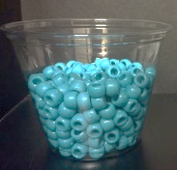  100% Transgenic | 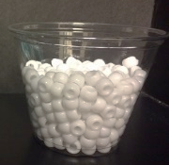  ×  100% Elite | 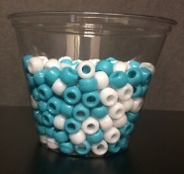  F1 Cross | ______% Transgenic  ______% Elite
Year 2 | ×  F1 Cross | 100% Elite | Backcross 1 | ______% Transgenic  ______% Elite
Year 3 | Backcross 1 | ×  100% Elite | Backcross 2 | ______% Transgenic  ______% Elite
Year 4 | Backcross 2 | ×  100% Elite | Backcross 3 | ______% Transgenic  ______% Elite
Year 5 | Backcross 3 | ×  100% Elite | Backcross 4 | ______% Transgenic  ______% Elite
Year 6 | ×  Backcross 4 | 100% Elite | Backcross 5 | ______% Transgenic  ______% Elite
- After completing the simulation, do you think the final backcross would have more traits like the transgenic plant or like the elite plant? Explain.

Video 2: Applying Backcross Breeding in the Field
On the “Journey of a Gene” website, watch the video “In the field” and answer the following questions.

- In your backcross breeding simulation, you bred a transgenic plant and an elite plant. In the video, George talks about a donor parent and a recurrent parent being used in the backcross. How are these terms related? Circle the word to best complete the sentence.

The transgenic plant is the __donor or recurrent____ parent.

The elite plant is the ___donor or recurrent_____ parent.

- Explain why transgenic plants do not speed up the availability of new varieties.

- If it is not faster, what is the benefit of transgenic plants?

Discussion and Reflection
- Should the backcross breeding process occur in a greenhouse or the field? Explain your answer.

- Why don’t genetic engineers just put the desired genes into the “elite” varieties that farmers really like?

