Space Invaders: Ecology and Evolution of Invasive Species
Teacher Resources

Summary
Space Invaders is a standards-aligned, 5-E life science unit teaching about the ecology, evolution, and effects of invasive species as it applies to both natural and agricultural ecosystems. Numerous hands-on, minds-on activities will get students out of their seats to explore a variety of evolution and ecosystem concepts including natural selection, selection pressure, adaptation, evolution, predation, biological control, and invasive species management. Students will examine how factors such as environment, reproductive capacity, and seed dispersal play key roles in an invasive plant species’ success by playing the game, “Space Invaders”.

Grade Level
9-12

Contents
Lesson 1 | What is an Invasive Species? 2
Lesson 2 | Adaptive Traits 6
Lesson 3 | Natural Selection and Evolution 17
Lesson 4 | Controlling Invasive Species 24
Lesson 5 | Biological Control of Invasive Species 31

Authors
Jonathan Anderson, Agriculture Education/FFA Teacher, Norfolk High School, Norfolk, Nebraska
Allison Zach, Coordinator, Nebraska Invasive Species Program
Erin Ingram, Curriculum Development Specialist, University of Nebraska-Lincoln, IANR Science Literacy
Molly Brandt, Graduate Research Assistant, University of Nebraska-Lincoln, IANR Science Literacy

Lesson 1 | What is an Invasive Species?

Background

Purpose
This lesson introduces the concept of an invasive species. Students will create a profile for an invasive species in their area to gain an understanding of the diversity of organisms that can become invasive, where to go for trusted information, how humans may be involved in their introduction and spread, and which native species or resources are threatened.

Standards
Next Generation Science Standards
- HS-LS4-5 - Evaluate the evidence supporting claims that changes in environmental conditions may result in: (1) increases in the number of individuals of some species, (2) the emergence of new species over time, and (3) the extinction of other species.
- HS-LS2-7. Design, evaluate, and refine a solution for reducing the impacts of human activities on the environment and biodiversity.
Common Core
- CCRA.R.9 Analyze how two or more texts address similar themes or topics in order to build knowledge or to compare the approaches the authors take.

Estimated Time
One 50-minute class period

Student Materials
- Various art supplies (Crayons, pencils, and/or markers, blank paper)
- Computer with internet access
- 1 computer per group or lesson can be adapted to computer lab

Teacher Materials
- PowerPoint presentation (optional)
- Computer with projector (if using PowerPoint presentation)

Vocabulary
- invasive species: any organism that is non-native (or alien) to the ecosystem. It is likely to cause harm to the economy, environment or human health.
- native: living or growing naturally in a particular place or region
- non-native: an organism that has arrived in a place or region from elsewhere

Key STEM Ideas
Interactions within a relatively stable ecosystem contribute to consistency in numbers and types of organisms over long periods of time. Invasive species represent a disruption to a relatively balanced ecosystem. Depending on the degree of disruption, the ecosystems may be resilient and return to balance. However, invasive species are a threat to biodiversity and may considerably shift the make-up of native communities.

Students’ Prior Knowledge
Students will benefit from a basic understanding of how a disruption to an ecosystem impacts dynamic homeostasis. Students should have prior knowledge of how to conduct a web search of a scientific topic and be able to identify high quality sources of information.

Connections to Agriculture
An invasive species is defined legally in the US as “an alien species whose introduction does or is likely to cause economic or environmental harm or harm to human health…‘Alien species’ means, with respect to a particular ecosystem, any species…that is not native to that ecosystem.” Novel species can be added to a community either by natural range extensions or because they are introduced because of human activity.

Invasive species rank second only to habitat destruction as a threat to biodiversity. Almost half of the species in the United States that are at risk of extinction are endangered because of the effects introduced species alone or because of their impacts combined with other processes. In fact, introduced species are considered a greater threat to native biodiversity than pollution, harvest, and disease combined. Invasive species threaten biodiversity by (1) causing disease, (2) acting as predators or parasites, (3) acting as competitors, (4) altering habitat, or (5) hybridizing with local species.

Virtually all ecosystems are at risk from the harmful effects of introduced species. Invasive species are a major threat to our environment because they (1) can change habitats and alter ecosystem function and ecosystem services, (2) crowd out or replace native species, and (3) damage human activities, costing the economy millions of dollars. For example, costs to agriculture, forestry, fisheries, and other human activities by introduced species are estimated at $137 billion per year to the U.S. economy alone.

Essential Links
- http://www.invasivespeciesinfo.gov/
- http://www.invasivespeciesinfo.gov/unitedstates/state.shtml
- http://www.invasive.org/
- https://www.fws.gov/invasives/index.html

Sources/Credits
- Connections to Agriculture section sourced from Mark McGinley (Lead Author); J. Emmett Duffy (Topic Editor) "Invasive species". In: Encyclopedia of Earth. Eds. Cutler J. Cleveland (Washington, D.C.: Environmental Information Coalition, National Council for Science and the Environment). [First published in the Encyclopedia of Earth July 25, 2010; Last revised Date April 8, 2011; Retrieved June 28, 2015]

Lesson Procedures
Engage
- Ask students if they know of any invasive species in their area. Have students add their ideas to the PowerPoint (slide 2) or write them on the board. Discuss where they learned about these invasive species and if they know what makes an organism an invasive species.
- Use slide 3 to define an invasive species as an organism that…
  - is not native to an ecosystem (it may be native to the region)
  - is likely to cause economic or environmental harm or harm to human health
Explore
Activity 1: Invasive Species Web Search
- Use slide 4 and provide students with access to computers with internet. Instruct students to conduct a web search for invasive species in their area (searching at the state level is recommended).
- Have students write an invasive species they found on the board.
- Discuss the diversity of organisms that can be invasive (you might encourage students to list a diversity of species so that plants, invertebrates, vertebrates, etc. are all represented)
- Have students share what websites they found that provided credible information.
  - Federal, state, and local governments share the responsibility for preventing, eradicating, and controlling invasive species so searching government websites can be a good strategy.
  - You may want to share with students that they can conduct a Google search of just government sites by adding site:gov to their search. The same can be done for education websites by adding site:edu.
  - Several good websites for invasive species info are included in the essential links.
Explain
Activity 2: Developing an Invasive Species Profile
- Divide into teams of 2-3 students and have each group select an invasive species from the list on the board.
- Provide students access to a variety of art supplies (paper, pens, coloring utensils)
- Using slides 5 & 6, instruct groups to develop an invasive species profile using good sources of information. The profile must include:
  - An image or drawing of the invasive species
  - How it was introduced (and when, if possible)
  - What species or resources it threatens
  - A reason it is biologically successful (how does it outcompete other species?)
- After giving students time to complete their invasive species profile, have students add their answers to slides 7-10 based on their findings. Alternatively, the questions can be written on the board. Discuss the following questions:
  - What are common routes of introduction?
  - How are humans involved in the introduction of invasive species?
  - What kinds of problems are caused by invasive species?
  - Why are invasive species so successful?
- Use slide 11 and have students imagine they are creating a list of “America’s Most Wanted” invasive species. Have students provide evidence for why their species is one of the following:
  - Most expensive to control?
  - Toughest to control?
  - Most damaging to an ecosystem?
  - Fastest invasion?
  - Sneakiest invasion?
  - Biggest up-and-coming invader?
Extend
- Use slide 12 to have students discuss strategies for stopping the introduction or spread of the invasive species from their group’s profile. Discuss benefits and limitations to their solutions.

Lesson 2 | Adaptive Traits

Background

Purpose
This lesson uses invasive species to teach about the role of selection pressure and adaptive traits in evolution of a population. Students will play an invasive species game, Space Invaders, to better understand adaptive traits of invasive plants in a new environment. Three types of adaptations are introduced: morphological, physiological, and behavioral. Students will identify these three types of adaptations in an invasive fish species. Students will develop a Super Competitor to illustrate their understanding of adaptive traits.

Standards
Next Generation Science Standards
- HS-LS4-4 Construct an explanation based on evidence for how natural selection leads to adaptation of populations.
- HS-LS4-5 Evaluate the evidence supporting claims that changes in environmental conditions may result in: (1) increases in the number of individuals of some species, (2) the emergence of new species over time, and (3) the extinction of other species.
Common Core
- CCRA.SL.2 Integrate and evaluate information presented in diverse media and formats, including visually, quantitatively, and orally.

Estimated Time
Two 50-minute class periods

Student Materials
- Space Invaders Game
  - Instructions
  - 3 game boards per group
  - 3 plant type cards per group
  - 3 different types of game pieces (Pennies, dimes, paper clips, safety pins, buttons, beads, etc.-- 24 pieces per student)
- Student worksheet
- Computer with internet access

Teacher Materials
- Teacher access to computer and projector (optional)
- PowerPoint presentation (optional)

Vocabulary
- invasive species: any organism that is non-native (or alien) to the ecosystem
- native: living or growing naturally in a particular place or region
- non-native: an organism that has arrived in a place or region from elsewhere
- adaptive trait: a heritable feature functioning to overcome selection pressure and increase fitness of an organism
- selection pressure: any biotic (living) or abiotic (non-living) factor impacting the reproductive success of some individuals in a population more than others

Key STEM Ideas
Selection pressure acts on the genetic variation present in a population. Organisms with an adaptive trait will experience an increase in fitness compared to other individuals lacking these adaptations. Invasive species may possess adaptive traits that assist them in succeeding in a new environment or selection pressure may be absent in these new environments. In addition, invasive species may act as a selection pressure on native organisms leading to a change in the number of native organisms possessing adaptive traits.

Students’ Prior Knowledge
Students will benefit from prior knowledge of invasive species in their area and features that make these invasive species biologically successful.

Connections to Agriculture and Natural Systems
Virtually all ecosystems are at risk from the harmful effects of introduced species. Invasive species are a major threat to our environment because they (1) can change habitats and alter ecosystem function and ecosystem services, (2) crowd out or replace native species, and (3) damage human activities, costing the economy millions of dollars. For example, costs to agriculture, forestry, fisheries, and other human activities by introduced species are estimated at $137 billion per year to the U.S. economy alone.

Essential Links
- Invasion of the Snakehead: https://youtu.be/nmU7etSYYqI

Sources/Credits
- Citation for Background on Connections to Agriculture and Natural Systems: Mark McGinley (Lead Author); J. Emmett Duffy (Topic Editor) "Invasive species". In: Encyclopedia of Earth. Eds. Cutler J. Cleveland (Washington, D.C.: Environmental Information Coalition, National Council for Science and the Environment). [First published in the Encyclopedia of Earth July 25, 2010; Last revised Date April 8, 2011; Retrieved June 28, 2015]
- $137 billion annual environmental and economic cost of invasive species citation: Pimentel D., Lach L., Zuninga R., and Morrison D., 2000, Environmental and economic costs of nonindigenous species in the United States: Bioscience: v. 50, p. 53-65.

Lesson Procedures
Prior to class…
- Make enough copies of the Space Invader game for each group to have all three of the game boards, a set of instructions, and a set of plant type cards.
- Gather 3 different types of game pieces (we suggest using paper clips, buttons, beads, safety pins, or coins) with at least 24 pieces for each student.
- Learn how to play the game using the instructions and slides 2-6 in the PowerPoint.
Day 1
Engage
- Facilitate a student discussion to determine if they believe all introduced species will become invasive.
Explore
Activity 1: Space Invader Game
- Provide students with access to the Space Invader game materials.
- Use slides 2-6 to introduce rules of the game. You may want to play a quick game of 5 rounds as a whole class so that all students fully understand the instructions.
- Have students complete 1 full game (5 rounds) and record their results in the game scorecard.
- If time allows, have students play an additional 2 games so they have a chance to play on all three game boards (wet, dry, and normal). This opportunity lets students observe differences in plant type performance under different environmental conditions.
- Once students have played the game, hand out the student worksheet and have students complete the reflection questions.
- Discuss reflection questions (slide 7) as a whole class. Have students discuss what factors influenced the success or failure of the different plant types.
  - Did all non-natives perform well?
  - Did some perform better under certain environmental conditions?
  - How did the invasive plants outcompete the other plants?
  - How might climate change have an impact on the success of the different plant types?
- Students should begin to see that traits such as reproductive capacity, ease of seed dispersal, and tolerance of different moisture conditions can greatly influence how a plant type performs and that a plant can be well adapted or not to differing environmental conditions.
Day 2
- Revisit student reflections about the Space Invaders Game from the student worksheet.
- Use slide 8 to explain to students that just like in their game, not all non-native organisms become invasive. Generally the probability is about 1 in 1000 non-native plants that is imported will go on to be an invasive pest. This is known as the ten-ten-ten rule.
  - One of every ten imported plants appears in the wild
  - One of those ten introduced plants becomes established in an ecosystem
  - One of those ten established plants actually becomes a pest
- Use slide 9 to explain to students that scientists don’t fully know why certain non-native become invasive while others don’t. Some possibilities include that invasive species have adaptive traits or that selection pressures may be removed for some species when they are introduced into a new environment. There may also be other factors at play that have not been examined yet. Not knowing why species become invasive makes it very difficult to predict which introductions will be problematic until it happens.
- Use slide 10 and the example of a camouflaged flat-tail horned lizard to introduce the criteria for an “adaptive trait”. It must…
  - Be heritable
  - Be functional
  - Arise due to selection pressure
  - Increase fitness
- Use slide 11 to explain to that not all traits are adaptive. Some are non-adaptive and provide no increase in fitness while others can be maladaptive and may reduce fitness if environmental conditions change.
  - Ask students if they can think of any traits that are non-adaptive or maladaptive?
  - Non-adaptive trait might be eye color. Maladaptive trait might be coloration if it no longer helps with camouflage.
- Use slide 12 to introduce “selection pressure” as any biotic (living) or abiotic (non-living) factor that impacts the reproductive success of some individuals in a population more than others (examples may include predation, parasitism, weather or climate, and exposure to pesticides).
- Facilitate a student discussion about how “selection pressure” and “adaptive traits” are connected.
  - Selection pressure acts on the genetic variation in a population. The genetic traits in the population that are best adapted or suited to the environment will become more common in future generations.
- Use slide 13 to introduce the three different types of adaptive traits and their definitions.
  - Morphological adaptations: Change occurs to the form or structure of the organism
  - Physiological adaptations: Change occurs to the function or response of the organism
  - Behavioral adaptations: Change occurs to the behavior of the organism
- Provide examples of the three adaptations as they appear in the Australian black snake in response to selection pressure from an invasive species, the cane toad, in Australia (slides 14-17).
  - Morphological: Cane toad arrival selected for snakes with bigger bodies and smaller heads as the probability of eating a toad large enough to be fatal decreases with an increase in snake body size.
  - Physiological: populations of snakes previously exposed to cane toads showed an increased resistance to the toad toxin. Snakes showed increasing resistance to toad toxin with increasing exposure time.
  - Behavioral: Populations of snakes exposed to cane toads for 40-60 years showed a preference for prey items other than cane toads. Populations of snakes never exposed to cane toads would eat either prey item (frog or cane toad). This was an innate behavioral response. This behavior could not be taught to snakes in a laboratory setting.
Explain
Activity 2: Snakehead Fish Adaptations
- Provide students with access to computers with internet to watch the video, Invasion of the Snakehead: https://youtu.be/nmU7etSYYqI or watch as a class on slide 18.
- As students are watching have them document the different types of adaptations mentioned in the video on the student worksheet.
- Use slide 19 to have students discuss the different adaptations of snakehead fish.
Extend
Activity 3: Build a Super Competitor
- Use slide 20, to introduce the final activity. Give students some time to brainstorm an invasive of their own creation (it does not need to be an organism that actually exists) that could survive on an alien planet.
- Have students sketch their invasive species on the student worksheet, give it a name, describe its adaptations, and what advantages those adaptations will provide them with in their new ecosystem.
- Have students share their “alien super competitors” with the class.
Evaluate
- Student worksheets and discussion will provide evidence for evaluation.

Space Invaders Game Board: Normal Year

Space Invaders Game Board: Dry Year (Drought)

Space Invaders Game Board: Wet Year (Flooding)

Space Invaders Scorecard
After each round, count the total number of pieces for each plant type on the game board. Record each population in the table below.
Game board used (circle one): Normal Dry Wet
Game 1 |  | Round 1 | Round 2 | Round 3 | Round 4 | Round 5
 | Native species
 | Introduced species
 | Invasive species

Game board used (circle one): Normal Dry Wet
Game 2 |  | Round 1 | Round 2 | Round 3 | Round 4 | Round 5
 | Native species
 | Introduced species
 | Invasive species

Game board used (circle one): Normal Dry Wet
Game 3 |  | Round 1 | Round 2 | Round 3 | Round 4 | Round 5
 | Native species
 | Introduced species
 | Invasive species

Plant species cards
Invasive Plant
Establishment: Begin with 2 plants
Habitat: Survives in all moisture conditions (wet, dry, moist)
Reproduction: Produces many seeds (gather 2 new plants for each pair)
Seed Dispersal: Maximized (place plants on any space on the board)

Introduced Plant
Establishment: Begin with 2 plants
Habitat: Survives in dry soil
Reproduction: Produces many seeds (gather 2 new plants for each pair)
Seed Dispersal: Minimal (place plants on any adjacent space from the reproducing plants)
Native Plant
Establishment: Begin with 5 plants
Habitat: Survives in moist soil
Reproduction: Produces some seeds (gather 1 new plant for each pair)
Seed Dispersal: Minimal (place plants on any adjacent space from the reproducing plants)

Space Invaders Instructions
Objective of the game:
The object of the game is for your plant type to survive in the plant ecosystem after 5 rounds of play.
Number of players:
Maximum of 3 players per game
Rules:
- Choose one of the three game boards (normal, dry, or wet year) to select your moisture conditions.
- Next, each player randomly selects one of the three plant species cards (native, introduced, and invasive). Each player must follow the rules of his or her plant type for the duration of the game.
- Each plant type is represented by a different type of game piece (these can be paper clips, candies, coins, etc.). You need a maximum of 24 game pieces per plant type.
- Each game piece represents a single plant.
- Each habitat space on the board can hold two plants.
- Once two plants of the same type are placed on a single space, the plants reproduce at the end of the player’s turn.
- For every pair of reproducing plants on the board, the player gathers the number of new plants noted by reproduction on their card. These plants will be placed on the player’s next turn.
- Only a single plant type can be placed on any space. A space with a single plant in it can be displaced by another plant type by placing two plants on the space.

To establish your plant ecosystem (Round 1)...
- Play will start with the player whose birthday is closest to Earth Day (April 22) and continue in clockwise direction.
- Each player will begin the game by placing the number of plants indicated by establishment on their card. No displacement can be done during establishment.
- All players will place their establishment pieces on game board spaces according to the rules of their plant type. For example, if your plant does not survive in wet soil, you may not place your plants on a wet habitat space on the board.
- Players will gather new plants according to their rules for reproduction. For example, for each pair of native plants occupying the same space, the player will gather one new plant to use on his or her next turn.
To continue playing (Rounds 2-5)….
- Play will continue with each player placing their new plants gathered from reproduction onto the game board. If no plants were gathered, the player’s turn is over and play continues with remaining players.
- After each round of play, record how many plants are on the board for each plant type. Results can be written in the Space Invaders Scorecard.
- Play ends after round 5 is complete.

Lesson 3 | Natural Selection and Evolution

Background

Purpose
This lesson uses a live-action predation simulation to illustrate natural selection and evolution of an invasive Chinese Mystery snail population. A reflection activity will allow students to think about the impact of biotic and abiotic changes in environment. Students will learn about the components necessary for natural selection to occur and identify these elements in an example animation.

Standards
Next Generation Science Standards
- HS-LS4-4 Construct an explanation based on evidence for how natural selection leads to adaptation of populations.
- HS-LS4-5 Evaluate the evidence supporting claims that changes in environmental conditions may result in: (1) increases in the number of individuals of some species, (2) the emergence of new species over time, and (3) the extinction of other species.
Common Core
- RI.11-12.7 Integrate and evaluate multiple sources of information presented in different media or formats (e.g., visually, quantitatively) as well as in words in order to address a question or solve a problem.

Estimated Time
One 50-minute class period

Student Materials
- Pens or pencils
- Coloring utensils
- Tape
- Scissors
- Student worksheet
- Computer with internet access

Teacher Materials
- PowerPoint presentation (optional)
- Computer with projector (optional
- Chinese Mystery Snail game
  - 1 predator handout
  - 1 snail handout per 6 students

Vocabulary
- invasive species: any organism that is non-native (or alien) to the ecosystem
- native: living or growing naturally in a particular place or region
- non-native: an organism that has arrived in a place or region from elsewhere

- adaptive trait: a heritable feature functioning to overcome selection pressure and increase fitness of an organism
- selection pressure: any biotic (living) or abiotic (non-living) factor impacting the reproductive success of some individuals in a population more than others
- natural selection: a mechanism of evolution in which organisms better adapted to their environment will tend to survive and produce more offspring than those that are poorly adapted
- evolution: change over time, descent with modification

Key STEM Ideas
Natural selection occurs when organisms well-adapted to their environment are better able to survive and reproduce. This process is a primary mechanism for evolution of populations. Invasive species often possess adaptive traits which allow them to outcompete native species for resources.

Students’ Prior Knowledge
Students should have a good understanding of inherited traits and genetic variation. They should be familiar with the concept of invasive species and that many of them have traits allowing them to outcompete native species for resources.

Connections to Agriculture
Invasive species have the ability to drastically alter ecosystems by disrupting the normal interactions between native species and biotic and abiotic features of their environment. The introduction of invasive species can lead to environmental and economic harm of both agricultural and natural systems.

In the case of the Chinese Mystery snail, populations of this invasive species were introduced to the U.S. in the 1890’s as part of the Asian food trade and also continue to be sold in the exotic aquatic pet trade. This particular species is larger in size and has a thicker shell than many native species. These morphological characteristics make Chinese Mystery snails less likely to be eaten by predators in new ecosystems, therefore, they are well-adapted to survive and reproduce. Their growing numbers impact ecosystems disrupting the food web when they feed on native species (such as the embryos of largemouth bass which are apex predators). This has economic implications as control of invasive species can be expensive and lack of control can negatively impact recreational tourism such as sport fishing.

Essential Links
- Natural Selection Animation video: https://youtu.be/M3bROOvWMcM

Sources/Credits
Image credits in PowerPoint presentation:
- http://www.friendsofcrystallakewis.org/snails.html
- http://www.dfw.state.or.us/conservationstrategy/invasive_species/mystery_snail.asp
- http://www.lessonpaths.com/learn/i/chinese-mystery-snail-4/chinese-mystery-snail-28

Lesson Procedures
Prior to the beginning of class…
- Make enough copies of the Chinese Mystery Snail game for 1 predator handout and enough snail pictures for each remaining student to have one snail image (there are 6 snails per page).
- Cut apart the snail images or have students do this before the start of the game.
Engage
Introduce Chinese Mystery snails
- Distribute student worksheets.
- Use slide 2 to introduce students to the Chinese Mystery snail, an invasive aquatic species in the U.S. Ask students to fill out the three questions on their student worksheet
  - How did humans play a role in the introduction of the Chinese Mystery snail?
Humans released the snails into local ecosystems via the aquarium releases and were intentionally released into the environment to establish a local population for Asian food markets.
  - What traits may help the Chinese Mystery snail outcompete the native snails in the U.S.?
Their larger size and thicker shells may make them more difficult for predators to consume.
  - Why would we consider the Chinese Mystery snail to be an invasive species?
Chinese Mystery snails are non-native to ecosystems in the U.S. and likely cause both economic harm by clogging water intake pipes, environmental harm via competition with native snail species, and are a threat to human health by their ability to carry parasites and diseases affecting humans.
Explore
Activity 1: Chinese Mystery Snail game
- Introduce the term natural selection as a process in which organisms that are well-adapted to their environment will survive and reproduce more than those organisms that are poorly adapted. Explain to students that they will be playing a game in order to illustrate the concept of natural selection.
- Use slide 4 to determine 1 student whose birthday is closest to October 31st.
- Using slide 4, let the selected student know they will need the predator handout and a pen or pencil before being directed to the hallway for 5 minutes. Their task is to draw an image of a snail predator.
- Once the student is directed to the hallway, use slide 5 to direct all remaining students to use provided coloring utensils and a snail image to decorate a Chinese Mystery snail offspring. Once complete, provide access to tape and have students hang their snail somewhere in the classroom.
- After about 5 minutes, ask the student from the hallway to return to the classroom. Ask him or her to share the snail predator drawing.
- Use slide 6 to direct the student that they will act as the snail predator. Explain that there are Chinese Mystery snails hung around the room. The student will have 1 minute to gather all of the snails they can.
- Time the “snail predator” for 1 minute then display the snails that were gathered.
- (Slide 7) Ask a student in the room to choose a color. Ask students to imagine that all snails with this color have a thicker shell and are unable to be eaten.
  - How might this change the way the population of predators hunt and survive?
More of the snails with the selected color will survive. Predators who preferentially hunt thin-shelled snails will have more access to food and likely outcompete predators who select thicker-shelled snails.

Explain
Review the happenings in game to describe natural selection
- After the class has played the Chinese Mystery snail game, have students use what they observed during the game to write down and describe the process of natural selection using the terms: genetic variation, inheritance, competition, selection pressure, and time. Remind them to be sure to discuss how natural selection results in evolution of both the native and invasive snail populations.
- Use slide 8 to review how the terms genetic variation, inheritance, competition, selection pressure, and time contribute to natural selection occurring.
Extend
- Have students get into groups of 3-4 and give them 10 minutes to discuss the 3 scenarios on the student worksheet. Make sure each group comes up with 3 comments for each of the scenarios to add to the group discussion.
- Encourage students to consider discussing adaptive traits, selection pressure, natural selection, evolution, individuals, populations, reproduction, or other relevant concepts.
- Write these comments on the student worksheet. Scenarios include:
  - What happens if a disease affecting Chinese Mystery snails sweeps through the ecosystem?
This represents the addition of another selection pressure for snails who can resist or tolerate the disease.
  - What happens if there are no snail predators?
This represents the removal of predation as a selection pressure. Snails with the adaptation of a thicker shell may no longer have the adaptive advantage.
  - What happens if a predator is born with a mutation that allows it to overcome the strength of the thicker shell?
An additional selection pressure will be placed on thick-shelled snails. This is a good example of an “arms race” in which predators and prey will develop adaptations and counter-adaptations in response to one another.
Evaluate
- Give students access to computers with internet. Have them watch the video, “Natural Selection Animation”: https://youtu.be/M3bROOvWMcM
- Answer the questions about the Lithipodius nulla creature in the video.
  - How does this video show genetic variation in the population?
The creatures had differing colors and differed in the amount they moved around.
  - What is the selection pressure?
Predation.
  - What adaptive traits did you observe?
Camouflage and behavioral hiding were adaptive traits.
  - Did any traits become maladaptive?
A tan coloration was adaptive at first, but became maladaptive when the environment experienced added moisture and changed to a green color.
  - Does natural selection cause evolution to occur at the individual or population level? Explain.
Natural selection did not give an adaptive trait to an individual, rather it allowed some individuals in a population to survive and reproduce which caused evolution at the population level.

Teacher Materials

Chinese Mystery Snail game
Background on the Chinese Mystery Snail
The Chinese Mystery snail is a large snail that was introduced to the U.S. through aquarium trade and Asian food trade. They are larger in size and have a thicker shell than some native species which makes them less prone to predation.
Mystery snails are problematic for a number of reasons. First, they are capable of carrying parasites and diseases known to infect humans. They also compete with native gastropod species for food and habitat. Lastly, their shells can clog screens of water intake pipes and restrict water flow.
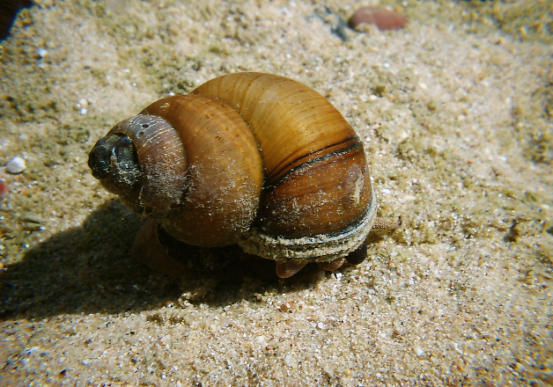Chinese Mystery Snail
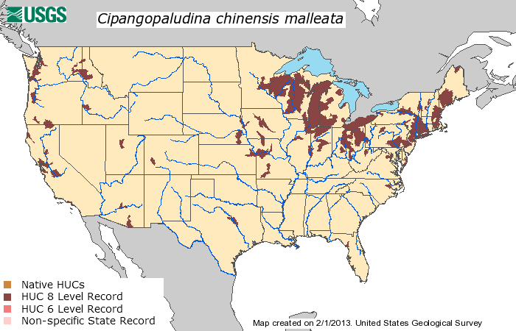Distribution of Chinese Mystery Snail as of 2013
Images from: http://www.friendsofcrystallakewis.org/snails.html

Objective: Illustrate natural selection as a mechanism for evolution in an aquatic ecosystem

Materials needed:
- Pens or pencils
- Crayons or colored pencils
- Tape
- Scissors
- Predator handout (included)
- Snail handout (included)
- Plain paper (optional)
Before class:
Make enough copies of the Chinese Mystery snail pictures so each student can have one (six pictures per page). Cut apart in advance or have students cut pictures apart during class.

Instructions:
The student with their birthday closest to October 31st will take a pen or pencil and the predator handout (page 2) and move to the hallway for 5 minutes. During this time their task will be to draw a picture of a snail predator.

Give remaining students in the class 5 minutes to color an offspring of a Chinese Mystery snail and hide their pictures in plain sight around the room.

After 5 minutes, call in the student from the hallway. Hang the student’s predator drawing on the board. Give the “predator” student 1 minute to gather as many snails as possible from around the room.

After 1 minute, display the snails gathered by the predator. Ask a student to choose a color. Ask students to imagine that all snails with that color have a thicker shell and are unable to be eaten by the predator.

Ask the students to brainstorm how this might change the way the predator hunts next time. What does this do to the snail population? What is the selection pressure? What is the adaptive trait?

Student with birthday closest to October 31
- Take a pen or pencil and this handout to the hallway
- Draw an organism that eats snails (Crayfish, toad, turtle, snake, bird, fish, etc.)

Snail Predator

Chinese Mystery Snail Pictures
Students can draw their own snails or cut out and color this provided image.
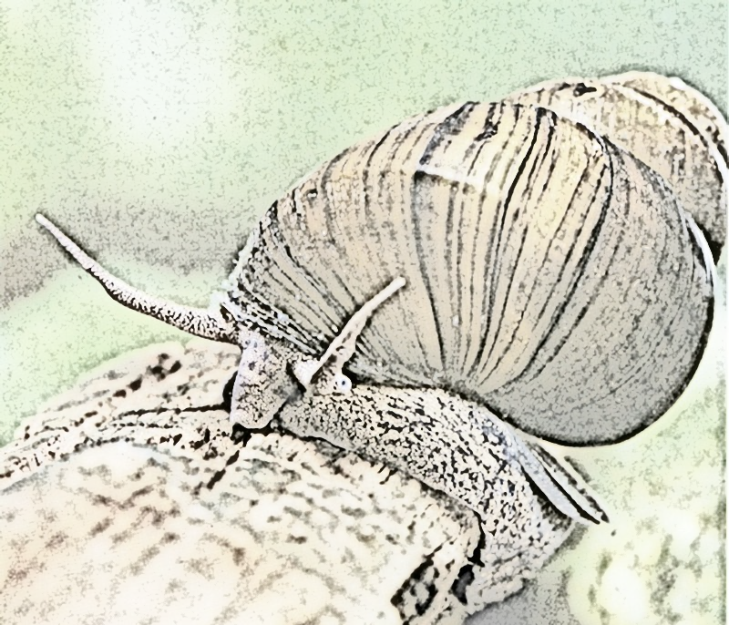

Lesson 4 | Controlling Invasive Species

Background

Purpose
This lesson introduces the invasive species, Eastern Red Cedar trees, and provides students with the opportunity to explore control methods for this organism. Students will calculate the cost of the invasion and of various control options. Students will use these calculations to evaluate and select an appropriate control method and provide evidence for its selection. Students will discuss how control methods can affect evolution of an invasive population by applying selection pressure.

Standards
Next Generation Science Standards
- HS-LS4-5 - Evaluate the evidence supporting claims that changes in environmental conditions may result in: (1) increases in the number of individuals of some species, (2) the emergence of new species over time, and (3) the extinction of other species.
- HS-LS2-7. Design, evaluate, and refine a solution for reducing the impacts of human activities on the environment and biodiversity.
Common Core
- CCRA.R.7 Integrate and evaluate content presented in diverse media and formats, including visually and quantitatively, as well as in words.

Estimated Time
One 50-minute class period

Student Materials
- Student worksheet
- Computer with internet access

Teacher Materials
- Set of Red Cedar Control Cards (enough for 1 card per student)
- Pictures of Eastern Red Cedar tree (4 per page included with control cards) or a cedar branch
- Computer and projector
- PowerPoint presentation

Vocabulary
- invasive species: any organism that is non-native (or alien) to the ecosystem
- native: living or growing naturally in a particular place or region
- non-native: an organism that has arrived in a place or region from elsewhere
- adaptive trait: a heritable feature functioning to overcome selection pressure and increase fitness of an organism
- selection pressure: any biotic (living) or abiotic (non-living) factor impacting the reproductive success of some individuals in a population more than others
- evolution: change over time, descent with modification

Key STEM Ideas
Invasive species represent a disruption to a relatively balanced ecosystem. Depending on the degree of disruption, an ecosystem may be resilient and return to balance. However, invasive species are a threat to biodiversity and may considerably shift the make-up of native communities.

Invasive species are costly because of the economic and/or environmental harm they cause, but control of invasive species is additionally expensive but often necessary to limit the spread of these harmful organisms.

Students’ Prior Knowledge
Students should be familiar with the harmful consequences of an invasive species introduction and subsequent spread. Students should have a basic understanding of adaptive traits, selection pressure, genetic variation, and evolution. Students should have basic computational skills (addition, subtraction, and multiplication) related to financial problem solving.

Connections to Agriculture
The Eastern Red Cedar tree is currently being treated as an invasive (or aggressive) species in the Midwest. Prior to widespread settlement, E. Red Cedar were controlled by fire (both wild and intentional). However, with increasing settlement came reduced use of fire as a control method. Without the use of fire to control the spread of cedar trees, overpopulation has occurred for more than 50 years.

E. red cedars also have various traits that encourage overpopulation including their ability to grow in many soil types, their drought tolerance, and their seed dispersal via birds.

The economic impact of the E. red cedar overpopulation impacts cattle producers by reducing grazing land. Cattle require pastures with non-woody vegetation for adequate grazing, however, the E. red cedar infestations limit the amount of food available to cattle. Additionally, it is expensive, yet necessary, to control the spread of E. Red Cedar trees via mechanical removal or prescribed burning.

Essential Links
- Eastern Red Cedar fact sheet: http://www.digitalprairie.ok.gov/cdm/ref/collection/stgovpub/id/40058
- Prescribed burn drone video: https://www.youtube.com/watch?v=GYJF-k8enz0

Sources/Credits
- Red cedar images: www.forestry.ok.gov/ercregistry
- Cows grazing: Scott Bauer, USDA, public domain
- Mechanical removal: http://www.fws.gov/southwest/es/oklahoma/Images/Cedar_Clearing.jpg
- Prescribed fire management: http://netnebraska.org/article/news/911117/firefighters-make-fire-work-them-prescribed-burn http://prairieecologist.com/2013/03/12/should-we-be-conducting-prescribed-fires-during-drought/

Lesson Procedures
Prior to class…
- Place a picture of an Eastern Red Cedar or a branch of a cedar tree at each student’s desk prior to class.
- Make enough copies of the red cedar control cards worksheet for each student to have one of each control method.
Engage
Activity 1: Selecting a control measure for Eastern Red Cedar
- After students enter the classroom, use slide 2 to explain to students that the tree/branch at their seat must be controlled before they can sit down.
- Instruct students to select one of the 6 control methods (intensive goat grazing, prescribed fire, mechanical removal, chemical treatment, cattle grazing, or no action) and place it on their desk. If they selected a control method, they may remove the tree/branch. If they selected no action, they will need to leave the tree/branch at their desk.
- Hand out the student worksheet and have students answer the questions regarding selection of a control method.
  - Which control measure did you select to eliminate the Eastern Red Cedar and why?
  - What factors might be important when selecting a control measure?
Factors might include cost, safety, feasibility, perceived effectiveness, etc.
  - What long-term impacts might a control measure have on a population?
The population might be eradicated or reduced; it also might have little impact on the overall population depending on invasion pressure from neighboring areas.
- Discuss student answers to these questions as a whole class.
Explore and Explain
- Use slide 4 to introduce the Eastern Red Cedar as an invasive species of the Midwest.
- Alternatively, students can work with a partner or in small groups to read the fact sheet from the Oklahoma Conservation Commission, http://www.digitalprairie.ok.gov/cdm/ref/collection/stgovpub/id/40058, and answer the follow-up questions.
  - What are some of the problems caused by the growing population of Eastern Red Cedar trees?
In Oklahoma, E. Red Cedar problems include “threatening the state’s economy, human health and safety, wildlife populations and the productivity of pasture, range and forest land.” Estimated cost for the state are also included and can be discussed:
Catastrophic wildfires, $107 million
Cattle forage, $205 million
Lease hunting, $107 million
Recreation, $17 million
Water yield, $11 million
Total loss by 2013, $447 million
  - Which control methods are recommended?
Prescribed burning and mechanical removal
  - Was your previously selected control method a good choice? Why or why not?
- Have students discuss if they would change their method of control and why based on what they read.
- Use slide 6 to discuss how Eastern Red Cedar infestations impact cattle production. Cattle require pasture with non-woody vegetation. Therefore, Eastern Red Cedar trees reduce the number of acres available to graze cattle.
- Use slides 7-9 to discuss how prescribed burning and mechanical removal function. Point out the importance of proactive, early control of cedar trees because of the difficulty of eliminating adult trees and their increased reproductive potential.
Activity 3: Calculating costs and evaluating control methods
- Explain to students that often a major deciding factor in a control method is financial cost.
- Using slide 11 and the student worksheet, have students calculate the economic loss caused by the presence of E. red cedar trees on pasture land.
32 pairs - 21 pairs = 11 pairs * $450 = $4950, cost of infestation
- Next, use slide 12 and the student worksheet to have students calculate and compare the cost of mechanical removal vs. prescribed burning.
160*$105 = $16,800
160*$15 = $2400 + 21*$450 = $11,850
$16,800 - $11,850 = save $4,950 by performing a prescribed burn
- Using these calculations as evidence, have students defend their selection of a control method.
Using only financial reasoning, the prescribed burn is a better choice.
- Other than financial reasons, can you think of any reasons to select one control method over another?
Students may bring up that environmental conditions or lack of qualified personnel or proper equipment make it unsafe to conduct a burn.
Extend
Activity 4: Potential Issues with Control
- Use slide 14 to introduce the idea that control measures can act as selection pressure. Have students imagine if a prescribed burn were conducted but that several large cedar trees were not killed in the fire.
- Have students discuss why the trees might have survived.
It is possible that these trees are especially tolerant of heat and that this trait is hereditary.
- Use slides 14-15 and the student worksheet to have students think about how control methods can impact the evolution of an invasive population.
  - What is the selection pressure being applied with a prescribed burn?
Fire is selecting trees that can withstand the temperatures.
  - What adaptive trait would be beneficial during a prescribed burn?
Trees with an adaptation for heat tolerance would survive.
  - How could this lead to genetic change in the population of Eastern Red Cedar trees in your pasture?
Trees with an adaptation for heat tolerance would survive to reproduce and this trait is passed onto their offspring.
  - Using the Eastern Red Cedar example, draw a diagram to illustrate how genetic variation, selection pressure, and an adaptive trait relate to evolution within a population.
  - What strategies might you use to avoid selecting for individuals resistant to a particular control method?
Selecting different types of control methods applies different selection pressure and reduces the likelihood that the entire population will be resistant to a specific method of control (such as fire).
- Use slide 16 to introduce students to a video (see Prescribed burn drone video in essential links) that explains a new technology for implementing a prescribed burn
- Have students discuss potential benefits from using drones to start prescribed burns.
Benefits may include cost efficiency and increased safety.

Evaluate
- Use the student worksheet to assist in evaluating student understanding.

Teacher Materials

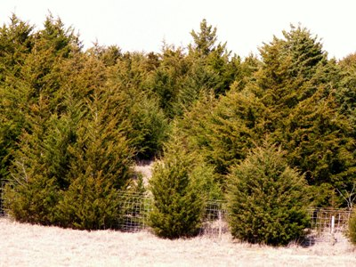
Eastern Red Cedar images from www.forestry.ok.gov/ercregistry. Before class: Place one on each student’s desk prior to class.

Eastern Red Cedar Control Cards
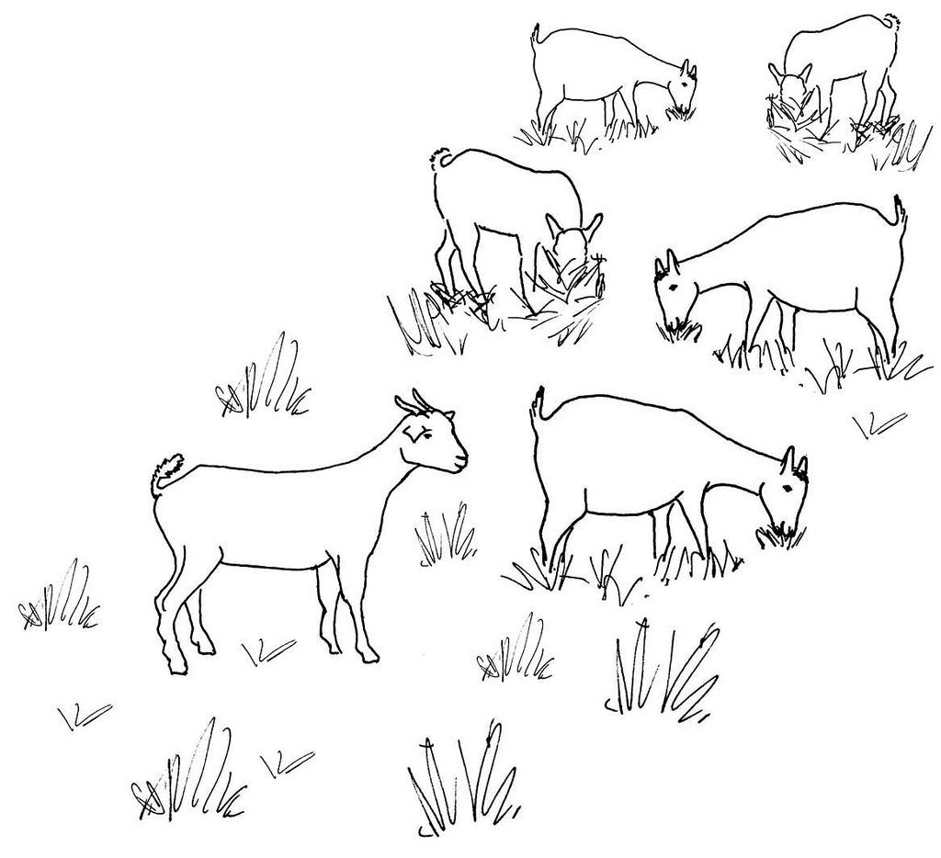
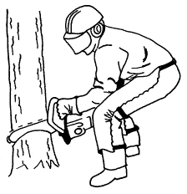
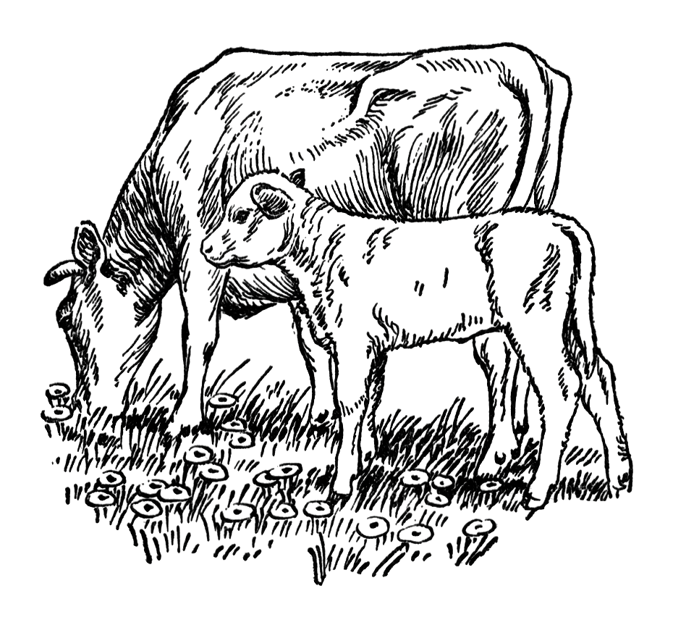
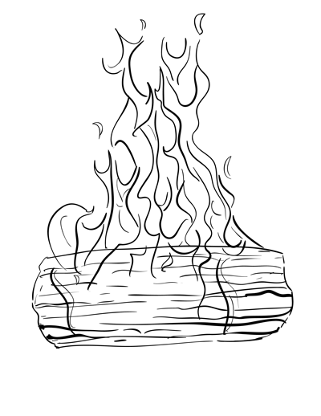
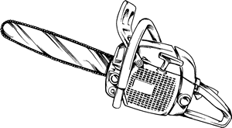
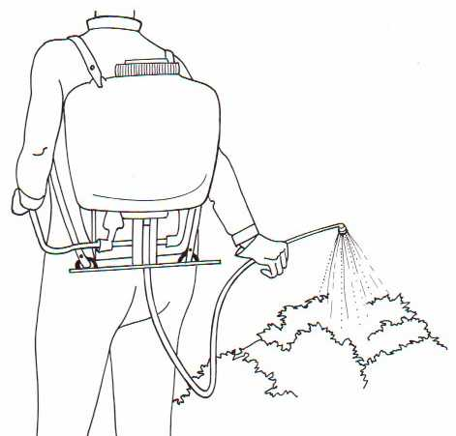
Before Class: Print, cut out, and tape cards to the board. Make enough cards so each student can choose a card.
Intensive Goat Grazing
Prescribed Fire
Cattle Grazing
Mechanical Removal
No Action
Chemical Treatment

Lesson 5 | Biological Control of Invasive Species

Background

Purpose
This lesson focuses on biological control as a potential solution for managing invasive species. Students will learn what biological control is and how it can be applied to various pest control situations. Students will read about successful and detrimental application of biological control against an invasive species. Students will learn about the regulatory process in place to limit unintended consequences and the state and federal agencies involved in overseeing the release of a biological control agent. Finally, students will use what they learn to design a successful biological control for a local invasive species that has limited unintended consequences.

Standards
Next Generation Science Standards
- HS-LS2-7. Design, evaluate, and refine a solution for reducing the impacts of human activities on the environment and biodiversity.
Common Core
- CCRA.R.1 Read closely to determine what the text says explicitly and to make logical inferences from it; cite specific textual evidence when writing or speaking to support conclusions drawn from the text.
- CCRA.R.2 Determine central ideas or themes of a text and analyze their development; summarize the key supporting details and ideas.

Estimated Time
One 50-minute class period

Student Materials
- Student worksheet
- Computer with internet access
- Colored pencils or crayons (optional)

Teacher Materials
- Answer key
- PowerPoint presentation

Vocabulary
- invasive species: any organism that is non-native (or alien) to the ecosystem
- biological control: pest control method in which natural enemies (predators, parasites, or pathogens) are used to regulate pest populations
- regulation: a governmental order having the force of law

Key STEM Ideas
Invasive species represent a disruption to a relatively balanced ecosystem. Depending on the degree of disruption, an ecosystem may be resilient and return to balance. However, invasive species are a threat to biodiversity and may considerably shift the make-up of native communities.

Biological control is a pest control method in which natural enemies (predators, parasites, or pathogens) are used to regulate pest populations. This method offers a potentially cost-effective, long-term, and nonpolluting means of regulating populations of invasive species. However, it also represents an intentional introduction of a non-native organism into an ecosystem. Therefore, prior to the release of a biological control agent, scientists and regulators must complete thorough assessments of environmental and non-target effects to ensure that unintended consequences do not result from the release of a biological control agent. Additionally, the risks and benefits of using biological control must be weighed against the continued harm inflicted on natural or agricultural ecosystems by an unmanaged invasive species.

Students’ Prior Knowledge
Students should have an understanding of what an invasive species is and some familiarity with invasive species in their area. Students would benefit from an understanding of selection pressure and how invasive species escaping natural enemies is an example of removing selection pressure.

Connections to Agriculture
Multiple theories exist to explain why some introduced species become invasive and others do not. The “Enemy Release Hypothesis” suggests that those introduced species that leave their natural enemies (predators, parasites, or pathogens) behind when they move into a new ecosystem experience an increase in their distribution and abundance. A potential pest control method known as biological control has been suggested as a means to restore the balance. By introducing a natural enemy of an invasive species, scientists hope to regulate invasive pest populations in both agricultural and natural ecosystems. While biological control offers a means of reducing invasive species populations, it also comes with some risks. Biological control has a checkered history with some releases leading to unintended damage to native organisms or endangered species. Due to the potential for off-target effects, government regulation of biological control has tightened over the past 20 years.

Essential Links
- “Invasive Species’ Big Advantage” found at http://www.sciencemag.org/news/2003/02/invasive-species-big-advantage
- “Weed-eating Insects Munch Wrong Plants” article found at http://www.sciencemag.org/news/2001/08/weed-eating-insects-munch-wrong-plants
- “A virus is taming Australia’s bunny menace, and giving endangered species new life” article found at http://www.sciencemag.org/news/2016/02/virus-taming-australia-s-bunny-menace-and-giving-endangered-species-new-life
- “How Scientists Obtain Approval to Release Organisms for Classical Biological Control of Invasive Weeds” by J. Scoles, J. P. Cuda and W. A. Overholt found at https://edis.ifas.ufl.edu/pdffiles/IN/IN60700.pdf

Sources/Credits
N/A

Lesson Procedures
Engage
Activity 1: Exploring Reasons for Successful Invasions
- Distribute student worksheets and provide students with access to computers and internet.
- The PowerPoint presentation provides a way to guide discussion as students fill out the student worksheet. However, use of the presentation is optional.
- Use slide 2 to direct students to read the article, “Invasive Species’ Big Advantage” in small groups or as a whole class (http://www.sciencemag.org/news/2003/02/invasive-species-big-advantage).
- Give students several minutes to answer the discussion questions individually or in pairs. Use slide 3 to facilitate student discussion. Answers are provided in the answer key.
  - What major advantage do invasive species have over native organisms according to the article?
  - What evidence does the article provide to support this idea?
  - In the article, an ecologist, Keith Clay, makes the statement, “It suggests that biological control is the most logical way to go.” However, he notes that it must be done carefully to avoid collateral damage.
  - What is your definition of biological control?
  - What “collateral damage” could be caused by improper use of biological control
  - In natural areas?
  - In agricultural areas?

Explore
Activity 2: Evaluation of Biological Control as a Solution
- Compare student-developed definitions of biological control to the definition provided on slide 4. If there are major differences, discuss these. Use images on slide 4 to illustrate examples of a predator, parasite, and pathogen that could be used as a biological control agent.
- Think-pair-share: Have students spend a few minutes to brainstorm 2 possible benefits and 2 possible risks that could happen when releasing a biological control agent. Add student answers to the board or to the PowerPoint slide 5. Discuss student ideas.
- Slide 6: Have students work in pairs or small groups to read two articles about biological control agents that have been previously released.
  - Scenario 1: “Weed-eating Insects Munch Wrong Plants” article found at http://www.sciencemag.org/news/2001/08/weed-eating-insects-munch-wrong-plants
  - Scenario 2: “A virus is taming Australia’s bunny menace, and giving endangered species new life” article found at http://www.sciencemag.org/news/2016/02/virus-taming-australia-s-bunny-menace-and-giving-endangered-species-new-life
- As a follow-up, have students answer the following and add their answer to the student worksheet. Answers can be collected as a class and placed in the table on slide 7:
  - What was the biological control agent?
  - What was the target invasive?
  - What evidence is given that the biological control was successful or not?
  - Was there evidence of unintended consequences?
- Based on this exercise, have students come up with their own definitions for how they would evaluate success or failure of a biological control release. In addition, students can come up with ideas for what government regulators should evaluate prior to a release. Collect student answers on the board or add them to PowerPoint slide 8.
Explain
Activity 3: Process of Selecting and Implementing Biological Control for Invasive Weeds
- Explain to students that now they have developed their own ideas, they will compare them with the regulatory process for biological control of invasive weeds as it exists now.
- Individually or in small groups provide students with access to the article “How Scientists Obtain Approval to Release Organisms for Classical Biological Control of Invasive Weeds” by J. Scoles, J. P. Cuda and W. A. Overholt found at https://edis.ifas.ufl.edu/pdffiles/IN/IN60700.pdf
- As students read the article they should be taking notes on the student worksheet of the agencies involved in the regulatory and implementation process of a biological control release and why the three different scientific tests or assessments are required. Answers are provided in the answer key.
Extend
Activity 4: Design a Biological Control for an Invasive Species
- Explain to students that their final activity will be to apply what they have learned about success and unintended consequences of biological control to develop a made-up biological control agent for a real invasive species in their area.
- Students should already be familiar with some invasive species in their area. If they aren’t, have students perform an internet search for an invasive species impacting the area.
- Students should use their student worksheet to draw a sketch of the invasive species and label it with its common and scientific name (if possible).
- Students can then be creative in designing a biological control agent. Their agent DOES NOT need to be a real parasite, pathogen, or predator but they can use real world examples for ideas.
- Lastly, students should answer the three questions:
  - How will the biological control agent regulate the invasive species population?
  - How will you determine if your biological control organism is successful?
  - What steps will be taken to ensure the biological control agent will not have unintended consequences?
- You may want to remind students to use the information they have gained from the readings to answer the three questions. For example, they may want to explain if the agent is a pathogen, parasite, or predator. It will probably be useful to refer to the definition of success they developed earlier to help them define how they would judge success for this release. Also, the scientific testing and assessments during the regulatory process could be included to ensure minimal unintended consequences.
Evaluate
- The student worksheet and participation in group discussion can serve as assessment or evaluation of student understanding.

Answer Key

Activity 1: Exploring Reasons for Successful Invasions
Read the article “Invasive Species’ Big Advantage” found here: http://www.sciencemag.org/news/2003/02/invasive-species-big-advantage
- What major advantage do invasive species have over native organisms according to the article?
The invasive species have escaped their natural enemies by moving into a new ecosystem.
- What evidence does the article provide to support this idea?
Two studies are presented.

In the first, researchers examined 26 invasive species in the US. They found that “on average, alien species had only seven species of parasites in the U.S., compared to 16 in their native habitat. Of these seven, four species of parasite had been acquired in their new home.”

In the second study, two Cornell University researchers “randomly picked 473 European plants from a database of introduced species in the U.S. About 120 are considered weeds. Then they searched the literature to find out how many types of pathogen affected these plants. On average, the introduced weeds (in U.S.) had 77% fewer species of fungus or virus than did the same plants back in Europe. Those that suffered from fewer pathogens were more likely to be listed as harmful invaders, whereas those that had picked up pathogens from their new home were less likely to be rampant.”

In the article, an ecologist, Keith Clay, makes the statement, “It suggests that biological control is the most logical way to go.” However, he notes that it must be done carefully to avoid collateral damage.
- What is your definition of biological control?
Accept reasonable answers and discuss. This is a good opportunity to gauge students’ prior knowledge of biological control.

- What “collateral damage” could be caused by improper use of biological control…
  - In natural areas?
Accept reasonable answers. You may wish to generally discuss host specificity (if biological control agent attacks organisms other than the target). Guide discussion toward effects on native and/or endangered species.
  - In agricultural areas?
Accept reasonable answers. Again, discuss host specificity. If biological control agent targets an invasive weed, it could also harm non-target crops. Biological control agents can compete or harm native natural enemies.

Activity 2: Evaluation of Biological Control as a Solution
Working in partners, read the following articles.

Scenario 1: “Weed-eating Insects Munch Wrong Plants” article found at http://www.sciencemag.org/news/2001/08/weed-eating-insects-munch-wrong-plants

- What organism is used as biological control?
A weevil (beetle), Larinus planus

- What is the invasive species it is meant to control?
Invasive weed, Canada thistle

- What evidence do you have that the biological control was successful or not?
The article does not mention if the target (Canada thistle) was successfully controlled by the weevil; however, a researcher noticed that the weevil was found on native Tracy thistle more often the target thistle. This would indicate this release has more damaging effects than successful control of an invasive weed.

- Was there any evidence that the biological control had unintended consequences?
Yes, more than 50% of damage to native Tracy thistle seeds was due to the weevil. The damage reported on native Tracy thistle was an unintended consequence.

Scenario 2: “A virus is taming Australia’s bunny menace, and giving endangered species new life” article found at http://www.sciencemag.org/news/2016/02/virus-taming-australia-s-bunny-menace-and-giving-endangered-species-new-life

- What organism is used as biological control?
Rabbit haemorrhagic disease virus (RHDV)

- What is the invasive species it is meant to control?
European rabbit

- What evidence do you have that the biological control was successful or not?
The virus was successful as it eradicated an estimated 60% of Australia’s rabbits, acting with particular lethality in arid areas. After the rabbits were killed, native vegetation bounced back, and populations of large herbivores such as kangaroos increased. In addition, predators of the rabbits (cats and foxes) are also responsible for other mammal extinctions. With the decrease in rabbit populations, Australia may save money on control of the cat and fox populations by simply eliminating their prey.

- Was there any evidence that the biological control had unintended consequences?
No, RHDV does not appear to have off-target effects on vulnerable species of small desert mammals including the dusky hopping mouse or the plains mouse. After the rabbits’ eradication, populations of these vulnerable species are actually increasing (dusky hopping mouse and the plains mouse tripled and doubled their occurrence, respectively).

Activity 3: Process of Selecting and Implementing Biological Control for Invasive Weeds
Read the article “How Scientists Obtain Approval to Release Organisms for Classical Biological Control of Invasive Weeds” by J. Scoles, J. P. Cuda and W. A. Overholt found at https://edis.ifas.ufl.edu/pdffiles/IN/IN60700.pdf

- Which federal agency is in charge of granting approval for a biological control release?
United States Department of Agriculture, Animal and Plant Health Inspection Service, Plant Protection Quarantine unit (USDA APHIS PPQ)

- When did this federal agency begin overseeing the release process?
In 2000, the Plant Protection Act gave them this authority.

- What multi-agency group acts as an advisory panel?
Technical Advisory Group (TAG)

- List five agencies that participate in the advisory panel.
Five of the following:
USDA, APHIS USDA Cooperative State Research, Education and Extension Service
USDA, Agricultural Research Service (ARS)
USDA ARS Biological Control Documentation Center
USDA, Forest Service
USDI (US Department of the Interior), Bureau of Land Management
USDI, Bureau of Reclamation
USDI, US Fish and Wildlife Service (USFWS)
USDI, National Park Service
USDI, Geological Survey
USDI, Bureau of Indian Affairs
US Environmental Protection Agency DOD,
US Army Corps of Engineers
National Plant Board

- Provide a brief explanation for why each of the following scientific tests or assessments are required before a biological control agent against an invasive weed can be released?
- Host specificity testing
This is done to ensure that the agent will not harm other organisms by demonstrating the natural enemy is host specific and therefore safe to release.
- Environmental assessment
This is done to ensure the release is in compliance with the National Environmental Policy Act (NEPA) and provides the public with the potential positive and negative environmental impacts that might occur as a result of the release of a biological control agent into the environment.
- Biological assessment
This is done to ensure the release is in compliance with the Endangered Species Act and provides a description of what the release will entail, the area impacted, any listed species or habitat that might be impacted, and an analysis of cumulative effects.

Activity 4: Design a Biological Control for an Invasive Species
Step 3: Evaluate safety and success of your biological control.
How will the biological control agent regulate the invasive species population?

How will you determine if your biological control organism is successful?

What steps will be taken to ensure the biological control agent will not have unintended consequences?
Step 2: Invent a biological control agent for your invasive species.
- This is an imaginary species that doesn’t exist-feel free to pull ideas from existing species though
- Can be a parasite, disease/pathogen, or predator
Draw picture of your biological control agent
Step 1: Choose an invasive species that impacts your area. If you have completed an invasive species profile, you may use that organism. Otherwise, perform an internet search.

Draw a picture of the target invasive species

