Space Invaders: Ecology and Evolution of Invasive Species
Student Resources

Student Name ___________________________________________

Contents
Lesson 2 | Adaptive Traits 2
Lesson 3 | Natural Selection and Evolution 5
Lesson 4 | Controlling Invasive Species 8
Lesson 5 | Biological Control of Invasive Species 12

Authors
Jonathan Anderson, Agriculture Education/FFA Teacher, Norfolk High School, Norfolk, Nebraska
Allison Zach, Coordinator, Nebraska Invasive Species Program
Erin Ingram, Curriculum Development Specialist, University of Nebraska-Lincoln, IANR Science Literacy
Molly Brandt, Graduate Research Assistant, University of Nebraska-Lincoln, IANR Science Literacy

Lesson 2 | Adaptive Traits

Student Name ___________________________________________
Activity 1: Space Invaders Game
Play the Space Invaders game in a group of 3 students. Reflect on the following questions:
Two non-native species were in the game.
- Were they both successful?

- Why do you think this was?

- What factors helped the invasive plant species outcompete the other plants?

- How might climate change impact the reproductive success of the different plant types?

Activity 2: Snakehead Adaptations
Watch the video, “Invasion of the Snakehead”: https://youtu.be/nmU7etSYYqI
What adaptations does the snakehead have?
Morphological
Physiological
Behavioral

Activity 3: Build a Super-Competitor
- Design, draw, and name an invading organism of your creation capable of surviving and reproducing on an alien plant.
- Describe your organism’s adaptive traits.
Species Name ______________________________________________

Adaptive traits of this species
- _________________________________________________________________________
- _________________________________________________________________________
- _________________________________________________________________________

- What advantages do these adaptations provide in their new ecosystem?
__________________________________________________________________________________________________________________________________________________________________________________________________________________________________________________________________________________________________________________________________________________________________________________________________________________________________________________________________________________________________________________________________________________________________

Lesson 3 | Natural Selection and Evolution

Student Name ___________________________________________

Introduction to Chinese Mystery snails
- How did humans play a role in the introduction of the Chinese Mystery snail?

- What traits may help the Chinese Mystery snail outcompete the native snails in the U.S.?

- Why would we consider the Chinese Mystery snail to be an invasive species?

Activity 1: Chinese Mystery snail game
After the class has played the Chinese Mystery snail game, use what you observed during the game to explain the process of natural selection using the terms: genetic variation, inheritance, competition, selection pressure, and time.
Be sure to discuss how natural selection results in evolution of both the native and invasive snail populations.

Activity 2: Group reflection
In groups of 3-4, discuss the following scenarios. Be prepared to offer 3 comments and/or questions to the group discussion of each scenario. Consider discussing adaptive traits, selection pressure, natural selection, evolution, individuals, populations, reproduction, or other relevant concepts.

What happens if…
Scenario 1: A disease affecting Chinese Mystery snails sweeps through the ecosystem.

Scenario 2: There are no snail predators.

Scenario 3: A predator is born with a mutation that allows it to overcome the strength of the thicker shell.

Activity 3: Identifying components of natural selection
Watch the video, “Natural Selection Animation”: https://youtu.be/M3bROOvWMcM. Answer the following questions.
- How does this video show genetic variation in the population?

- What is the selection pressure?

- What adaptive traits did you observe? Did any traits become maladaptive?

- Does natural selection cause evolution to occur at the individual or population level? Explain.

Lesson 4 | Controlling Invasive Species

Student Name ___________________________________________

Activity 1: Selecting a control measure for Eastern Red Cedar
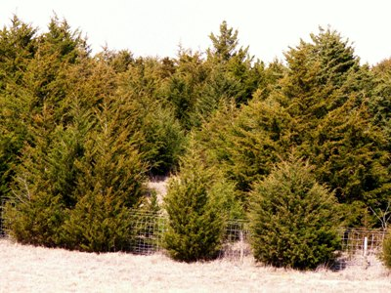
- Which control measure did you select to eliminate the Eastern Red Cedar and why?

- What factors might be important when selecting a control measure?

- What long-term impacts might a control measure have on a population?

Activity 2: Learning about appropriate controls
Read the fact sheet, http://www.digitalprairie.ok.gov/cdm/ref/collection/stgovpub/id/40058, and answer the following questions.
- What are some of the problems caused by the growing population of Eastern Red Cedar trees?

- Which control methods are recommended?

- Was your previously selected control method a good choice? Why or why not?

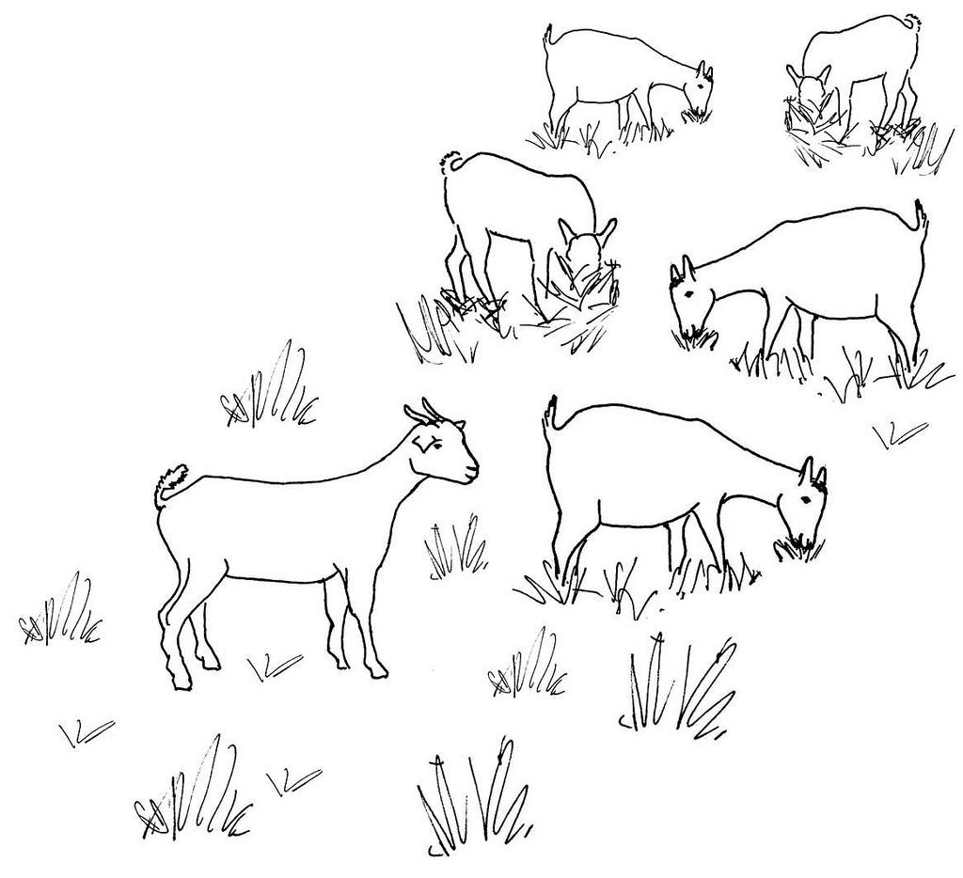
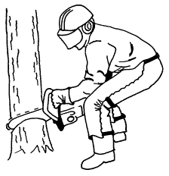
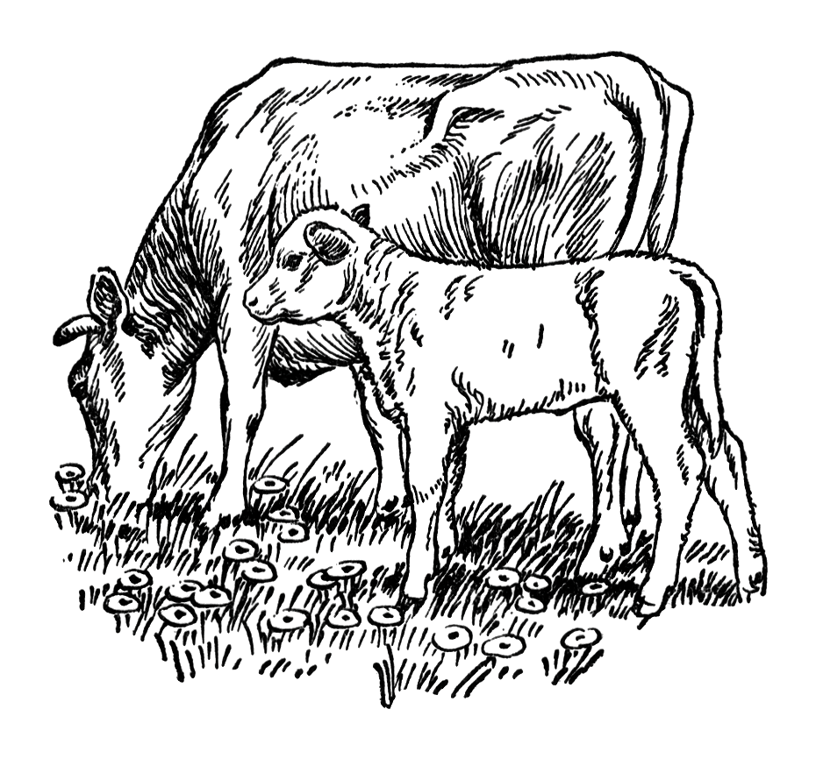
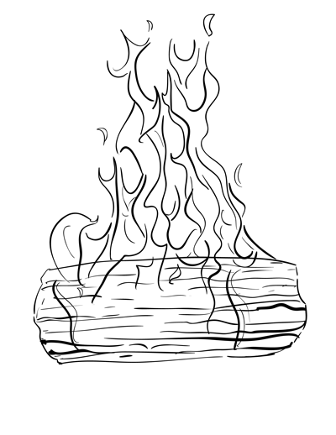
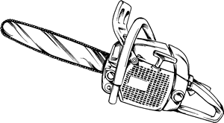
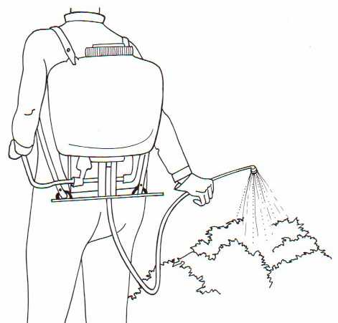

Activity 3: Calculating costs and evaluating control methods
- You recently inherited 160 acres of pastureland from your great aunt’s estate. You want to rent out the land to a cattle producer for grazing purposes, however, the pasture is infested with cedar trees. Currently, the land can only support grazing for 21 cow-calf pairs in the pasture during a season. However, most other pastures in the area can graze 32 pairs per 160 acres.

In 2015, the average rent per cow-calf pair in the area was $450 per year.

How much money would the cedar tree infestation cost you per year?

- You were quoted a cost of $105 per acre to clear the cedar trees off your pasture mechanically with a skid loader and grinder.

A prescribed burn will cost $15 per acre, but you would have to not graze the pasture for one year before the burn.

Compare the costs of these two control measures. Which control measure is more economical?

Which control measure did you select and why?

- Other than financial reasons, can you think of any reasons to select one control method over another?

Activity 4: Potential Issues with Control
Imagine after a prescribed burn, there were several large Eastern Red Cedar trees that didn’t die.

- What is the selection pressure being applied with a prescribed burn?

- What adaptive trait would be beneficial during a prescribed burn?

- How could this lead to genetic change in the population of Eastern Red Cedar trees in your pasture?

- Using the Eastern Red Cedar example, draw a diagram to illustrate how genetic variation, selection pressure, and an adaptive trait relate to evolution within a population.

- What strategies might you use to avoid selecting for individuals resistant to a particular control method?

Lesson 5 | Biological Control of Invasive Species

Student Name ___________________________________________

Activity 1: Exploring Reasons for Successful Invasions
Read the article “Invasive Species’ Big Advantage” found here: http://www.sciencemag.org/news/2003/02/invasive-species-big-advantage
- What major advantage do invasive species have over native organisms according to the article?

- What evidence does the article provide to support this idea?

In the article, an ecologist, Keith Clay, makes the statement, “It suggests that biological control is the most logical way to go.” However, he notes that it must be done carefully to avoid collateral damage.

- What is your definition of biological control?

- What “collateral damage” could be caused by improper use of biological control…

  - In natural areas?

  - In agricultural areas?

Activity 2: Evaluation of Biological Control as a Solution
Working in partners, read the following articles.

Scenario 1: “Weed-eating Insects Munch Wrong Plants” article found at http://www.sciencemag.org/news/2001/08/weed-eating-insects-munch-wrong-plants
- What organism is used as biological control?

- What is the invasive species it is meant to control?

- What evidence do you have that the biological control was successful or not?

- Was there any evidence that the biological control had unintended consequences?

Scenario 2: “A virus is taming Australia’s bunny menace, and giving endangered species new life” article found at http://www.sciencemag.org/news/2016/02/virus-taming-australia-s-bunny-menace-and-giving-endangered-species-new-life
- What organism is used as biological control?

- What is the invasive species it is meant to control?

- What evidence do you have that the biological control was successful or not?

- Was there any evidence that the biological control had unintended consequences?

Activity 3: Process of Selecting and Implementing Biological Control for Invasive Weeds
Read the article “How Scientists Obtain Approval to Release Organisms for Classical Biological Control of Invasive Weeds” by J. Scoles, J. P. Cuda and W. A. Overholt found at https://edis.ifas.ufl.edu/pdffiles/IN/IN60700.pdf

- Which federal agency is in charge of granting approval for a biological control release?

- When did this federal agency begin overseeing the release process?

- What multi-agency group acts as an advisory panel?

- List five agencies that participate in the advisory panel.
  - ________________________________________________________________________
  - ________________________________________________________________________
  - ________________________________________________________________________
  - ________________________________________________________________________
  - ________________________________________________________________________
- Provide a brief explanation for why each of the following scientific tests or assessments are required before a biological control agent against an invasive weed can be released?

- Host specificity testing

- Environmental assessment

- Biological assessment

Activity 4: Design a Biological Control for an Invasive Species
Step 3: Evaluate safety and success of your biological control.
How will the biological control agent regulate the invasive species population?

How will you determine if your biological control organism is successful?

What steps will be taken to ensure the biological control agent will not have unintended consequences?
Step 2: Invent a biological control agent for your invasive species.
- This is an imaginary species that doesn’t exist-feel free to pull ideas from existing species though
- Can be a parasite, disease/pathogen, or predator
Draw picture of your biological control agent
Step 1: Choose an invasive species that impacts your area. If you have completed an invasive species profile, you may use that organism. Otherwise, perform an internet search.

Draw picture of the target invasive species

