Increasing Production with Precision Agriculture
Teacher Resources

Summary
How many people will inhabit the world in 2050? About 9.2 billion-- up from the 7 billion here today! To make sure that everyone has enough to eat, global food production will need to increase by 70 percent. So how exactly will this be done? Precision agriculture is the answer! In this hands-on lesson, students will learn how precision agriculture uses geographic information systems (GIS) to help farmers and manufacturers make smart, efficient, and responsible decisions about how and when they plant, grow, irrigate, harvest, and transport crops. Students will use an engineering design process to construct a simple variable rate irrigation design solution. Students will perform calculations to determine water use efficiency of a variable rate irrigation system and to provide evidence for its purpose in agricultural production.

Grade Level
7-12

Contents address the following Next Generation Science Standards
- MS-ETS1-2. Evaluate competing design solutions using a systematic process to determine how well they meet the criteria and constraints of the problem.

Authors
Molly Brandt, Graduate Research Assistant, University of Nebraska-Lincoln, IANR Science Literacy

Background

Standards
Next Generation Science Standards
- MS-ETS1-2. Evaluate competing design solutions using a systematic process to determine how well they meet the criteria and constraints of the problem.
Common Core
CCSS.Math.Content.7.EE.B.4
- Use variables to represent quantities in a real-world or mathematical problem, and construct simple equations to solve problems by reasoning about the quantities.

Estimated Time
One class period (60-75 minutes)

Materials
Each group of students will need:
- Student worksheet (1 per student)
- Calculator
- 16 oz. water bottles
- 1 Styrofoam cup
- 3 plastic cups
- Various straws (jumbo, regular, coffee)
- Various art supplies (scissors, tape, rubber bands, paper clips, rulers)

Powerpoint presentation

Vocabulary
- irrigation: the artificial application of water to the land or soil
- pivot: equipment used to irrigate fields (large sprinkler)
- acre: a unit of area equal to 43,560 square feet (about the size of a football field)
- section: one square mile of land (640 acres)
- bushel: a measure of capacity usually for dry goods equal to 64 pints
- yield: measure of grains or seeds generated from a unit of land (agricultural output)
- water use efficiency (WUE): the ratio of water used in plant metabolism to water lost by the plant through transpiration)
- variable rate irrigation: applies exactly the right amount of water to each foot/meter of the field
- Global Positioning System (GPS): a space-based satellite navigation system that provides location and time information in all weather conditions, anywhere on or near the Earth
- finite resources: resources that do not renew themselves at a sufficient rate (nonrenewable)

Key STEM Ideas
Engineering allows us to define and solve real-world problems. Engineering concepts are changing agriculture by applying technology to improve food production. New equipment allows farmers to put in less labor to achieve larger yields. Precision agriculture is a farming management concept based on observing, measuring, and responding to inter- and intra-field variability in crops. Variable rate irrigation is a type of precision agriculture that involves applying water at a variable rate along the center pivot rather than one uniform rate along the entire length of the system. Variable rate irrigation has many uses for applying water at different rates to wet areas, different soil types, and overlapping pivots.

Students’ Prior Knowledge
Students are not expected to have any background knowledge on this topic prior to completing the lesson. Basic vocabulary terms are listed in the presentation to review during lesson.

Students will learn the following in the lesson:
Variable rate irrigation is made possible by the use of the GPS, field computer, rate controller, telematics, and meter. GPS is used by farmers to create field maps to determine a field’s boundaries. Field computers allow farmers to control the application of fertilizers, herbicides, and pesticides through automated delivery systems. Farmers are able to monitor yields and moisture using computers. Rate controllers make it possible for farmers to control how much irrigation, fertilizer, etc. is applied in a field. Telematics allows information collected in a field to be transferred in the internet.

Water use efficiency is calculated by determining the difference between irrigated yield and dryland yield and dividing that by the irrigation in inches. By performing these calculations, farmers will discover how much they should irrigate a section in order to increase yields and save water.

Connections to Agriculture
Agriculture has changed dramatically throughout the past years. In the past, almost everyone was a farmer. These farmers produced a variety of crops and livestock that they fed to their immediate families. Today, only 2% of the population is involved in production agriculture. These farmers have specialized operations and feed 155 people (Prax, 2010).

In order to accomplish this increase in agricultural productivity, farmers/ranchers use technology to increase their outputs with fewer inputs while using the same amount of space. Precision agriculture allows farmers to produce more using fewer resources, and variable rate irrigation is a great example of farmers using this technique.

Essential Links
Links to YouTube videos are embedded into PowerPoint. The links are also listed below:
- https://www.youtube.com/watch?v=2jF2IsicDC4
- http://www.youtube.com/watch?v=YFy6ZAjbeew&feature=related

Sources/Credits
Engineering activity adapted from Joe Luck- University of Nebraska – Lincoln, Biological Systems Engineering

Photos from the following websites:
- www.tryengineering.org
- https://eyadmin.files.wordpress.com/2014/06/14h05150_rm.jpg
- http://modernfarmer.com/2014/02/10-silicon-valley-agriculture-start-ups/
- http://janiceperson.com/cotton/cotton-101-impact-irrigation-drought/
- http://www.motherearthnews.com/homesteading-and-livestock/soil-type-zbcz1404.aspx
- http://beready.caseih.com/equipment-technology/harvest-report-bumper-crops-but-rough-harvest-conditions-in-western-canada/
- http://www.wanderjunkie.com/?attachment_id=2863
- http://blog.primemeridiandata.com/category/precision-products/
- http://www.lasermanca.com/media/images/product/aggps-fmx-right-layers-medium-web.jpg
- http://www.stackyard.com/news/2012/07/machinery/09_claas_satellite.html
- http://www.sitechsw.com/Products/Agriculture/Flow_Application_Products/Rawson_Drive/
- https://www.google.com/search?q=acre+size+of+football+field&rls=com.microsoft:en-US:IE-SearchBox&source=lnms&tbm=isch&sa=X&ved=0ahUKEwjS1avx0sXKAhXCzoMKHaYKBrAQ_AUICCgC&biw=1280&bih=918#imgrc=_uWKxt3kB_6vOM%3A

Lesson Procedures
Engage and Explain
Introduction: 15-20 minutes
- Start lesson using the PowerPoint and play the embedded YouTube video on slide 2. Highlight the need for precision agriculture to feed the growing population on slide 3.
- Using notes found in the PowerPoint, facilitate large and small group discussions about technology being used in agriculture today (slide 4). Introduce students to advances in agricultural technology from slide 5. Discuss how farmers use those technologies and how technologies can be used together. Watch the embedded video of an agricultural robot by clicking on the image. Discuss what technology students observed being used.
- Explain to students that this lesson will focus on variable rate application technology. Introduce what variable rate application (VRA) is from slide 6. (VRA is application of different rates of an input to match the needs of a specific area.)
- Explain variable rate irrigation and the importance of maximizing yields from slide 7. Discuss the following with students:
- How does the availability of water impact crop growth? Water is essential for crops to grow. Without water, crops would not flourish.
- In this field, is adequate water being applied to particular areas of the field? Where is more water needed? It appears that adequate water is being applied to the left side of the field. More water is needed on the right side.
- Imagine that all the beans in this image are receiving the same amount of water, what environmental factors might be impacting the plant growth in this field? The type of soil could play a factor. The use of fertilizers and herbicides could also have an impact on crop growth.
- Discuss how soil influences the amount of water contacting the plant roots. Discuss how this may impact crop productivity.
Clay holds most moister of the 3 types of soil. This allows the roots to soak in the water for a longer time. Water easily runs through sand while it is more difficult for it to run through clay.
- Facilitate large group discussion about why farmers might want to use variable rate irrigation.
Farmers want to increase yields and decrease inputs.
- Using slide 10, discuss with students the types of technologies that are used together to make variable rate irrigation possible. Provide examples of how technology is changing agriculture. (Driverless tractors make it easier for a single person to harvest a field, less water is used through increased water efficiency, etc.)
- Do a quick review of vocabulary terms from slide 11 before starting the activity.
Explore and Explain
Activity 1: 15-20 minutes
- Show students on slide 12 what a center pivot looks like from an aerial view and from a landscape view. Discuss how the pivot travels in a circle (or pivots) around the center point, providing water to the crop. This is like a giant sprinkler. Everything within the yellow circle is considered irrigated land. Everything outside the yellow circle is not being provided water from the pivot.
- Lead students in discussion of yield map on slide 13. Note that some areas of the field are more productive than others. Discuss which areas might benefit from more or less water? (Red areas need more water. Potentially, green areas don’t need as much.)
- Give students the worksheet. Work through an example WUE equation from slide 14 before letting students work in groups. Explain to students how they will use the image from slide 15 (this is also included on the worksheet) to solve the water use efficiency equations.
- Students will calculate water use efficiency and the irrigation needed to match WUE. Walk around the room to see if any students need assistance with the WUE equation. Have students share findings with class.
- Introduce to students how the equation for water use efficiency can be rearranged to solve for amount of irrigation. Complete an example irrigation equation with students using slides 19-20.
- Have students calculate irrigation equations in small groups and share their findings with the class.
- Discuss benefits of using variable rate irrigation on slides 23-24. (Yield was increased by 3,000 bushels and 4.3 million gallons of water were saved.)
Elaborate
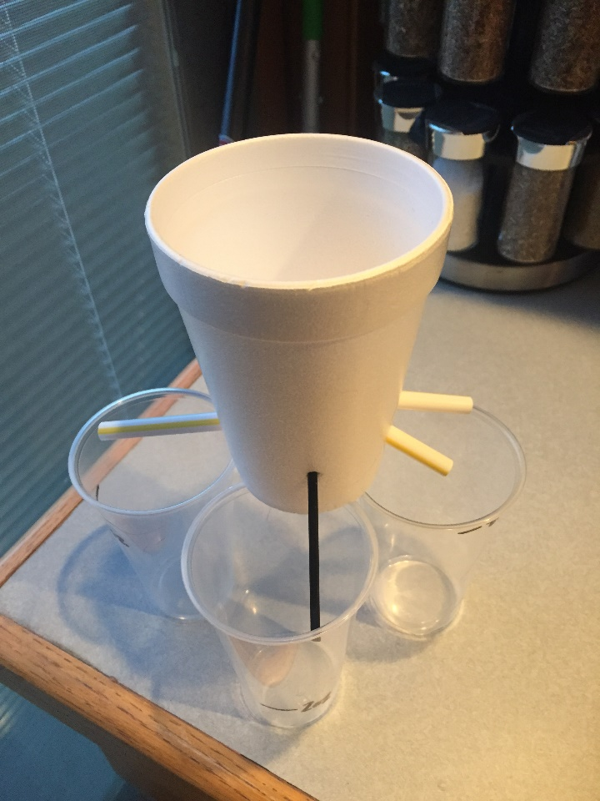
Activity 2: About 30 minutes
- Guide students through instructions for variable rate irrigation activity on student worksheet. Using slides 26-27, explain to students that they will build a device to vary water flow (just like in variable rate irrigation). Their goal is to build a system to divide 16oz of water into three cups with 2 oz., 6 oz., and 8 oz. of water in each.
- Using slide 28-29, form students into groups of 3 students. Distribute a 16 oz. water bottle, 3 cups, scissors, and a choice of straws or other materials to each group.
- Using slide 30, discuss engineering design process with students and have them complete the corresponding worksheet.
- Give students 10 minutes to construct a device to divide the water into 3 different amounts. Give students 5 minutes to discuss their design with the class. Have students spend 5 minutes testing their design and recording results.
Evaluate
Reflection and Clean-up: 5-10 minutes
- Encourage students to reflect on activity using class discussion by asking students reflection questions:
- Was your design successful?
- What could you do to improve your design?
- Why do you think that varying water amounts is useful?
- Ask students why they think precision agriculture is important.

Increasing Production with Precision Agriculture: Answer Key
Activity 1: How does water use efficiency vary within the field?
Yield data were collected during harvest. Sensors in the harvest equipment record the amount of corn harvested in each location of the field and record that data in a yield map. An average of the yield in each section was calculated to measure water use efficiency (WUE) in each section.

Overall field yield:
Irrigated yield: 190 bushels/acre
Dry land yield: 168 bushels/acre
Irrigation: 10 inches

WUE = $\frac{Irrigated Yield -Dry land Yield}{Irrigation (in)}$

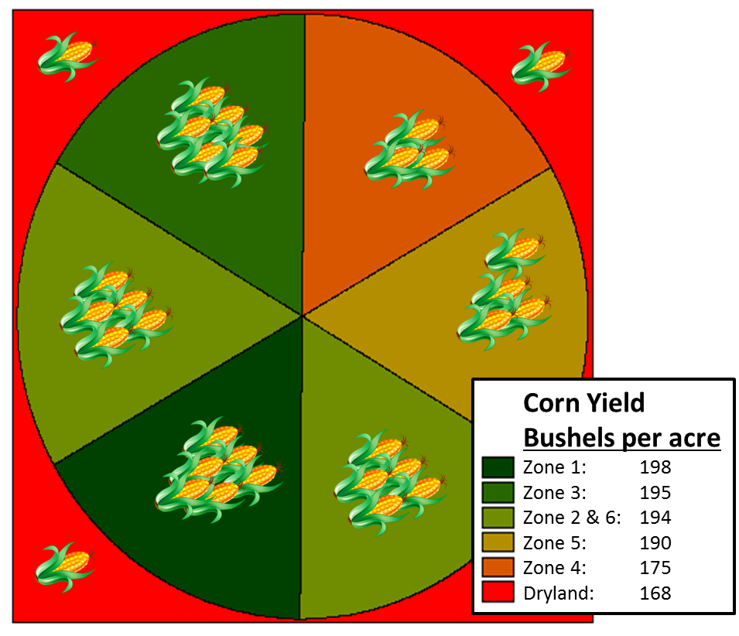
Calculate WUE for the zones of the irrigated field:
1
2
3
4
5
6

WUE = $\frac{190\frac{bushels}{acre} - 168\frac{bushels}{acre} }{10 in}$

WUE = 2.20 $\frac{bushels}{acre∙in}$

Calculate the WUE for each zone of the irrigated field. Show your work.

WUE = $\frac{Irrigated Yield -Dry land Yield}{Irrigation (in)}$
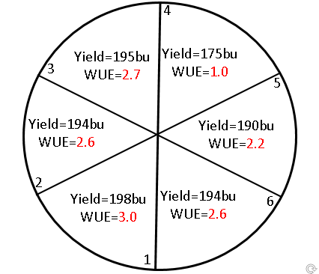
Zone 1 calculations
=198-168 WUE = 3.0 bu/ac·in
10

Zone 2 calculations
=194-168 WUE = 2.6 bu/ac·in
10

=

Zone 3 calculations
=195-168 WUE = 2.7 bu/ac·in
10

Zone 4 calculations
=175-168 WUE = 1.0 bu/ac·in
10

Zone 5 calculations
=190-168 WUE = 2.2 bu/ac·in
10

Zone 6 calculations
Irrigation=10 in
Dry land Yield=168bu/ac
=194-168 WUE = 2.6 bu/ac·in
10

=

Water use efficiency (WUE) values above the field average (2.2 bu/ac·in) correspond to greater yields. For instance, Zone 1 has an additional 3 bushels per acre for every inch of irrigated water compared to dry land, but the irrigated field average only has an increase of 2.2 bushels per acre.

Could we use our water more efficiently?
Assuming yield stays constant, how much water should be used in each section to match overall WUE? Calculate the irrigation for each zone of the irrigated field. Show your work.

Irrigation (in) = $\frac{Irrigated Yield -Dryland Yield}{WUE}$
Zone 1 calculations
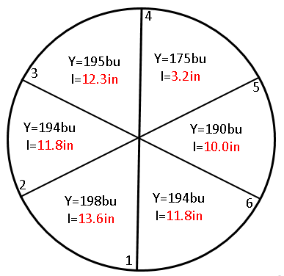
=198-168 I = 13.6 in
2.2

Zone 2 calculations
=194-168 I = 11.8 in
2.2

Zone 3 calculations
=195-168 I = 12.3 in
2.2

Zone 4 calculations
=175-168 I = 3.2 in
2.2

Zone 5 calculations
=190-168 I = 10.0 in
2.2

Zone 6 calculations
WUE = 2.2
Dryland Yield=168bu/ac
=194-168 I = 11.8 in
2.2

If yield is assumed to be constant, adding extra water (beyond 10 inches) will not have a positive effect. However, if some sections could produce the same yield with less water we could reduce the amount of water used for irrigation.

How many gallons of water could be saved from the under-producing zone?

Useful information:
- Each section is 23.3 acres
- 1 acre = 43,560 ft²
- 1 gallon = 0.1337 ft³

