Increasing Production with Precision Agriculture
Student Name _________________________________________

Activity 1: How does water use efficiency vary within the field?
Yield data were collected during harvest. Sensors in the harvest equipment record the amount of corn harvested in each location of the field and record that data in a yield map. An average of the yield in each section was calculated to measure water use efficiency (WUE) in each section.

Overall field yield:
Irrigated yield: 190 bushels/acre
Dry land yield: 168 bushels/acre
Irrigation: 10 inches

WUE = $\frac{Irrigated Yield -Dry land Yield}{Irrigation (in)}$

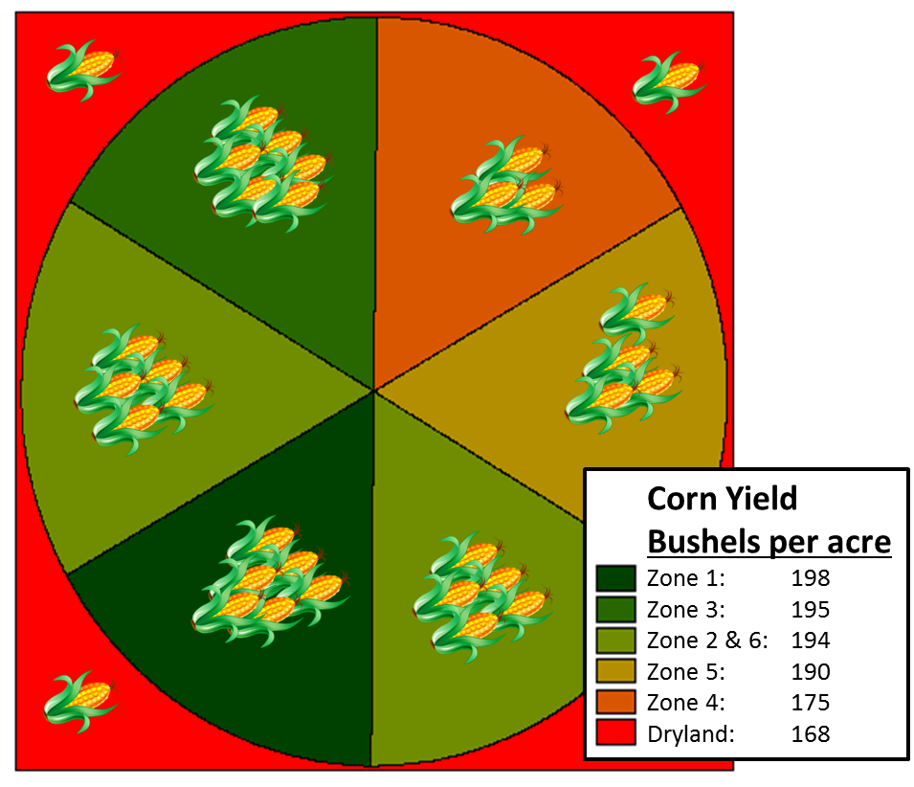
Calculate WUE for the zones of the irrigated field:
1
2
3
4
5
6

WUE = $\frac{190\frac{bushels}{acre} - 168\frac{bushels}{acre} }{10 in}$

WUE = 2.20 $\frac{bushels}{acre∙in}$
Calculate the WUE for each zone of the irrigated field. Show your work.

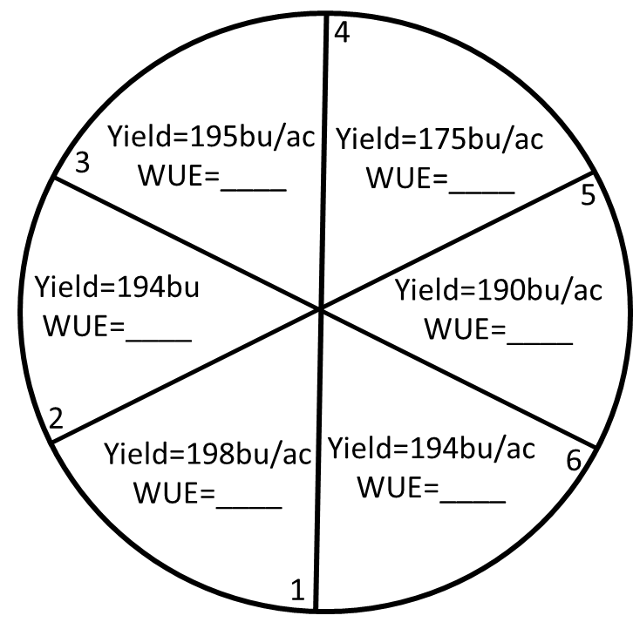
WUE = $\frac{Irrigated Yield -Dry land Yield}{Irrigation (in)}$

Zone 1 calculations

Zone 2 calculations

Zone 3 calculations

Zone 4 calculations

Zone 5 calculations

Zone 6 calculations
Irrigation=10 in
Dry land Yield=168bu/ac

Water use efficiency (WUE) values above the field average (2.2 bu/ac·in) correspond to greater yields. For instance, Zone 1 has an additional 3 bushels per acre for every inch of irrigated water compared to dry land, but the irrigated field average only has an increase of 2.2 bushels per acre.

Could we use our water more efficiently?
Assuming yield stays constant, how much water should be used in each section to match overall WUE? Calculate the irrigation for each zone of the irrigated field. Show your work.

Irrigation (in) = $\frac{Irrigated Yield -Dryland Yield}{WUE}$
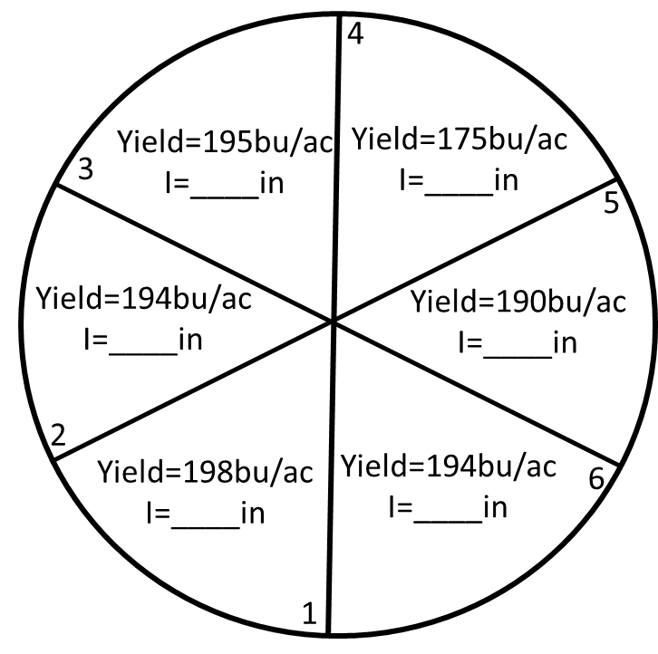
Zone 1 calculations

Zone 2 calculations

Zone 3 calculations

Zone 4 calculations

Zone 5 calculations

WUE = 2.2
Dryland Yield=168bu/ac
Zone 6 calculations

If yield is assumed to be constant, adding extra water (beyond 10 inches) will not have a positive effect. However, if some sections could produce the same yield with less water we could reduce the amount of water used for irrigation.

How many gallons of water could be saved from the under-producing zone?

Useful information:
- Each section is 23.3 acres
- 1 acre = 43,560 ft²
- 1 gallon = 0.1337 ft³

How can we construct a device to vary water flow using the engineering design process?
Brainstorming
Problem and Objective

Ex. Differences in straw diameters will play a factor
Ex. Need to construct a device to vary water flow

Constraints and Criteria
Ex. Allowed to use only 2 materials (limited resources)

Testing
Potential Solutions
Ex. Need to use different types of straws
Ex. Water flowed into amounts of 5 fl oz, 5 fl oz, 6 fl oz

Final Solution

How accurate was your design? Record the amount of water that went into each cup.

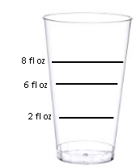

Was your design successful?
____________________

What could you do to improve your design?
____________________

Why do you think that varying water amounts is useful?
____________________

