Grow Stand Math
Student Name _________________________________________

Introduction to Growing Plants with Lights
Prior to the invention of the light bulb, plants were limited to producing energy though photosynthesis only during daylight hours. For farmers and gardeners, this meant the typical growing season for plants and crops was limited to times of year with a long photoperiod. A photoperiod is the amount of time in a single day that a plant or animal is exposed to light. However, once lightbulbs became readily available, plant researchers began to test if artificial light could be used to grow plants during times of the year with short photoperiods. By combining artificial lighting technology with the use of greenhouse space, researchers observed elongated stem growth in plants exposed to artificial light.
In the years since the first artificial lighting was developed, improved technology and design has impacted the quality, intensity, longevity, and safety of lights. Currently, gardeners use grow lights indoors to sprout seeds well before spring arrives. In addition, indoor farming operations use grow lights to produce crops such as lettuce, tomatoes, basil, kale, and chives during the winter season.
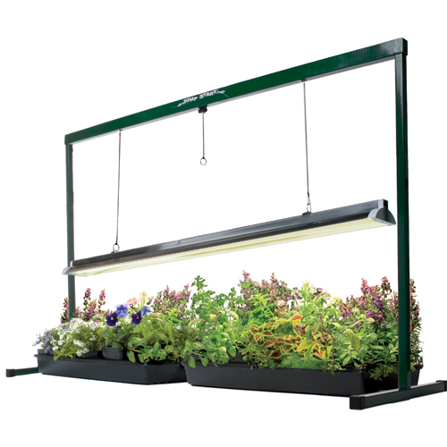
In this lesson, we will be using engineering principles to design and construct an artificial lighting set-up that could be used to grow plants indoors under controlled conditions. The product you construct could be used to help set up controlled experiments testing the effects of artificial light on plant growth.
An artificial lighting set-up including grow light and a stand.
If you were allowed to manipulate light in a variety of ways to test how environmental conditions affect plant growth, what are some of the variables that you might want to test?

Remember, in an experiment, you would select only ONE of these variables to test.
Activity #1: Engineering a Grow Light Stand
The following steps are taken by engineering when they are designing a solution to a particular problem.
- Identify a need or problem
- Collect information
- Brainstorm ideas to fix problem or satisfy need
- Develop a model (or prototype)
- Test and analyze the model
- Make improvements on design
- Present results
As a class, answer the following questions.
- What is the need or problem?

- What information should you collect before you begin?

- How might you fix this problem?

Now, we will be focusing on step 4, developing a model. Modeling is an important step in the engineering process because engineers need to brainstorm what the finished product should look like and how it should function before they begin building it. A scale model is a representation or copy of an object that is usually smaller than the actual size of the object being represented. Scale models are useful to both the developer and the consumer because it can show what the finished product will look like and how it can be constructed.
- Can you think of anything that could be described as a “scale model”?

- Sketch a design for a grow light stand that you could build from a 10-foot piece of PVC pipe.

Activity #2: Making Calculations

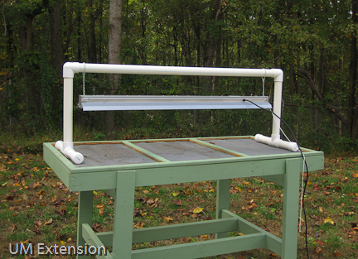
Materials Needed:
- 1 plastic drinking straw
- 1 pair of scissors
- 1 ruler
- tape

A grow light stand could be constructed in many different ways. We are going to work in groups to build a grow light that looks similar the image to the right. Using the materials listed above, you can build a scale model of this grow light. Before we begin building the model, we need to calculate how long each of the pieces needs to be. Use your understanding of calculating percentages to complete the following questions. Be sure to show your work!
- What is the length of your straw? (in inches)

- How long is 43% of the straw? (in inches)

- How long is 20% of the straw? (in inches)

- How long is 4% of the straw? (in inches)

- How would you cut your straw in order to construct your model?

- Draw a sketch of how you would put these pieces together to create a grow light stand.

Activity #3: How can grow lights be applied to modern agriculture?
Read the article “The light fantastic” (http://www.economist.com/node/21602194/print) from The Economist, May 17, 2014 for an example of how grow lights are being used to impact indoor agriculture in Indiana. The article showed how technology and science can be applied to impact agriculture; this is the job of agricultural engineers.
Answer the following questions.
- Briefly explain the lighting technology being used in this indoor farming example.

- What crops are being grown in this facility?

- What are three benefits that can result from moving crops into indoor growing facilities?

- What are two problems that are solved by moving agriculture into a warehouse?

