Golden Rice: A Genetically Engineered Solution to Vitamin A Deficiency
Teacher Resources

Summary
In this standards-aligned, 5-E lesson plan, students will learn about the development of Golden Rice, a genetically-engineered organism, as a way to combat vitamin A deficiency (VAD) in developing countries.

Grade Level
9-12

Contents address the following Next Generation Science Standards
- HS-ETS1-1. Analyze a major global challenge to specify qualitative and quantitative criteria and constraints for solutions that account for societal needs and wants.
- HS-ETS1-3. Evaluate a solution to a complex real-world problem based on prioritized criteria and trade-offs that account for a range of constraints, including cost, safety, reliability, and aesthetics as well as possible social, cultural, and environmental impacts.

Authors
Dr. Joan Christen, Beatrice High School, Beatrice, Nebraska
Dr. Don Lee, Department of Agronomy and Horticulture, University of Nebraska-Lincoln
Erin Ingram, Curriculum Development Specialist, University of Nebraska-Lincoln, IANR Science Literacy
Molly Brandt, Graduate Research Assistant, University of Nebraska-Lincoln, IANR Science Literacy

Lesson x | xxx

Background

Standards
Next Generation Science Standards
- HS-ETS1-1. Analyze a major global challenge to specify qualitative and quantitative criteria and constraints for solutions that account for societal needs and wants.
- HS-ETS1-3. Evaluate a solution to a complex real-world problem based on prioritized criteria and trade-offs that account for a range of constraints, including cost, safety, reliability, and aesthetics as well as possible social, cultural, and environmental impacts.
Common Core
- CCSS.ELA-Literacy.RST.9-10.9 Compare and contrast findings presented in a text to those from other sources (including their own experiments), noting when the findings support or contradict previous explanations or accounts.

Estimated Time
Two, 50-minute class periods

Student Materials
- Computers with internet access
- Student worksheet

Vocabulary
- genetic engineering: process of manually adding new DNA to an organism with the goal of expressing new traits not already found in the organism
- vitamin A deficiency (VAD): lack of an important micronutrient necessary to prevent blindness and a weakened immune system
- micronutrient: essential elements needed in small quantities
- beta-carotene: also known as precursor Vitamin A, is a carotenoid used by animals to manufacture Vitamin A
- bio-fortified: breeding crops to increase their nutritional value
- carotenoid: any of a group of unsaturated pigments occurring in many plants and animals
- recombination: the formation of new gene combinations involving the joining of genes, sets of genes, or parts of genes through laboratory manipulation
- transformation: the process of transferring a foreign piece of DNA into a cell.
- transgenic: an organism in which a foreign gene has been incorporated into its genome
- retinoid: a class of chemical compounds that are forms of vitamin A or related to it
- Golden Rice: a variety of rice (Oryza sativa) produced through genetic engineering to biosynthesize beta-carotene, a precursor of vitamin A, in the endosperm of the rice
- endosperm: tissue that surrounds and nourishes the embryo in the angiosperm seed

Key STEM Ideas
Genetic engineering solutions can be applied to solve real-world issues such as combating micronutrient deficiencies. Evaluation of safety, cost, reliability, and aesthetics or perception of a solution is an essential process prior to adoption of a particular solution.

Students’ Prior Knowledge
Students should have a basic understanding of the need for micronutrients (vitamins and minerals) for proper development and survival. This lesson would provide a good example of how genetic engineering is used in a real world context prior to or following students learning more about the specifics of how they are designed and created.

Connections to Agriculture
In order to consume the nutrients, vitamins, and minerals needed for survival and proper development, humans eat a diversity of foods. In some developing nations, access to many different types of food is limited. In these countries, cereals such as wheat, rice, or corn are staple foods meaning they are regularly eaten and provide the majority of the calories necessary for survival.

Rice is a staple food for over 3 billion people, representing the major carbohydrate and protein source in Southeast Asia and Africa. Unfortunately, rice is a poor source of many essential micronutrients (vitamins and minerals). Therefore, a rice-based diet is the primary cause of micronutrient deficiencies throughout much of the developing world. Iron, zinc, and vitamin A deficiencies are common in rice-consuming regions. These deficiencies account for decreased work productivity, reduced mental capacity, stunting, blindness, increased child mortality, and elevated morbidity and mortality in general.

These micronutrient deficiencies affect particularly children, impairing their immune system and normal development, causing disease and ultimately death. The best way to avoid micronutrient deficiencies is by way of a varied diet, rich in vegetables, fruits and animal products. However, other solutions may be implemented to improve the nutritional health in developing nations.

Golden Rice was invented by Ingo Potrykus, a retired Swiss professor, and Professor Peter Beyer of the University of Freiburg, Germany as a solution to vitamin A deficiency. The rice was genetically engineered to produce and accumulate a carotenoid, beta-carotene, in the edible part of the grain (the endosperm). Beta-carotene is often called pro-vitamin A and is transformed into vitamin A by the body. Transforming the rice to include the genes for beta-carotene, is an economical way to provide relief from vitamin A deficiency (VAD).

Essential Links
- https://ods.od.nih.gov/factsheets/VitaminA-HealthProfessional/
- http://goldenrice.org/PDFs/Golden_Rice_flyer_2015.pdf
- http://www.goldenrice.org/
- http://www.nature.com/nbt/journal/v21/n9/full/nbt0903-971.html
- http://www.goldenrice.org/PDFs/The_Golden_Rice_Project_Mayer_et_al_2006.pdf
- http://www.littleredcapsule.ca/
- http://data.unicef.org/nutrition/vitamin-a.html
- http://www.unicef.org/publications/files/Vitamin_A_Supplementation.pdf
- https://ods.od.nih.gov/factsheets/VitaminA-HealthProfessional/#h3
- http://stream.publicbroadcasting.net/production/mp3/pri/local-pri-819181.mp3

Sources/Credits
Information in the student worksheet introduction came from goldenrice.org
- Golden Rice image: http://goldenrice.org/image/silver+gold.jpg
- Vitamin A drops image: http://littleredcapsule.ca

Lesson Procedures
Engage
- Explain to students that vitamin A deficiency (VAD) is one of the leading causes of blindness and death in the world with 6,000 people dying each day. Ask students to discuss the following: if creating a genetically engineered organism could cure this deficiency, should we use it? Why or why not?
- Write on the board some of the themes that are discussed on both sides of the issue (Improved health in developing nations, questions of safety or regulation, question of cost, question of acceptance or effectiveness, etc.)
Explore and Explain
- Hand out the student worksheet. Read through the introduction with students as a whole class or have students read it with a partner.
- Provide students with access to computers and the internet. Have students visit the National Institute of Health webpage on vitamin A facts (https://ods.od.nih.gov/factsheets/VitaminA-HealthProfessional/)
- Have students answer the follow-up questions. Discuss answers as a whole class.
- Have students name a food they ate that day that provided provitamin A.
- Let students brainstorm potential solutions to the issue of vitamin A deficiency. Discuss their answers in small groups and then as a whole class (Students may come up with a variety of answers such as growing more foods rich in provitamin A, importing surplus food from developed nations, providing vitamin A supplements, etc.)
- Discuss which is the most important provitamin A carotenoid found in foods. (beta-carotene)
Activity 1: Golden Rice webquest
- Have students explore the Golden Rice fact sheet (http://goldenrice.org/PDFs/Golden_Rice_flyer_2015.pdf) to learn more about Golden Rice. Have students answer the questions on their own and discuss as a group.
Elaborate
Activity 2: Evaluating solutions to solve vitamin A deficiency
- Divide students into groups of four. Explain that each group will be examining 2 different potential solutions for vitamin A deficiency- vitamin A drops and Golden Rice. Vitamin A drops are currently being offered twice yearly for young children in many developing countries. Golden Rice has been developed and is in the process of gaining approvals for use in developing countries.
- Students can work in pairs to gather information on one of the two solutions using the resources provided on the student worksheet or other trustworthy sources. Information and associated sources should be recorded on the appropriate table in the worksheet. Both pairs should listen to the podcast link provided in the worksheet which includes information and perspectives on both solutions.
Evaluate
- Each pair will share their findings with the group. The group will write up a report on their findings.
- Individually, each student will then write a paragraph with their evidence-based solution or combination of solutions to combat vitamin A deficiency.

Golden Rice: Answer Key
Global Issue: Preventing vitamin and mineral deficiencies
In order to consume the nutrients, vitamins, and minerals needed for survival and proper development, humans eat a diversity of foods. In some developing nations, access to many different types of food is limited. In these countries, cereals such as wheat, rice, or corn are staple foods meaning they are regularly eaten and provide the majority of the calories necessary for survival.
Rice is a staple food for over 3 billion people, representing the major carbohydrate and protein source in Southeast Asia and Africa. Unfortunately, rice is a poor source of many essential micronutrients (vitamins and minerals). Therefore, a rice-based diet is the primary cause of micronutrient deficiencies throughout much of the developing world. Iron, zinc, and vitamin A deficiencies are common in rice-consuming regions. These deficiencies account for decreased work productivity, reduced mental capacity, stunting, blindness, increased child mortality, and elevated morbidity and mortality in general.
These micronutrient deficiencies affect particularly children, impairing their immune system and normal development, causing disease and ultimately death. The best way to avoid micronutrient deficiencies is by way of a varied diet, rich in vegetables, fruits and animal products. However, other solutions may be implemented to improve the nutritional health in developing nations.

Why do we need vitamin A?
Read the online resource from the National Institute of Health on Vitamin A (https://ods.od.nih.gov/factsheets/VitaminA-HealthProfessional/) and answer the follow-up questions.
- Why is provitamin A important for health?
It is converted into vitamin A in the body.

- What health problems are linked to a vitamin A deficiency?
Blindness, susceptibility to infections like HIV-AIDS, measles, and other childhood diseases which leads to increased mortality, increased risk of diarrhea

- Which groups of people are at risk of vitamin A deficiency? Why?
Premature infants; infants, young children, and pregnant or lactating women in developing countries; people with cystic fibrosis

- List five foods which contain a high level of provitamin A.
Answers may vary. Most dietary provitamin A comes from leafy green vegetables, orange and yellow vegetables, tomato products, fruits, and some vegetable oils. The top food sources of vitamin A in the U.S. diet include dairy products, liver, fish, and fortified cereals; the top sources of provitamin A include carrots, broccoli, cantaloupe, and squash.

Activity 1: Golden Rice Webquest
Learn about the genetically engineered product, Golden Rice, at http://goldenrice.org/PDFs/Golden_Rice_flyer_2015.pdf. Use what you learn to answer the following questions.

- How is golden rice different from white rice?
Golden rice contains beta-carotene in the edible part of the grain while white rice only contains beta-carotene in the leaves of the plant.

- How was golden rice developed?
It was genetically engineered to contain beta-carotene and other carotenoids in the endosperm (the edible part of the grain).

- Where did the genes used to create golden rice come from?
Golden rice was created by transforming rice with only two beta-carotene biosynthesis genes, one from a soil bacterium and another from maize (corn).

- Who were the scientists that designed golden rice?
Ingo Potrykus from ETH Zürich (Switzerland) and Peter Beyer from the University of Freiburg (Germany)

- How much does it cost the farmers for this new technology? Why is this so?
It will cost the same as planting an equivalent white rice variety. The nutritional benefit will be added at no additional cost to the farmer.

- If countries grow golden rice, how will the people be helped?
The consumers of this rice will have improved nutrition and be better able to avoid vitamin a deficiency. This will help prevent childhood mortality and blindness.

Activity 2: Evaluating solutions to solve vitamin A deficiency
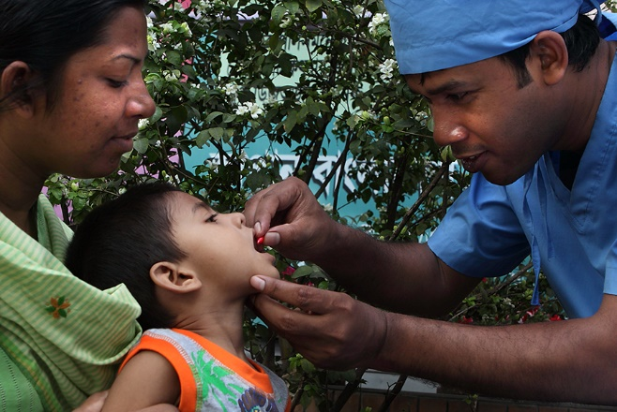
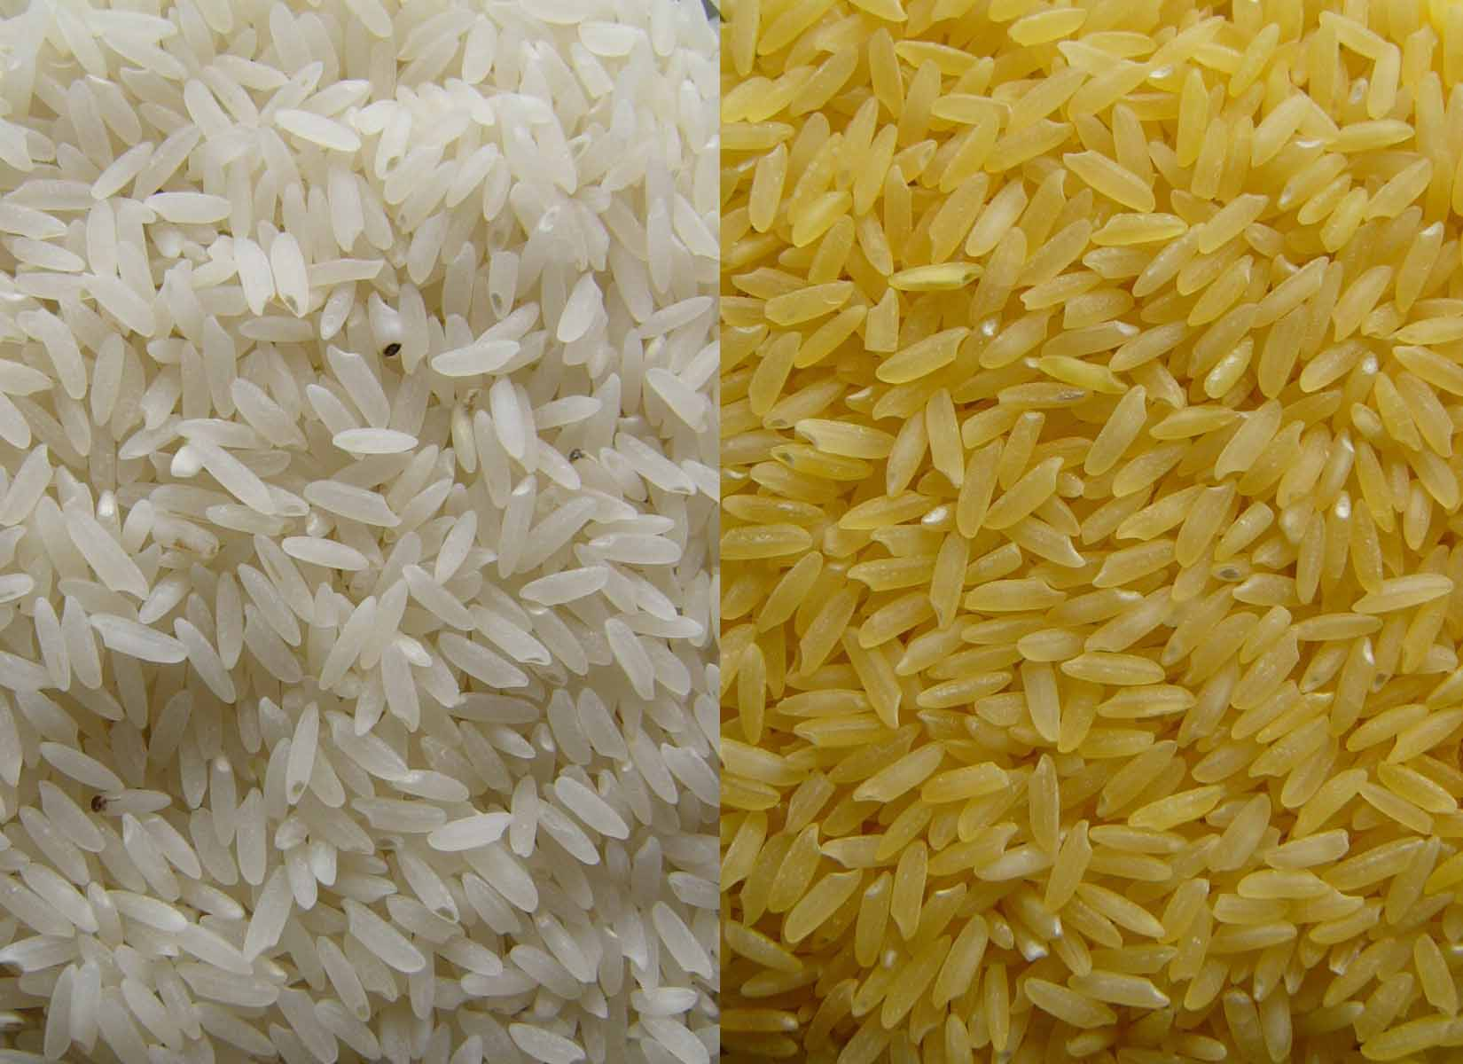
When designing a solution for a given problem, it is important to consider many factors that may contribute to the success or failure of a solution. In the case of vitamin A deficiency, a variety of different solutions (or combinations of solutions) might be implemented to prevent and treat vitamin A deficiency. Students will break up into groups and gather evidence from online resources about cost, safety, reliability, and aesthetics of two possible solutions to vitamin A deficiency.
- Divide into groups of 4.
- Half of your group will examine aspects of golden rice and the other half will examine aspects of vitamin A drops.
- Gather information from online resources about golden rice or vitamin A drops as a solution to combat vitamin A deficiency in developing countries.
- Each pair will summarize the information they learn in the appropriate table below. Don’t forget to include sources of your information!
- Compare information gathered about each solution and write up a report with your group synthesizing the benefits, challenges, and unknowns associated with each solution.
- Individually, each student will write a paragraph proposing their preferred solution to vitamin A deficiency in developing countries and why they selected this solution.
Golden Rice resources:
- http://goldenrice.org/
- http://www.nature.com/nbt/journal/v21/n9/full/nbt0903-971.html
- http://www.goldenrice.org/PDFs/The_Golden_Rice_Project_Mayer_et_al_2006.pdf
Vitamin A drop resources:
- http://www.littleredcapsule.ca/
- http://data.unicef.org/nutrition/vitamin-a.html
- http://www.unicef.org/publications/files/Vitamin_A_Supplementation.pdf
- https://ods.od.nih.gov/factsheets/VitaminA-HealthProfessional/#h3

Golden Rice
Cost
Sources:
Safety
Sources:
Reliability
Sources:
Aesthetics/
Perception
Sources:

Vitamin A Drops
Cost
Sources:
Safety
Sources:
Reliability
Sources:
Aesthetics/
Perception
Sources:

