Golden Rice
Student Name _________________________________________

Global Issue: Preventing vitamin and mineral deficiencies
In order to consume the nutrients, vitamins, and minerals needed for survival and proper development, humans eat a diversity of foods. In some developing nations, access to many different types of food is limited. In these countries, cereals such as wheat, rice, or corn are staple foods meaning they are regularly eaten and provide the majority of the calories necessary for survival.

Rice is a staple food for over 3 billion people, representing the major carbohydrate and protein source in Southeast Asia and Africa. Unfortunately, rice is a poor source of many essential micronutrients (vitamins and minerals). Therefore, a rice-based diet is the primary cause of micronutrient deficiencies throughout much of the developing world. Iron, zinc, and vitamin A deficiencies are common in rice-consuming regions. These deficiencies account for decreased work productivity, reduced mental capacity, stunting, blindness, increased child mortality, and elevated morbidity and mortality in general.

These micronutrient deficiencies affect particularly children, impairing their immune system and normal development, causing disease and ultimately death. The best way to avoid micronutrient deficiencies is by way of a varied diet, rich in vegetables, fruits and animal products. However, other solutions may be implemented to improve the nutritional health in developing nations.

Why do we need vitamin A?
Read the online resource from the National Institute of Health on Vitamin A (https://ods.od.nih.gov/factsheets/VitaminA-HealthProfessional/) and answer the follow-up questions.
- Why is provitamin A important for health?

- What health problems are linked to a vitamin A deficiency?

- Which groups of people are at risk of vitamin A deficiency? Why?

- List five foods which contain a high level of provitamin A.

Activity 1: Golden Rice Webquest
Learn about the genetically engineered product, Golden Rice, at http://goldenrice.org/PDFs/Golden_Rice_flyer_2015.pdf. Use what you learn to answer the following questions.

- How is golden rice different from white rice?

- How was golden rice developed?

- Where did the genes used to create golden rice come from?

- Who were the scientists that designed golden rice?

- How much does it cost the farmers for this new technology? Why is this so?

- If countries grow golden rice, how will the people be helped?

Activity 2: Evaluating solutions to solve vitamin A deficiency
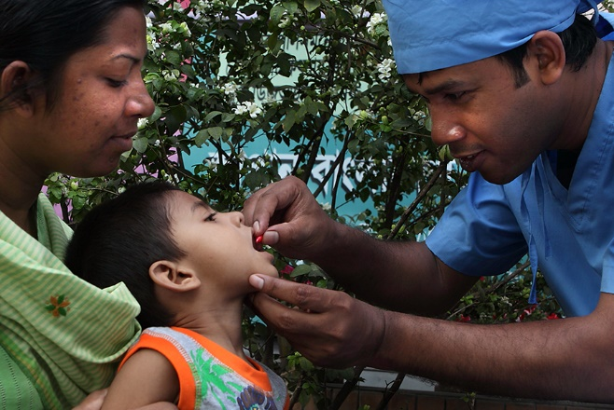
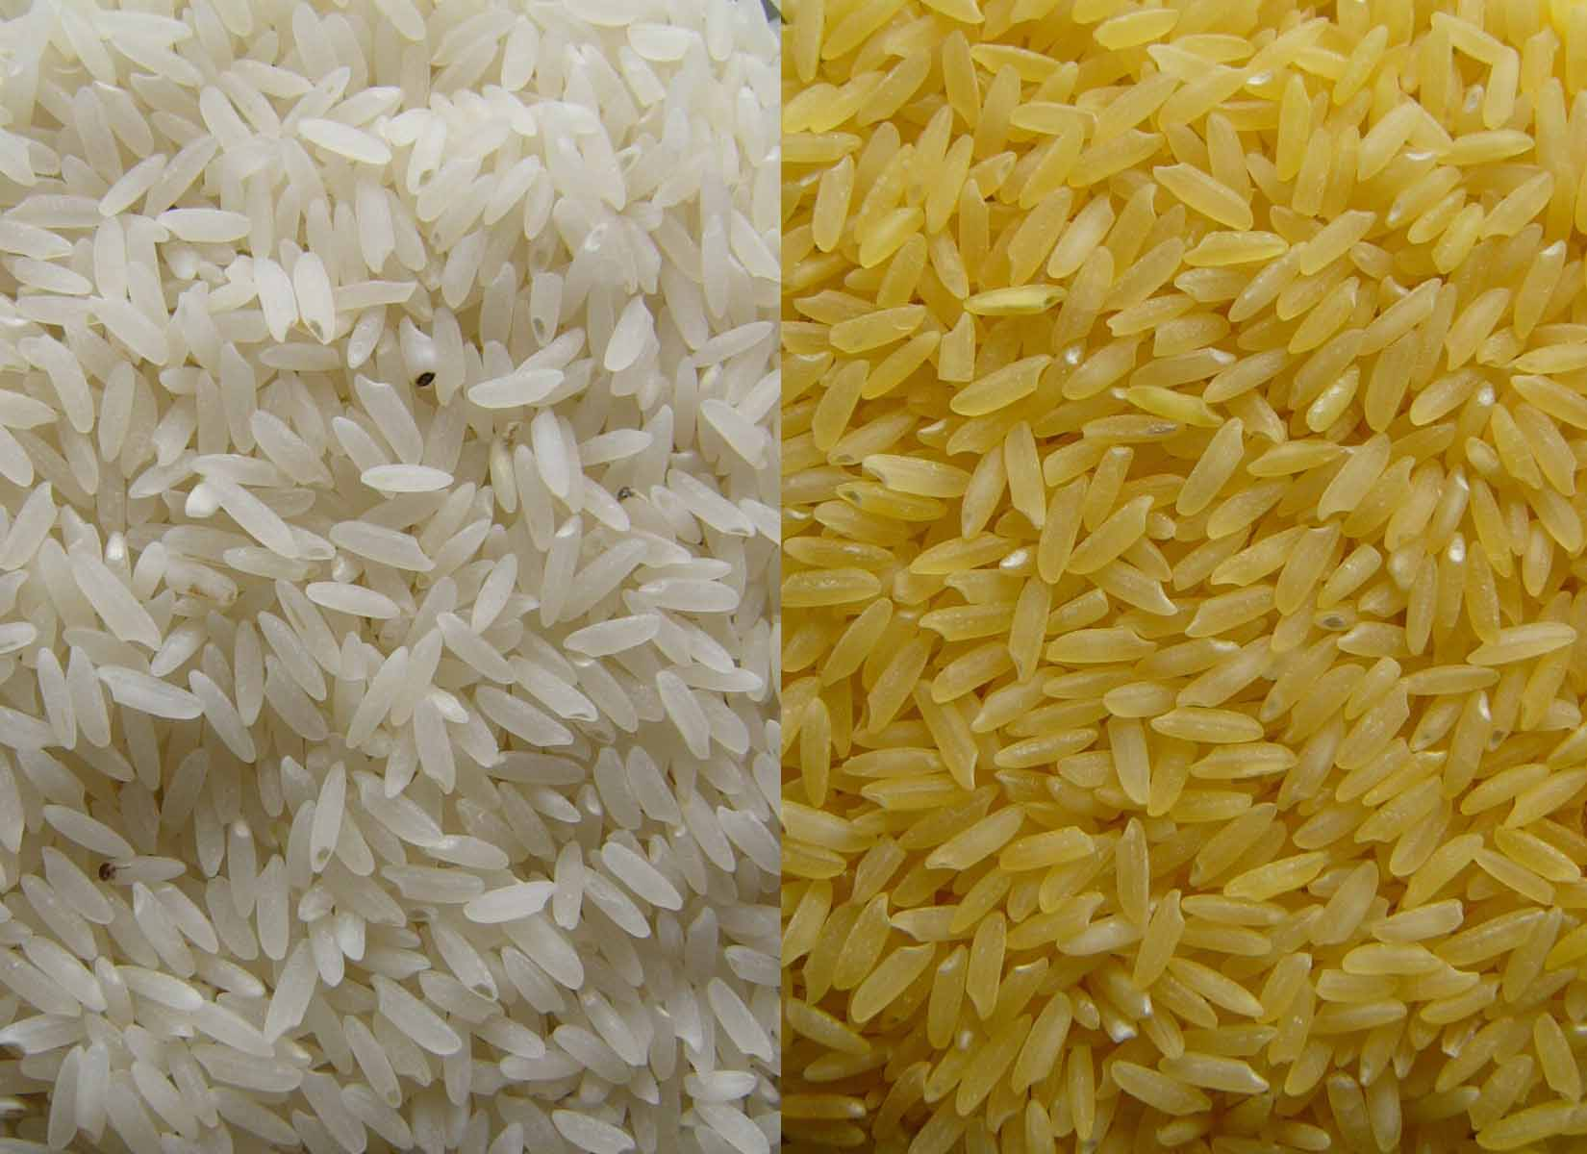
When designing a solution for a given problem, it is important to consider many factors that may contribute to the success or failure of a solution. In the case of vitamin A deficiency, a variety of different solutions (or combinations of solutions) might be implemented to prevent and treat vitamin A deficiency. Students will break up into groups and gather evidence from online resources about cost, safety, reliability, and aesthetics of two possible solutions to vitamin A deficiency.
- Divide into groups of 4.
- Half of your group will examine aspects of golden rice and the other half will examine aspects of vitamin A drops.
- Gather information from online resources about golden rice or vitamin A drops as a solution to combat vitamin A deficiency in developing countries.
- Each pair will summarize the information they learn in the appropriate table below. Don’t forget to include sources of your information!
- Compare information gathered about each solution and write up a report with your group synthesizing the benefits, challenges, and unknowns associated with each solution.
- Individually, each student will write a paragraph proposing their preferred solution to vitamin A deficiency in developing countries and why they selected this solution.
Golden Rice resources:
- http://goldenrice.org/
- http://www.nature.com/nbt/journal/v21/n9/full/nbt0903-971.html
- http://www.goldenrice.org/PDFs/The_Golden_Rice_Project_Mayer_et_al_2006.pdf
Vitamin A drop resources:
- http://www.littleredcapsule.ca/
- http://data.unicef.org/nutrition/vitamin-a.html
- http://www.unicef.org/publications/files/Vitamin_A_Supplementation.pdf
- https://ods.od.nih.gov/factsheets/VitaminA-HealthProfessional/#h3
Podcast with information on both solutions (11:36):
http://stream.publicbroadcasting.net/production/mp3/pri/local-pri-819181.mp3

Golden Rice
Cost
Sources:
Safety
Sources:
Reliability
Sources:
Aesthetics/
Perception
Sources:

Vitamin A Drops
Cost
Sources:
Safety
Sources:
Reliability
Sources:
Aesthetics/
Perception
Sources:

