Garden TOOLS for Corn Unit
Unit Question: How can we use existing technology tools and create or modify new technology tools to explore, understand, and improve our garden?

Estimated Time
- 12 hours for lessons 1-12
- 3-5+ hours for lesson 13 (based on student projects and time constraints)

Table of Contents
Lesson 1: Exploring initial ideas about technology in the garden 1
Lesson 2: Introducing the BBC microbit 4
Lesson 3: Exploring the power of computers and computational thinking in everyday life 7
How can we beautify the garden with art or music? 12
Lesson 4: Creating garden art 12
Lesson 5: Animating your garden art with a fruit button 17
Lesson 6: Modifying the fruit button code to play garden music 20
How can technology help us to manage our garden better? 24
Lesson 7: Exploring weather and other environmental conditions in the garden 24
Lesson 8: Using data to make better decisions 29
Lesson 9: Precision agriculture technologies 32
Lesson 10: Agricultural automation and robotics technologies 36
Lesson 11: Agricultural biotechnology 38
Can we create our own technology solutions to a real garden challenge? 43
Lesson 12: Using the engineering design process to solve a problem 43
Lesson 13: Addressing real problems through a grand garden design challenge 47

Lesson 1: Exploring initial ideas about technology in the garden
Big Idea
- We may think of cell phones or computers when we think of “technology”, but technologies can be simple or complex.
- Technology is any tool created by applying what we know about the natural world and human behavior to meet our needs or wants.
Time and Location
1 hour; indoor
Guiding Questions
- What is technology?
- What are some technologies used in the garden and why are they used?
Materials
- Supplies to collect students ideas and discuss
  - Chart paper or white board and markers
  - Google Jamboard or other interactive whiteboard
Lesson objectives
Students will be able to…
- Decide if garden tools can be considered technologies based on a provided definition
- Identify overlooked gardening technologies
Warm-up
Engage
- Engage students’ prior knowledge and ideas about technology.
  - Display the word, technology. Ask students to discuss with a partner. Share out student ideas. Record them on chart paper or white board.
    - What does the word “technology” mean to you?
    - What things come to mind when we talk about technology?
- Introduce the lesson objective:
  - Today we are going to talk about what technology is and talk about some garden tools to see if our ideas about technology change.
Activity
Explore
- Ask students to think about a common garden tool- a bucket.
  - Discuss:
    - What are all of the ways you can think of to use a bucket in a garden?
  - Think-Pair-Share: Ask students to think about their ideas for 1 minute then discuss with a partner. Share out and record student ideas.

Explain
- Introduce the definition of technology.
  - Display definition: Technologies are tools created by applying what we know about the natural world and human behavior to design solutions to meet our needs or wants.
  - Read the definition aloud or ask for a volunteer to read.
  - Give examples of needs and wants to help students make personal connections.
    - Needs might be… access to water, grow food, provide shelter, protect our bodies, etc.
    - Wants might be… to measure something, to do something faster, to do a task automatically, to find information, to communicate with someone, etc.

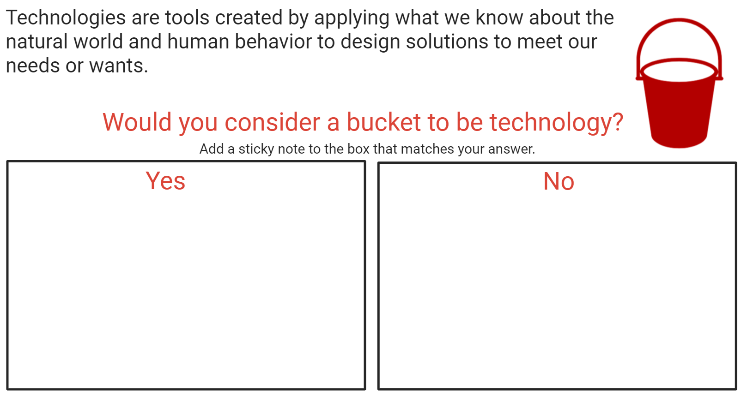

- Ask students to challenge their initial ideas about technology.
  - Post the question, Would you consider a bucket to be technology?, on chart paper or white board.
  - Have students review the definition and decide if they agree or disagree that a bucket is a technology. Add a sticky note to show their answer.
  - Discuss student answers.

- Ask students to think about technologies that might be overlooked in the garden.
  - Pose the question on chart paper or white board.
  - Ask students to add a sticky note to show their ideas

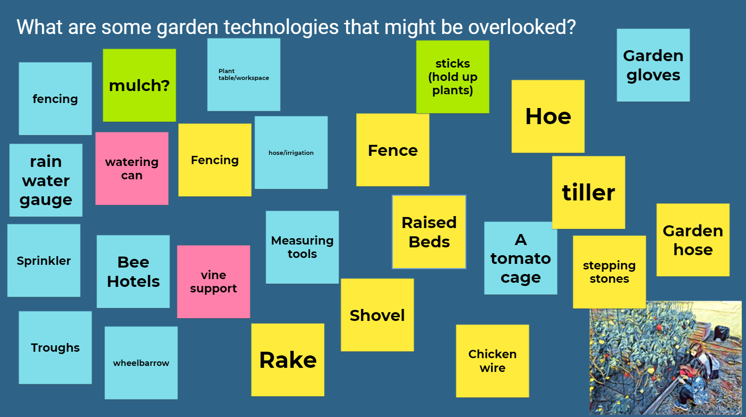
Wrap-up
Elaborate
- Guide students to reflect on their initial ideas of technology compared to their new ideas with the goal of expanding students’ often narrow initial ideas of what “technology” is.
  - Highlight that technology does not need to be electronic like computers, tablets, or phones; it can be simple or very complex; and it can help us understand or measure things better or help to solve a problem.
- (Optional) Ask students to write a short description or draw a picture of a technology you wish could be invented and how it would improve your life.
  - What is a new technology you wish would be invented to solve a problem or improve something in your life? It might make something easier, better, faster, more beautiful or enjoyable, etc.

Lesson 2: Introducing the BBC microbit
Big ideas
Computers are an example of flexible technology tools that can be used in many different ways to perform many different tasks and help solve many different problems. A computer can be programmed and reprogrammed to meet many different needs making it a very powerful tool when trying to solve complex problems.
Time and Location
20 minutes to code the sensors prior to the lesson
1 hour for the lesson; indoors and then outdoors.
Guiding Questions
- Why is a computer, like the microbit, an especially helpful tool that can be used in the garden (and many other places)?
Materials
- White board or chart paper
- Markers
- 1 copy of the safety guide from BBC microbit: https://microbit.org/guide/safety-guide-students/
- BBC Micro:bits (1 per 2-3 students) coded as different tools (sensors, counters, compass, etc.)
- Battery packs (1 per 2-3 students)
Lesson Objectives
Students will be able to…
- Safely, respectfully, and responsibly use the microbits to explore their use in the garden
- Collaboratively compare and contrast different microbit uses in small groups
- Identify several different ways the microbits can be used
- Discuss and communicate ways that computers (such as microbits) are powerful tools
Before you get started…
- Select several ways the micro:bit can be used in the garden:
  - Light sensor
  - Temperature sensor
  - Wildlife counter
  - Step counter
  - Compass
- Micro:bits will need to be coded prior to teaching this lesson. For instructions on coding and uploading files, see the Garden TOOLS website.
Warm-up
Engage
- Engage students’ previous knowledge and experiences with garden tools and technologies.
  - Who remembers some of the garden tools and technologies we have talked about?
- Introduce the lesson objective:
  - We are going to explore our garden today using a technology tool called a microbit. When we are using it, I want you to think about a guiding question: Why do you think the microbit is a powerful technology tool?
Activity
Explore
- Introduce the microbit to the whole group.
  - Show students the microbit. Explain that it is a handheld, programmable microcomputer. Highlight a few of the key features and how they are similar or different from a standard computer:
    - Does it look like a computer? What looks similar? Is anything missing?
    - Similarities
      - It does have a place to plug in a USB cable
      - It does have various microchips and sensors on the back
    - Differences
      - It doesn’t have a screen, but it does have a 5x5 LED grid – 25 lights in the middle that can show you text, numbers, and images
      - It doesn’t plug into the wall, but it does have a battery pack- provides power to our microcomputer just like a computer needs to be plugged into the wall to have power.
      - It doesn’t have a keyboard, but it does have two programmable buttons- labelled A and B, these can be programmed to do things when pressed.
      - It doesn’t have a place to plug in your headphones, but it does have pins along the bottom –these allow you to connect the microbit to external components (The 3V and the GND pins relate to power supply and should NEVER be connected to one another.)
  - Before getting started, explain safe, responsible, and respectful use of the microbits using the student safety sheet provided by BBC microbit found here: https://microbit.org/guide/safety-guide-students/
    - Finally, we need to use this microcomputer safely, responsibly, and respectfully.
    - Handle the microbit by its edges- try not to touch the chips or sensors on the back of the microbit.
    - Handle the microbit with dry hands- it should not get wet.
    - Do not touch microbit with metal objects. This can damage the microbit and increase the risk of burn or fire.
- Take students outside and challenge them to explore the garden environment using the micro:bit.
  - Explain the task: Just like a real computer, the microbit can do many different things. Each of the micro:bits is already program as a tool for exploration. Not every micro:bit is programmed to explore in the same way. I challenge you to work with a partner to use the micro:bit to explore the garden.
  - Divide students into partners. Provide each group with one pre-coded microbit and a battery pack.
  - Encourage students to spend a few minutes exploring freely to get a sense of what their microbit is programmed to do and what it can tell them about their environment.
    - You may want to press the buttons, give the microbit a little shake, move which way it is facing- just try different things to see what your microbit can do.
- Ask groups to compare their microbit with another group.
  - How is your microbit similar to another group? How is it different?
- Discuss the different uses of the microbits as whole group:
  - What does your group think your microbit is programmed to do?
    - Does it measure how much of something? What do you think it is measuring?
    - How did you test it?
Wrap-up
Explain
- Ask students to reflect back on the guiding question from the beginning of the lesson.
  - Think back on our guiding question: Why is the microbit, or any computer, such a powerful technology tool?
  - Have students discuss their ideas and document them on chart paper for reference at a later date.

Lesson 3: Exploring the power of computers and computational thinking in everyday life
Big ideas
- Computers are an example of flexible technology tools that can be used in many different ways to perform many different tasks and help solve many different problems.
- Solving a complex problem can be made easier by applying computational thinking skills
Time and Location
1 hour; indoors only
Guiding Questions
- What is computational thinking?
- How can computational thinking be used to help solve a problem?
Materials
- White board or chart paper
- Markers
- Computational Thinking lesson from code.org- https://studio.code.org/unplugged/unplug2.pdf

Each group will need:
- Computational Thinking diagram (1 per group)
- Make a Monster catalog (1 per group)
  - Pages 7-9 in the Computational Thinking lesson
- Make a Monster “parts” (1 set per group)
  - Pages 10-23 printed on transparencies OR provide students with tracing paper
- (Optional) Tracing paper
- Blank pieces of paper (3 per student)
- Markers, pens, pencils (1 pack per group)
- Scissors
Lesson Objectives
Students will be able to…
- Recognize that computers are powerful tools because they offer a flexible problem solving tool that can be used in different ways
- Learn four steps in computational thinking
- Use teamwork and apply computational thinking to solve a complex problem
- Recognize that computational thinking strategies offer an approach to breaking down a complex problem in a way that a computer could be used to help solve it.
Before you get started…
- Print a copy of the Computational Thinking lesson from code.org
  - Print the Make-a-Monster catalog (p 7-9) on plain paper
  - Print the monster “parts” (p. 10-23) on transparencies (or students can trace monster parts on tracing papers.
- Print copies of the computational thinking diagram (1 per student) OR (optional) display the diagram via projector or DocCam.
Warm-up
Engage
- Engage students’ prior experiences with using a computer as a powerful technology tool because of its many uses.
  - Remember when we explored several different ways we could use a microbit in the garden. We talked about how computers like the microbit are powerful tools. Why did we think they were powerful or useful or helpful?
  - Review students’ ideas.
- Introduce the lesson objective:
  - You came up with some great ideas about why computers like the microbit are powerful tools. Today, we are going to try to solve some really tough problems and learn about how using a special problem solving strategy like computers use can make them easier to solve.
Activity
- Introduce the “Figuring it Out” activity
  - Write on a whiteboard or chart paper, “Find the sum of numbers from 1 to 200”
  - I have a challenge for you. The challenge is to sum up all the numbers from 1 to 200 in your head. I’ll give you 1 minute to work on the challenge. Ready? Go!
  - Watch how students react to the challenge. Who is frustrated or has given up? Are some students trying to solve the problem in their head?
- Talk students through a solution to the problem.
  - Who is ready to share their solution? (Pause to see if anyone wants to share.) Who thought the problem was so hard that they didn’t really try? Is it a big problem to do in your head?

  - Let’s see if we can break it up into smaller pieces that are easier to manage. We’ll start with the two ends. What is the sum of 200 plus 1? (Pause for someone to say 201.) What about 199 plus 2? (Pause) 198 plus 3?

  - Are you seeing a pattern? (Pause so someone can describe the pattern.) How many pairs will add up to 201? What is the last pair in this pattern? (It would be 100+101=201.) That means we have 100 pairs of numbers that equal 201. Does that make it easier to figure out the sum of all the numbers? (Pause)

  - If we added all these pairs together, we would be adding 201 + 201 + 201 + 201 for 100 times. Does anyone have a quick way to add the same number 100 times? (Pause for someone to suggest that the answer is 201*100=20,100.)

  - Now let’s think about how we could make this a solution that would work for other challenges, like finding the sum of all numbers between 1 and 2000. What would that look like? If we think about it, I think we could even come up with a solution that would work for any set of numbers. (If the group is interested, give them time to think about the algorithm, or just continue with sharing the solution.)

  - Write on the whiteboard or piece of flip chart paper that you used before. “The sum of all numbers between 1 and ______ is ______/2 * ________+1” (Pause so the group can discuss this solution if they want to.)
    - ________/2 = # of pairs
    - ________ + 1 = the sum total for each pair

  - Would everyone agree that that was a tough challenge? And we used a problem solving strategy to make it easier?

- Introduce the term “computational thinking and help students to define four steps or parts of computational thinking (decomposition, pattern recognition, abstraction, algorithms). Write it on the whiteboard or on chart paper.
  - Write the words “computational thinking” on the white board or chart paper.
    - Have students share their ideas for what they think computational thinking is.
      - What does this say? What do you think it means?
    - Introduce the definition of computational thinking.
      - Computational thinking is a problem solving approach. When we formulate a problem in a way so that we can use a computer to help us solve this problem and other problems similar to it, that’s computational thinking.
  - Display the computational thinking diagram of four steps or parts and review how we used these four steps in solving our “Figuring it Out” challenge.
    - Decomposition: Breaking down a big problem into smaller, simpler problems
      - In our “Figuring it Out” activity, we broke down a very hard math problem into smaller pieces by adding up two numbers at a time starting at the beginning and the end of the sequence (1 and 200)
    - Pattern Recognition: Look for commonalities or similarities in the smaller problems or in a problem you have solved previously
      - We repeated this process and noticed a pattern. All of our pairs added up to 201.
    - Abstraction: After finding the patterns, you can “abstract out” or ignore the details that make things different and use the general framework to find a solution that works for more than one problem.
      - We looked for a way to describe a solution that would work for any set of numbers.
    - Algorithm: Once you have a solution, you can write it out in a way that allows it to be processed step-by-step.
      - We wrote our solution as an algorithm, or a series of steps.
- Divide students into groups of 2-3 and complete the Make a Monster activity.
  - Give each group the necessary materials.
  - Use the Computational Thinking instructions from the code.org lesson to facilitate the Make a Monster activity. A short summary is provided here.
  - Challenge: Write a set of instructions (an algorithm) that someone else can follow to make a monster.
  - Decompose: What needs to be done to make the monster?
    - This is a big task and there are so many options. We need to decompose this complex problem into smaller tasks.
  - Pattern Recognition: What do these monsters have in common?
    - Look at the Classified Monsters in the Make a Monster catalog.
    - What are some things that all of the monsters have? What are things that are similar between monsters of certain groups?
  - Abstraction: What’s different? Take it out.
    - One monster may have Wackus Eyes, while another has Spritem Eyes, but they both have eyes. That means we could say that “This monster has __________ eyes” and later we would be able to fill in the blank based on whatever monster we’ll be drawing.
    - Make a list of the different features with the details abstracted out.
      - The monster has a ________ head.
      - The monster has _________eyes.
      - The monster has a ________nose.
      - The monster has_______ ears.
      - The monster has a ________mouth.
  - Algorithm: How can you put this together to make a series of instructions that your classmates can follow?
    - Arrange your steps into a list that other groups can use to recreate a monster.
  - When students are done writing their algorithm, have them test it with a partner.
    - Give your set of instructions (or algorithm) to a group member and draw the monster described. Did your algorithm work?
Wrap-up
- Discuss and debrief the day’s activities and how computational thinking can be a powerful approach to solving problems.
  - How did we practice the four steps of computational thinking in today’s lesson?
    - Decomposition: We broke a complex task down into smaller pieces. What needed to be done to make the monster?
    - Pattern Recognition: We looked for similarities or repeating patterns in the smaller pieces. What did those monsters have in common?
    - Abstraction: We removed the details that made the drawings different. What was different about the monsters? We took it out.
    - Algorithm: We created a list of steps in a sequence so a partner could finish the task. How did you put this together into a series of instructions that your classmates could follow?
  - Earlier you had some great ideas about how computers like the microbit are powerful problem solving tools. How did formulating a problem like a computer (computational thinking) help you today to solve a complex problem?

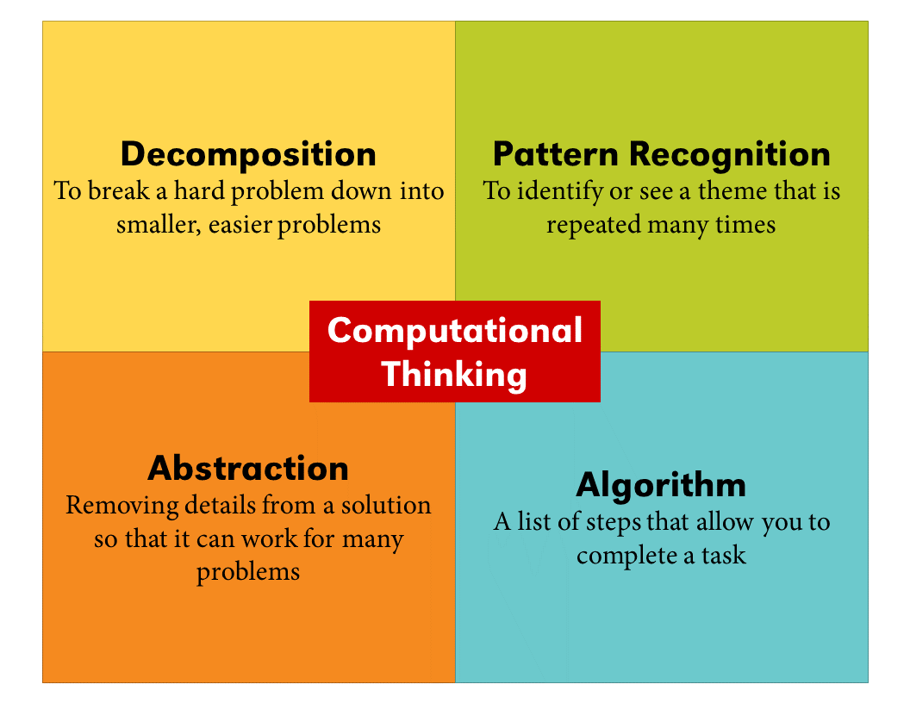

How can we beautify the garden with art or music?

Lesson 4: Creating garden art
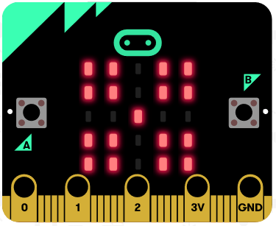
Big Ideas
Humans and computers communicate in different ways. If we want to use computers to help solve a problem, we need to use computational thinking skills to formulate the problem in a way that can be communicated with computers.
Time and Location
1 hour; indoors only
Guiding Questions
- How do humans and computers operate in similar and different ways?
- How can we use computers and coding to create garden art?
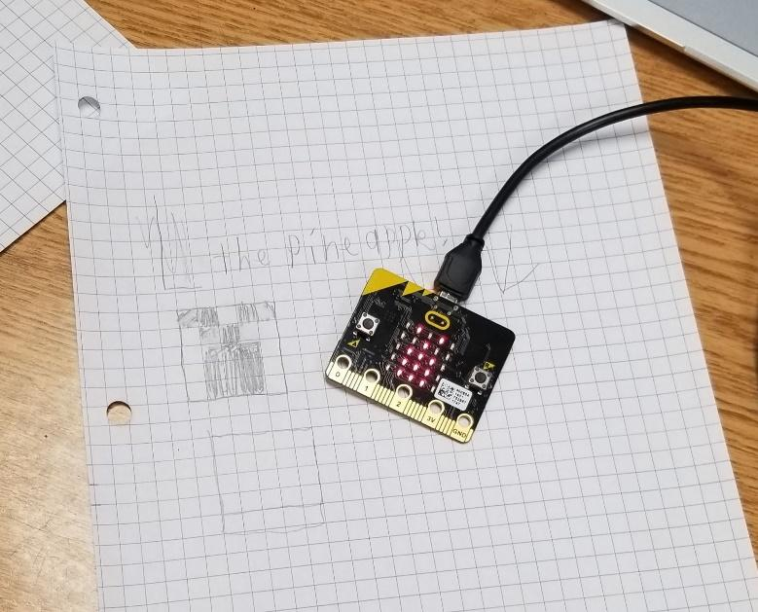
Materials
Each student will need:
- Graph paper
- Pencil
Each group of 2-3 students will need:
- A BBC microbit microcontroller
- USB cord
- Device with internet connection
- Microbit Quick Start guide
Lesson Objectives
Students will be able to…
- Gain familiarity coding the microbit microcontroller
- Create a garden icon using drag-and-drop code blocks and download it to the microbit
- Share their creation with other students
Before you get started…
- Post the computational thinking diagram or be prepared to give out paper copies for students to review during the Warm-up discussion.
- Code a microbit to show a smiling icon as described in the activity before starting the lesson.

Warm-up
- Review students’ prior experiences with garden tools and computational thinking.
  - Let’s review what we learned about problem solving and computers. What was that problem-solving approach called? When you did the Make-a-Monster activity, what were some of the steps you went through?
- Highlight prior learning:
  - We discussed how different technologies including computers can be applied to solve a problem. We also discussed how computational thinking helps us to formulate the problem in a way that allows us to use computers to help solve it.
  - Review the four steps of computational thinking by reviewing the diagram.
- Introduce the lesson objective:
  - Today, we are going to create art on our microbits that expresses how we feel about the garden. We are going to communicate with the microbit using computer code that tells the microbit what we want it to do. This is why coding or programming is important.

Activity
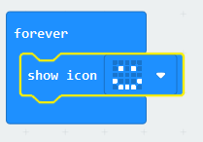
- Show students a picture of a smiling icon or program a microbit to show a smiling icon using the following code:
- Discuss:
  - What does this icon or emoji make you think of?
  - What is this picture saying without using any words?
- Explain:
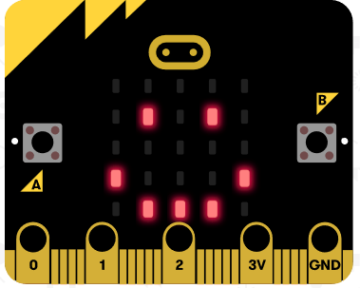
  - We use icons or emojis to say something with a picture but without using any words.
  - Today, I want you to design a school garden icon or emoji. It can be any picture that expresses something about your school garden. It might be something you find in a garden, or how you feel when you are gardening.
  - Once you have a design, you can program the microbit to display your icon.

- Lead a discussion about the decomposition and algorithmic thinking steps of the computational thinking approach that students will go through to create their garden art.
  - What are the smaller tasks you will need to do to make the microbit show your garden art?
    - Decide what your art will look like.
    - Translate a complicated sketch into an icon that can be expressed in a grid of 25 lights.
    - Create the code for the microbit.
    - Download the code to the microbit and see if it works.
  - Review decomposition and algorithmic thinking as it relates to these steps.
    - So we broke down a complex task into smaller parts. Do you remember which computational thinking step is involved with breaking down a problem? (Decomposition)
    - Then, we talked about needing to create a code, or a sequence of steps that the microbit will follow to show your art. Do you remember which step in computational thinking involves creating a sequence of steps? (Algorithm)
- Ask students to brainstorm what they would like their garden art to communicate about how they feel in the garden.
  - Write down a list of words or draw a few pictures of something that are related to your feelings in the garden. It doesn’t have to be a face. It can be flowers or fruit or anything else that’s related to the garden.
- (Optional) Take a trip out to the garden for inspiration!
  - Take pictures, sketch objects, or collect some garden artifacts (flowers, leaves, etc.) that might guide your creation!
- Translate this word or sketch into a form that can be shown in the microbit LED grid.
  - Provide each student with graph paper and pencil. Explain to students that the microbit can only display an icon using the 25 lights on the front panel and they will need to simplify their drawing into something that can be drawn using the grid of 25 lights.
    - Draw a 5 x 5 grid on a piece of graph paper. Each box represents one of the 25 lights.
    - Show an example of drawing a smiley face on the 5 x 5 grid.
    - Explain to students that by shading in boxes on the graph paper, they can design an icon.

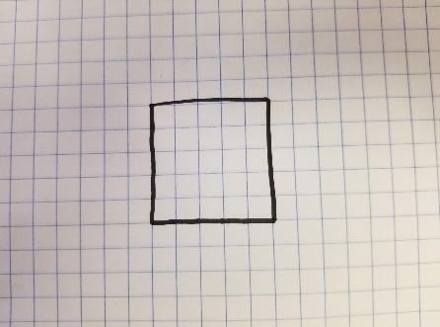  Blank 5 x 5 grid | 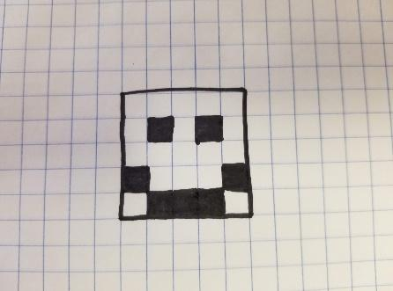  Sample smiley icon | 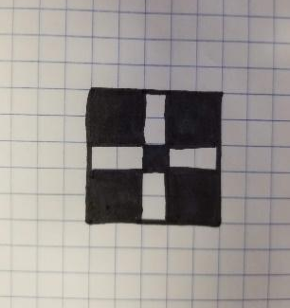  Sample flower as a garden icon

ADAPTATION FOR YOUNGER STUDENTS:
If students are struggling or do not feel comfortable drawing a garden icon on their own, they can simply select an icon they feel relates to the school garden from “show icon” code block under the Basic menu.
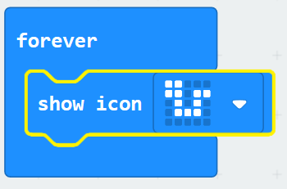  Snake | 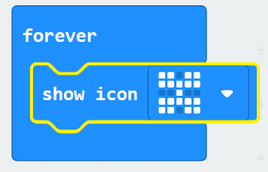  Butterfly | 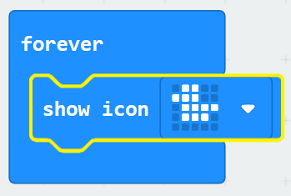  Duck

- Introduce students to the MakeCode Microbit editor.
  - Divide students into programming pairs. Provide each pair with a microbit, USB cord, and device (desktop, laptop, tablet, or phone)
  - On the laptop, have one partner open a browser and navigate to https://makecode.microbit.org.
- Complete the Flashing Heart tutorial.
  - Before you start showing your garden art, I want you to explore a little by completing the Flashing Heart tutorial.
- Test the Flashing Heart code on the simulator BEFORE downloading the code to the microbit.
  - Highlight how students can view their code in action via the microbit simulator on the left side of the coding platform BEFORE they download it to their microbit.
  - When students are ready to test their code on their microbit, use the microbit.org quick start guide to lead students through the steps to connect their microbit to the device.
  - Click the purple “Download” button to download the program to the computer.
  - Using the USB cord, connect the micro:bit to the computer.
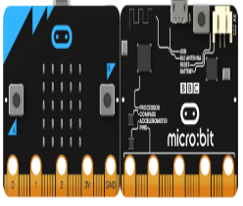

  - Upload the program to the micro:bit
- Next, modify the Flashing Heart code to create garden art.
  - Ask students to modify the Flashing Heart code to show their garden-related icons. They may even want to include a heart in their design.
- Name the program.
- Discuss coding successes and struggles as a whole class:
  - Did your code work?
  - Did anyone have any problems? How did you work through the difficulties?
- Share and compare garden icons with another group.
  - Can another group guess what your icons are and how they are related to the garden?
- Depending on time or for an extra challenge, students can modify their art in a number of ways.
  - Can you add another picture to your garden art?
  - Can you figure out how to make your garden art flash on and off?
Wrap-up
- Congratulate students on a job well done and review computational thinking steps, decomposition and algorithmic thinking.
  - Great job! You used computational thinking to formulate your task in a way that a computer could be used to develop garden art! Who remembers two of the steps in computational thinking you used today?
    - Decomposition- breaking a problem down into smaller pieces
    - Algorithmic thinking- create a sequence of steps (coding or programming) that the computer can follow to complete the task

Lesson 5: Animating your garden art with a fruit button
Big Ideas
- Energy in our microbit comes from electricity. The power source of the electric energy is either the battery pack or electricity flowing through the computer.
- Whether electricity flows in a loop depends on whether the circuit is open or closed. A closed circuit allows electricity to flow in a loop. An open circuit does not.
- Some objects allow electricity to move or flow- these are known as conductors. Other objects or materials do not allow electricity to flow- these are known as insulators.
- Water, by itself, does not conduct electricity. Impurities like salt or citric acid are conductors as they allow electricity to flow. Fruits (and humans) are made up of water and contain impurities. This helps us to conduct or move electric energy.
Time and Location
2 hours; indoors
Guiding Questions
- How can we create a system using the microbit in which electric energy is moved and changed into energy that we can see or hear?
- How is electric energy (electricity) converted into light in the microbit system?
Nebraska Science Standards
- SC.4.4.2.B Make observations to provide evidence that energy can be transferred from place to place by sound, light, heat, and electrical currents.
- SC.4.4.2.D Apply scientific ideas to design, test, and refine a device that converts energy from one form to another.
Materials
For the fruit button demonstration set-up:
- Piece of fruit (orange, banana, apple, etc.)
- 2 alligator clips
- Various insulators or conductors to test (rubber dishwashing gloves, plastic cutlery, metal cutlery, paper clips, coins, aluminum foil, etc.)
- BBC Microbit
- Battery pack
- USB cord
- Laptop, tablet, or phone with USB port or Bluetooth connectivity
Lesson Objectives
Students will be able to…
- Collaboratively use creative action (drawing, writing, acting, etc.) to explain how electricity moves through a circuit based on investigations of a fruit button
- Collaboratively revise their explanation of electricity movement based on investigations and information from video media
- Recognize the role that conductors and insulators play in moving or stopping electricity from moving
Before you get started…
- Make and code a microbit fruit button to animate a “flashing” garden art icon from the previous lesson.
  - For instructions on coding and uploading files, see the Garden TOOLS website.
  - For information on how the fruit button works: https://youtu.be/GEpZrvbsO7o
Day 1
Warm-up
Engage
- Take a class poll:
  - Do you think I can make a button out of a piece of fruit so that when I press it something happens on the microbit? Thumbs-up if you think this is possible. Thumbs-down if you think it is not.
- Discuss learners’ ideas as a whole group and record ideas on chart paper or white board to reference later.
- Show youth the pre-coded microbit in which you can complete a closed circuit using an orange (or other fruit) to make an image display on the microbit light grid. Touch the piece of fruit to show youth what happens.
  - What did you observe?
  - What do you think is happening here?
  - Do you think this is magic? Is there something special about this fruit?
- Introduce the lesson objective:
  - Today we are going to work together to explain what’s happening with the fruit button. Once we understand a bit about how it works, I will challenge you to remix and reprogram the microbit as yet another technology tool—this time for making music!
Activity
Explore
- Divide students into small groups to discuss changes they could make to the microbit fruit button set-up to learn more about how it works.
  - What do you think would happen if we…
    - Remove the source of power- unplug the microbit from the computer, unplug the battery pack, or remove a battery
    - Replace the fruit with a different type of fruit or other object entirely (plastic cutlery)
    - Put rubber gloves on your hands before you touch the button.
- Discuss predictions for how these changes would affect the button, test students’ ideas, and record what happens on chart paper or white board.
Explain
- Have youth work collaboratively to develop an explanation of how the fruit button works and why it works.
  - Divide students into small groups. Give each group some way of recording their ideas (journal, scratch paper, chart paper and writing utensils)
  - How does the fruit button work?
  - Your challenge is to draw a pictures, use symbols, write words, or act out what is happening to make the fruit button work.
- Encourage students to compare and discuss their ideas as a whole group.
  - What do you think is happening?
  - Why do you think that?
  - Who can add onto that idea?
  - Can anyone rephrase or repeat?
  - Does everyone in your group agree?
  - Does anyone want to respond to that idea?
- Create a diagram, skit, or other creative product that combines and showcases students’ ideas.
  - If there are areas of disagreement, add a question mark to the diagram or record multiple ideas on sticky notes and hold off deciding until youth can gather more evidence.
Day 2
- Play a video to learn more about how the fruit button works: https://youtu.be/GEpZrvbsO7o
  - As you watch the video including some special terms to explain the fruit button, make notes about any key ideas you think are important to explaining why the fruit button works, but some of our other tested designs did not work.
- Discuss key ideas in the video and help students connect these ideas to their prior experiences with the fruit button:
  - Key ideas to discuss:
    - Energy in our microbit comes from electricity. The power source of the electric energy is either the battery pack or electricity flowing through the computer.
    - Whether electricity flows in a loop depends on whether the circuit is open or closed. A closed circuit allows electricity to flow in a loop. An open circuit does not. Some objects allow electricity to move or flow and others do not. Introduce terms “conductor” (allows flow) and “insulator” (does not allow flow).
    - Water, by itself, does not conduct electricity. Impurities like salt or citric acid allow electricity to flow. Fruits (and humans) are made up of water and contain impurities. This helps us to conduct or move electric energy.
  - Possible discussion questions:
    - What does energy have to do with our fruit button setup?
    - How did energy move through our setup?
    - Can you describe a time when energy was unable to move?
    - How did we know the energy moved? How did we “see” it happen?
Elaborate
- Ask students to revise their explanation diagrams based on what they have learned.
  - Discuss with students what information from the video they might want to add to their diagrams.
    - Are there any new words or labels that we could add to our diagrams that would better explain why the fruit button works?
  - Allow students time to make revisions to their previous explanations and discuss their revision with a partner. Consider tracking revisions using a different colored writing utensil.
    - How did your explanation of how the fruit button works change?

Lesson 6: Modifying the fruit button code to play garden music
Big Ideas
- Energy in our microbit comes from electricity. The power source of the electric energy is either the battery pack or electricity flowing through the computer.
- Whether electricity flows in a loop depends on whether the circuit is open or closed. A closed circuit allows electricity to flow in a loop. An open circuit does not.
- Some objects allow electricity to move or flow- these are known as conductors. Other objects or materials do not allow electricity to flow- these are known as insulators.
- Water, by itself, does not conduct electricity. Impurities like salt or citric acid are conductors as they allow electricity to flow. Fruits (and humans) are made up of water and contain impurities. This helps us to conduct or move electric energy.
Time and Location
1 hour; indoors
Guiding Questions
- How can we create a system using the microbit in which electric energy is moved and changed into energy that we can hear?
- How is electric energy (electricity) converted into sound in the microbit system?
Nebraska Science Standards
- SC.4.4.2.B Make observations to provide evidence that energy can be transferred from place to place by sound, light, heat, and electrical currents.
- SC.4.4.2.D Apply scientific ideas to design, test, and refine a device that converts energy from one form to another.
Materials
Each pair or group of students will need the following to create garden music:
- Laptop, tablet, or phone with USB port or Bluetooth connectivity
- BBC Microbit
- USB cord
- Four alligator clips
- Headphones (no wireless earbuds) or mini speakers
- Battery pack
Lesson Objectives
Students will be able to…
- Apply what they learn about circuits, conductors, and insulators to design, test, and refine a device that converts electrical energy into sound energy

Warm-up
- Review the previous lesson when students transformed electric energy into light energy using the fruit button.
  - We learned in our previous lesson that we could use a piece of fruit to animate our garden art. Can anyone remind me how that worked?
- Review the big ideas from students’ explanations.
  - Energy can be transformed from electricity into light.
  - Closed circuits allow energy to flow in a loop while open circuits do not.
  - Conductors allow electricity to flow and insulators do not. Review conductor and insulator examples that were tested.
- Introduce today’s objective:
  - Today we are going to apply what we learned about circuits and transforming energy, but instead of transforming electric energy into light we are going to transform it into another form of energy, sound.
Activity
- Divide students into programming pairs and provide them with necessary materials.
- Explain to groups that they can start with the existing fruit button code and modify it as necessary.
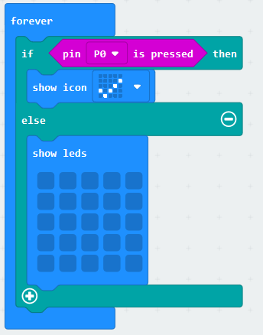
  - Provide each pair with the completed fruit button code shown here- https://makecode.microbit.org/63560-42549-83580-58574
- Explain that in our fruit button example, we used a piece of fruit as a button, but that they can simply program the A or B buttons in the same way.
  - Substitute the pin P0 is pressed code block with the button A is pressed code block
  - Test out this new program on the simulator by clicking on the A button to light up an icon on the LED grid.
- Have students use what they learned to design and create a new or interesting musical addition to the garden.
  - Can you apply what you learned to design and test a new setup that moves electricity through the microbit and produces a sound? Hint: you may want to look for code blocks that have to do with music.
- If students require guidance:
  - Explain that this time, we don’t want a light to turn on and show an icon on the LED grid. Instead, we want some sort of music to play.
    - Remove the show icon code block and blank show LED code block and throw them in the trash.
    - Does anyone see a menu that might help us create sounds?
  - Introduce students to the music menu.
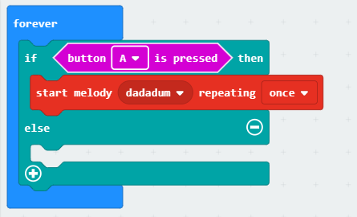
    - Select the start melody dadadum repeating once code block and place it within the “if button A is pressed then” code block.
  - Test out the new code to see if the program will play a musical tune!
    - Show students how to select different songs from the drop-down menu.
  - Give students time to play with the different music code blocks to make their own sounds or songs.
- Once students have modified the program from showing an icon to playing music, provide instructions to students to hook up their microbit to their headphones or a mini speaker.
  - Hack Your Headphones: https://makecode.microbit.org/projects/hack-your-headphones/make
    - **NOTE: We would NOT recommend inserting earbuds in the ears as the volume is very loud and will not be comfortable for students. The music can be heard without inserting the earbuds.
  - Using a Buzzer: https://learn.sparkfun.com/tutorials/microbit-educator-lab-pack-experiment-guide/experiment-3-using-a-buzzer
    - **NOTE: If you flip the buzzer over and look at the bottom, you will see that one pin has a (+) next to it. That pin gets connected to a signal from the P0 pin. The other pin should be connected to ground.
Wrap-up
- Reflect and discuss with a partner:
  - How is the fruit button that lights up the microbit similar to your new program that makes a sound?
  - Look at the two programs. What similarities and differences do you notice?
- Discuss how this activity required students to practice their computational thinking skills.
  - Does anyone remember what we called it when we remove details to make a solution work for different problems? (Abstraction)
  - How did you use abstraction when you modified the code?
  - Some of the code blocks are still there and function the same way. But you were able to take out the details that you didn’t need anymore (show LED) and replace it with a new set of code blocks. This created a new device that functions in a different way and solves a different garden design challenge!
Extension Activities
- For students who finish early or are looking for an additional challenge:
  - How might you use what you learned about circuits to create a device to count garden visitors?

How can technology help us to manage our garden better?

Lesson 7: Exploring weather and other environmental conditions in the garden
Big Ideas
- Technology tools (including sensors) can be used to measure the environmental conditions of the garden.
- Math is involved when using sensors because we are measuring things with numbers.
- Math and measurement is important to science and engineering because it allows us to make more exact observations which helps us to recognize differences and make comparisons.
- Tracking measurements or counts over time helps us to see patterns and variation allowing us to make better predictions.
Time and Location
20 minutes to code the microbits before the lesson
1 hour; indoors and outdoors
Guiding Questions
- Why might it be important to measure things when we explore?
- How might we use coded sensors to make better decisions in our garden?
Materials
To code the microbits:
- Coding instructions for temperature sensing
- Coding instructions for light sensing
- Coding instructions for soil moisture sensing
- BBC Micro:bits (1 per 2-3 students)
- Connection between microbits and device (either via USB connector cable OR Bluetooth connection)
- Laptop, tablet, or phone with microbit app or internet access
- 2 alligator clips (per soil moisture sensing microbit)
- 2 long nails (per soil moisture sensing microbit)

During the lesson:
- Chart paper
- Markers
- Supplies for recording data
  - Garden journals
  - Loose-leaf paper and clipboards
  - Writing utensils
- Supplies for reporting data
  - Sticky notes on white board
  - Google Jamboard or other digital whiteboard
- BBC Micro:bits (1 per 2-3 students)
- Battery packs (1 per 2-3 students)
Lesson Objectives
Students will be able to…
- Measure light, temperature, or soil moisture in the garden using a pre-coded micro:bit
- Investigate features of the garden space (shade provided by trees or buildings, hot concrete, etc.) that impact light level, temperature, or soil moisture
Before you get started…
- Microbits will need to be coded prior to teaching this lesson. For instructions on coding and uploading files, see the Garden TOOLS website.
Warm-up
Engage

- Ask students to describe the environmental conditions (weather) in the garden to a partner without using any tools.
  - Take students outside. Ask students to work with a partner to write down . Have several partners share out what they described. Record answers on chart paper.
  - Discuss:
    - How did you describe the weather?
    - What conditions were described (temperature, light level/cloud cover, wind, etc.)?
    - Did you use words (hot, warm, cool, cold, sunny, cloudy, windy, breezy, etc.)?
    - Did anyone use numbers to describe the weather?
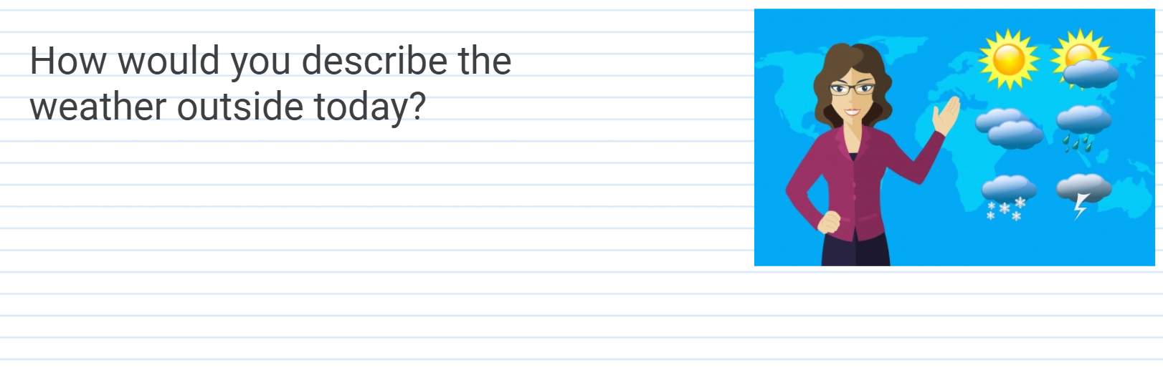
Hot
Sunny
Nice
Breezy
- Review previously discussed garden technologies as a whole group:
  - Previously, we talked about garden technologies. Some garden technologies help us to detect or measure something.
- Introduce sensors as an electronic technology that measures or detects something.
  - Post the word “sensor” and its definition on the board: A sensor is a kind of technology that detects or measures something and records, indicates, or responds to this measurement.
  - Explain: Sensors are all around us! Give some examples of sensors: fingerprint sensor on cell phone, thermometer (temperature sensor) for taking your body temperature, motion sensors on paper towel or soap dispensers, etc.
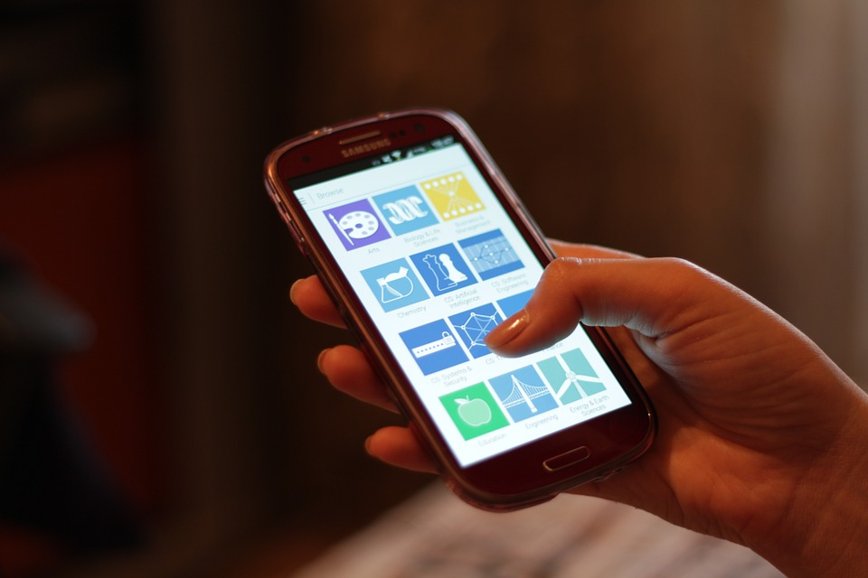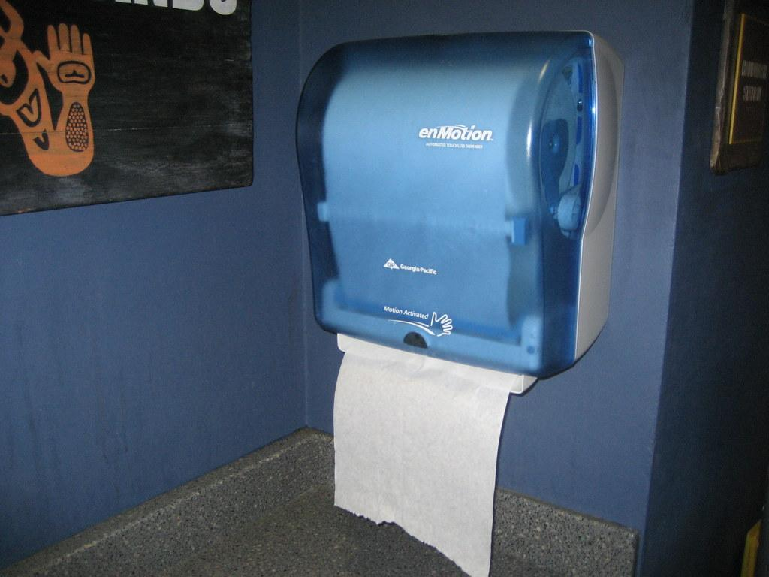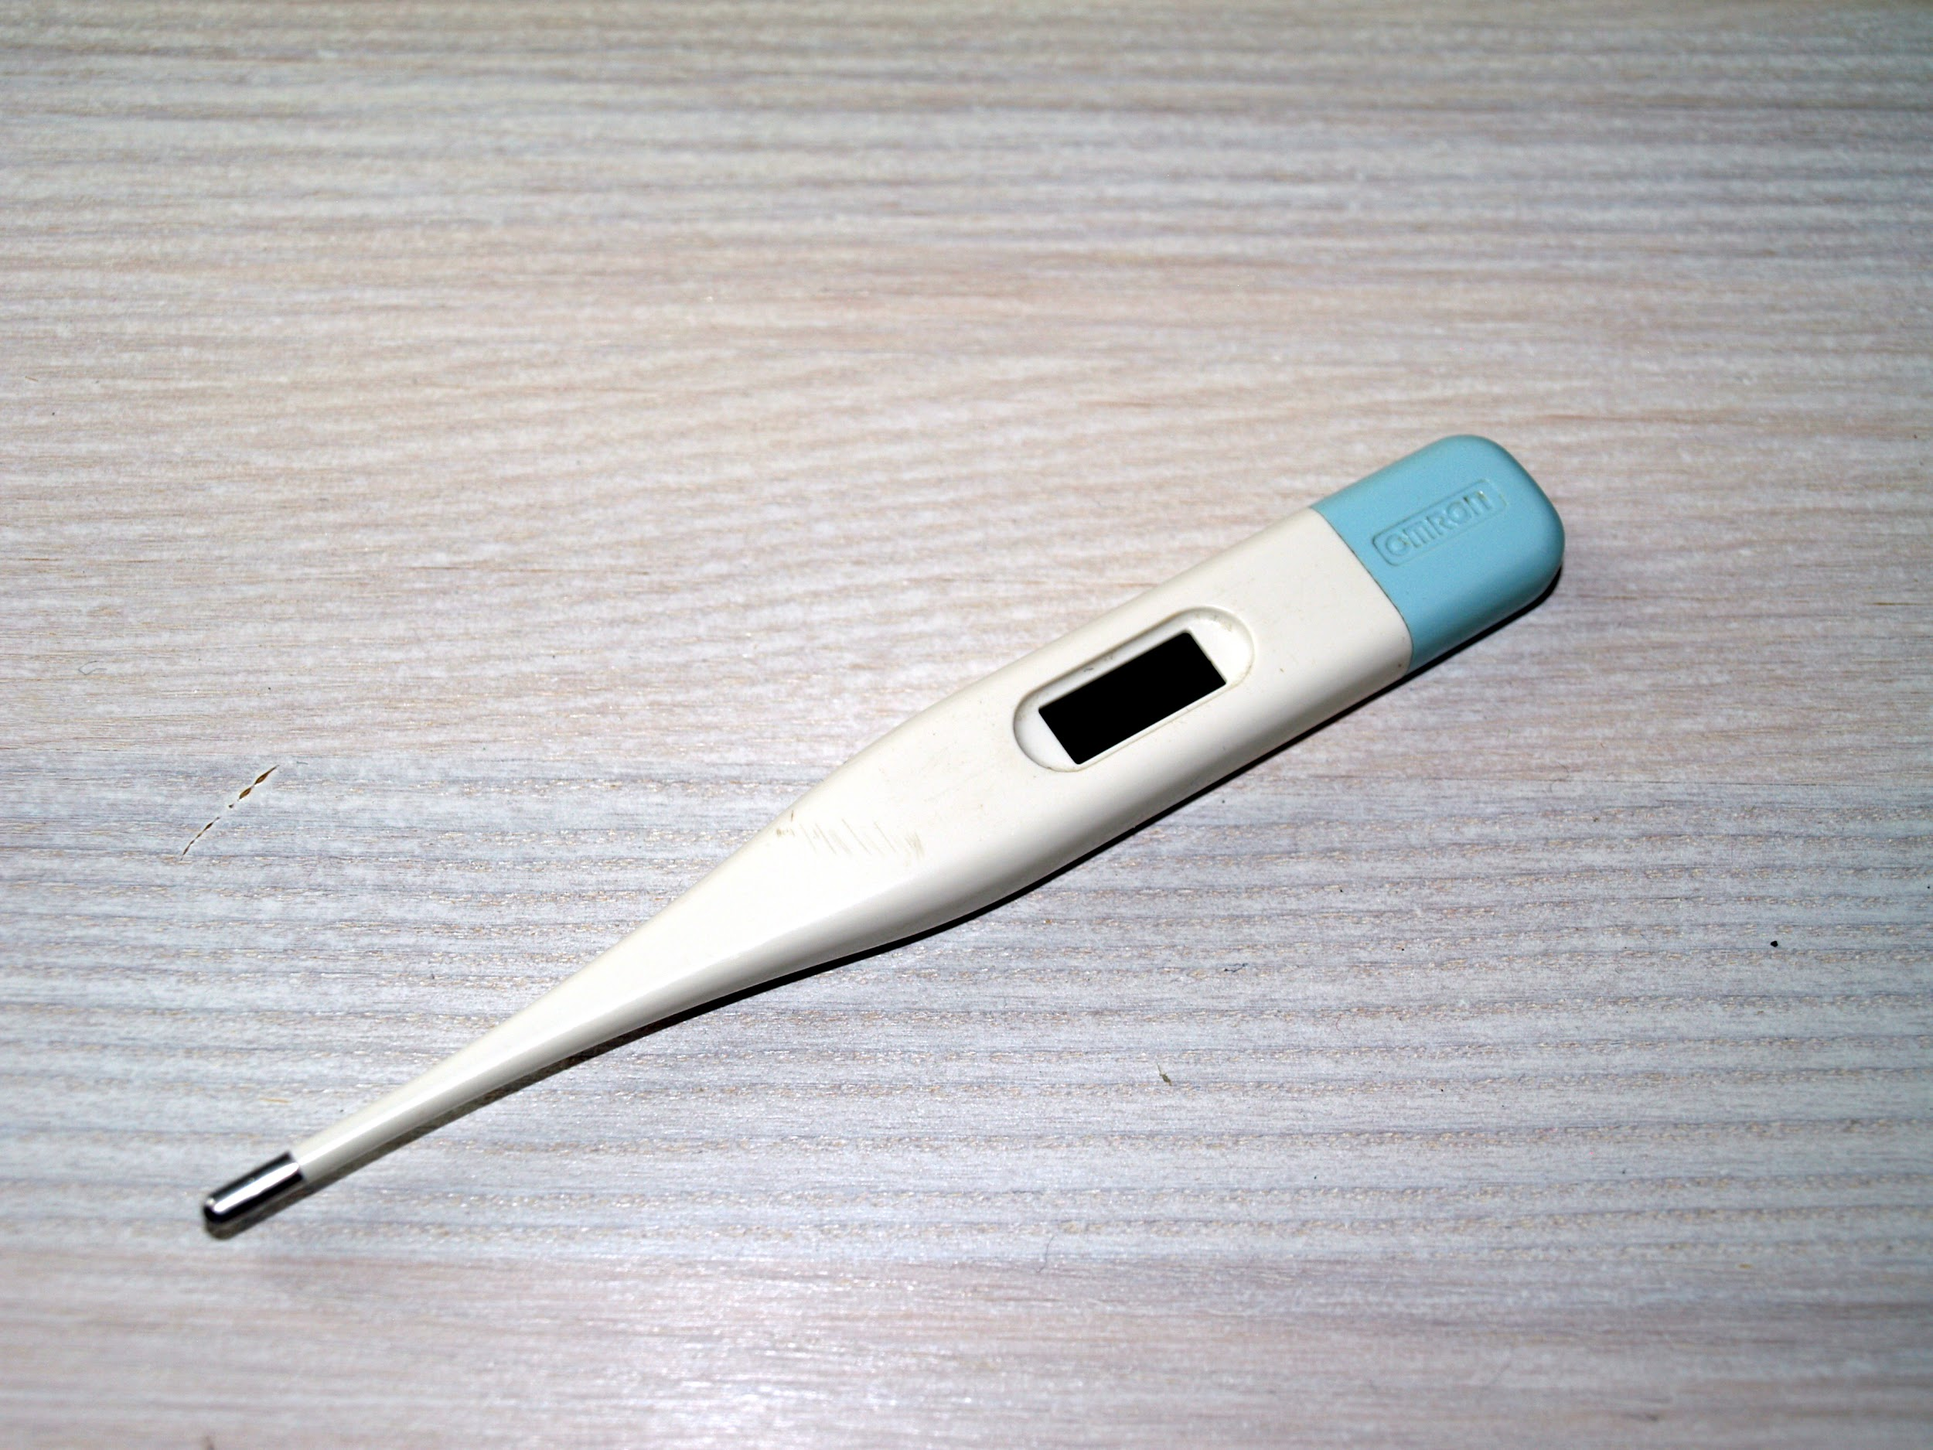
Senses touch
Senses temperature
Senses motion
  - Explain: The BBC micro:bit has several sensors to measure things like light, temperature, motion, and moisture (via soil resistivity, or how much soil resists or conducts electricity).
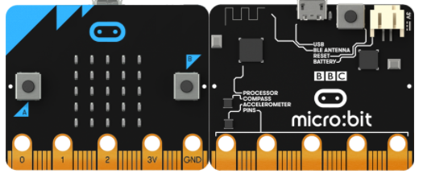
Front
Back
BBC Micro:bit Sensors
Compass: measures magnetic fields
Accelerometer: measures movement
Light sensors: measures light
Temperature sensor: measures temp
Pins: can be coded to measure soil moisture via soil resistivity
- Introduce the lesson objective:
  - With your partner, you described the environmental conditions of the garden without using any technology tools. Today we are going to be using the microbit and its on-board sensors coded a few different ways to explore the garden and measure some environmental conditions.
Activity
Explore
- Review safe, responsible, and respectful use of the microbits if necessary.
- Challenge students to explore conditions in the garden in pairs or small groups using a microbit programmed to measure light, temperature or soil moisture.
  - Ask students to work individually, in partners, or in small groups depending on preference.
  - Provide each individual or group with one pre-coded microbit (sensing light level, temperature, or soil moisture) and a battery pack.
  - Give students access to a means of recording their observations (keeping notes in a garden journal or on loose-leaf paper with a clipboard).
- Encourage students to spend a few minutes exploring freely to get a sense of how the microbit shows measurements.
  - Can you find two ways that your BBC micro:bit shows measurements?
    - A plot or graph is shown using the 5 x 5 LED grid.
      - This visual is especially good at showing rapid changes as the graph continually updates as you explore.
    - If you press the A button, a number scrolls across the LED grid.
      - This is a numeric measurement of either light or temperature. For light, the number will be between 0 (dark) and 255 (bright). For temperature, the number is given in degrees Celsius (unless coded otherwise) between -25º and 75ºC.
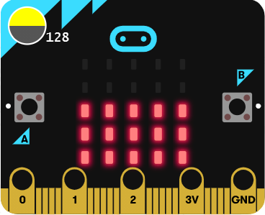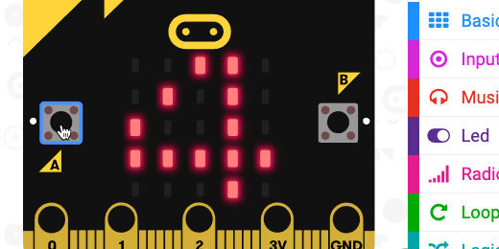
Can you find two ways that your BBC micro:bit shows measurements?
A plot or graph of the measurement using the 5x5 LED grid.
If you press the A button, a number scrolls across the LED grid.
- Once students understand how the microbit can be used to gather measurements/data, ask students to focus on finding differences or variability in their environment. Record observations when possible.
  - Where are the darkest and brightest areas in the garden?
  - Where are the warmest and coolest areas?
  - Where are the wettest and driest soil areas?
- Provide a way for students to share their observations and data.
  - Write data on sticky notes and collect on white board or poster
  - Add sticky notes to Google Jamboard or other digital whiteboard.
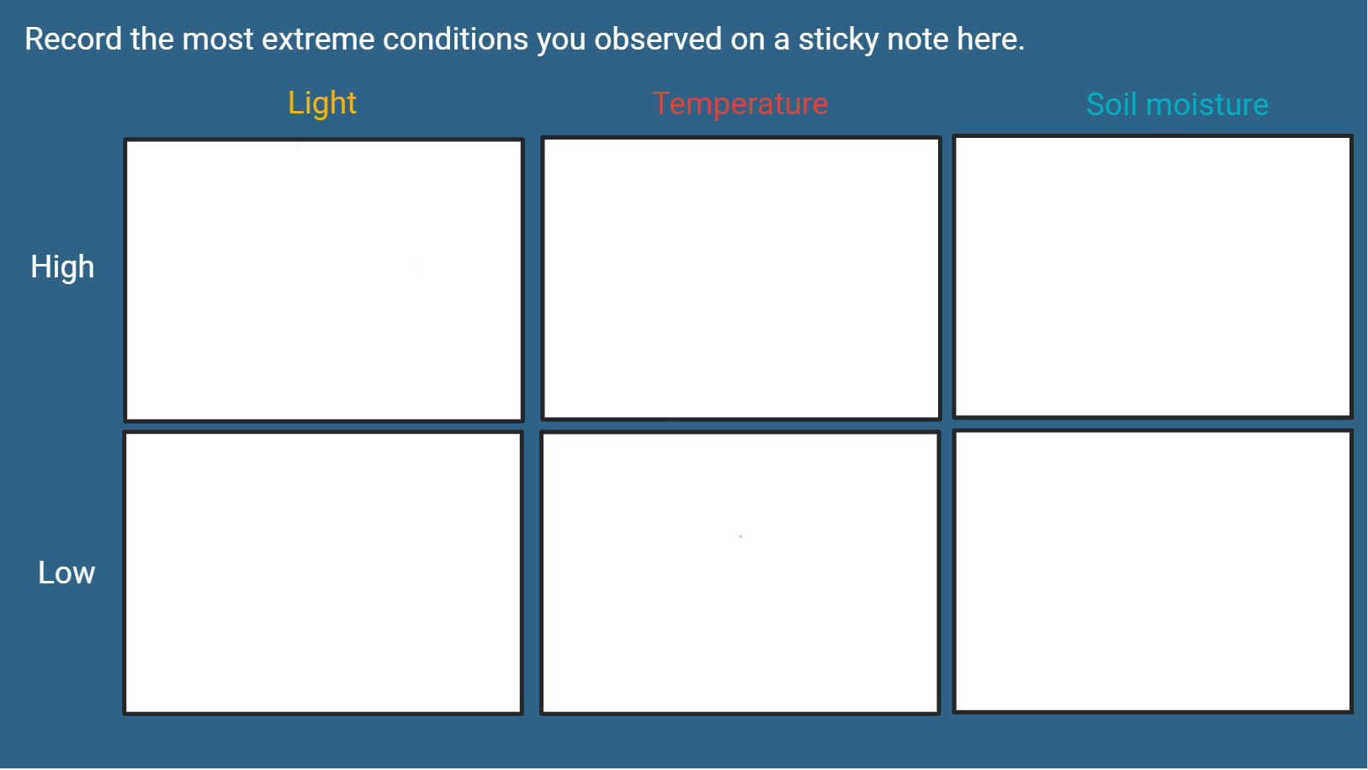

Wrap Up
- Discuss as a whole group:
  - At the beginning of the lesson, you described the weather (environmental conditions) in the garden without any tools. Now that you have had a chance to use the different sensors to measure conditions in the garden. I want you to think about how using technology might change the way you describe the garden conditions.
  - Look back at the original descriptions. Is there anything you can add now to make your description of garden conditions better?
    - For example, instead of just saying the temperature is “hot” or “warm”, how might you describe the temperature?
  - How can using math (measurement) help us to improve our descriptions in the garden?
    - Measuring tools help us to make more precise or exact observations. If we say it is “hot” outside that can mean something different to you and to me.
    - Measuring tools help us to more easily recognize differences and make comparisons. We can even make comparisons with measurements from a long time ago- an inch of rain 100 years ago is still an inch of rain today.
    - Keeping track of measurements over time helps us to make predictions. For example, we can look at measurements of rain in our area over time and predict when we will need to water our plants, and when watering is not as necessary due to natural rainfall.
- Ask students to reflect on the following question and write down their ideas.
  - How might taking measurements of the weather help to make better decisions about planting or watering in the garden?

Lesson 8: Using data to make better decisions
Big Ideas
- Technology can be used to gather data in gardening or agriculture.
- We can make better garden management decisions if we use data to guide our choices.
Time and Location
45 minutes, outside
Guiding Questions
- Why might it be important to use data as we make decisions in our garden?
Materials
- BBC micro:bits (coded as soil moisture sensors)
- Supplies for recording data
  - Garden journals
  - Loose-leaf paper and clipboards
  - Writing utensils
- Supplies for reporting data
  - Sticky notes on white board
  - Google Jamboard or other digital whiteboard
Lesson Objectives
Students will be able to…
- Gather soil moisture data on different areas of the garden
- Analyze collected data to make a decision about garden irrigation
Before you get started...
- Micro:bits will need to be coded as soil moisture sensors prior to teaching this lesson. For instructions on coding and uploading files, see the Garden TOOLS website.
Warm-up
- Discuss: Gardening means making lots of decisions.
- What decisions do we make in our garden?
  - Possible answers: When to plant, water, harvest; where and what to plant; what to remove (is this a weed or a plant?)
- Introduce today’s lesson objective and pose a challenge to the whole class:
  - We want to make a responsible decision about when to water our garden (irrigate) and I want your help. Can you help me to take measurements of soil moisture in different areas of the garden and analyze the data to help us decide if we should irrigate (water our plants) or not?
Activity
Explore
- Review safe, responsible, and respectful use of the microbits if necessary.
- Challenge students to gather data on soil moisture in the garden using a micro:bit pre-programmed as a soil moisture sensor.
  - Ask students to work individually, in partners, or in small groups depending on preference.
  - Provide each individual or group with one pre-coded microbit (sensing soil moisture) and a battery pack.
  - Give students access to a means of recording their observations (keeping notes in a garden journal or on loose-leaf paper with a clipboard).
- Make a quick sketch of the garden layout and have students add their data to the map.

Our school garden
355
301
225
316
215
202
380
220
287
- Remind students that the soil moisture sensor measures from 0-1023. Dry soil measures around 200. Wet soil measures around 900 or more.
- In partners or small groups, ask students
  - What do they notice?
  - Is the soil moisture the same across the entire garden?
  - Are some areas drier or wetter than others?
- Discuss their noticings and wondering as a whole class.
Explain
- It’s time to make a data-informed decision! Post an agree/disagree t-chart with the question: Should we water our garden today?
Yes, I agree
No, I do not agree
Should we water our garden today?
  - Ask students to add a sticky note to the side of the chart that matches their answer.
  - Ask students to point to the data on the garden map that helped them make their decision.
Wrap up
- Discuss as a whole group:
  - Today we analyzed soil moisture data from our garden to decide if we should irrigate or not. Why might our process using data to guide our decision making be better than just going outside and turning on the garden hose?
  - Possible answers: It could save us time, water, energy. It could be better for our plants to only give them water when they need it (not over or underwater them).

Lesson 9: Precision agriculture technologies
Big Ideas
- Sensors can be partnered with other technologies to make management decisions when conditions are variable or changing.
- Soil moisture is not the same throughout the garden. One of the ways conditions are different is how much soil moisture is in the garden at different depths.
- Plants need access to water where their roots are.
- soil moisture, it is important to measure where the root tips are.
Time and Location
1 hour; indoors
Guiding Questions
- How can technology be used to reduce the amount of resources (like water or fertilizer) we use in our garden?
Materials
This lesson is based on the Microbit project cards for Soil Moisture Sensor Design found on the Garden TOOLS for Corn website.
- Precision Agriculture Jamboard presentation
- Root depth models
  - Nebraska Extension publication G2189: Water Wise Vegetable and Fruit Production
  - Ruler
  - Paper or notecards
  - Markers
  - Yarn or string
  - Hole punch
- Improved soil moisture sensor probes
  - Microbit project cards for Soil Moisture Sensor Design
  - Garden flags
  - Duct tape, if making probes longer than ~20”
- (Optional) Soil moisture probe casings (for installing probes long-term in the garden)
  - (Optional) Soil sampler probe (if soil is too hard or compact)
  - (Optional) ½” PVC pipe, 2 pipes per soil moisture sensor
  - (Optional) PVC pipe cutter
  - (Optional) Hammer or mallet
  - (Optional) ½” PVC pipe end caps, 2 caps per soil moisture sensor
Lesson Objectives
Students will be able to…
- explain how plants use their roots to take up moisture from different depths in the soil
- measure soil moisture at several different soil depths
- compare soil moisture level to root depth to determine if plants can access water
Warm-up
- Conduct a student poll to gauge students’ thirst.
  - Raise your hand if you are…
    - Extremely thirsty
    - Somewhat thirsty
    - Not thirsty at all
  - What would happen if everyone was given water to drink, even those who are not thirsty?
    - Likely water would be wasted.
  - What might be a better way to deliver water to thirsty students?
    - Have students share their ideas. Highlight minimizing water use by being more efficient.
- Relate variation in student thirst to variation in plants’ need for water
  - How can we tell if a plant is thirsty? Can we go around and ask each plant?
  - How about when we water our plants? How can we give only plants who are thirsty the water that they need?
- Introduce the lesson objective.
  - In this lesson, we are going to explore a technology that can help us not to waste resources in our garden, by applying water (or other inputs) ONLY where and when they are needed.

Activity
- Review the role of plant roots in taking up water and diversity in root depth.
  - If helpful, display the provided Jamboard.
  - Explain that plants use their roots to take up water much like drinking from a straw.
  - Explain that different plants have different root depths. Some are shallow, some are deep.
  - (Optional) Show students real plant roots in the garden. If possible, pull up at least two different plants and compare their root systems.
- Challenge students to research root depths of various garden plants and create a root depth model (as shown here) for one garden plant.
  - Research root depth of different garden plants using the table provided in the Nebraska Extension publication G2189 (see link above).
  - Create a root depth model of a garden plant of choice.
    - Label paper or notecard with plant name and root depth.
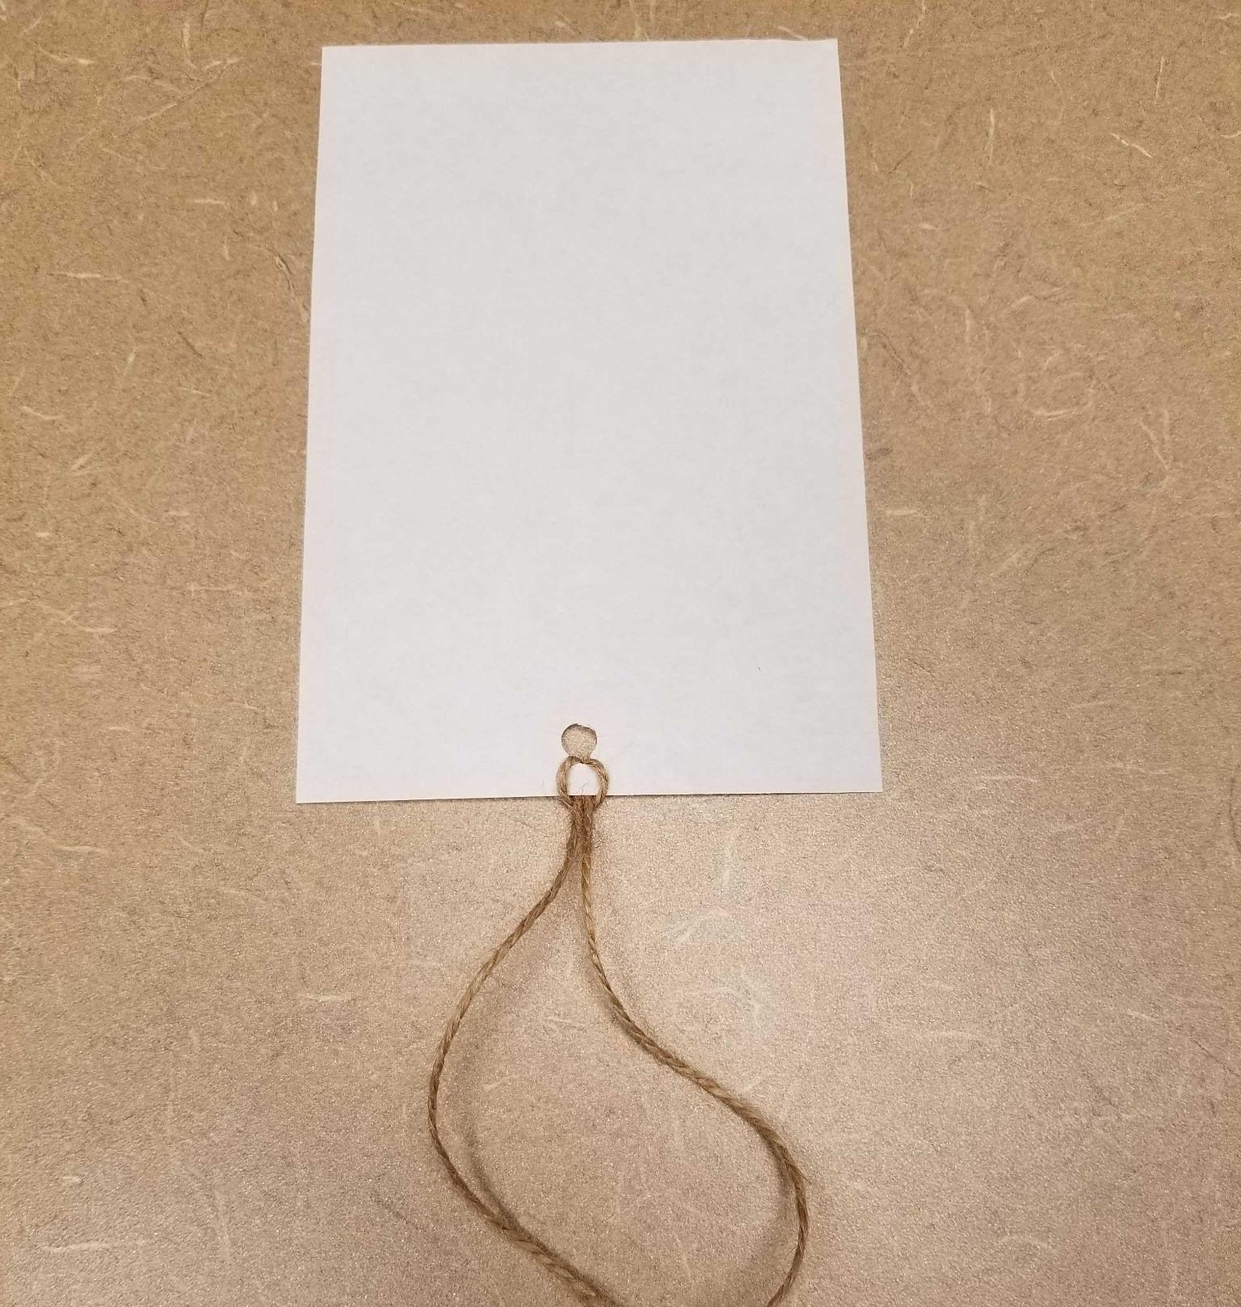
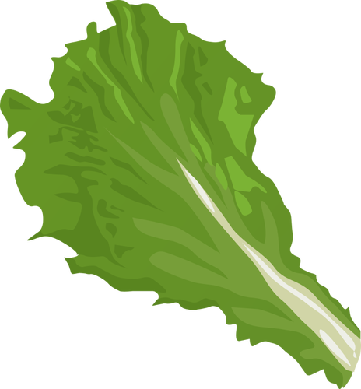
    - Punch a hole at the bottom of the paper or notecard.
Lettuce
6”
    - Measure and cut yarn or string to match DOUBLE the plant root depth.
    - Make a loop in the middle of your string
    - Thread the length of yarn or string through the hole.

- Guide a student discussion on the need for longer soil moisture probes that match different plant root depths.
  - We have measured soil moisture with a BBC micro:bit, but the probes (nails) are only a few inches long. This isn’t where the plant roots are drawing up water. What could we change about our design to measure soil moisture deeper in the soil where the roots of our plants take up water?

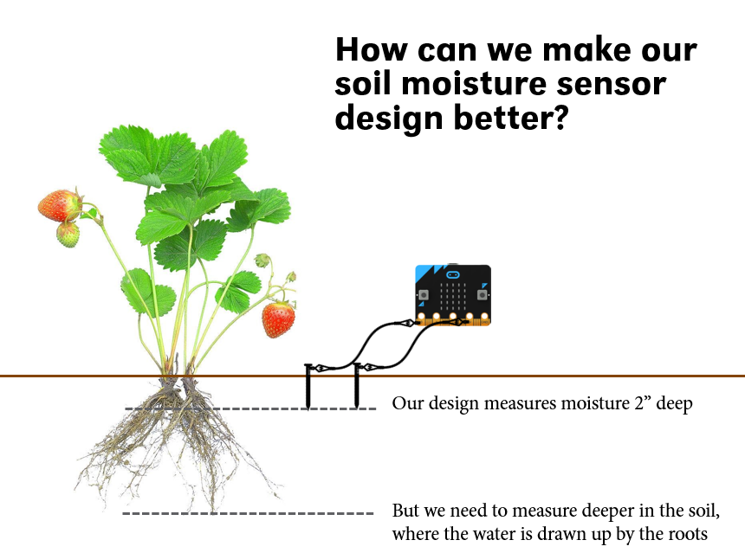

- Introduce the concept of precision.
  - Discuss “precise” or “precision”. Being precise means being more exact. For example, rather than just saying it is “hot” outside, we might provide the temperature.
  - Discuss student ideas of precision: Can you think of an example of being precise?
    - Examples might include:
      - Meet me outside vs. meet me at the front doors of the school
      - I like Italian food vs. I like pepperoni pizza
- Introduce precision agriculture technology.
  - Explain that by taking soil moisture readings at different depths we can be more exact about how much moisture is at different soil depths.
  - Rather than just saying the soil is wet, we can give a measurement at a more exact depth (for example, at 6” deep where our plant roots need the water)
  - Explain that with more precise information, we can make better decisions about whether our plants need to be watered or not.
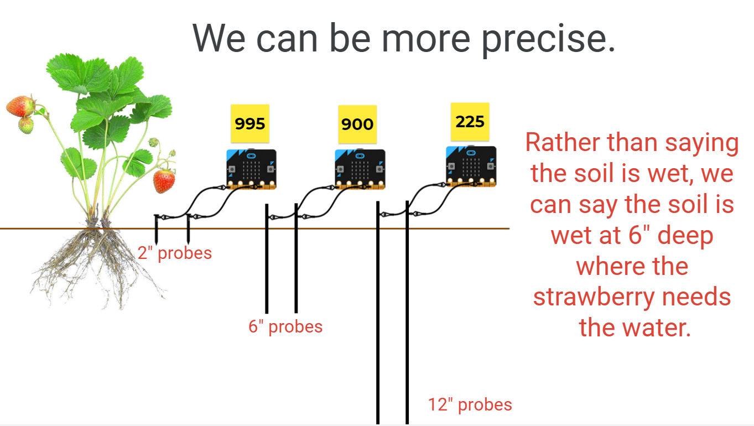

- Use microbit project cards provided to make soil moisture probes of different lengths.
  - Steps 3-5: Code the soil moisture sensor
  - Step 6: Create different length soil probes to match desired root depths
  - (Optional) Steps 7-8: Install soil probes long-term in the garden by making PVC pipe casings

Wrap up
- Review precision ag technologies and their benefits as a whole group:
  - In this lesson, we researched root depths of different garden plants and created soil probes to match. This is an example of a precision ag technology because it helps us to gather more precise soil moisture data from our garden to make better watering or irrigation decisions. This helps us save money and water.
- (Optional) Introduce students to other real-world precision agriculture technologies that farmers use.
  - Examples you might present:
    - Variable rate irrigation to apply water only to plants that need it
    - Precision fertilizer application to apply fertilizer only to plants that need it
    - Drones to minimize fuel use when applying fertilizer or herbicide
    - GPS-guided tractors to minimize fuel use and reduce unnecessary driving on fields

Lesson 10: Agricultural automation and robotics technologies
Big Ideas
- Technology tools (including sensors) can be used to measure the environmental conditions of the garden.
- When partnered with other technologies, sensors can be used to trigger other behaviors automatically like turning on a light, making a motor move something, or a speaker to play a sound. This is automation.
- Automated agricultural technologies can save time by triggering an event automatically. Automation and robotics can also be used to take over tasks that are repetitive, strenuous, or possibly harmful to humans.
Time and Location
1 hour; indoors
Guiding Questions
- Why might it be useful to have sensors trigger an event or behavior?
Materials
This lesson is based on the Microbit project cards for Pest-B-Gone, a light-triggered scarecrow, found on the Garden TOOLS for Corn website.
- Crafting materials to make a scarecrow
  - Popsicle sticks or plastic spoons (1 per student)
  - Hot glue gun, glue sticks, or white glue
  - Assorted craft materials
- Materials to make scarecrow move
  - Rubber bands
  - Zip ties
  - Servo motor (1 per student)
  - Alligator clips with pigtail end
Lesson Objectives
Students will be able to…
- Modify existing code that uses sensors to measuring light to additionally trigger an event (in this case, making a servo motor move)
Warm-up
- Introduce automated technologies and robotics by having students draw an imagined robot doing their least favorite task.
  - Discuss with an elbow partner: What is your least favorite chore to do?
  - Provide students with drawing paper and art utensils (crayons, markers, colored pencils, etc.) and ask students to draw a picture of a robot doing their least favorite chore or job or task.
    - I want you to imagine a robot could do your least favorite chore or task for you. What would it look like? How would it function?
  - Ask students to share their picture with an elbow partner.
- Introduce the lesson objective:
  - In today’s lesson, we are going to learn more about robotics and automation in the garden and use what we learn to create a scarecrow that will move when it is triggered by a sensor.
Activity
- Introduce similarities between automation and robotics
  - Write the word and definition of each on the whiteboard or chart paper
    - Robotics is the process of designing, creating and using robots to perform a certain task.
    - Automation is the process of using physical machines, computer software and other technologies to perform tasks that are usually done by humans.
    - The two areas overlap but they are not the same. Physical robots may be used in automation, but many robots are not created for automation.
    - For example: Robots can be used in factories to assemble cars. This is automation because this is usually a job done by humans. However, robot pets have been created to provide humans with pet-like companionship. This is robotics but not automation because they are not performing a human task.
- Introduce an automated robot called Farmbot as an example of automation and robotics used in a garden setting.
  - Play the video of the Farmbot: https://youtu.be/uNkADHZStDE
  - Discuss:
    - What tasks did you see the Farmbot accomplish?
    - What benefits does an automated robot like the Farmbot provide? Do you see any disadvantages?
- Discuss how students have used sensors in the garden previously to measure light, temperature, and soil moisture.
- Discuss how sensors can be used in a new way-- to trigger an event.
  - What if we could use the microbit to measure something like light in the garden (using sensors) and THEN use the information gathered by the sensor to trigger something else to happen. For example, when the microbit measures light level below a certain amount, maybe all the lights on the LED panel turn on to make a nightlight?
- Explain how the microbit can be programmed to sense light level and then trigger movement and this can be used to program an automated light-triggered scarecrow:
  - Use the provided microbit project cards for the Pest-B-Gone for this activity.
  - Step 1: Craft a scarecrow
  - Steps 2-6: Create the code for a light-level triggered scarecrow that moves
  - Steps 7-8: Attach the scarecrow to the servo motor and test it out
Wrap up
- Review automation and robotics and their scarecrow creation.
  - What task in the garden does the scarecrow help to automate? (Pest control)
  - Why might an automated scarecrow be a good option for a garden? (Many pests might be afraid of humans, but a robot could scare away pests when humans are not in the garden.)
  - What are some limitations of the scarecrow as it is designed? (It won’t work when it is very bright outside. It might not work unless a pest gets very close the microbit (close enough to cast a shadow on the microbit)
  - If you were to redesign your robot, what would you change?

Lesson 11: Agricultural biotechnology
Big Ideas
- Technology is more than just computers. Technologies are tools built on our understanding of science and engineering.
- Biotechnology is using living organisms and their biological processes (like reproduction) to make a new product.
- Gardeners or farmers use biotechnology when they plant different crop varieties or or genetically modified organisms (also called transgenics).
Time and Location
30-45 minutes; indoors
Guiding Questions
- How do we create new crops that meet our changing needs and wants?
Materials
- (Optional) Apple variety taste test
  - Several varieties of apples
  - Sharp knife or apple divider
- Biotechnology Jamboard presentation
- Coding worksheet and My Corn Plant worksheet (1 per student)
- Writing utensils
- Coloring utensils (crayons, markers, colored pencils, etc.)
Lesson Objectives
Students will be able to…
- compare and contrast crop varieties to point out similarities and differences
- use a set of codes to select traits for a new crop variety
- draw a picture of the new crop variety that matches the selected codes
Background
Want to learn a bit more specifically about genetically modified organisms (GMOs, also called transgenics), check out information and videos from the FDA: https://www.fda.gov/food/consumers/agricultural-biotechnology
Before you get started…
- If you plan to conduct a taste test of different varieties, you should gather several different varieties of produce. Cut or divide up produce so that every student can taste test every variety.
Warm-up

- Have students experience and discuss variation in the same kind of produce. You can approach this in a few different ways.
- Option 1: Conduct a taste test of apple varieties or other produce from the school garden.
  - Discuss: What similarities or differences do you notice? What do you wonder?
    - Note differences in color, shape, size, taste, etc.
  - Take a poll to compare students’ favorite varieties.
    - Discuss: Did everyone like the same variety?
- Option 2: Compare pictures of varieties using digital Jamboard.
  - Use the provided Jamboard to have a discussion about variation in color, size, shape, and taste in a garden crop like corn, tomatoes, apples, or pumpkins.
    - Show a picture of crop varieties.
    - Discuss: What similarities or differences do you notice? What do you wonder?
      - Note differences and/or similarities in color, shape, size, etc.
- Introduce the term “variety”
  - Have you seen different types of tomatoes in your garden or the grocery store? Some are big. Some are small. Some are even different colors. These are different varieties.
- Discuss: Why might we want different varieties? Why might we WANT crops that look, taste, or grow in different ways?
  - Note that different people have different preferences. For example, some people might like a sweeter apple (Braeburn) while other may like one that is more tart or sour (Granny Smith)
  - We use different varieties for different purposes in our meals. For example, we might want a cherry tomato to put on our salad and a Roma tomato to make spaghetti sauce.
- Introduce the lesson objective:
  - Explain that in this lesson we won’t go into detail about HOW new varieties are created. This process is pretty complicated. However, we will be acting like plant breeders and creating a code and drawing a picture of a new variety.
Activity
- Use the Jamboard presentation or show students a seed and explain how coded instructions in the seed determine the plant’s traits (the way the plant looks and functions)
  - Explain that even though we can’t see it, there are special coded instructions inside the seed that decide how the plant that grows from this seed will look, taste, and grow.
  - Some codes are almost like super powers! They help the plant survive in tough conditions like when it is hot and dry (a drought) or when pests might attack the plant.
  - Explain that this is agricultural biotechnology.
- Introduce a plant breeder and what they do.
  - Explain that a plant breeder is a scientist that can create or invent new varieties using what they know about these special coded instructions and what they know farmers or gardeners need or want.
  - Give a real world example:
    - These student researchers are using plant breeding to create a new type of jalapeno popper: https://youtu.be/X1nrMEGPmWU?t=71
    - This UNL research team created a new variety of popcorn that is more nutritious: https://news.unl.edu/newsrooms/today/article/genes-to-proteins-efforts-enriching-nutrition-of-popcorn-sorghum/
- Encourage students to imagine that they are a plant breeder creating a new variety of corn.
  - Provide students with a copy of the coding worksheet
  - Read over directions together with students
    - Think about what they want their plant to look like: What color? How tall? What superpower?
    - Select one code from each of the sections (kernel color, plant height, and special function) and write the codes in the boxes.
    - Imagine your seed grows up into a plant-- how will it look and function? Draw a picture to match your coded instructions!
Wrap up
- Review that technology means more than just computers or smartphones. Plants can be technology too!
  - Review that agricultural biotechnology is using what we know about the science of plants work to create new crop varieties that have special functions (sort of like superpowers!).
- Reflect and discuss:
  - What traits (how the plant looks, tastes, and functions) might farmers or growers want in a new crop variety? What traits might consumers want in a new crop variety?

Coding Worksheet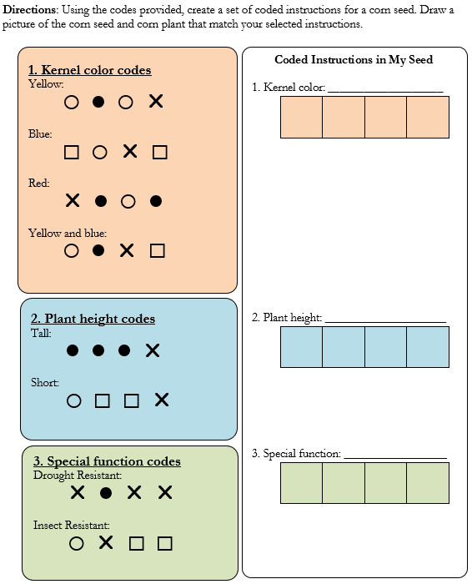

Can we create our own technology solutions to a real garden challenge?

Lesson 12: Using the engineering design process to solve a problem
Big Idea
Engineers are problem solvers who use a systematic process, called the engineering design process, to design, create, test, and improve solutions (such as creating a new technology or applying an existing technology to a new problem). The process is flexible and repeats as engineers test and improve their designs.
Time and Location
1 hour; indoors or outdoors
Guiding Questions
- What is the engineering design process (EDP)?
- How can we use the EDP to design a solution to solve an irrigation problem?
Materials
Each group of 3 students will need:
- 16 oz bottle of water
- 3 plastic cups
- Permanent marker
- Scissors
- Straws of assorted sizes (coffee, regular, jumbo)
- (Optional) Other construction materials such as cotton balls, spoons, etc. for variety
- Paper towels for cleaning up spills
- Engineering design process diagram
- Student worksheet or notebook
- Pencils or pens
Lesson objectives
Students will be able to…
- Identify the steps of the engineering design process by watching it in action
- Apply the steps of the engineering design process to a design challenge
- Design, create, and test a watering can design
Before you get started…
- Gather materials for the design challenge.
- Mark 3 plastic cups for each group with lines at 2oz, 6oz, and 8oz.
Warm-up
Engage
- Review students’ prior ideas and experiences with technologies.
  - Previously, we talked about garden technologies. Who can remember what a technology is?
  - Review the definition of technologies: Tools created by applying what we know about the natural world and human behavior to design solutions to meet our needs or wants.
- Discuss: What is engineering? What do engineers do?
  - Have students share with a partner and then share out several ideas with the whole group.
  - Engineers are problem solvers. They use a special problem solving method called the engineering design process to identify problems and create, test, and improve solutions. Their solution might be a new way of doing something (a process), a new system, or a new technology (like the ones we found in the garden).
- Introduce the lesson objective:
  - Today you will tackle an engineering challenge and solve a real problem in gardening and agriculture using the engineering design process.
Activity
Explore
- Divide students into engineering teams.
  - Form work groups of 3-4 students. Provide each group with a diagram of the engineering design process to use as a guide and a worksheet to track their progress in the process.
  - *Note: You may want to explain to students that while they will be going through each step in the EDP, often engineers may only work on one or two steps in the process before handing off the project to another team member.
- Introduce the engineering design process diagram.
  - Provide students with a student worksheet or a notebook to document their steps in the engineering design process.
  - Highlight that the EDP is…
    - Flexible: The steps might blur into one another sometimes. Engineers don’t always move through the steps one after another in sequence. Sometimes we need to move backward to a previous step to gain clarification or play with materials while we brainstorm.
    - Repeating: Engineers will repeat this process as they test and modify designs based on what they learn. This is called iteration and usually the end product turns out better the more times the design is adjusted and improved. This isn’t failure, it’s all part of the engineering design process!
- Introduce the overall design challenge.
  - Explain that this is a real problem being solved by agricultural engineers!
  - Challenge student groups to engineer a variable rate irrigation system (a way to provide different amounts of water to plants with different needs).
- Outline the problem and objective.
  - Your goal is to build a system to divide 16oz of water into three cups with 2 oz., 6 oz., and 8 oz. of water in each.
- Determine criteria and constraints.
  - Describe the materials available and the amount of time they will have to work.
  - Provide cups marked with lines to denote 2oz, 6oz, and 8oz.
  - Provide access to a 16 oz. water bottle, 3 cups, scissors, and a choice of straws and other construction materials to each group.
  - For an extra challenge, students can be given a fictional price list and challenged to create the least expensive system possible.
- Brainstorm solutions.
  - During this time, students should be able to sketch their ideas, explore potential materials, and discuss ideas with one another.
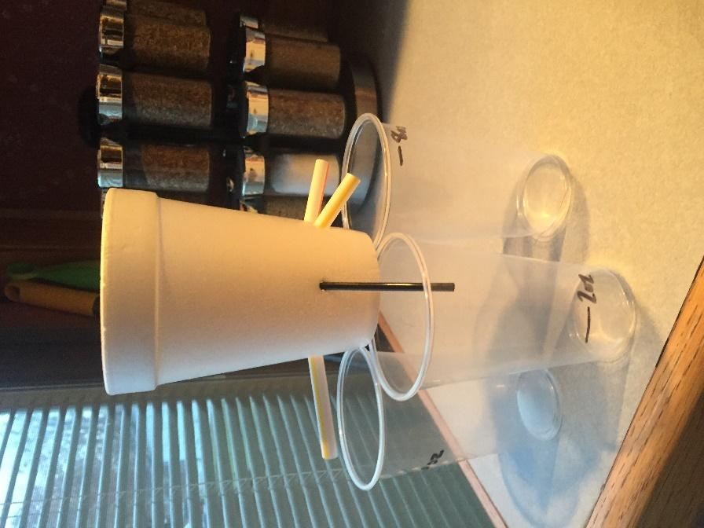
  - You may want to remind youth to accept all ideas enthusiastically at this stage! Don’t rule any idea out just yet. Practice being accepting of all ideas by saying “Yes, and…” instead of “Yes, but…” or outright saying “No”.
- Create a prototype and test the design at least once.

Explain
- Ask students to share their design progress with the larger group. Sharing can be done informally by filming a quick video or talking through the process between groups.
  - How was the problem identified? How would you know if you were successful (criteria)? What were limitations for this challenge?
  - What were some of the initial brainstormed ideas (especially ones that didn’t move on to be prototyped and why)?
  - How did you test your design?
  - How did your group use results from the design tests to modify the design? (this step may not be complete yet and that’s okay)
- When groups are not presenting, they should be providing meaningful feedback.
  - What is one thing about the design you noticed? What made you curious?
  - What is one thing about the design you want to understand better?
  - What is one thing that you really like about their design or their process/approach to working together?
- Refine designs based on test results and discussions within and outside the group.
Wrap-up
Elaborate
- Reflect and discuss in small groups:
  - Is the device you created considered “technology”? Why or why not?
- Discuss successes and struggles of the EDP in small groups:
  - What did you learn about the engineering design process through this activity?
  - What worked? What didn’t? What would you do differently next time?
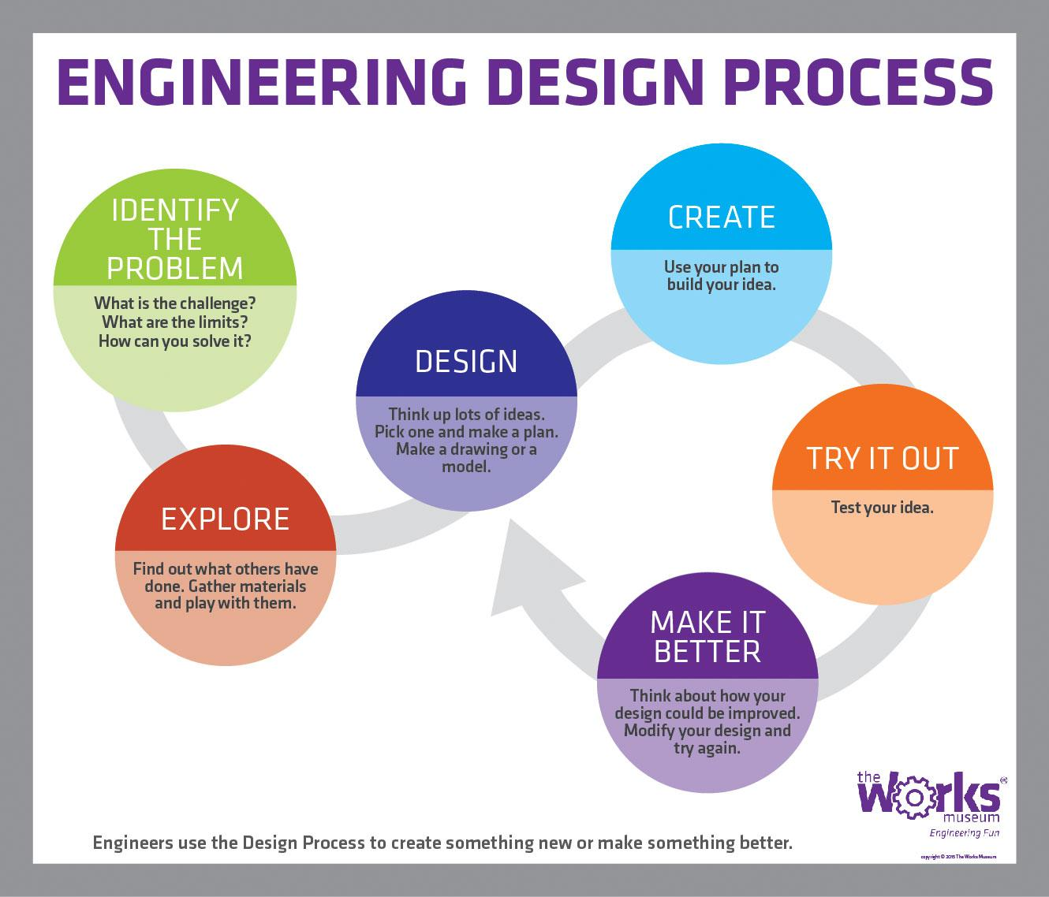

How can we construct a device to divide the water into three different amounts using the engineering design process?
Identify the problem | Create and Try it Out  Does your design divide the bottle of water into three different amounts?
What are your limitations and what would success look like?

Explore and Design

 | How do you want to change your design to make it better?

Lesson 13: Addressing real problems through a grand garden design challenge
Big Idea
We can apply the engineering design process (EDP) to design solutions to problems that are personally meaningful.
Time and Location
Variable (3-5 hours); indoors and outdoors based on need
Guiding Questions
- How can we use the EDP to address a real-world problem in our garden?
Nebraska Science Standards
Third grade
- SC.3.7.2.D Make a claim about the merit of a solution to a problem caused when the environment changes and the types of plants and animals that live there may change.
- SC.3.7.2.E Generate and compare multiple possible solutions to a problem based on how well each is likely to meet the criteria and constraints of the problem.
Fourth grade
- SC.4.13.4.D Generate and compare multiple solutions to reduce the impacts of natural Earth processes on humans.
Fifth grade
- SC.5.13.4.D Define a simple design problem that can be solved by applying scientific ideas about the conservation of fresh water on Earth.
- SC.5.13.4.E Define a simple design problem reflecting a need or a want that includes specified criteria for success and constraints on materials, time, or cost.
Materials
- Engineering design process diagram (1 per group of 3-4 students)
- Student notebook (1 per student)
- Writing utensils
- Assorted tools and materials (based on garden problem(s) selected and solution(s) proposed)
- BBC Microbits (1 or more per engineering team)
- Devices (laptop, desktop, tablet, or phone)
Lesson Objectives
Students will be able to…
- Identify a garden problem or challenge
- Apply the steps of the engineering design process to propose and test a solution to the problem
- Collaboratively present their design to a public audience
Before you get started…
- Decide on each of the following:
  - What time, tools, and materials will students have available to them? If students want to collect recyclables or other materials, you may want to coordinate this effort prior to or as the projects progress.
  - What public group could students share their designs with and what format presentation will take? You may consider hosting a family event at the garden to strengthen family and community connections with the garden.
  - Will the whole group design solutions to a single problem or will groups have the freedom to address a problem of their choosing? We encourage you to support student-driven decisions as much as is feasible, but understand that coordinating many different types of projects can be challenging.
Warm-up
- Ask students to think back on the Engineering Design Process (EDP) and relate their prior knowledge and experiences with the steps to a partner
  - Turn to your neighbor. In your own words, describe the engineering design process you used to design an irrigation device that delivers different amounts of water.
- Provide small groups of 3-4 students with the EDP diagram. Have several students share out their favorite experiences to illustrate the stages in the EDP.
  - What was your favorite part of the process? Why?
  - Did anyone enjoy a different part of the process? (Repeat until all steps are reviewed.)
- Introduce the lesson objective:
  - You’ve had some practice using the engineering design process. Now, we will apply the same process to tackle a grand garden challenge in our own garden.
Activity
Option 1: Provide a single engineering challenge for all groups to address
- Present students with a garden problem:
  - What happens to our garden if it doesn’t rain for a long time and if we forget to water it?
  - If we are in a drought or if regular garden irrigation is limited, some plants can survive, some may suffer, and some may die completely.
- Introduce the design challenge:
  - We need to design a water-wise plan for our garden to make sure our plants survive and produce as much food as possible.
- Divide into engineering teams of 3-4 students to solve this particular garden problem and provide a way for students to document their progress.
  - Provide students with a notebook to document their experiences with the engineering design process. Explain that this journal is a place to jot down ideas, sketch designs, brainstorm, and document results from design tests.
Option 2: Allow students to identify a garden problem of interest to them and use the engineering design process to create a solution
- Ask students to brainstorm garden problems that could be addressed.
  - Identify a problem they would like to solve.
  - Divide into engineering teams based on shared interest in solving a particular garden problem.

Apply the engineering design process
- Discuss the potential power of including a microbit or other computing device in their solution.
  - Do you think the microbit or another computer tool might be useful in solving your garden challenge?
- Consider criteria and constraints:
  - What are they trying to accomplish and what would success look like?
  - How much time is available?
  - What materials will be available?
  - What is our budget?
- Evaluate several proposed solutions and select one the team would like to pursue.
- Create a prototype
- Test the prototype.
- If possible, make modifications based on tests.
- Present projects to a public audience.

