**Biotechnology: Enviropigs**

**Summary**

Biotechnology: Enviropigs is a standards-aligned, 5-E life science unit focused on debating the application of genetic engineering to solve an environmental problem of nutrient pollution. This unit begins by introducing the environmental issue of phosphate pollution related to hog production. After exploring the environmental issue, students will learn more about a proposed solution, Enviropigs. Students will learn more about the biotechnology tools used to create and safety test Enviropigs. The final lesson connects science with language arts as students critically examine various texts and engage in argument from evidence in order to write an argumentative essay for or against the production and commercialization of Enviropigs for human consumption.

**Grade Level**

9-12

**Contents**

Lesson 1 | Nutrient Pollution and Environmental Problem Solving 2

Lesson 2 | Testing Transgenics with DNA Analysis Protein Detection 8

Lesson 3 | Constructing an Argument 22

**Contents address the following Next Generation Science Standards**

* HS-ETS1-1. Analyze a major global challenge to specify qualitative and quantitative criteria and constraints for solutions that account for societal needs and wants.
* HS-ETS1-2. Design a solution to a complex real-world problem by breaking it down into smaller, more manageable problems that can be solved through engineering.
* HS-ETS1-3. Evaluate a solution to a complex real-world problem based on prioritized criteria and trade-offs that account for a range of constraints, including cost, safety, reliability, and aesthetics as well as possible social, cultural, and environmental impacts.
* HS-ESS3-4. Evaluate or refine a technological solution that reduces impacts of human activities on natural systems.

**Authors**

Caitlin Falcone, Life Science Teacher, Lourdes Central Catholic School, Nebraska City, Nebraska

Dr. Don Lee, Professor of Agronomy and Horticulture, University of Nebraska-Lincoln

Erin Ingram, Curriculum Development Specialist, University of Nebraska-Lincoln, IANR Science Literacy

Molly Brandt, Graduate Research Assistant, University of Nebraska-Lincoln, IANR Science Literacy

# Lesson 1 | Nutrient Pollution and Environmental Problem Solving

## Background

###### Purpose

This lesson introduces students to the hog industry, the environmental challenges presented by the high levels of phosphorus found in hog manure, and using genetic engineering as a solution to this agricultural issue.

###### Standards

**Next Generation Science Standards**

* HS-ETS1-2. Design a solution to a complex real-world problem by breaking it down into smaller, more manageable problems that can be solved through engineering.
* HS-ESS3-4. Evaluate or refine a technological solution that reduces impacts of human activities on natural systems.

**Common Core**

* W.9-10.7 Conduct short as well as more sustained research projects to answer a question (including a self-generated question) or solve a problem; narrow or broaden the inquiry when appropriate; synthesize multiple sources on the subject, demonstrating understanding of the subject under investigation.
* RI.11-12.7 Integrate and evaluate multiple sources of information presented in different media or formats (e.g., visually, quantitatively) as well as in words in order to address a question or solve a problem.

###### Estimated Time

One 60-minute class period

###### Student Materials

* Whiteboard
* Dry erase markers
* Paper
* Pens or Pencils
* Access to computers and internet

###### Teacher Materials

* PowerPoint presentation
* Stations in classroom labeled:
  + Strong agree
  + Agree
  + Neutral
  + Disagree
  + Strongly disagree

###### Vocabulary

* **eutrophication:** the enrichment of an ecosystem with chemical nutrients, typically compounds containing nitrogen, phosphorus, or both
* **nutrient pollution:** when too many nutrients, mainly nitrogen and phosphorus, are added to bodies of water and can act like fertilizer, causing excessive growth of algae, poor water quality, and potential death of aquatic life
* **Enviropigs:** genetically engineered pigs with modified salivary glands that produce phytase, an enzyme which breaks down indigestible phytate in their diet into digestible phosphate; produces manure low in phosphorus
* **phosphorus:** chemical element necessary in the diet of pigs; can pollute bodies of water if present in large quantities
* **phytase:** enzyme which breaks down indigestible phytate into digestible phosphate
* **phytate:** indigestibleform of phosphorus in diet of pigs
* **phosphate:** digestible form of phosphorus in diet of pigs
* **algal bloom:** a rapid increase or accumulation in the population of algae (typically microscopic) in a water system
* **genetic engineering:** process of manually adding new DNA to an organism; goal is to add one or more new traits that are not already found in that organism
* **transgenic:** organism which are genetically engineered, also called genetically modified organism (GMO)

###### Key STEM Ideas

A variety of environmental issues are due in part to human activity. Fortunately, humans are also capable of applying science, technology, and engineering concepts to develop and implement solutions. Developing new solutions and analyzing the feasibility as well as costs and benefits of these solutions are critical skills for students to develop. This lesson uses the real-world example of nutrient pollution and its tie to agricultural animal production to practice developing and analyzing solutions and weighing authentic costs and benefits.

###### Students’ Prior Knowledge

Activities 1, 2, and 3 do not require a great deal of science content knowledge from students, instead it requires students to explore a problem, brainstorm possible solutions, and critically think about their benefits and challenges. However, activity 4 will require students to have a basic understanding of biotechnology, transgenics, genetic engineering, and genetic modification.

###### Connections to Agriculture

The presence of excessive nitrogen and phosphorus in bodies of water, known as nutrient pollution, is often the result of human activity. Nutrient pollution impacts water quality by causing algal blooms which quickly grow, die, and consume oxygen during decomposition. This consumption of oxygen leads to low levels of dissolved oxygen in the water which can kill fish and other aquatic animals.

Sources of nutrient pollution can include polluted runoff from urban land after rain, ineffective wastewater treatment facilities, and agricultural inputs such as animal manure and excess fertilizer. Manure from farm animals is an important natural fertilizer for the growth of crops, but manure from large hog farms is a serious environmental problem because of high levels of phosphorous. Approximately 50% to 75% of phosphorus present in the diet of pigs is in the form of phytate, a type of phosphorous that is indigestible to pigs. As a result of not being able to digest phytate, pigs often have phosphorous levels in their manure that can lead to water contamination which harms humans and algal blooms which harms aquatic life.

###### Essential Links

* Get information on nutrient pollution from the following EPA webpages:
  + <http://www.epa.gov/nutrientpollution/problem>
  + <http://www.epa.gov/nutrientpollution/sources-and-solutions>
  + <http://www.epa.gov/nutrientpollution/effects>
  + <http://www.epa.gov/nutrientpollution/effects-human-health>
  + <http://www.epa.gov/nutrientpollution/effects-economy>
  + <http://www.epa.gov/nutrientpollution/effects-environment>
* NPR’s story “How Mass-Produced Meat Turned Phosphorus Into Pollution” <http://www.npr.org/sections/thesalt/2014/01/02/257393870/how-mass-produced-meat-turned-phosphorus-into-pollution>
* Information on Enviropigs from “Scientists improve transgenic ‘Enviropigs’ from Science Daily, March 7, 2013: <https://www.sciencedaily.com/releases/2013/03/130307124802.htm>
* Information on Enviropigs from University of Guelph: <http://www.uoguelph.ca/enviropig/technology.shtml>

###### Sources/Credits

* Image: iil_diagram_hypoxia_global_warming_and_the_free_state.png
  + Required Attribution: Jane Thomas, Integration and Application Network, University of Maryland Center for Environmental Science (ian.umces.edu/imagelibrary/). <http://ian.umces.edu/imagelibrary/displayimage-7439.html>
* Image: iil_diagram_nitrogen_phosphorus_sources_defending_our_national_treasure.png
  + Required Attribution: Jane Thomas, Integration and Application Network, University of Maryland Center for Environmental Science (ian.umces.edu/imagelibrary/). <http://ian.umces.edu/imagelibrary/displayimage-7450.html>
* Image of Dr. Cecil Forsberg from www.uoguelph.ca
* Image of pigs from pixabay.com
* Image of “How the Enviropig Works” on slide 13 from “Ethical Issues Arising from Enviropigs: A Cooperative Learning Ethics Case Study” developed by Robert Streiffer and Sara Gavrell Ortiz, found at: <http://www.public.iastate.edu/~ethics/EnviropigLong.pdf>

## Lesson Procedures

**Engage**

**Activity 1: Sharing views on environmental problem solving**

1. For this activity, set up 5 stations in the room. Label them strongly agree, agree, neutral, disagree, and strongly disagree.
2. Introduce instructions for activity to students using slide 2.
   1. We will read statements about environmental protection.
   2. Students will think about their level of agreement and move to the station that most closely matches their views.
   3. Students should be prepared to provide a reason for their answer.
   4. Record student answers on the white board and discuss trends in student opinion and student reasoning.
3. Using slide 3, gather views on whose responsibility is it to protect the environment
   * Individuals have a responsibility to protect the environment.
   * Government agencies have a responsibility to protect the environment.
   * Businesses or corporations have a responsibility to protect the environment.
4. Using slide 4, gather views on considerations that should be taken into account when solving an environmental issue.

* Cost, safety, aesthetics, and public perception should be considered when solving an environmental issue.

1. Discuss with students any other factors that they think are important when deciding on a solution to an environmental problem.
2. 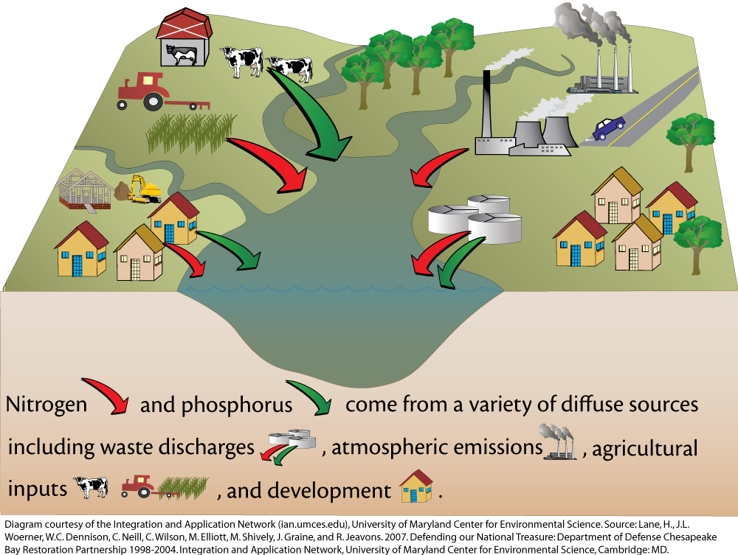Explain that they will be learning about nutrient pollution in general, then focusing on phosphorus pollution resulting from agricultural sources and designing possible solutions.

**Explore and Explain**

**Activity 2: Learning about nutrient pollution**

1. Using slides 5-7, have students examine webpages from the EPA (see essential links) either digitally or in hard copy to gather information on nutrient pollution.

* What is the problem?
* Why is it a problem?
* What are sources of nutrient pollution?
* What are the effects of nutrient pollution?
  + On humans
  + On the environment

1. Have students write their answers on a white board OR use the PowerPoint to have students fill in their information and share with the class.
2. Explain to students that they will be focusing more specifically on the issue of phosphorus pollution from agricultural animal production.
3. Using slide 8, listen to the news report from NPR “How Mass-Produced Meat Turned Phosphorus Into Pollution” (4:35) (see essential links)
4. 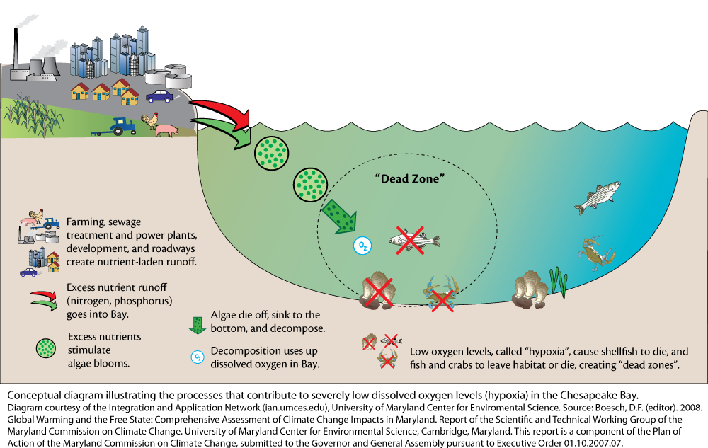Have students work together to draw an illustration on a white board or large piece of paper explaining how the challenges in agricultural animal production contribute to nutrient pollution.

**Extend**

**Activity 3: Brainstorming solutions to phosphorus pollution**

1. Using slide 9 for direction, refer back to the students’ illustration of phosphorus pollution. As a whole class, discuss areas of the process that could be changed to avoid pollution of waterways.
2. Give students 5-10 minutes to brainstorm on their own and jot down a potential solution.
3. Have students select a partner and work together to discuss, compare, and provide feedback on proposed solutions.
4. Students will write how their solution addresses the problem and any advantages or disadvantages for consumers, producers (farmers), and the environment.
5. Teachers may instruct students to share their writing with the class as a presentation or write a more formal paper and turn in this assignment as a means of evaluating understanding.

**Explore, Explain, Extend**

**Activity 4: Introducing Enviropigs**

1. After students have shared their solutions, facilitate a discussion about students’ proposed solutions and how they approached the problem from different perspectives. (Some students may propose mechanical or physical solutions such as shipping manure far from farms, or policy solutions such as implementing zoning restrictions that limit how close farms can be located from waterways, or a science or engineering design such as a filter that eliminates phosphorus from the water.)
2. Using slide 10, explain to students that researchers from the University of Guelph in Ontario, Canada, developed a biotechnology solution to potentially solve the environmental problem of pig manure that is too high in phosphorus.
3. Conduct a discussion of what biotechnology is and ask students to imagine how biotechnology might be applied to solve the problem of animal waste contributing to phosphorus pollution.
4. Using slide 11, have students access information on Enviropigs from the article “Scientists improve transgenic ‘Enviropigs’ and the University of Guelph webpage on Enviropigs (see essential links). The first webpage will provide more general information, the second webpage will provide specifics and can be used for more advanced discussion.
5. Using slide 12, have students work together to draw a diagram using the words salivary glands, phytate, phytase, phosphate, and phosphorus to explain how Enviropigs are different from non-transgenic pigs. This can be done on a whiteboard or on a large sheet of paper.
6. Facilitate a discussion with students about what benefits and challenges students might predict if this solution was adopted.
7. Compare student diagrams to the diagram provided on slide 13.

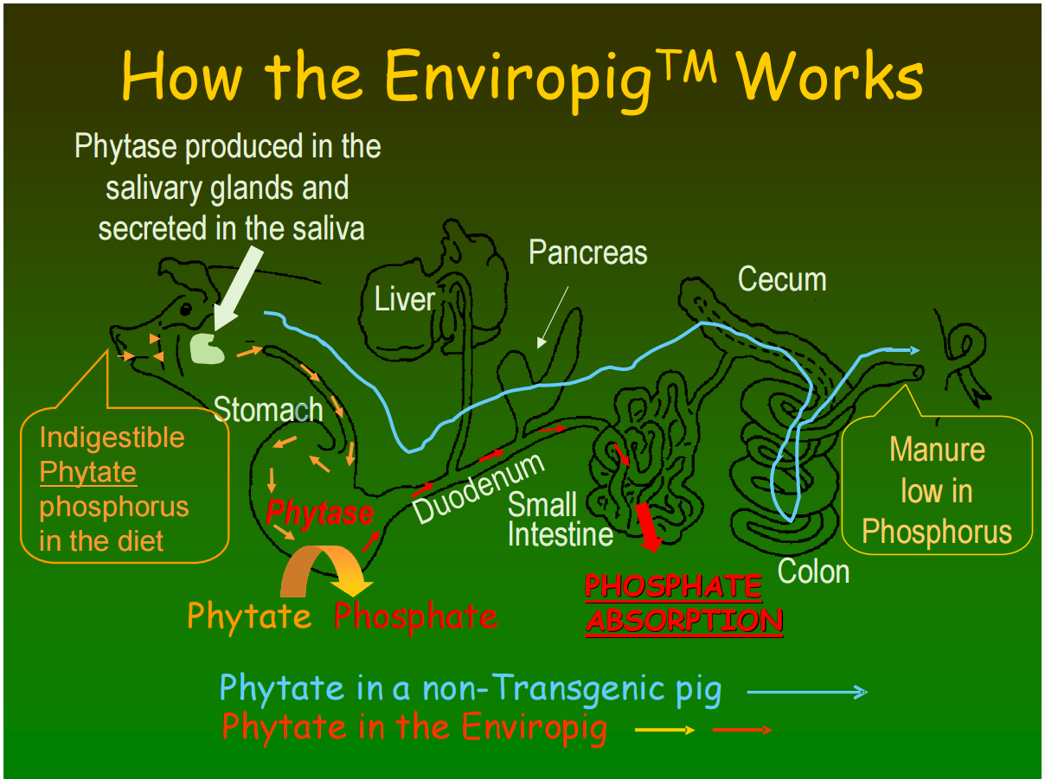

# Lesson 2 | Testing Transgenics with DNA Analysis Protein Detection

## Background

###### Purpose

Students will learn about the use of DNA analysis to identify the presence or absence of the *E. coli* phytase gene in Enviropigs and non-transgenic pigs. Additionally, students will learn about the importance of protein detection as a tool to identify if atransgene is being expressed and what tests are available to test for presence/absence and quantification of protein.

###### Standards

**Next Generation Science Standards**

* HS-ETS1-1. Analyze a major global challenge to specify qualitative and quantitative criteria and constraints for solutions that account for societal needs and wants.
* HS-ETS1-3. Evaluate a solution to a complex real-world problem based on prioritized criteria and trade-offs that account for a range of constraints, including cost, safety, reliability, and aesthetics as well as possible social, cultural, and environmental impacts.
* HS-ESS3-4. Evaluate or refine a technological solution that reduces impacts of human activities on natural systems.

**Common Core**

* RST.11-12.2 Determine the central ideas or conclusions of a text; summarize complex concepts, processes, or information presented in a text by paraphrasing them in simpler but still accurate terms.
* RST.11-12.9 Synthesize information from a range of sources (e.g., texts, experiments, simulations) into a coherent understanding of a process, phenomenon, or concept, resolving conflicting information when possible.

###### Estimated Time

Two 50-minute class periods

###### Student Materials

* Student worksheet
* Computers with internet access

###### Teacher Materials

* Answer key
* PowerPoint presentation

###### Vocabulary

* **gel electrophoresis:** a technique which uses electricity to separate molecule fragments according to size so they can be studied
* **PCR (polymerase chain reaction):** a method for making lots of copies of a particular gene or sequence of DNA in the lab. PCR is used to generate greater amounts of DNA for analysis or to determine if a particular DNA sequence exists
* **antibody**: a blood protein produced in response to a specific antigen
* **antigen**: any substance (such as a toxin or enzyme) that can combine specifically with an antibody
* **lateral flow strip test:** a test that detects the presence (or absence) of a specific protein using antibodies
* **ELISA (enzyme-linked immunosorbent assay):** a protein detection test that scientists use to determine how much of a specific protein is present in a small sample of body fluid or plant tissue
* **GMO** **(genetically modified organism)**: also known as a transgenic, an organism whose genetic material has been altered using genetic engineering techniques in a way that does not occur naturally by mating and/or natural recombination
* **protein:** molecules that ‘do the work’ of a cell. DNA provides the instructions to build these large molecules which are made of folded chains of amino acids. Once built, proteins have jobs that involve the structure, function, or regulation of the organism’s cells, tissues, and organs.

###### Key STEM Ideas

The process of developing a GMO or transgenic line requires genetic engineers to design a transgene to express a particular trait, insert it into the genome of an organism, breed the transgene through generations of plants or animals, and finally conduct testing to ensure that the gene and protein are present in the final product. Scientists conduct DNA analysis and protein detection to ensure that the transgene is passed down from parent to offspring and that propagation of the transgene will occur in subsequent generations. Successful development of a transgenic line that expresses the desired trait is an important step, however, the process of gaining acceptance or commercialization of a transgenic line takes much longer. A host of regulatory and safety testing must be conducted. In addition, public perception, economics, and politics play a large part in the decision to release a transgenic line into the environment or our food supply.

###### Students’ Prior Knowledge

Students should be familiar with the basic process of developing a transgene, transforming an embryo, and breeding a transgene into a transgenic line. This lesson will cover the fourth step of the genetic engineering process, DNA analysis and protein detection to test for presence of a trait in a final product. Students should be familiar with the following vocabulary: genetically modified organism, transgenic, genetic engineering, gene, trait, protein, enzyme, antigen, and antibody. Students should be familiar with the development of the transgenic Enviropig and the environmental issue (nutrient pollution) it was developed to help solve.

###### Connections to Agriculture

Manure from farm animals is an important natural fertilizer for the growth of crops, but manure from large hog farms is a serious environmental problem because of high levels of phosphorous. The phosphorus makes its way into bodies of water causing algal blooms which quickly grow, die, and consume oxygen during decomposition. This consumption of oxygen leads to low levels of dissolved oxygen in the water which can kill fish and other aquatic animals.

In order to help solve this problem, Dr. Cecil Forsberg and his team of scientists at the University of Guelph in Ontario, Canada genetically engineered pigs to have modified salivary glands that produce the enzyme, phytase. Phytase breaks down indigestiable phosphorus (phytate) in a pig’s diet and reduces the phosophorous load in their feces. Enviropigs were developed to help farmers stay within environmental regulations and prevent nutrient pollution.

The intention was to eventually have Enviropigs on the market for human consumption. Gaining government approval to take a genetically modified organism like Enviropigs to market is difficult and expensive. In addition, public approval is often low. In 2012, the project lost its funding and was terminated in part because of a drop in phytase feed additive costs that reduced the demand for Enviropigs by hog producers.

Despite financial, regulatory, social, and political issues surrounding GMOs, a growing human population could benefit greatly from the acceptance of GM food products in order to meet demand while protecting the environment. In order to make an informed decision about the costs and benefits of GMOs, it is important for the public to have a fundamental understanding of the genetic tools used in developing GMOs to better understand the differences between a GM product and a non-GM product.

Scientists use DNA analysis to identify which organisms have the DNA of interest in them. Scientists and regulatory personnel can use lateral flow tests or ELISA assays to test if an organism is expressing a protein encoded by the DNA not normally found in that species. A fundamental understanding of DNA analysis and protein detection in GM animals and plants is necessary for farmers, consumers, and regulatory agencies to assess the costs, benefits, and safety of GM technology.

###### Essential Links

* Journey of a Gene online module – <http://passel.unl.edu/ge/enviropig>
* Lateral flow animation: <https://passel.unl.edu/pages/animation.php?a=latflow07d2.swf>
* ELISA narrated animation: <http://www.sumanasinc.com/webcontent/animations/content/ELISA.html>
* Learning module sections on protein detection:
  + <http://passel.unl.edu/pages/informationmodule.php?idinformationmodule=1081367867&topicorder=8&maxto=8&minto=1>
  + <http://passel.unl.edu/pages/informationmodule.php?idinformationmodule=1081367867&topicorder=4&maxto=8&minto=1>
  + <http://passel.unl.edu/pages/informationmodule.php?idinformationmodule=1081367867&topicorder=2&maxto=8&minto=1>

###### Sources/Credits

* Images of lateral flow strip test and diagram of transgenic from UNL Plant and Soil Science E-Library
* Oregon State Fair Pigs, ELISA, gel electrophoresis, and thermocycler from Wikipedia
* Gel electrophoresis loading wells from libguides.fredhutch.org
* Enviropigs (CassieGilts&Boars_040B) from University of Guelph
* Eppendorf tube and pig outline- royalty free images

## Lesson Procedures

**Engage**

1. Review with students what they know about Enviropigs and the environmental problem of phosphorus pollution they were developed to help solve.
2. Show students slide 2. Have students discuss if they can tell which image shows genetically engineered Enviropigs. Students should note that there aren’t any observable differences in the images that indicate which pigs are transgenic.
3. Before moving on, ask the students to define what a GMO is and how they differ from organisms that have not been altered through genetic engineering. The students should understand that genetically engineered organisms have one or more genes added to their genome. The gene encodes for a protein. Although some genetically engineered plants or animals have visible differences, other plants or animals may not have outwardly visible signs of having a transgene.

**Explore**

1. Hand out student worksheets.
2. Show slide 3 and have students work on their own or in pairs to come up with differences between a transgenic Enviropig and a non-transgenic pig.
3. Using slide 4, discuss differences between the pigs. Have students brainstorm ideas about how these differences might be taken into consideration when designing a way to test for transgenics. Discuss student answers.
4. Briefly review with students the first three steps in the process of genetic engineering:
   1. Developing a transgene
   2. Inserting that transgene into an embryo (known as transgenic transformation)
   3. Breeding the transformed organism with others to develop a transgenic line
5. If there are gaps in understanding or misconceptions, this is a good opportunity to address them.
6. Explain that this lesson will focus on the fourth step in the genetic engineering process: conducting tests to ensure that the gene and protein are present in the final product
7. Ask students if they can think of any tests a scientist could use to verify if the Enviropigs pigs have or are producing the transgene or phytase protein. Students may indicate that you could test the DNA or look for the protein created by the transgenic DNA. Using slide 5, guide students to think about using DNA testing to look for the transgene or testing for the protein.

**Explain**

**Activity 1 – DNA Analysis**

1. Using slide 6, direct students to step 4 on the webpage, [passel.unl.edu/ge/enviropig](http://passel.unl.edu/ge/enviropig), where they will learn about the steps of DNA analysis for the Enviropigs. Students may watch the videos as a class or individually. Have students complete the follow-up questions in Part 1 of the student worksheet after watching the videos.
2. Review the DNA analysis process using slide 7.
3. Have students engage in conversation as a class or in small groups about the application of DNA analysis to transgenic animals and crops as well as nontransgenic crops and animals. Have them discuss what gene or genes they would test using DNA analysis.

**Explain**

**Activity 2 – Protein Detection**

1. Show the students the picture of the Enviropigs again. Ask the students what else Dr. Foresberg might want to test for in those pigs. Ask questions to see if the students understand how genes encode for proteins. If needed, direct students to the video in step 1 of the Journey of a Gene called “What is a Gene?”
2. Use slides 8-12 to introduce two types of protein assays, lateral flow strip tests and ELISA tests.
3. Have students watch an animation to learn how a lateral flow test works: <https://passel.unl.edu/pages/animation.php?a=latflow07d2.swf>. Have students answer the follow-up questions 1-9 on Part 2 to check for understanding.
4. After completion of the questions, discuss how lateral flow strips are protein specific. Students should be aware that a lateral flow test for Bt (GMO) corn would not work on all GMO plants as different lines of transgenic corn produce different proteins. Lateral flow strips test for a specific protein, so no one lateral flow strip test will be able to test for all GMO plants or animals.
5. Have students watch the narrated animation of a Direct ELISA to learn how this test works: <http://www.sumanasinc.com/webcontent/animations/content/ELISA.html>
6. Have students compare lateral flow tests to ELISA tests and discuss. Have students answer questions 10-12.
7. Direct students to sections of the learning module found here and answer the remaining questions.
   1. <http://passel.unl.edu/pages/informationmodule.php?idinformationmodule=1081367867&topicorder=8&maxto=8&minto=1>
   2. <http://passel.unl.edu/pages/informationmodule.php?idinformationmodule=1081367867&topicorder=4&maxto=8&minto=1>
   3. <http://passel.unl.edu/pages/informationmodule.php?idinformationmodule=1081367867&topicorder=2&maxto=8&minto=1>
8. Discuss the advantages and disadvantages for ELISA and lateral flow strip tests. Have students consider how test strips could be used to test food in your own home. Talk about ELISA tests being good for researcher to know how well their genetically engineered crops or animals are producing a specific protein. Ask students if these protein tests can be used on more things than just GMOs. Have them give examples.

**Extend**

**Reflection and Extension**

1. Have students reflect on what they have learned by answering the following questions:
   1. Why is DNA analysis or protein detection an important part of the genetic engineering process?
   2. How might this testing be applied to safety testing of GMO’s by regulatory agencies? (One example is allergic reactions are due to a reaction of the immune system to proteins. Testing can be done to ensure the transgene incorporated into a GMO does not produce a protein that might cause an allergic reaction.)

## Answer Key

#### Differences between transgenic and non-transgenic pigs

1. 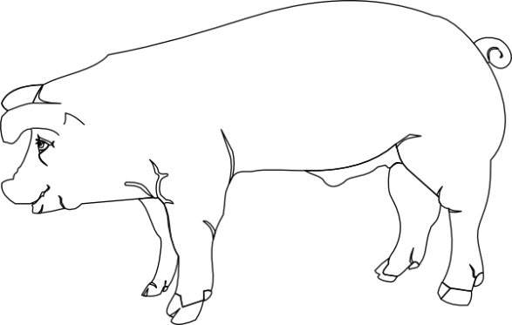How are transgenic Enviropigs and non-transgenic pigs different?

* Does not contain a transgene
* Does not produce protein, phytase
* Cannot digest phytate
* High levels of phosphorus in feces

**Transgenic Enviropig**

**Non-transgenic pig**

* Contains a transgene
* Produces protein, phytase, in the salivary glands, secreted in the saliva
* Can digest phytate
* Low level of phosphorus in feces

1. In general, how might we use this information when designing a transgenic test?

We can design a test to check if the trans**gene** or the **protein** it codes for are present in the organism.

#### Part 1: Learning about DNA Analysis

Go to *passel.unl.edu/ge/enviropig* to familiarize yourself with how Dr. Forsberg and his team identified the phytase transgene (look at the fourth step). You may complete the two animations in that step by going to these links:

* <http://passel.unl.edu/pages/animation.php?a=PCR.swf>
* <http://passel.unl.edu/pages/animation.php?a=Gel_electrophoresis.swf>

After reviewing the questions, answer the following questions:

1. What is the purpose of PCR (Polymerase Chain Reaction)?
   1. It separates large and small segments of DNA using electricity through a gel
   2. It is the device that emits UV rays to illuminate segments of DNA.
   3. It breaks open cells and releases the DNA from the nucleus
   4. It combines two segments of DNA into one segment
   5. *It makes many, many copies of a segment of DNA*
2. What is the purpose of gel electrophoresis?
   1. *It separates large and small segments of DNA using electricity through a gel*
   2. It is the device that emits UV rays to illuminate segments of DNA.
   3. It breaks open cells and releases the DNA from the nucleus
   4. It combines two segments of DNA into one segment
   5. It makes many, many copies of a segment of DNA
3. What is the purpose of DNA extraction?
   1. It separates large and small segments of DNA using electricity through a gel
   2. It is the device that emits UV rays to illuminate segments of DNA.
   3. *It breaks open cells and releases the DNA from the nucleus*
   4. It combines two segments of DNA into one segment
   5. It makes many, many copies of a segment of DNA
4. What does DNA look like during the DNA extraction process?
   1. *The DNA is so small that you could never see strands of DNA*
   2. The DNA looks like alphabet soup in a test tube
   3. The DNA looks like snot floating around in a test tube
5. PCR, gel electrophoresis, and DNA extraction can be used to do more than just DNA analysis. What do you think are possible uses?
   1. Isolating and making copies of a promoter for a transgene
   2. Isolating and making copies of a coding region for a transgene
   3. Detecting proteins
   4. *a and b*
6. What do the bands on this gel represent?

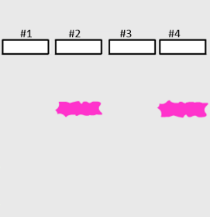

* 1. All of the DNA in the animal you are completing an analysis on
  2. It’s just food coloring that went through the gel
  3. The transgenic protein (such as the *E. Coli* phytase enzyme)
  4. *A relatively short piece of DNA that is the gene of interest (such as the E. coli phytase gene)*

1. Which pigs have the transgene according to these gel electrophoresis results?



* 1. Pig 1 & pig 3
  2. *Pig 2 & pig 4*
  3. None of the pigs
  4. All of the pigs

1. Which gene is longer?

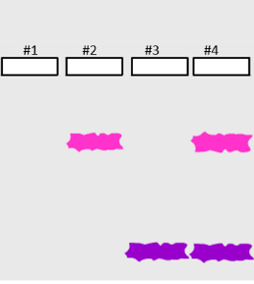

* 1. *The uppermost one in pigs 2 and 4.*
  2. The lowermost one in pigs 3 and 4.
  3. The genes are the same length.
  4. There is no way to comparatively know if the uppermost band is longer or shorter than the lowermost band.

1. Where is DNA analysis typically done?
   1. *In a laboratory*
   2. In your own home
   3. In a kitchen
   4. Outside in a field
2. How long does DNA analysis take?
   1. *A day or two, maybe. Besides preparing your DNA, you have to wait for the “gel to run” for several hours.*
   2. It is instantaneous.
   3. Only a couple of minutes. It’s a relatively speedy process.
3. After completing whole DNA analysis process shown in step 4 of the Envriopigs Journey of a Gene webpage, what did Dr. Forsberg’s team know?
   1. If the *E. coli* phytase protein was in the pig’s saliva
   2. The location of the *E. coli* phytase gene within the pig’s DNA
   3. *If the E. coli phytase gene was in the pig’s DNA*
   4. All of the above

Teacher note, question number 11: Although a and b seem like they could be correct, DNA analysis does not test for proteins, so it cannot be a. Answer b is not correct either because DNA analysis during the PCR stage will only make copies of a gene if it is there. By the end of DNA analysis, all you have are copies of a specific gene, but you will not have an indication of which chromosome it was on. There are some DNA analysis methods that can identify where exactly a gene was inserted, but in this lesson, the scientists do not identify exactly where the gene is.

1. What cells can be used for a DNA analysis of Enviropigs?
   1. Blood cells
   2. Skin cells
   3. Buccal (mouth) cells
   4. *Any of the cells above*
2. Explain what biological knowledge about DNA and cells you used to help you answer the question about where you can obtain cells for DNA analysis.

*All of the cells in an animal contain DNA.*

1. Can DNA analysis be used on non-GMO’s?
   1. No, non-GMO plants and animals do not contain DNA.
   2. *Yes, all living things have DNA in them that can be analyzed.*
   3. Yes, but there’s no reason for scientists to analyze or study DNA unless the organism is genetically engineered.
   4. No, DNA analysis can only be conducted on organisms that have a transgene in them.
2. There are three main laboratory processes that must be done to complete a DNA analysis. Watch the videos in step 4 of *The Journey of a Gene* to identify the three main laboratory processes, the order they go in, and the picture that depicts them. Fill in chart below to match the steps Dr. Forsberg would compete a DNA analysis on Enviropigs. Use your answers from the rest of this worksheet to help you fill in the diagram.

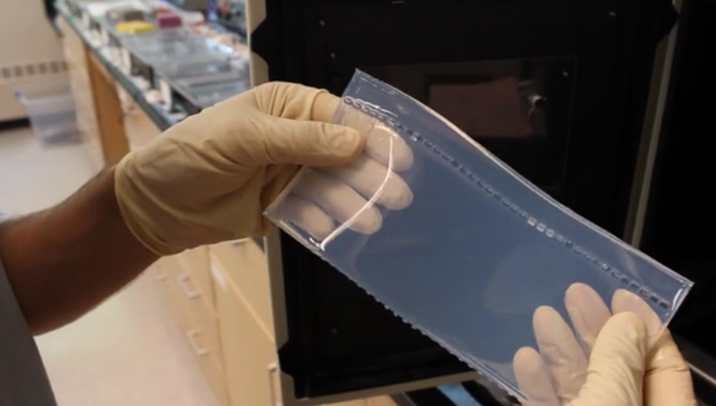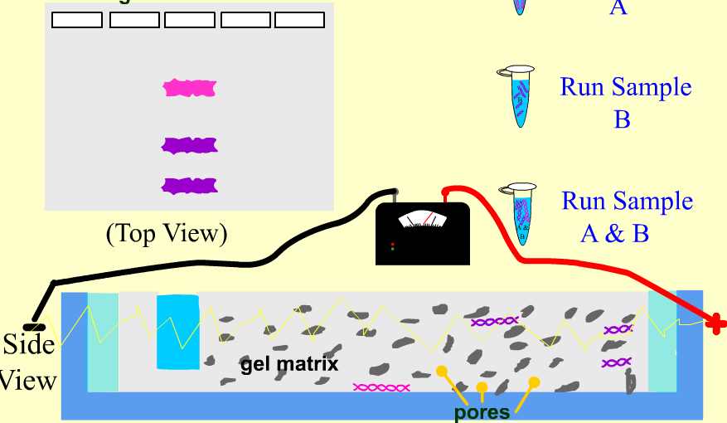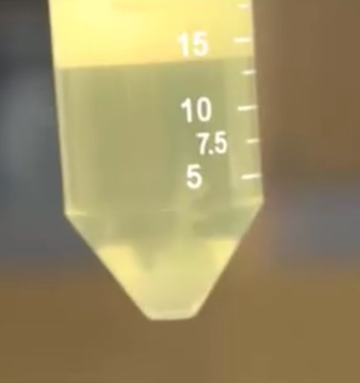

**A**

**B**

**C**

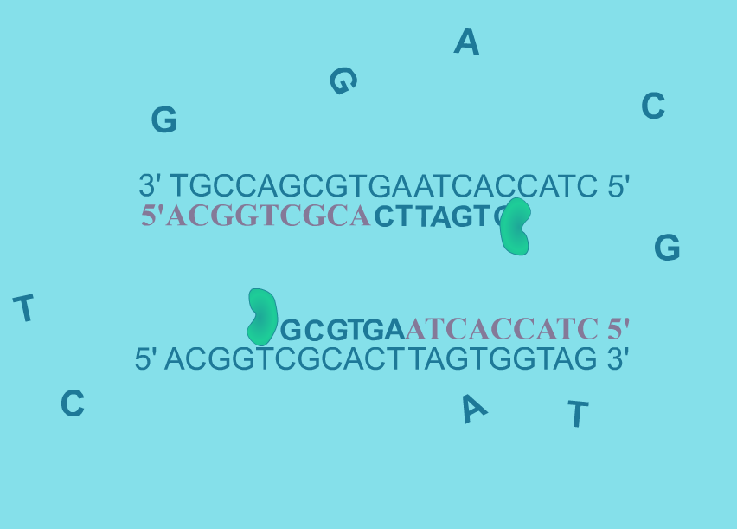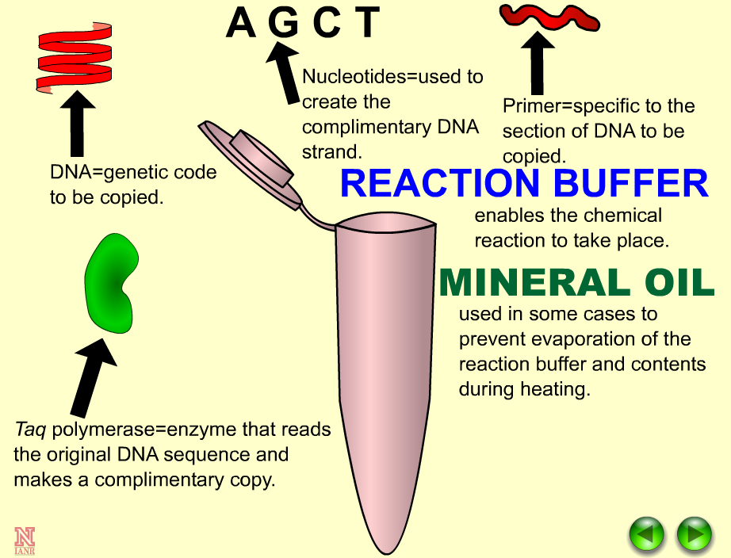

#### Part 2: Learning about Protein Detection

Although not shown on the *The Journey of a Gene* Enviropigs webpage (http://passel.unl.edu/ge/enviropigs), Dr. Forsberg would want to test for the presence of the phytase protein in addition to testing for the phytase DNA.

Protein detection can be done through lateral flow strips tests and ELISA. To start, we will learn how lateral flow strips test for the presence of proteins. Watch the following animation (<http://passel.unl.edu/pages/animation.php?a=latflow07d2.swf>) on how lateral flow strips work and answer the following questions:

#### Protein detection vs. DNA detection

1. Which biomolecule has the ability to form a structure that can operate as an enzyme and catalyze chemical reactions?
2. antibodies
3. DNA
4. *proteins*
5. all of the above
6. Which biomolecule has the ability to code for the amino acid sequence of a specific protein?
7. antibodies
8. *DNA*
9. other proteins
10. all of the above
11. Which biomolecule would be found in every cell of your body?
12. *the DNA sequence that codes for the enzyme that controls my hair color*
13. the enzyme that controls my hair color
14. both of the above

#### Lateral flow tests

1. In your own words, explain how lateral flow strip tests work.

Gold particles attached to antibodies are placed on the reservoir pad. When wetted with a specific protein, the protein will attach to the antibodies. As the liquid moves up the test strip, it goes through the first window on the test strip. The first window indicates that the protein/enzyme of interest is present in the sample if it becomes colored. The coloration is a result of antibodies binding to proteins and binding to the test strip. The sample continues to move up the test strip into the second window. The second window should be colored whether the protein/enzyme is present no matter what because that window indicates that the test strip is working. (Students should mention proteins, the windows, and antibodies.)

1. What are the main components of a lateral flow strip test (circle all that apply)?
   1. Color dye
   2. *Two results windows*
   3. *Gold particles attached to an antibody for the protein of interest*
   4. *A reservoir pad*
2. Label the protein, gold particle, and antibody.



Protein

Antibody

Gold particle

1. What does a positive lateral flow strip result indicate about the presence or absence of the protein of interest?
2. A positive result indicates that the protein of interest in NOT present
3. *A positive result indicates that the protein of interest IS present*
4. Label in the picture which result is positive and which is negative.

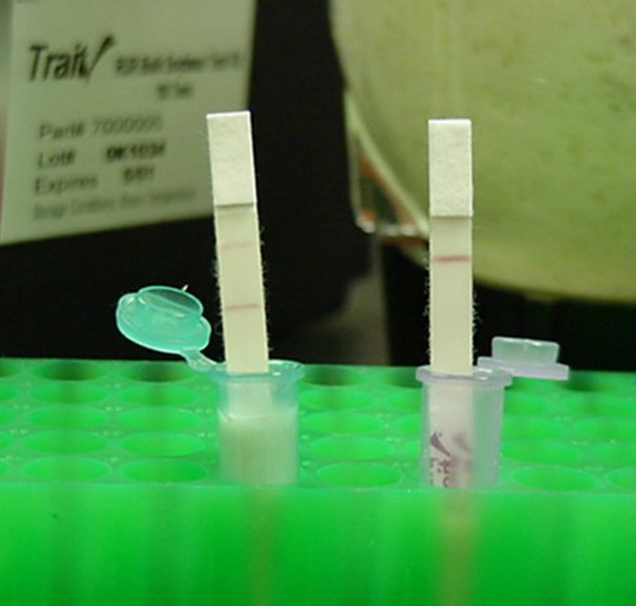

Strip on left with two bands is positive, strip on right with single band is negative.

1. Circle the items below that seem to be advantages of the lateral flow strip test.
2. *It is fast way to know if a protein is present or absent*
3. *It requires few laboratory items*
4. It tells you how much protein is present
5. *The protocol is simple*
6. *The results are easy to read*
7. The test strip tells you what plants and animals are transgenic

#### ELISA tests

For Enviropigs, Dr. Forsberg would want to know how much of the *E. coli* phytase protein is present in the pig’s saliva. To do this, he’ll need to use a different protein detection test called Enzyme-linked immunosorbent assay (ELISA). To learn how the ELISA tests work, go to the animation listed below.

Watch the narrated animation of a Direct ELISA to learn how this test works: <http://www.sumanasinc.com/webcontent/animations/content/ELISA.html>

Read about the use of ELISA here: <http://passel.unl.edu/pages/informationmodule.php?idinformationmodule=1081367867&topicorder=4&maxto=8&minto=1>

Answer the following questions about ELISA.

1. List two ways ELISA tests are different from lateral flow tests.

ELISA tests can quantify proteins where lateral flow tests cannot. ELISA tests use a plastic plate of wells rather than a test strip. ELISA tests are done in the laboratory whereas lateral flow tests can be conducted in the field. Other answers may be given.

1. What are some advantages of an ELISA test? Circle all the advantages.
   1. The test is quick
   2. *The test tells a scientist how much of a specific protein is present in a sample*
   3. The test can easily be interpreted with the naked eye
   4. The protocol is simple and can be done in your own home
2. How do scientists interpret ELISA tests?
3. *A computer analyzes the colors in the ELISA test and tells the scientist how much of the protein of interest is present.*
4. The scientist looks at the colors in the ELISA test and compares it to a color grade that tells them how much protein is present. It’s similar to an aquarium pH test.
5. ELISA tests are interpreted the same way as lateral flow strip tests except that the darkness of the bands tells the scientist how much protein is present.

#### Protein detection methods

Read these webpages about the use of protein detection in GMOs:

* <http://passel.unl.edu/pages/informationmodule.php?idinformationmodule=1081367867&topicorder=8&maxto=8&minto=1>
* <http://passel.unl.edu/pages/informationmodule.php?idinformationmodule=1081367867&topicorder=4&maxto=8&minto=1>
* <http://passel.unl.edu/pages/informationmodule.php?idinformationmodule=1081367867&topicorder=2&maxto=8&minto=1>

Based on what you’ve learned about protein detection tests, answer the following questions.

1. What are two strengths and two weaknesses of using protein detection in GMO testing?

**Strengths**:

Provide a direct measure of biologically active protein; can be validated and reproduced across testing locations and different proteins; flexibility: can be simple tests for presence/absence or more precise, quantified; widely accepted methods for regulatory agencies

**Weaknesses:**

No single method for detecting all biotechnology-derived products (DNA or protein-based); need for validation when importing or exporting products; when testing different proteins, antibodies may cross-react.

1. What are methods used for detecting proteins? (Circle **all** that apply.)
   1. Polymerase Chain Reaction (PCR) and gel electrophoresis
   2. *Lateral flow strip test*
   3. *ELISA*
   4. Titration
2. Which of the following are potential applications of protein detection? (Circle **all** that apply.)
3. *Pregnancy testing*
4. *Human Immunodeficiency Virus (HIV) testing*
5. Tuberculosis (TB) testing
6. *Testing for transgene protein production in a genetically modified organism*
7. Circle **all** of the projects below where lateral flow strips tests could be used.
8. *Identify if a corn plant is making the Bt protein*
9. Identify how many chemical compounds are in Bt corn
10. *Identify if a pig has the phytase protein in its saliva*
11. Identify if watermelon will grow seeds

#### Part E: Applying protein detection techniques to the testing of Enviropigs

1. The test strips for Dr. Forsberg’s Enviropigs would detect the presence of what?
2. The *E. coli* phytase DNA
3. *The E. coli phytase protein*
4. The *E. coli* phytase antibody
5. Any *E. coli* DNA
6. A farmer wants to identify if his pigs are successfully producing the phytase protein. The design of the phytase protein gene is shown below. What part of the pig should the farmer test?



1. *Its saliva since this is where the protein is designed to be produced at.*
2. The skin cells since the pig will be shedding phytase from its skin.
3. The pig’s hair because it’s a good source of DNA.
4. Any of the above. All of these places contain DNA that can be tested for the phytase protein.
5. Why should Dr. Forsberg test for the *E. coli* phytase protein in the saliva AND test for the presence of the *E. coli* phytase gene within the DNA? (Think about what these two different tests are detecting and how this relates to cellular processes, DNA, and proteins.)

Here, students should mention something about how DNA encodes for proteins. GMOs could have transgenic DNA, but not produce the protein. Dr. Forsberg would test for the protein and for the DNA because it is possible to have the phytase DNA in the pig, but to not produce the protein (perhaps the wrong promoter is attached and the protein does not get read).

1. Can a lateral flow strip test for the Bt protein found in transgenic corn be used to detect the *E. Coli* phytase protein? Why or why not?

It is not possible to use a flow strip test for the Bt protein to detect the *E. Coli* phytase protein. This is because lateral flow strip tests are protein-specific. There simply aren’t any lateral flow strip tests that will tell you if an organism is genetically modified, because GMOs have differing protein sequences added to their DNA.

# Lesson 3 | Constructing an Argument

## Background

###### Purpose

This lesson teaches students about the difference between engaging in argument from evidence and providing a persuasive argument. Students will write an argumentative essay describing their position, for or against, the production and commercialization of Enviropigs for human consumption.

###### Standards

**Next Generation Science Standards**

* HS-ETS1-3. Evaluate a solution to a complex real-world problem based on prioritized criteria and trade-offs that account for a range of constraints, including cost, safety, reliability, and aesthetics as well as possible social, cultural, and environmental impacts
* HS-ESS3-4. Evaluate or refine a technological solution that reduces impacts of human activities on natural systems.

**Common Core**

* RST.11-12.2 Determine the central ideas or conclusions of a text; summarize complex concepts, processes, or information presented in a text by paraphrasing them in simpler but still accurate terms.
* RST.11-12.9 Synthesize information from a range of sources (e.g., texts, experiments, simulations) into a coherent understanding of a process, phenomenon, or concept, resolving conflicting information when possible.
* CCRA.SL.3 Evaluate a speaker's point of view, reasoning, and use of evidence and rhetoric.

###### Estimated Time

Two 50-minute class periods to present the lesson and read/compare texts.

More time necessary outside of class to write the argumentative essay.

###### Student Materials

* Student worksheet
* Access to computers and internet
* Hard copy of persuasion map or use interactive, online map: <http://www.readwritethink.org/files/resources/interactives/persuasion_map/>

###### Teacher Materials

* PowerPoint presentation
* Articles on Enviropigs (provide copies of these for students to read)
  + Forsberg- An Environmentally Friendly Pig
  + Schmickle- Enviropig raises a whole new stink
  + Taylor- A Less Polluting Pig
  + Vestel- The Next Pig Thing
  + Editorial, Minnesota Daily- Enviropigs will not help the environment
  + Surveys- Attitudes about Genetically Engineered Foods

###### Vocabulary

* **claim**: a basic belief about a particular topic, issue, event, or idea
* **counterclaim**: a solid and reasonable argument that opposes or disagrees with your claim
* **rebuttal**: a written or verbal response to a counterclaim. The object of the rebuttal is to take into account the ideas presented in the counterclaim and explain why they aren’t persuasive enough, valid enough, or important enough to outweigh your own claim
* **support**: specific facts or specific evidence used to support why a claim is true
* **refute**: argue against a position or prove it to be wrong
* **qualify**: a “partly-agree” stance in which you agree (in part) with another person’s argument or position but also disagree with part of it

###### Key STEM Ideas

A key practice in science is to engage in argument from evidence. This practice of argumentation is different from developing a persuasive essay in that argumentation requires making claims based on factual evidence rather than opinion. A convincing argument also strives to provide reasonable claims and evidence and avoids simply appealing to the audience’s emotion. Students will use their knowledge of how Enviropigs were developed and their proposed use to develop an argument for or against the production and commercialization of Enviropigs for human consumption. Forming a defensible argument will require students to understand and address a variety of social, economic, ethical, political, and aesthetic issues that frame any scientific or technological solution to a real-world problem.

###### Students’ Prior Knowledge

Students should have a good understanding of what Enviropigs are, how they were developed, and the environmental problem of nutrient pollution they were developed to address. Students do not need to have prior formal experience engaging in argument from evidence. Students would benefit from previous practice constructing a 5-paragraph essay and/or constructing an argumentative or persuasive essay.

###### Connections to Agriculture

Manure from farm animals is an important natural fertilizer for the growth of crops, but manure from large hog farms is a serious environmental problem because of high levels of phosphorous. The phosphorus makes its way into bodies of water causing algal blooms which quickly grow, die, and consume oxygen during decomposition. This consumption of oxygen leads to low levels of dissolved oxygen in the water which can kill fish and other aquatic animals.

In order to help solve this problem, Dr. Cecil Forsberg and his team of scientists at the University of Guelph in Ontario, Canada genetically engineered pigs to have modified salivary glands that produce the enzyme, phytase. Phytase breaks down indigestiable phosphorus (phytate) in a pig’s diet and reduces the phosophorous load in their feces. Enviropigs were developed to help farmers stay within environmental regulations and prevent nutrient pollution.

The intention was to eventually have Enviropigs on the market for human consumption. Gaining government approval to take a genetically modified organism like Enviropigs to market is difficult and expensive. In addition, public approval is often low. In 2012, the project lost its funding and was terminated in part because of a drop in phytase feed additive costs that reduced the demand for Enviropigs by hog producers.

A variety of financial, regulatory, social, and political concerns surround GMOs and students could benefit greatly from a better understanding of what makes for a strong argument for or against the use of scientific technologies such as genetic engineering.

###### Essential Links

* Argumentative essay formats: <http://www.essaywritinghelp.com/argumentative.htm>
* Persuasion map: <http://www.readwritethink.org/files/resources/interactives/persuasion_map/>

###### Sources/Credits

* Parts of this lesson plan modified from: <http://rpdp.net/files/ccss/ELA/ELA_9-10_Curr_Res/Writing%209-10/Writing%20Standard%201%20(9-10).pdf>
* Articles sourced from Enviropig case study found here: <http://www.public.iastate.edu/~ethics/EnviropigLong.pdf>

## Lesson Procedures

**Engage and Explore**

**Activity 1: Introducing argumentation vocabulary**

1. Hand out the student worksheet. Using slide 2 of the PowerPoint, read through the key vocabulary terms at the top of the student worksheet with the class and discuss their meanings.
2. Using slide 3, decide on a topic of interest to the students. The topic should be fun and does not need to be directly tied to the lesson. The chosen topic should be applicable to all students in the class. Possible topics may include
   1. Better to have siblings or be an only child
   2. Best social media platform: Facebook, YouTube, Twitter, etc.
   3. Better vacation location: the beach or the mountains
   4. Best transportation: Public transit, car, walk, bike, etc.
3. Have students provide their claims, counterclaims, rebuttals, and support statements. Have students practice qualifying and refuting these statements.
4. Encourage students to jot down examples of each of these vocabulary words to help them remember what they look like in an argument.
5. Discuss which rebuttals were most effective and why.
6. Discuss when it is a good strategy to qualify a position or refute it entirely.

**Explain**

**Activity 2: What’s the difference between an argumentative essay and a persuasive essay?**

1. HHHHHHHslkjdlkjsdfjjeeFacilitate a class discussion of differences between having an argument and being persuasive. Many students may consider these two things very similar or the same thing.
2. Using slide 4, discuss the differences between argumentation and persuasion.
3. Using slide 5, have students decide if their position on the topic from Activity 1 was an argument, a persuasion, or a mixture of the two. Write down their answer on the worksheet and be sure to provide evidence for why they selected the answer they did.
4. Discuss answers and evidence as a class.
5. Have students discuss how they would decide if a source of information is reliable or credible.
6. Using slide 6, discuss with students how several questions may help them to decide if a source is trustworthy, reliable, or credible:
   1. Is data used to support their claim?
   2. Has it been scientifically demonstrated?
   3. What are their qualifications to speak on this issue?
   4. Do they have a personal investment in this issue?

**Extend and Evaluate**

**Activity 3: Writing an argumentative essay**

1. Using slide 7, ask students to discuss what considerations are important to them in the debate over genetically modified foods. What considerations might be important to others? Write these answers on the board or add them to the PowerPoint.
2. Read through the instructions with the class on writing an argumentative essay on page 3 of the student worksheet.
3. Explain to students that their objective is to write an argumentative essay describing their position, for or against, the production and commercialization of Enviropigs for human consumption.
4. Explain to students that the first step they will take is to read and compare texts with information about Enviropigs.
5. Give students access to the 6 articles/texts
   1. Forsberg- An Environmentally Friendly Pig
   2. Schmickle- Enviropig raises a whole new stink
   3. Taylor- A Less Polluting Pig
   4. Vestel- The Next Pig Thing
   5. Editorial, Minnesota Daily- Enviropigs will not help the environment
   6. Survey- Attitudes about Genetically Engineered Foods
6. Have students take notes (digitally or by hand) on the following:
   1. Identify who is the source of the information.
   2. Determine if the source is reliable and credible.
   3. Identify what claims, counterclaims, and rebuttals are made.
   4. Determine what support, if any, is provided.
   5. Determine if the support is sufficient and reliable.
   6. Identify how a position is qualified or if a position is entirely refuted.
   7. Identify information gaps (things they wish they had more information about).
7. Using slide 9, have students point out what information was presented about various concerns (safety, political, economic, social, ethical, and environmental)
8. Using their notes, have students begin to construct their own position on the issue by filling in the table on page 4 of the student worksheet. It may help to complete an example of making a claim and providing supporting evidence from the articles by having students fill in the table on slide 10 or writing an example on the board.
9. Have students visit the website <http://www.essaywritinghelp.com/argumentative.htm> to see examples of argumentative essay formats.
10. Have students select a format and write an outline of their argumentative essay on page 5 of the student worksheet.
11. Students may choose to fill out a persuasion map found here: <http://www.readwritethink.org/files/resources/interactives/persuasion_map/> to organize their thoughts. A blank map can also be printed and filled in by hand. This is a good option for students who have difficulty organizing their writing without a guide or scaffold.
12. Instruct students to complete their argumentative essay either using class time or as an out of class assignment.