Biotechnology: Enviropigs

Student Name ___________________________________________

Contents
Lesson 2 | Testing Transgenics: DNA Analysis and Protein Detection 2
Lesson 3 | Constructing an Argument 11

Authors
Caitlin Falcone, Life Science Teacher, Lourdes Central Catholic School, Nebraska City, Nebraska
Dr. Don Lee, Professor of Agronomy and Horticulture, University of Nebraska-Lincoln
Erin Ingram, Curriculum Development Specialist, University of Nebraska-Lincoln, IANR Science Literacy
Molly Brandt, Graduate Research Assistant, University of Nebraska-Lincoln, IANR Science Literacy

Lesson 2 | Testing Transgenics: DNA Analysis and Protein Detection

Student Name ___________________________________________

Differences between transgenic and non-transgenic pigs
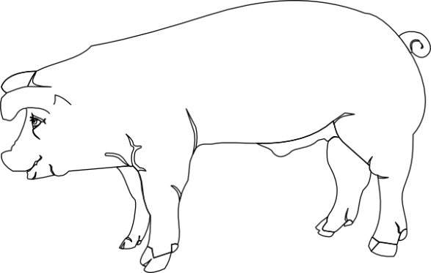
- How are transgenic Enviropigs and non-transgenic pigs different?
Transgenic Enviropig
Non-transgenic pig

- In general, how might we use this information when designing a transgenic test?

Part 1: Learning about DNA Analysis
Go to passel.unl.edu/ge/enviropig to familiarize yourself with how Dr. Forsberg and his team identified the phytase transgene (look at the fourth step). You may complete the two animations in that step by going to these links:
- http://passel.unl.edu/pages/animation.php?a=PCR.swf
- http://passel.unl.edu/pages/animation.php?a=Gel_electrophoresis.swf
After reviewing the questions, answer the following questions:
- What is the purpose of PCR (Polymerase Chain Reaction)?
  - It separates large and small segments of DNA using electricity through a gel
  - It is the device that emits UV rays to illuminate segments of DNA.
  - It breaks open cells and releases the DNA from the nucleus
  - It combines two segments of DNA into one segment
  - It makes many, many copies of a segment of DNA

- What is the purpose of gel electrophoresis?
  - It separates large and small segments of DNA using electricity through a gel
  - It is the device that emits UV rays to illuminate segments of DNA.
  - It breaks open cells and releases the DNA from the nucleus
  - It combines two segments of DNA into one segment
  - It makes many, many copies of a segment of DNA

- What is the purpose of DNA extraction?
  - It separates large and small segments of DNA using electricity through a gel
  - It is the device that emits UV rays to illuminate segments of DNA.
  - It breaks open cells and releases the DNA from the nucleus
  - It combines two segments of DNA into one segment
  - It makes many, many copies of a segment of DNA

- What does DNA look like during the DNA extraction process?
  - The DNA is so small that you could never see strands of DNA
  - The DNA looks like alphabet soup in a test tube
  - The DNA looks like snot floating around in a test tube

- PCR, gel electrophoresis, and DNA extraction can be used to do more than just DNA analysis. What do you think are possible uses?
  - Isolating and making copies of a promoter for a transgene
  - Isolating and making copies of a coding region for a transgene
  - Detecting proteins
  - a and b

- What do the bands on this gel represent?
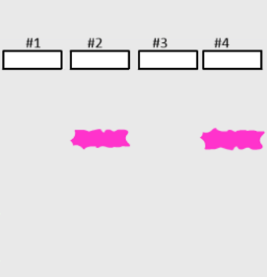
  - All of the DNA in the animal you are completing an analysis on
  - It’s just food coloring that went through the gel
  - The transgenic protein (such as the E. Coli phytase enzyme)
  - A relatively short piece of DNA that is the gene of interest (such as the E. coli phytase gene)

- Which pigs have the transgene according to these gel electrophoresis results?
  - Pig 1 & pig 3
  - Pig 2 & pig 4
  - None of the pigs
  - All of the pigs

- Which gene is longer?
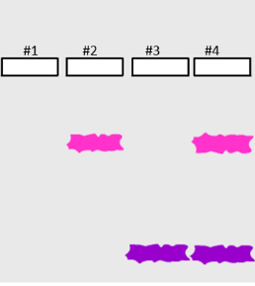
  - The uppermost one in pigs 2 and 4.
  - The lowermost one in pigs 3 and 4.
  - The genes are the same length.
  - There is no way to comparatively know if the uppermost band is longer or shorter than the lowermost band.

- Where is DNA analysis typically done?
  - In a laboratory
  - In your own home
  - In a kitchen
  - Outside in a field

- How long does DNA analysis take?
  - A day or two, maybe. Besides preparing your DNA, you have to wait for the “gel to run” for several hours.
  - It is instantaneous.
  - Only a couple of minutes. It’s a relatively speedy process.

- After completing whole DNA analysis process shown in step 4 of the Envriopigs Journey of a Gene webpage, what did Dr. Forsberg’s team know?
  - If the E. coli phytase protein was in the pig’s saliva
  - The location of the E. coli phytase gene within the pig’s DNA
  - If the E. coli phytase gene was in the pig’s DNA
  - All of the above
- What cells can be used for a DNA analysis of Enviropigs?
  - Blood cells
  - Skin cells
  - Buccal (mouth) cells
  - Any of the cells above

- Explain what biological knowledge about DNA and cells you used to help you answer the question about where you can obtain cells for DNA analysis.

- Can DNA analysis be used on non-GMO’s?
  - No, non-GMO plants and animals do not contain DNA.
  - Yes, all living things have DNA in them that can be analyzed.
  - Yes, but there’s no reason for scientists to analyze or study DNA unless the organism is genetically engineered.
  - No, DNA analysis can only be conducted on organisms that have a transgene in them.

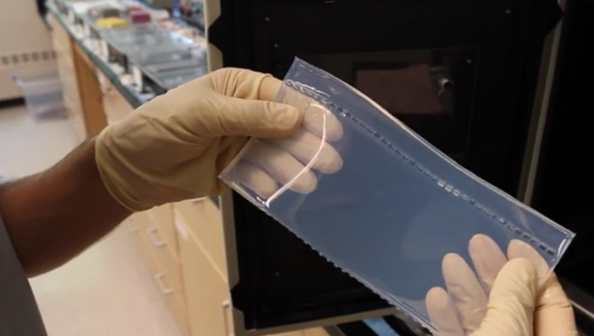
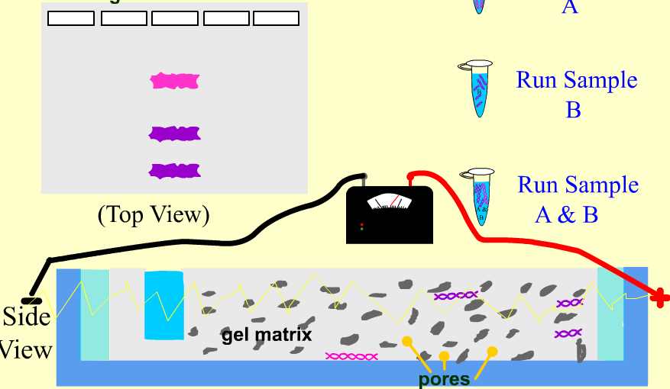
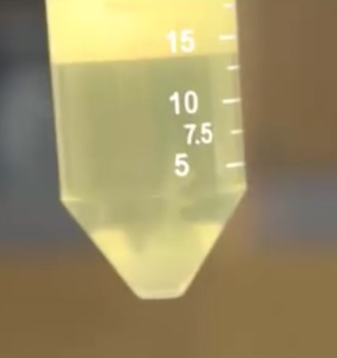
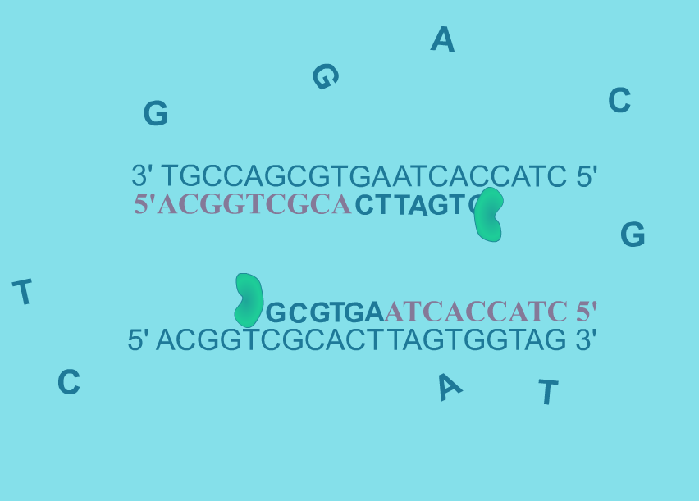
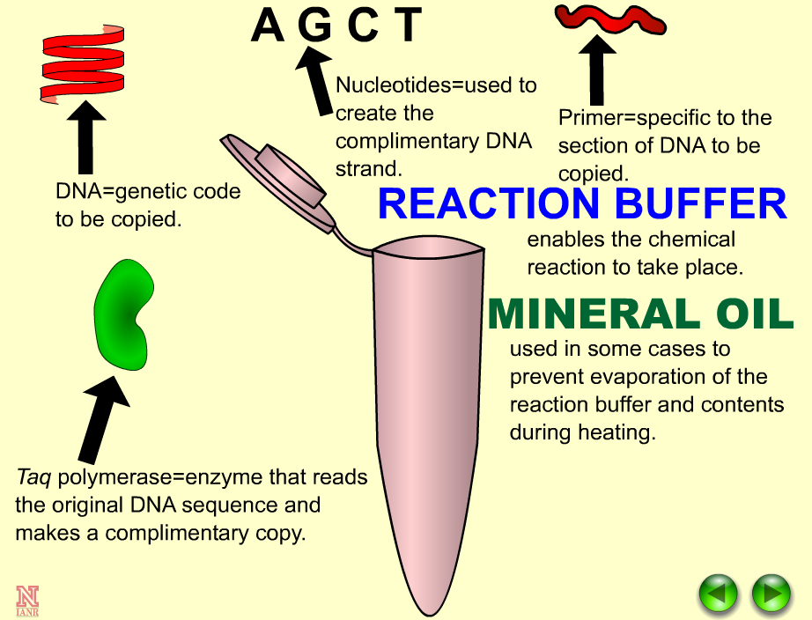
- There are three main laboratory processes that must be done to complete a DNA analysis. Watch the videos in step 4 of The Journey of a Gene to identify the three main laboratory processes, the order they go in, and the picture that depicts them. Fill in chart below to match the steps Dr. Forsberg would compete a DNA analysis on Enviropigs. Use your answers from the rest of this worksheet to help you fill in the diagram.
A
B
C

Part 2: Learning about Protein Detection
Although not shown on the The Journey of a Gene Enviropigs webpage (http://passel.unl.edu/ge/enviropigs), Dr. Forsberg would want to test for the presence of the phytase protein in addition to testing for the phytase DNA.
Protein detection can be done through lateral flow strips tests and ELISA. To start, we will learn how lateral flow strips test for the presence of proteins. Watch the following animation (http://passel.unl.edu/pages/animation.php?a=latflow07d2.swf) on how lateral flow strips work and answer the following questions:
Protein detection vs. DNA detection
- Which biomolecule has the ability to form a structure that can operate as an enzyme and catalyze chemical reactions?
- antibodies
- DNA
- proteins
- all of the above

- Which biomolecule has the ability to code for the amino acid sequence of a specific protein?
- antibodies
- DNA
- other proteins
- all of the above

- Which biomolecule would be found in every cell of your body?
- the DNA sequence that codes for the enzyme that controls my hair color
- the enzyme that controls my hair color
- both of the above

Lateral flow tests
- In your own words, explain how lateral flow strip tests work.

- What are the main components of a lateral flow strip test (circle all that apply)?
  - Color dye
  - Two results windows
  - Gold particles attached to an antibody for the protein of interest
  - A reservoir pad

- Label the protein, gold particle, and antibody.

- What does a positive lateral flow strip result indicate about the presence or absence of the protein of interest?
- A positive result indicates that the protein of interest in NOT present
- A positive result indicates that the protein of interest IS present

- Label in the picture which result is positive and which is negative.
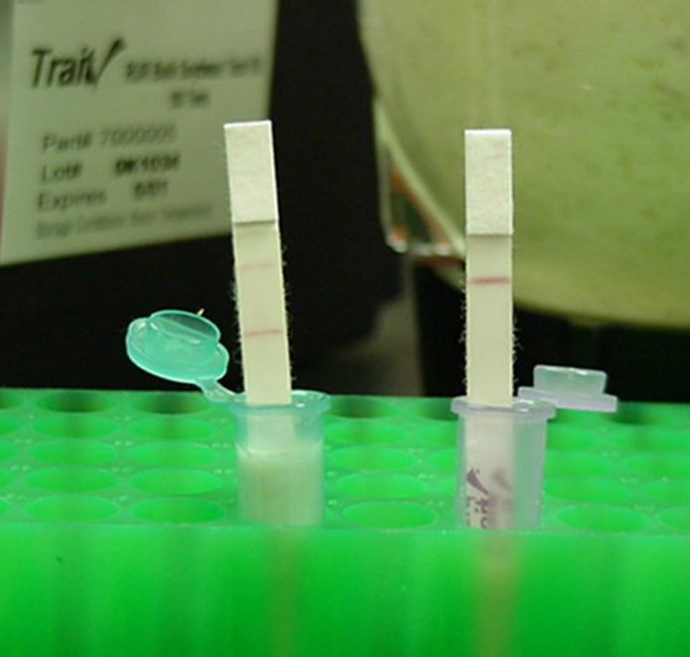

- Circle the items below that seem to be advantages of the lateral flow strip test.
- It is fast way to know if a protein is present or absent
- It requires few laboratory items
- It tells you how much protein is present
- The protocol is simple
- The results are easy to read
- The test strip tells you what plants and animals are transgenic

ELISA tests
For Enviropigs, Dr. Forsberg would want to know how much of the E. coli phytase protein is present in the pig’s saliva. To do this, he’ll need to use a different protein detection test called Enzyme-linked immunosorbent assay (ELISA). To learn how the ELISA tests work, go to the animation listed below.
Watch the narrated animation of a Direct ELISA to learn how this test works: http://www.sumanasinc.com/webcontent/animations/content/ELISA.html
Read about the use of ELISA here: http://passel.unl.edu/pages/informationmodule.php?idinformationmodule=1081367867&topicorder=4&maxto=8&minto=1
Answer the following questions about ELISA.
- List two ways ELISA tests are different from lateral flow tests.

- What are some advantages of an ELISA test? Circle all the advantages.
  - The test is quick
  - The test tells a scientist how much of a specific protein is present in a sample
  - The test can easily be interpreted with the naked eye
  - The protocol is simple and can be done in your own home

- How do scientists interpret ELISA tests?
- A computer analyzes the colors in the ELISA test and tells the scientist how much of the protein of interest is present.
- The scientist looks at the colors in the ELISA test and compares it to a color grade that tells them how much protein is present. It’s similar to an aquarium pH test.
- ELISA tests are interpreted the same way as lateral flow strip tests except that the darkness of the bands tells the scientist how much protein is present.

Protein detection methods
Read these webpages about the use of protein detection in GMOs:
- http://passel.unl.edu/pages/informationmodule.php?idinformationmodule=1081367867&topicorder=8&maxto=8&minto=1
- http://passel.unl.edu/pages/informationmodule.php?idinformationmodule=1081367867&topicorder=4&maxto=8&minto=1
- http://passel.unl.edu/pages/informationmodule.php?idinformationmodule=1081367867&topicorder=2&maxto=8&minto=1

Based on what you’ve learned about protein detection tests, answer the following questions.
- What are two strengths and two weaknesses of using protein detection in GMO testing?

- What are methods used for detecting proteins? (Circle all that apply.)
  - Polymerase Chain Reaction (PCR) and gel electrophoresis
  - Lateral flow strip test
  - ELISA
  - Titration

- Which of the following are potential applications of protein detection? (Circle all that apply.)
- Pregnancy testing
- Human Immunodeficiency Virus (HIV) testing
- Tuberculosis (TB) testing
- Testing for transgene protein production in a genetically modified organism

- Circle all of the projects below where lateral flow strips tests could be used.
- Identify if a corn plant is making the Bt protein
- Identify how many chemical compounds are in Bt corn
- Identify if a pig has the phytase protein in its saliva
- Identify if watermelon will grow seeds

Part E: Applying protein detection techniques to the testing of Enviropigs
- The test strips for Dr. Foresberg’s Enviropigs would detect the presence of what?
- The E. coli phytase DNA
- The E. coli phytase protein
- The E. coli phytase antibody
- Any E. coli DNA

- A farmer wants to identify if his pigs are successfully producing the phytase protein. The design of the phytase protein gene is shown below. What part of the pig should the farmer test?
- Its saliva since this is where the protein is designed to be produced at.
- The skin cells since the pig will be shedding phytase from its skin.
- The pig’s hair because it’s a good source of DNA.
- Any of the above. All of these places contain DNA that can be tested for the phytase protein.

- Why should Dr. Forsberg test for the E. coli phytase protein in the saliva AND test for the presence of the E. coli phytase gene within the DNA? (Think about what these two different tests are detecting and how this relates to cellular processes, DNA, and proteins.)

- Can a lateral flow strip test for the Bt protein found in transgenic corn be used to detect the E. Coli phytase protein? Why or why not?

Lesson 3 | Constructing an Argument

Student Name ___________________________________________

Activity 1: Introducing key vocabulary
Claim – Your basic belief about a particular topic, issue, event, or idea.
Counterclaim – A solid and reasonable argument that opposes or disagrees with your claim.
Rebuttal – A written or verbal response to a counterclaim. The object of the rebuttal is to take into account the ideas presented in the counterclaim and explain why they aren’t persuasive enough, valid enough, or important enough to outweigh your own claim.
Support – Your specific facts or specific evidence used to support why your claim is true.
Refute – Argue against a position or prove it to be wrong.
Qualify – A “partly-agree” stance in which you agree (in part) with another person’s argument or position but also disagree with part of it.
As a class, decide on a topic. The chosen topic is ___________________________________________. Using the vocabulary from above, provide your position on this topic.

- Claim:

- Counterclaim:

- Rebuttal:

- Support:

- Refute:

- Qualify:

Activity 2: What is the difference between an argumentative essay and a persuasive essay?
Argumentative essay | Persuasive essay
Makes claims based on factual evidence. | May make claims based on opinion.
Makes counter-claims. The author takes opposing views into account. | May not take opposing ideas into account.
Neutralizes or “defeats” serious opposing ideas.
Convinces audience through the merit and reasonableness of the claims and proofs offered. | Persuades by appealing to the audience’s emotion or by relying on the character or credentials of the writer – less on the merits of her or his reasons and evidence.
Often compares texts or ideas to establish a position.
Logic-based | Emotion-based

- Based on these definitions, did you make an argumentative or persuasive case in the previous activity? Circle one.
Argumentative Persuasive Both
What is your evidence for this?

- An argumentative essay requires the presentation of factual evidence. What are three things to consider when deciding if a source of information is reliable or credible?

Activity 3: Writing an argumentative essay
The objective of this activity to write an argumentative essay describing your position, for or against, the production and commercialization of Enviropigs for human consumption.

Step 1: Gather background information and evidence for your position

In this activity, you will read and compare information and ideas from a variety of external sources. The articles and texts will present information about Enviropigs as well as provide arguments for and against the development and potential use of Enviropigs. These sources of information (news articles, surveys, fact sheets, expert opinions, etc.) as well as your personal understanding of the genetic engineering process can be used as evidence to support your position.

When reading the texts, be sure to take notes on the following:
- Identify who is the source of the information.
- Determine if the source is reliable and credible.
- Identify what claims, counterclaims, and rebuttals are made.
- Determine what support, if any, is provided.
- Determine if the support is sufficient and reliable.
- Identify how a position is qualified or if a position is entirely refuted.
- Identify information gaps (things you wish you had more information about).
Articles and Texts
- Background information
- An Environmentally Friendly Pig by Cecil Forsberg
- Articles presenting arguments
- Enviropig Raises a Whole New Stink by Sharon Schmickle
- A Less Polluting Pig by David Taylor
- The Next Pig Thing by Leora Broydo Vestel
- Enviropigs will not help the environment, an editorial by the Minnesota Daily
- Surveys of public and scientist opinion
- Environics Poll on Canadian Consumer Attitudes to Genetically Engineered Foods by The Council of Canada
- Survey of Public and Scientists Views on Science and Society by Pew Research Center

Step 2: Identify the information you will use to construct your argument

In this step, you should fill in the table below with information gathered from the articles and texts that you feel is necessary to make a good argument for your position about this issue. Be sure to address several issues beyond safety of genetic engineering such as social, political, economic, or ethical questions which need to be answered.

Your Claim, Counterclaim, or Rebuttal | Support from Articles and Texts

Step 3: Construct your argumentative essay

Argumentative essays can be written using several different formats (see examples here: http://www.essaywritinghelp.com/argumentative.htm). Choose one of the formats from the website and use the claims, counterclaims, and rebuttals that you wrote in step 2 to help construct your argumentative essay.

You may also want to make a persuasion map to help organize your thoughts (http://www.readwritethink.org/files/resources/interactives/persuasion_map/).
Make an outline of what you will include in your essay in the space below.

Outline:

Introduction (claim and counterclaim statement)

Body

Conclusion

