Double the Muscle: Probabilities and Pedigrees
Teacher Resources

Summary
Students often fail to realize that a Punnett square represents the process of gene segregation in which the alleles encoding for a trait are separated during the formation of reproductive cells. In this standards-aligned, 5-E lesson plant, students will participate in an activity that allows the abstract concept of Mendelian studies to be applied to a trait easily seen in cattle, through the double muscling trait. Students will use their knowledge of Mendelian inheritance and probabilities to complete a pedigree worksheet that requires them to predict the phenotype or genotype of specific cattle.

Grade Level
9-12

Contents address the following Next Generation Science Standards
- HS-LS3-3. Apply concepts of statistics and probability to explain the variation and distribution of expressed traits in a population.

Authors
Stacie Turnbull, Curriculum Development Consultant, University of Nebraska-Lincoln
McKinzie Peterson, Graduate Research Assistant, University of Nebraska-Lincoln, IANR Science Literacy
Erin Ingram, Curriculum Development Specialist, University of Nebraska-Lincoln, IANR Science Literacy Molly Brandt, Graduate Research Assistant, University of Nebraska-Lincoln, IANR Science Literacy

Background

Standards
Next Generation Science Standards
- HS-LS3-3. Apply concepts of statistics and probability to explain the variation and distribution of expressed traits in a population.
Common Core
CCSS.MATH.CONTENT.HSS.IC.A.2
- Decide if a specified model is consistent with results from a given data-generating process, e.g., using simulation.
CCSS.MATH.CONTENT.HSS.MD.A.3
- Develop a probability distribution for a random variable defined for a sample space in which theoretical probabilities can be calculated; find the expected value.

Estimated Time
Two, 1-hour class periods

Student Materials
Each group of 2-3 students needs
- 2 coins
- 1 calculator
- Student Worksheet

Vocabulary
- allele: an alternative version of a gene autosome: non-sex chromosome
- chromosome: DNA is found in large molecules in the nucleus known as chromosomes. Each chromosome is composed of thousands of genes. During cell division, chromosomes duplicate and divide, maintaining the genetic integrity of the organism.
- diploid: cells that have two sets of chromosomes or organisms that are made of diploid somatic cells.
- dominant allele: whenever this allele is present, the dominant trait is expressed
- gamete: a mature male or female reproductive cell (sperm /pollen or egg/ ovum) containing half of the total number of chromosomes in a cell.
- genotype: the allelic composition of a cell or organism, usually represented with a mix of capital and lower case letters.
- haploid: one set of chromosomes
- heterozygous: a diploid organism that has two different alleles at one gene pair (or more locations on a chromosome pair).
- homozygous: a diploid organism that has two identical alleles at a gene pair (or more locations on a chromosome.)
- hyperplasia: the enlargement of an organ or tissue caused by an increase in the reproduction of its cells.
- hypertrophy: an enlargement of an organ or tissue caused by an a increase in the size of individual cells within the organ or tissue
- phenotype: the physical appearance of an organism determined by the genotype
- Punnett square: a visual depiction of all the possible ways the alleles from two parents could combine.
- recessive allele: two copies of this allele must present for the recessive trait to be expressed
- segregation: the behavior of the genes at a gene pair during gamete formation where the paired genes separate.
- somatic cell: diploid cells that are specialized and make up the body of a multicellular organism.

Key STEM Ideas
Pedigrees are a way of tracking genetic and inheritance information to visualize parental crosses and their resulting offspring’s genotype. Probabilities are calculated to predict the likelihood of crosses resulting in offspring with particular genotypes or phenotypes. Scientists and breeders use pedigrees to make a plan for selecting for certain traits or qualities that they feel are desirable or undesirable.

Students’ Prior Knowledge
Students should be familiar with how genes are related to DNA and inheritance. Students should be knowledgeable of Mendelian genetics and using Punnett squares to calculate genotype and phenotype probabilities. Students should also be familiar with the terms heterozygous, homozygous, dominant, and recessive. Students will learn that pedigrees are used to map and predict the genotype or phenotype of livestock animals. Students will apply their knowledge of Punnett squares and probabilities to help a farmer decide which cattle should be mated to maximize the probability of getting offspring with the desirable phenotype.

Connections to Agriculture
Gregor Mendel originated the science of modern genetics. He conducted careful and detailed studies with garden pea plants and generated large numbers of different families from crossing two parents that differed in obvious traits. By generating large numbers of pea seeds and plants, he could look for mathematical regularities in the inheritance data in these families of peas across several generations. Mendel observed repeatable patterns of ratios in his experiments and proposed a biological model to explain the ratios. Mendel proposed traits that vary and are inherited are controlled by variation in “particles” that were inside the somatic cells and traveled in the gametes. These particles were later called genes by other biologists. Mendel called his explanation or model the principle of segregation. This model explains how genes are passed from generation to generation with predictable outcomes.

Cattle breeders and producers use the principles of inheritance uncovered by Mendel to predict and breed cattle for desirable traits while avoiding undesirable characteristics. Breeders use their knowledge of inherited genetic traits to select for traits such as muscle, milk production, and even coat color.

Double muscling is a naturally occurring homozygous recessive genetic defect. Double muscling in cattle is a result of the loss of function of a gene coding for myostatin. Myostatin is a hormone that controls the growth of muscles. Cattle that do not have functional myostatin will display an increase in the number of muscle fibers (hyperplasia) and, to a lesser extent, an enlargement (or hypertrophy) of muscle fibers.

Breeders are interested in double-muscled cattle because studies have shown that the meat quality (assessed by tenderness, ease of fragmentation, and amount of connective tissue) was better in carcasses with at least one defective myostatin gene than in carcasses with two normal myostatin genes. The meat on double muscled cattle is more valuable to consumers and producers, which may drive producers to breed for double muscling.

Under normal conditions, probability calculations can help us to predict what will result from potential genetic combinations of two parents. This concept is illustrated using Punnett squares and the outcomes can be mapped on pedigree charts. A pedigree can be used to determine trends in desirable traits (such as more muscle or higher milk production) or undesirable traits (such as susceptibility to disease). In addition, pedigrees can help breeders plan for crosses that will maximize the likelihood of desirable traits and minimizing the risk of undesirable traits.

Essential Links
- Double muscled meat: http://www.ars.usda.gov/is/graphics/photos/jul04/k11279-3.htm
- Normal cattle meat: http://www.ars.usda.gov/is/graphics/photos/jul04/k11279-1.htm

Sources/Credits
- Facts about myostatin in cattle: http://www.southdevon-cattle.com.au/myostatin.htm
- Information about Gregor Mendel and inheritance: http://passel.unl.edu/pages/informationmodule.php?idinformationmodule=1130447136&topicorder=6&maxto=9&minto=1
- Meat from double-muscled cattle: (http://www.ars.usda.gov/is/graphics/photos/jul04/k11279-3.htm)
- Meat from normal cattle: (http://www.ars.usda.gov/is/graphics/photos/jul04/k11279-1.htm)
- Meat from heterozygous cattle: http://www.ars.usda.gov/is/graphics/photos/jul04/k11279-2.htm
- Lesson adapted from Cornhusker Genetics lesson plan by Caitlin Falcone, Lourdes Central Catholic, Nebraska City, NE

Lesson Procedures
Engage
- Use slide 2 or simply show students the images of meat from double muscled cattle (http://www.ars.usda.gov/is/graphics/photos/jul04/k11279-3.htm) and from normal cattle (http://www.ars.usda.gov/is/graphics/photos/jul04/k11279-1.htm).
- Have students discuss how the cuts of meat look different from one another.
- Ask students to discuss what might cause this and why it might be a good or bad trait for (1) the cattle, (2) a consumer, and (3) a farmer/producer.

Explain
- Review with students the vocabulary on slides 3-4. Be sure students have a solid understanding of genetics and inheritance before continuing with the rest of the lesson.
- Hand out student worksheet 1.
- Use slide 5 to explain to students that the differences in muscle and fat in the different meat cuts are a result of a genetic mutation of the gene producing myostatin (not sterioids or level of cattle activity). Explain that this trait is known as double muscling and introduce the two new vocabulary words
  - hyperplasia: the enlargement of an organ or tissue caused by an increase in the reproduction of its cells
  - hypertrophy: an enlargement of an organ or tissue caused by an increase in the size of individual cells within the organ or tissue
- Students should already be familiar with how to use a Punnett square to visualize the genotypes and phenotypes of potential offspring.
- Explain to students that they will conduct a series of activities demonstrating that math can be applied to predict the outcome of random events such as a coin toss (or the segregating of allele during gamete formation). This lesson will illustrate how knowledge of statistics and probability allows breeders to predict the ratios of resulting possible genotypes and phenotypes.

Explore
Activity 1: Calculating the probability of genotypes
- Hand-out coins and calculators to groups of 2-3 students. Discuss procedures/ expectations of lab. It is suggested that students use books as a back stop for coin flips.
- Read through the introduction to activity 1 with students to explain to students that they will be using their coins to represent the random chance of a parent contributing 1 of 2 alleles (represented by heads and tails of the coin).
- Using a coin to illustrate the following are the different steps of the activity.
  - Step 1: Calculate gametes for the bull.
  - Step 2: Calculate gametes for the cow.
  - Step 3: Compare the bull and cow results.
  - Step 4: Predict offspring genotypes from a mating of a heterozygous bull and cow.
  - Step 5: Calculate the probability of each offspring type.
  - Step 6: Reflect on the coin tossing results.
- As students begin step 1, write tables on the board for students to fill in their coin toss data from steps 1 and 2.
- Assist students as needed to calculate the percentage of head and tail flips for the entire class. It is recommended that you work through an example calculation.
- Have students share and compare their findings from steps 1 and 2 in step 3. Help students connect the idea that their equal chance of getting heads or tails in a coin toss is the same probability that happens when gametes are formed and receive one of two alleles. In step 1, the heterozygous bull is just as likely to give the dominant allele as the recessive allele. The same is true for the heterozygous cow in step 2.
- In step 4, students will determine the four possible combinations when 1 allele is contributed from each parent and understand that these combinations represent the potential genotypes of the offspring (DD, Dd, and dd).
- Discuss whether Dd and dD are phenotypically distinct from each other. They are not distinct from each other and the probability of getting heads and tails in any order would be found by adding the 2 separate probabilities (¼ and ¼). Phenotype and genotype probabilities can be illustrated using a sample Punnett square on slide 6.
- Before step 5, assign students to work in pairs (if they aren’t already doing so) and provide each group with two different coins. This will make it easier for students to keep track of coin flips simulating the bull gametes and the cow gametes.
- For step 5, encourage students to predict how often the DD, Dd, dD, and dd genotypes will be flipped (as a percentage) and decide how many coin tosses should be done as a class to adequately test their prediction.
- Pairs of students will conduct as many coin tosses as needed to feel confident in the genotype probabilities. Have students contribute their data to a class data table on the board.
- Have students calculate the total number of coin tosses completed for the whole class.
- Assist students as needed in calculating the percent coin tosses in Step 5, #5.
- Assuming students conducted a reasonable number of trials, all allele combinations (or genotypes) should have approximately a ¼ chance of being tossed.
- For evaluation, have students complete step 6 on their own.
- Step 6, #1 the answer is ¼ and uses the product rule. The product rule states that the probability of independent events occurring together is equal to the product of the probabilities of these events occurring separately. For example, if you tossed 2 different coins simultaneously, the probability of both turning up heads is as follows:
Coin 1 | Coin 2
$$Turning up heads × Turning up heads$$
$$\frac{1}{2}×\frac{1}{2}= \frac{1}{4} or 0.25 or 25\%$$

Expand
Activity 2: Using a Pedigree
- Discuss with students how you are going to further explore Mendelian genetics by applying their knowledge to a pedigree.
- Discuss how a knowledge of inheritance and probabilities can help make predictions that, when used in conjunction with pedigrees, can help breeders select for desirable traits or select against undesirable traits.
- Distribute student worksheet 2 and read the introduction about the beef rancher, Walter, and his cattle herd.
- Students MUST have a basic understanding of pedigrees for this activity therefor, using the pedigree from the student worksheet, discuss the basics of how pedigrees work.
  - Talk about circles representing females, squares representing males, and how shading typically indicates that an animal or plant has a specific trait.
  - The horizontal lines that connect circles to squares indicate a mating (or a marriage in humans).
  - The vertical lines coming from a “marriage” line indicates the individuals had offspring.
  - Multiple offspring are shown with a vertical line connecting to a horizontal line where several vertical lines can be drawn and connected to offspring.
- Discuss the purpose of pedigrees. In genetics, pedigrees help breeders keep track of the genotype and phenotype of related individuals. In humans, pedigrees are often used to show relationships between family members, but can also be used to make predictions about genetic disease inheritance in families.
- Once students are comfortable with how a pedigree works and its purpose, have students add the information from activity 2 (top of page 2) to Walter’s cattle herd pedigree.
- As students work through updating the pedigree, encourage them to write the suspected genotypes of the animals in the pedigree shown. If students need guidance, indicate that working up from the bottom can be helpful and that we may not be able to identify the genotype for every animal in the pedigree.
- Once students have determined the updated pedigree and the associated genotypes, have students compare their pedigrees to the answers on slides 7 & 8 in the PowerPoint presentation. Alternatively, students can collectively build an updated pedigree on the board and fill in genotype information.
- Have students work independently to show their understanding on questions 7-10.

Evaluate
- Student worksheets can be gathered as a means of assessing student understanding.

Double the Muscle: Probabilities and Pedigrees

Answer Key
Introduction to the Double Muscle Trait
In some organisms, including cattle, a recessive genetic mutation will result in the inactivation of a gene that produces myostatin, a negative regulator of skeletal muscle growth. Cattle born with two recessive alleles will have higher muscle mass and less fat. The differences you see below are due to hyperplasia and hypertrophy.

Hyperplasia: the enlargement of an organ or tissue caused by an increase in the reproduction of its cells
Hypertrophy: an enlargement of an organ or tissue caused by an increase in the size of individual cells within the organ or tissue

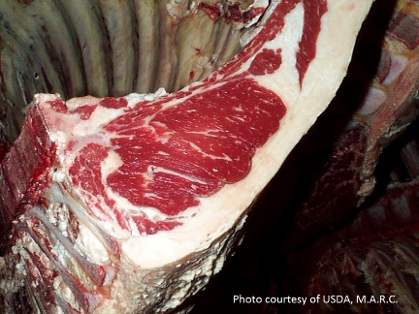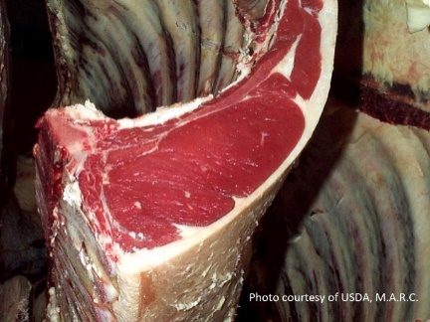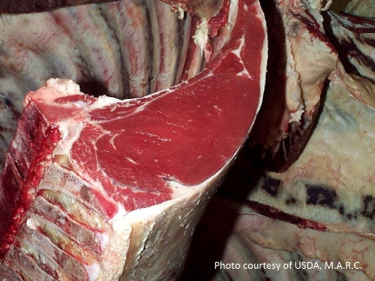The genetic differences pictured above are possible because of the law of segregation. The cattle are diploid organisms, meaning they have two sets of chromosomes. During sexual reproduction, the two sets of chromosomes are segregated. Two haploid cells called gametes are created during meiosis with one gene from each gene pair being contributed to each gametes. In the case of the myostatin gene, the offspring have a one in two (or 50%) chance of getting either the normal muscle allele, D, or the mutated allele, d.
Homozygous normal muscle,
DD
Heterozygous normal muscle,
Dd
Homozygous double muscle,
dd
A Punnett square shows what gametes are made by the parents and how segregated alleles come together to form offspring. Punnett squares are used to predict the possible genotypes of the offspring from the two adult organisms.

Activity 1: Calculating the probability of genotypes
In this activity, we will learn how to make mathematical predictions based on the segregating alleles of cattle heterozygous for the Double Muscle (Dd) gene. See the Punnett square below to visualize the resulting offspring from two heterozygous individuals being bred together.
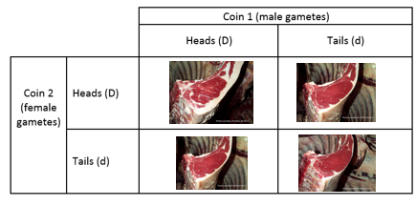
We can think of the two sides of a coin as dominant (D) and recessive (d) alleles for the Double Muscle gene pair. The coin always has two sides so it represents how heterozygous cattle have both the D and d alleles in all of their somatic cells. The result of a coin toss, being either heads (D) or tails (d), represents the segregation of alleles during gamete production. When a male or female produces gametes, only one allele of the two alleles the adults have is passed on to the offspring.
Step 1: Calculate gametes for the bull.
Step 2: Calculate gametes for the cow.
Step 3: Compare the bull and cow results.
Step 4: Predict offspring genotypes from a mating of a heterozygous bull and cow.
Step 5: Calculate the probability of each offspring type.
Step 6: Reflecting on the coin tossing results.

Step 1: For the heterozygous (Dd) male bull, calculate the percentage of D gametes and d gametes created.
- You will conduct a probability experiment by flipping a coin 10 times. Before flipping the coin, PREDICT the outcome you expect.

$\frac{}{10} × 100=$Heads (D) ________% $\frac{}{10}× 100=$ Tails (d) __________%

- Flip the coin 10 times and record your data in the space below.
Your Data
Heads | Tails

- Add your data to the board at the front of the classroom. Then fill in the table below with the classroom data.
Whole Class Data
Heads | Tails

- Calculate the percent heads your class flipped.
$$\frac{\# of heads flipped}{\# of heads and tails flipped}x 100$$
- Calculate the percent tails your class flipped.
$$\frac{\# of tails flipped}{\# of heads and tails flipped}x 100$$
- Based on the experimental data (the data from the board), about how often does a bull with genotype Dd create gametes with the D allele?
½ or 50% of the time
- About how often does the Dd bull create gametes with the d allele?
½ or 50% of the time

Step 2: For the heterozygous (Dd) female cow, calculate the percentage of D gametes and d gametes created.
Critical thinking: You are about to complete the same procedures for the female Dd cow, as you did with the Dd bull. Will your results be the same or similar for the female Dd cow? Why or why not?
The answers for step 2 will, in fact, be similar for the cow as it was with the bull. The reason for this is that both the cow and the bull are the same genotype Dd, so they will create gametes that are D and d at roughly the same frequencies. Since the answers for this part of the worksheet should be the same as part 1, look at step 1 for the answers.

- Before flipping the coin, what percent of coin tosses do you expect to be heads (the dominant trait, D) or tails (the recessive trait, d)?

$\frac{}{10} × 100=$Heads (D) ________% $\frac{}{10}× 100=$ Tails (d) __________%
- Flip the coin 10 times and record your data in the space below.
Your Data
Heads | Tails

- Add your data to the board at the front of the classroom. Then fill in the table below with the classroom data.
Whole Class Data
Heads | Tails

- Calculate the percent heads your class flipped:
$$\frac{\# of heads flipped}{\# of heads and tails flipped}x 100$$

- Calculate the percent tails your class flipped:
$$\frac{\# of tails flipped}{\# of heads and tails flipped}x 100$$

- Based on the experimental data (the data from the board), about how often does a bull with genotype Dd create gametes with the D allele?
½ or 50% of the time
- About how often does the Dd bull create gametes with the d allele?
½ or 50% of the time

Step 3: Compare the results of step 1 and 2.
- Look at your answer to question 6 in step 1 and step 2. Did you have similar answers to both of those questions? Why or why not? Hint: Think about segregation of alleles and the genotype of the male and the female.
The answers for both of the steps should be similar. They are similar because the male and female are both the same genotype (Dd). When segregation happens, about ½ of their gametes will have the D allele and the other half will have the d allele.

Step 4: Predict offspring types from a mating between the heterozygous bull and cow.
For this portion of the activity, you will work in pairs to learn how the segregation of alleles in the bull and the cow impact the type of offspring the two animals are expected to produce.
- What are the four possible allele combination that can result from crossing a heterozygous bull and cow?

_____DD_______ ______Dd______ _______dD______ ______dd________
- These 4 combinations represent what? *Hint: read the background information at the beginning of this worksheet.
These 4 combinations represent the offspring genotypes.

Step 5: Calculate the probability of each offspring type.
- Each student should have their own coin to flip. Designate one person to flip coin 1 to represent the segregation of alleles in the male bull and the other person to flip coin 2 to represent the segregation of alleles in the female cow. It may be helpful to have two different types of coins to keep track of the alleles coming from the male and from the female.
- Now, you and your partner will flip a coin at the same time. You will make a tally in the square below that represents the outcome of each round of coin tossing in the Punnett square below. You may do as many rounds of coin tossing as you think you should in order to obtain a result that you are confident represents the expected outcome.

 |  |  | Coin 1 (male gametes)
 |  |  | Heads (D) | Tails (d)
Coin 2  (female gametes) |  | Heads (D) | Both coins were heads (DD). | Head (D) from female, tail (d) from male.
 |  | Tails (d) | Tail (d) from female, head (D) from male. | Both coins were tails (dd).

- Add your data to the board at the front of the room. Once everyone has completed their coin tosses, combine the class data and write it in the chart below.

 |  | Whole Class Data
 |  | Male gametes
 |  | Heads (D) | Tails (d)
Female gametes | Heads (D) | Both coins were heads (DD). | Head (D) from female, tail (d) from male.
 | Tails (d) | Tail (d) from female, head (D) from male. | Both coins were tails (dd).

- Calculate the total number of tosses by all groups (add up the numbers in the four squares for the classroom data), write your result here. ________________

- Calculate the percent of coin tosses that were DD, dD, Dd, and dd. Divide each of the numbers you filled into the chart for question 3 of this step and divide it by the number you calculated in question 4 of this step.

 |  | Male gametes
 |  | Heads (D) | Tails (d)
Female gametes | Heads (D) | $$\frac{\# of DD tosses}{total \# of tosses}x 100$$ | $$\frac{\# of Dd tosses}{total \# of tosses}x 100$$
 | Tails (d) | $$\frac{\# of dD tosses}{total \# of tosses}x 100$$ | $$\frac{\# of dd tosses}{total \# of tosses}x 100$$

- Which of the fractions below is closest to your class’s results for DD?
0 ¼ ½ ¾ 1
- Which of the fractions below is closest to your class’s results for dD?
0 ¼ ½ ¾ 1
- Which of the fractions below is closest to your class’s results for Dd?
0 ¼ ½ ¾ 1
- Which of the fractions below is closest to your class’s results for dd?
0 ¼ ½ ¾ 1

Step 6: Implication of coin tossing results.
- If the two heterozygous (Dd) cattle have offspring, what fraction of the time does it appear that the offspring will be double-muscled (dd)?
¼
- If the two heterozygous (Dd) cattle have offspring, what fraction of the time does it appear that the offspring will be normal-muscled (DD or Dd)? Hint: You’ll need to do some adding!
¼ + ¼ + ¼ = ¾
- Using your knowledge of biology and mathematics, explain how you are able to make predictions about the genotype of offspring based on the genotype of two parents.
We can make predictions because each parent has two alleles they could pass on. If they’re two different alleles, there’s a ½ chance of passing on one of those alleles or the other one. We can multiply the probability of getting a specific allele from one parent by the probability of getting a specific allele from another parent to determine how often an offspring will get a particular genotype. We can add when we want to know the probability of getting a genotype in offspring when there are multiple ways a particular genotype (such as getting Dd and dD).

- Did the number of times you tossed the coin have an impact on the mathematical outcome of your coin toss experiment? *Hint: Think about how often you expect to flip a heads or a tails. If you flip the coin twice, will you get what you expect? As you flip the coin more and more times, do you think you will get closer to the number of heads and tails you should get in terms of percentage?
As the students flip the coins more and more times, they should notice that they get closer and closer to 50% of the coin tosses being heads and 50% being tails. Having more data means there’s less chance (or random error) happening in the data.
- Imagine that we could test for the same trait in mice. The gestation period for mice is 19-21 days compared to 274 days for cattle. In addition, a mouse produces 6-8 offspring per litter compared to 1 offspring produced per cow.
Based on your answer from #4 of this step, would you rather work with a trait in mice or a trait in cattle for inheritance studies? *Hint: Is there an advantage to quickly producing lots of mice as compared to a few cattle?
The advantage of mice is that they can breed quickly, so you can quickly get data and minimize error due to chance.

Introduction to Pedigrees
Geneticists use pedigrees to understand the genetic relationship between organisms in a family. In this worksheet, we will practice creating a pedigree relating to double muscling and making predictions from the pedigree.
A beef rancher, Walter, recently had a calf born to his herd with unusually large muscles. Lance, another one of his cattle, seems to have the same condition. Out of curiosity and concern, Walter searched the Internet for an explanation of the calf’s condition.
Soon, Walter discovered a genetic condition that causes double muscling in cattle when two recessive (dd) genes are present. To Walter’s relief, the condition itself is not fatal. Walter learns that the double muscle trait has advantages and disadvantages. Double-muscled cattle have a higher birth weight, rib eye area, feed efficiency, and improved retail product yield. However, cows delivering double-muscled calves have difficulty with labor due to the larger size of the calf and the double-muscled cows show decreased female fertility and lower stress tolerance.
In light of this information, Walter decides to start tracking double-muscling in his cattle via a pedigree. Walter needs some help with updating his current pedigree for the cattle on his land. Below is the pedigree with limited information recorded. 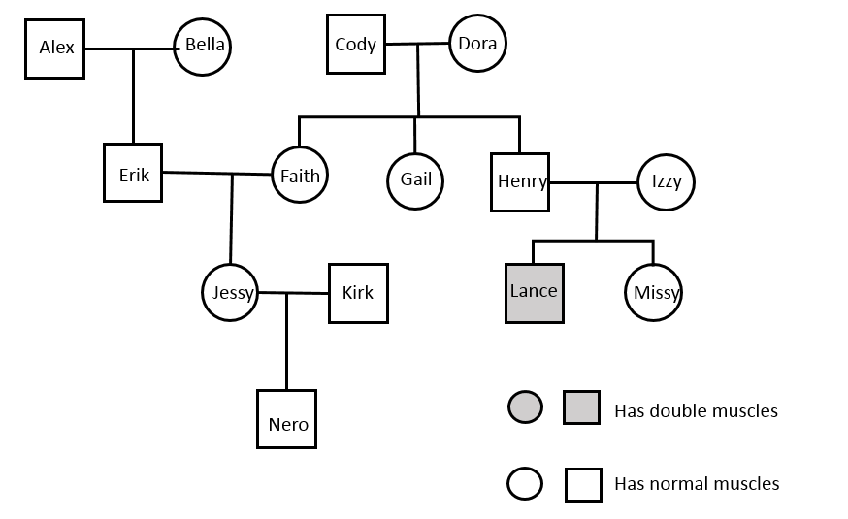
Female
Male

Activity 2: Amending the Pedigree and Determining Genotypes
Help Walter out by adding the following information to the pedigree:
- Jessy and Kirk had two more calves after Nero: Omar (a male) and Penelope (a female).
- Penelope is the young female calf who is double-muscled.
- Walter talked with the previous owners of Dora. According to the previous owners, Dora once had a male calf that was double-muscled.
- Walter also reveals that Alex has never been on his farm. Walter had Bella artificially inseminated with sperm from Alex. Amidst the paperwork telling Walter about Alex’s genetic history, he sees that double-muscling is NOT something Alex is a carrier for.
Teacher note: The fact that Bella was artificially inseminated may mean Walter, the farmer, has less phenotypic or genotypic information about the bull than other bulls he has raised himself. Walter took the initiative to ask about the bull’s genotype or the phenotypic information of his offspring to get additional information about the sperm donor that will help Walter make predictions about his herd.
Updated Pedigree
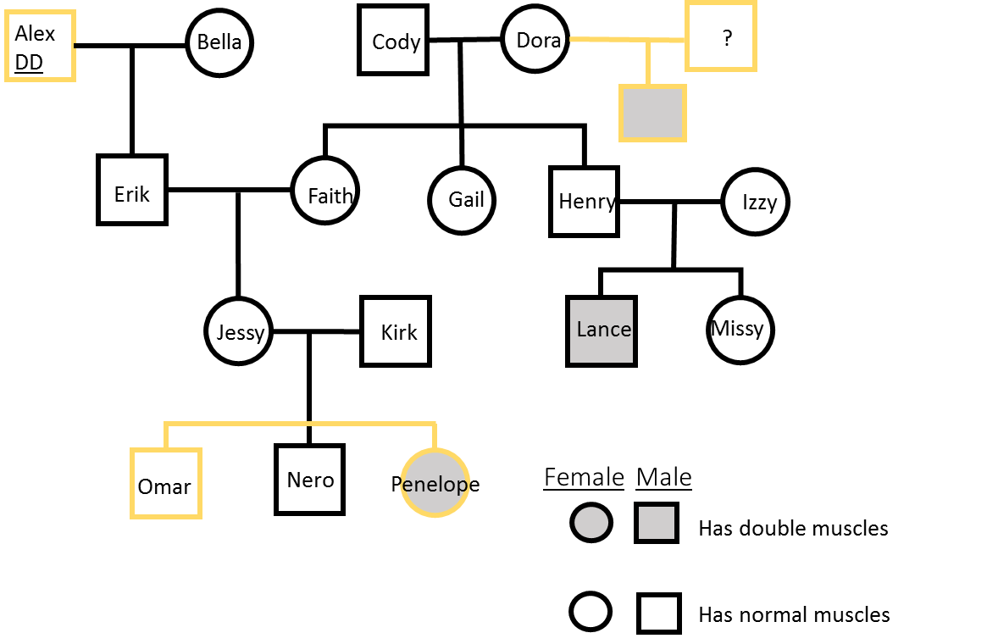

Known and Unknown Genotypes
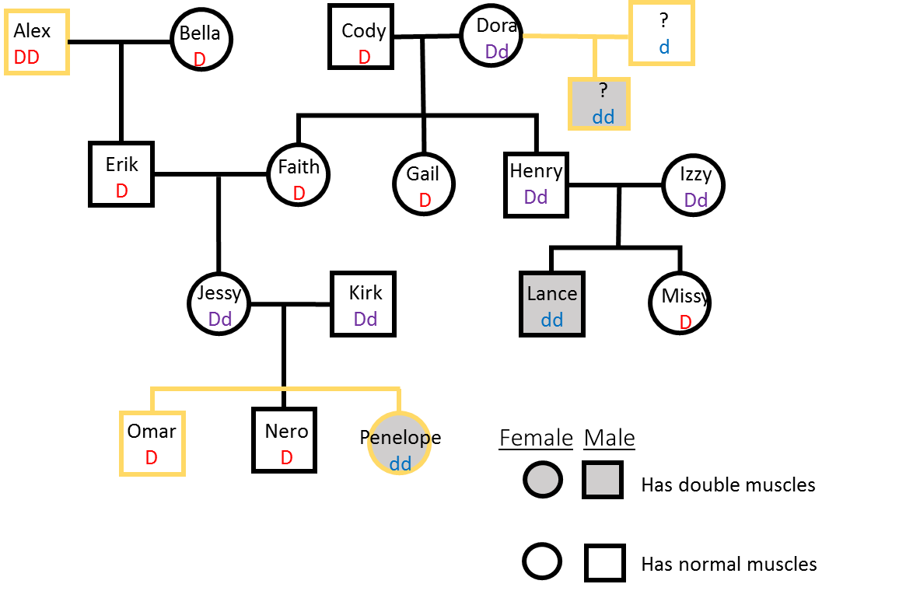
Teacher refresher:
Genotype is the allelic composition of a cell or organism, usually represented with a mix of capital and lower case letters (such as DD, Dd, and dd).
Phenotype is the physical appearance of an animal. In this instance, you can see if the animal has double muscles or is normal.
The shaded symbols in the pedigree above provide you with phenotypic information that you can use to help determine genotypic information.
In pedigrees, the males are squares and the females are circles. A horizontal line going from a male to a female is a mating. Horizontal lines with small vertical lines attached to squares or circles indicate offspring that are siblings.

Answer the following questions about the genotypes of the cattle in Walter’s herd.
- What do you know about Penelope’s genotype?
dd
- What do you know about Kirk’s genotype?
Dd
- What do you know about Jessy’s genotype?
Dd

- What do you know about Faith’s genotype?
DD or Dd
- What do you know about Erik’s genotype?
DD or Dd
- What do you know about Nero’s genotype?
DD or Dd
- Could Gail be a carrier of the double-muscle gene? Draw a Punnett square to justify your answer.
Yes. Cody is either Dd or DD. Whether he’s DD or Dd, Gail can still be a carrier.
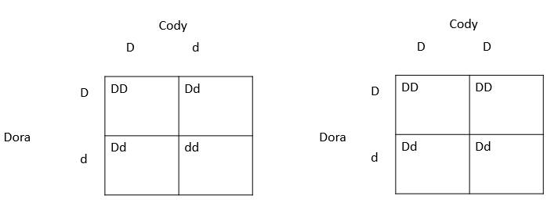
- Could Missy be a carrier of the double-muscle gene? Draw a Punnett square to justify your answer.
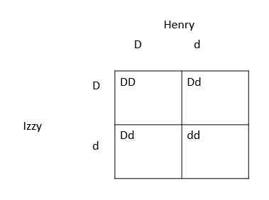
Yes. Students will need to show a Punnett square of Missy’s parents, Henry and Izzy.

- Which cattle in Walter’s herd could be crossed to guarantee a double-muscled offspring?
Penelope and Lance are both dd for the double muscle mutation. If they were crossed, they would have a 100% chance of producing only double-muscled offspring.

- If Walter wants to avoid double-muscled offspring, which cattle should he cross? Why?
Alex is the only known bull that is not a carrier. Therefore, crossing Alex with any cow that is not double-muscled will produce offspring that are not double muscled.

