Double the Muscle: Probabilities and Pedigrees

Student Name _________________________________________
Introduction to the Double Muscle Trait
In some organisms, including cattle, a recessive genetic mutation will result in the inactivation of a gene that produces myostatin, a negative regulator of skeletal muscle growth. Cattle born with two recessive alleles will have higher muscle mass and less fat. The differences you see below are due to hyperplasia and hypertrophy.

Hyperplasia: the enlargement of an organ or tissue caused by an increase in the reproduction of its cells
Hypertrophy: an enlargement of an organ or tissue caused by an increase in the size of individual cells within the organ or tissue

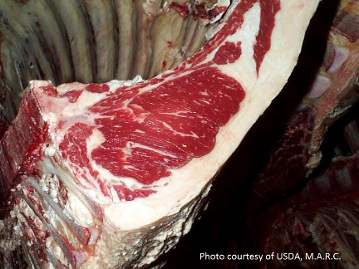
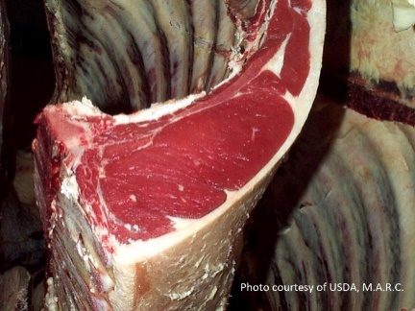
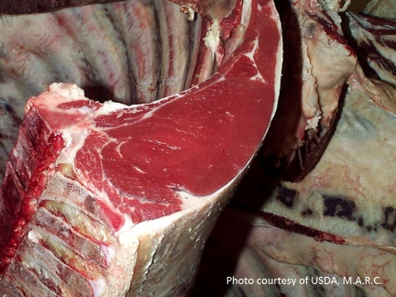
The genetic differences pictured above are possible because of the law of segregation. The cattle are diploid organisms, meaning they have two sets of chromosomes. During sexual reproduction, the two sets of chromosomes are segregated. Two haploid cells called gametes are created during meiosis with one gene from each gene pair being contributed to each gametes. In the case of the myostatin gene, the offspring have a one in two (or 50%) chance of getting either the normal muscle allele, D, or the mutated allele, d.
Homozygous normal muscle,
DD
Heterozygous normal muscle,
Dd
Homozygous double muscle,
dd
A Punnett square shows what gametes are made by the parents and how segregated alleles come together to form offspring. Punnett squares are used to predict the possible genotypes of the offspring from the two adult organisms.

Activity 1: Calculating the probability of genotypes
In this activity, we will learn how to make mathematical predictions based on the segregating alleles of cattle heterozygous for the Double Muscle (Dd) gene. See the Punnett square below to visualize the resulting offspring from two heterozygous individuals being bred together.
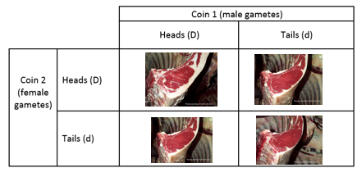
We can think of the two sides of a coin as dominant (D) and recessive (d) alleles for the Double Muscle gene pair. The coin always has two sides so it represents how heterozygous cattle have both the D and d alleles in all of their somatic cells. The result of a coin toss, being either heads (D) or tails (d), represents the segregation of alleles during gamete production. When a male or female produces gametes, only one allele of the two alleles the adults have is passed on to the offspring.
Step 1: Calculate gametes for the bull.
Step 2: Calculate gametes for the cow.
Step 3: Compare the bull and cow results.
Step 4: Predict offspring genotypes from a mating of a heterozygous bull and cow.
Step 5: Calculate the probability of each offspring type.
Step 6: Reflect on the coin tossing results and implications.

Step 1: For the heterozygous (Dd) male bull, calculate the percentage of D gametes and d gametes created.
- You will conduct a probability experiment by flipping a coin 10 times. Before flipping the coin, PREDICT the outcome you expect.

$\frac{}{10} × 100=$Heads (D) ________% $\frac{}{10}× 100=$ Tails (d) __________%

- Flip the coin 10 times and record your data in the space below.
Your Data
Heads | Tails

- Add your data to the board at the front of the classroom. Then fill in the table below with the classroom data.
Whole Class Data
Heads | Tails

- Calculate the percent heads your class flipped.

- Calculate the percent tails your class flipped.

- Based on the experimental data (the data from the board), about how often does a bull with genotype Dd create gametes with the D allele?

- About how often does the Dd bull create gametes with the d allele?

Step 2: For the heterozygous (Dd) female cow, calculate the percentage of D gametes and d gametes created.
Critical thinking: You are about to complete the same procedures for the female Dd cow, as you did with the Dd bull. Will your results be the same or similar for the female Dd cow? Why or why not?

- Before flipping the coin, what percent of coin tosses do you expect to be heads (the dominant trait, D) or tails (the recessive trait, d)?

$\frac{}{10} × 100=$Heads (D) ________% $\frac{}{10}× 100=$ Tails (d) __________%
- Flip the coin 10 times and record your data in the space below.
Your Data
Heads | Tails

- Add your data to the board at the front of the classroom. Then fill in the table below with the classroom data.
Whole Class Data
Heads | Tails

- Calculate the percent heads your class flipped:

- Calculate the percent tails your class flipped:

- Based on the experimental data (the data from the board), about how often does a bull with genotype Dd create gametes with the D allele?

- About how often does the Dd bull create gametes with the d allele?

Step 3: Compare the results of step 1 and 2.
- Look at your answer to question 6 in step 1 and step 2. Did you have similar answers to both of those questions? Why or why not? Hint: Think about segregation of alleles and the genotype of the male and the female.

Step 4: Predict offspring types from a mating between the heterozygous bull and cow.
For this portion of the activity, you will work in pairs to learn how the segregation of alleles in the bull and the cow impact the type of offspring the two animals are expected to produce.
- What are the four possible allele combination that can result from crossing a heterozygous bull and cow?

____________ ____________ _____________ ______________
- These 4 combinations represent what? *Hint: read the background information at the beginning of this worksheet.

Step 5: Calculate the probability of each offspring type.
- Each student should have their own coin to flip. Designate one person to flip coin 1 to represent the segregation of alleles in the male bull and the other person to flip coin 2 to represent the segregation of alleles in the female cow. It may be helpful to have two different types of coins to keep track of the alleles coming from the male and from the female.
- Now, you and your partner will flip a coin at the same time. You will make a tally in the square below that represents the outcome of each round of coin tossing in the Punnett square below. You may do as many rounds of coin tossing as you think you should in order to obtain a result that you are confident represents the expected outcome.

 |  |  | Coin 1 (male gametes)
 |  |  | Heads (D) | Tails (d)
Coin 2  (female gametes) |  | Heads (D) | Both coins were heads (DD). | Head (D) from female, tail (d) from male.
 |  | Tails (d) | Tail (d) from female, head (D) from male. | Both coins were tails (dd).

- Add your data to the board at the front of the room. Once everyone has completed their coin tosses, combine the class data and write it in the chart below.

 |  | Whole Class Data
 |  | Male gametes
 |  | Heads (D) | Tails (d)
Female gametes | Heads (D) | Both coins were heads (DD). | Head (D) from female, tail (d) from male.
 | Tails (d) | Tail (d) from female, head (D) from male. | Both coins were tails (dd).

- Calculate the total number of tosses by all groups (add up the numbers in the four squares for the classroom data), write your result here. ________________

- Calculate the percent of coin tosses that were DD, dD, Dd, and dd. Divide each of the numbers you filled into the chart for question 3 of this step and divide it by the number you calculated in question 4 of this step.

 |  | Male gametes
 |  | Heads (D) | Tails (d)
Female gametes | Heads (D) | $$\frac{\# of DD tosses}{total \# of tosses}x 100$$ | $$\frac{\# of Dd tosses}{total \# of tosses}x 100$$
 | Tails (d) | $$\frac{\# of dD tosses}{total \# of tosses}x 100$$ | $$\frac{\# of dd tosses}{total \# of tosses}x 100$$

- Which of the fractions below is closest to your class’s results for DD?
0 ¼ ½ ¾ 1
- Which of the fractions below is closest to your class’s results for dD?
0 ¼ ½ ¾ 1
- Which of the fractions below is closest to your class’s results for Dd?
0 ¼ ½ ¾ 1
- Which of the fractions below is closest to your class’s results for dd?
0 ¼ ½ ¾ 1

Step 6: Implication of coin tossing results.
- If the two heterozygous (Dd) cattle have offspring, what fraction of the time does it appear that the offspring will be double-muscled (dd)?

- If the two heterozygous (Dd) cattle have offspring, what fraction of the time does it appear that the offspring will be normal-muscled (DD or Dd)? Hint: You’ll need to do some adding!

- Using your knowledge of biology and mathematics, explain how you are able to make predictions about the genotype of offspring based on the genotype of two parents.

- Did the number of times you tossed the coin have an impact on the mathematical outcome of your coin toss experiment? *Hint: Think about how often you expect to flip a heads or a tails. If you flip the coin twice, will you get what you expect? As you flip the coin more and more times, do you think you will get closer to the number of heads and tails you should get in terms of percentage?

- Imagine that we could test for the same trait in mice. The gestation period for mice is 19-21 days compared to 274 days for cattle. In addition, a mouse produces 6-8 offspring per litter compared to 1 offspring produced per cow.
Based on your answer from #4 of this step, would you rather work with a trait in mice or a trait in cattle for inheritance studies? *Hint: Is there an advantage to quickly producing lots of mice as compared to a few cattle?

Introduction to Pedigrees
Geneticists use pedigrees to understand the genetic relationship between organisms in a family. In this worksheet, we will practice creating a pedigree relating to double muscling and making predictions from the pedigree.
A beef rancher, Walter, recently had a calf born to his herd with unusually large muscles. Lance, another one of his cattle, seems to have the same condition. Out of curiosity and concern, Walter searched the Internet for an explanation of the calf’s condition.
Soon, Walter discovered a genetic condition that causes double muscling in cattle when two recessive (dd) genes are present. To Walter’s relief, the condition itself is not fatal. Walter learns that the double muscle trait has advantages and disadvantages. Double-muscled cattle have a higher birth weight, rib eye area, feed efficiency, and improved retail product yield. However, cows delivering double-muscled calves have difficulty with labor due to the larger size of the calf and the double-muscled cows show decreased female fertility and lower stress tolerance.
In light of this information, Walter decides to start tracking double-muscling in his cattle via a pedigree. Walter needs some help with updating his current pedigree for the cattle on his land. Below is the pedigree with limited information recorded. 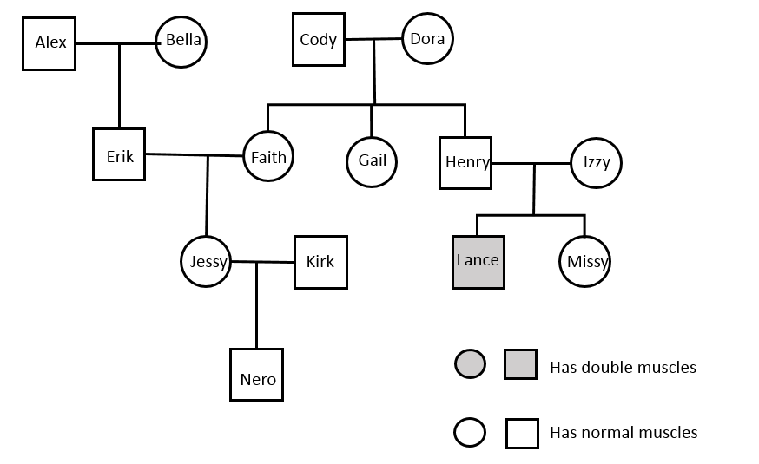
Female
Male

Activity 2: Amending the Pedigree and Determining Genotypes
Help Walter out by adding the following information to the pedigree:
- Jessy and Kirk had two more calves after Nero: Omar (a male) and Penelope (a female).
- Penelope is the young female calf who is double-muscled.
- Walter talked with the previous owners of Dora. According to the previous owners, Dora once had a male calf that was double-muscled.
- Walter also reveals that Alex has never been on his farm. Walter had Bella artificially inseminated with sperm from Alex. Amidst the paperwork telling Walter about Alex’s genetic history, he sees that double-muscling is NOT something Alex is a carrier for.

Answer the following questions about the genotypes of the cattle in Walter’s herd.
- What do you know about Penelope’s genotype?

- What do you know about Kirk’s genotype?

- What do you know about Jessy’s genotype?

- What do you know about Faith’s genotype?

- What do you know about Erik’s genotype?

- What do you know about Nero’s genotype?

- Could Gail be a carrier of the double-muscle gene? Draw a Punnett square to justify your answer.

- Could Missy be a carrier of the double-muscle gene? Draw a Punnett square to justify your answer.

- Which cattle in Walter’s herd could be crossed to guarantee a double-muscled offspring?

- If Walter wants to avoid double-muscled offspring, which cattle should he cross? Why?

