Conserving Bumble Bees
Teacher Resources

Summary
This standards-aligned, 5-E lesson provides students with a case study approach examining bumble bee population surveys and conservation strategies. Students will examine and evaluate real-world data about the challenge growers face today in conserving important native pollinators—bumble bees. Bumble bees are important pollinators of several high-value crops including tomatoes, peppers, and strawberries. Students will examine data in graphical format to determine if there is evidence of declining bumble bee populations. Then, possible causes for this decline are discussed. Students will examine data to determine which land management conservation strategies in agricultural ecosystems are most successful in attracting and supporting bumble bee populations.

Grade Level
9-12

Contents address the following Next Generation Science Standards
- HS-LS2-1. Use mathematical and/or computational representations to support explanations of factors that affect carrying capacity of ecosystems at different scales.
- HS-LS4-5. Evaluate the evidence supporting claims that changes in environmental conditions may result in: (1) increases in the number of individuals of some species, (2) the emergence of new species over time, and (3) the extinction of other species.

Author
Erin Ingram, Curriculum Development Specialist, University of Nebraska-Lincoln, IANR Science Literacy

Background

Standards
Next Generation Science Standards
- HS-LS2-1. Use mathematical and/or computational representations to support explanations of factors that affect carrying capacity of ecosystems at different scales.
- HS-LS4-5. Evaluate the evidence supporting claims that changes in environmental conditions may result in: (1) increases in the number of individuals of some species, (2) the emergence of new species over time, and (3) the extinction of other species.
Common Core
CCSS.ELA-LITERACY.CCRA.R.1
- Read closely to determine what the text says explicitly and to make logical inferences from it; cite specific textual evidence when writing or speaking to support conclusions drawn from the text.

Estimated Time
1-2, 50-minute class periods

Student Materials
- Student worksheet

Vocabulary
- dependent variable: a factor that can is measured over the course of an experiment; change will be based on the independent variable
- independent variable: a factor that is changed by the scientist
- control group: a group that does not receive a treatment; minimized the effects of variables other than the independent variable; allows for comparison of treatment effects
- confounding factor: a variable that is not able to be controlled by the scientist and may impact the dependent variable
- replication: multiple runs of the same experimental conditions are conducted to determine if an outcome is consistent and predictable; reduces variability in experimental results, increasing their significance and the confidence level with which a researcher can draw conclusions about an experimental factor

Key STEM Ideas
An important part of making informed decisions about socioscientific issues requires students to examine and evaluate data to determine if a problem exists, identify potential causes of the problem, and evaluate solutions as they are implemented under real-world conditions. This lesson provides students with the opportunity to become familiar with methods used by real scientists to identify population declines in species of bumble bees and use real-world data to identify and select successful conservation strategies that can be used by growers wanting to balance agricultural production while minimizing environmental impacts.

Students’ Prior Knowledge
Students should be familiar with designing experiments and knowledgeable of vocabulary including dependent and independent variable, control treatment, confounding factor, and replication. A very basic understanding of bumble bee biology would also be helpful (such as understanding of the mutualistic relationship between bees and flowers).

Connections to Agriculture
Bumble bee conservation is a real concern for growers depending on their specialized pollination services for tomato, peppers, and strawberries. In order to show a need for federal or state protections and affect agricultural policy, researchers must show evidence of population declines. However, it can be difficult to determine if declines are occurring if baseline data is absent or inaccessible.

If declines can be determined, researchers can then begin to examine potential causes of the decline and evaluate solutions to the problem. In the case of bumble bee decline in the U.S., researchers suspect that habitat and foraging resource loss is a limiting factor in agro-ecosystems’ ability to support bumble bee populations.

Another step toward conservation of bumble bees requires researchers to compare land management strategies and their effect on bumble bee species’ abundance and diversity.

Essential Links
- Washington Post article “The enormous threat to America’s last grasslands” - https://www.washingtonpost.com/news/energy-environment/wp/2016/06/16/the-enormous-but-forgotten-threat-to-americas-last-grasslands/?postshare=4371466435192774&tid=ss_fb

Sources/Credits
Data and graphs were used from the following works:
Calderone, N. W. (2012). Insect Pollinated Crops, Insect Pollinators and US Agriculture: Trend Analysis of Aggregate Data for the Period 1992–2009. PLoS ONE, 7(5), e37235. http://doi.org/10.1371/journal.pone.0037235

Cameron, S. A., Lozier, J. D., Strange, J. P., Koch, J. B., Cordes, N., Solter, L. F., & Griswold, T. L. (2011). Patterns of widespread decline in North American bumble bees. Proceedings of the National Academy of Sciences, 108(2), 662–667.

Carvell, C., Meek, W. R., Pywell, R. F., Goulson, D., & Nowakowski, M. (2007). Comparing the efficacy of agri-environment schemes to enhance bumble bee abundance and diversity on arable field margins. Journal of Applied Ecology, 44(1), 29–40.

Colla, S. R., Otterstatter, M. C., Gegear, R. J., & Thomson, J. D. (2006). Plight of the bumble bee: pathogen spillover from commercial to wild populations. Biological Conservation, 129(4), 461–467.

Gallant, A. L., Sadinski, W., Roth, M. F., & Rewa, C. A. (2011). Changes in historical Iowa land cover as context for assessing the environmental benefits of current and future conservation efforts on agricultural lands. Journal of Soil and Water Conservation, 66(3), 67A–77A. http://doi.org/10.2489/jswc.66.3.67A

Goulson, D., Lye, G. C., & Darvill, B. (2008). Decline and conservation of bumble bees. Annu. Rev. Entomol., 53, 191–208.

Lesson Procedures
Engage
- Show students a real tomato or picture of a tomato. Have students discuss what is needed to produce this crop.
- Facilitate discussion of the need for proper growing conditions (soil, nutrients, light, temperature, moisture) and adequate pollination specifically by bumble bees.
Explore
Part 1: Value of Pollinators and Introducing the Problem
- Distribute the student worksheet.
- Read Part 1 with students to provide context for the issue of conserving bumble bees.
- Discuss the agricultural and natural ecosystem implications if bumble bees were no longer providing pollination services.
- Consider discussing questions such as…
  - Could other pollinators take their place?
    - No, bumble bees are some of the few species that can buzz pollinate.
  - What would happen to wild plants that rely on bumble bees for pollination?
    - If no other pollinator could adequately pollinate these plants, no seeds would be produced and the plant population would decline or possibly become extinct.
  - What effect might the loss of bumble bees have on consumers?
    - Crops pollinated by bumble bees would likely be more expensive, or might be unavailable.
- Read the section “The Problem: Pollinators in Peril” with students.

Explain
- Using what they learned from the reading, have students explain how scientists can tell if a species is in decline or not.
  - Students should understand that historical baseline data is necessary to determine if populations are declining.
  - It should be reiterated that in some cases, historical data or counts are simply not available making it impossible to provide evidence of population declines.
  - Have students discuss why consistent and repeatable survey methods are so important when comparing historical abundance counts to current abundance counts.
- Introduce students to the idea of measuring relative abundance. Relative abundance is one way of determining if the proportion of each species has remained stable over time or has changed.
- You may wish to provide students with a relatable example by comparing relative abundance of girls to boys in the class (# of girls/total vs. #of boys/total).
- Have students examine the chart on page 2.
- Answer the questions as a whole class or in small groups and compare their answers.

Extend
- Once students are confident in reading a graph of relative abundance, they can individually work to examine figure 5 on page 3 and answer the three follow-up questions.
Explore
Part 2: Likely Culprits of Bumble Bee Decline?
- Now that students have seen evidence of population decline in some bumble bee species, students can begin to formulate ideas or hypotheses of why this decline might be happening.
- Provide a very brief discussion of what bumble bees need to survive provided on page 4:
  - High-quality habitat for nesting
  - Plentiful food and water resources nearby throughout the spring, summer, and fall
  - An environment relatively free of pests, parasites, pathogens, and pesticides
Explain
- Have students formulate a hypothesis about factors that might impact bumble bee populations.
- Have students discuss their answers in small groups and determine which factors are driven by human actions.
- Have students read the excerpt from the blog post by Matt Miller from the Nature Conservancy. Facilitate a discussion comparing the factors they came up with and some of the factors discussed in the blog post. Were any factors missing? Did any factors surprise them?
Extend
- Have students answer the follow-up questions individually.
- Discuss student answers as a whole class. Matt Miller does not explicitly state what actions should be taken to help conserve pollinators. However, students can discuss what personal actions might be inferred from the context provided in the article.
  - Matt indicates that habitat restoration and foraging resource provision even on a small scale could help reverse trends of pollinator decline.
Explore
Part 3: Taking a Closer Look at Habitat Loss
- Read part 3 in small groups and have students discuss how land has changed over time.
- Discuss the role of humans in land use change and the importance of balancing food, fuel, and fiber production with sustainable use of natural resources (such as converting land from native prairie to agricultural production).
- As a supplement to this discussion, you may have students read an article from The Washington Post published on June 16, 2016 about the threat to grasslands in the U.S. found here: https://www.washingtonpost.com/news/energy-environment/wp/2016/06/16/the-enormous-but-forgotten-threat-to-americas-last-grasslands/?postshare=4371466435192774&tid=ss_fb
- This section provides a great opportunity to facilitate a discussion of how we should decide what land is used for agricultural production and what is left undisturbed to protect biodiversity.
  - Should money be spent to protect animals such as bumble bees and the native plants they pollinate?
  - Who should decide this?
  - What things should be considered when making this decision?
Explain
- Have students work individually or in small groups to design an experiment to test the effect of land management strategies on bumble bee abundance.
- Discuss their experimental design as a whole class. Be sure students discuss…
  - What the independent and dependent variables are
  - Their control treatment
  - How they will replicate their experiment
  - Confounding factors that should be considered
Extend
- Read the section “Examining the Effectiveness of Conservation Strategies”.
- Have students examine the graph of bee forage flower abundance in relation to number of bumble bees.
- Have students answer the follow-up questions
  - Discuss the trends they observed across land management type for
    - Bee forage flower abundance
    - Number of bumble bees
- What correlation or relationship do they see between these two variables?
- Which land management strategy would they recommend to growers?
- Have students reflect on what they have learned about bumble bee decline and conservation strategies. How can they use the data presented to inform agricultural policy?
Evaluate
- An evaluation of student understanding can be determined using the answers in the student worksheet and participation in small group work.

Conserving Bumble Bees: TEACHER NOTES
Part 1: Value of Pollinators
Insects are responsible for the pollination of approximately 80% of all flowering plants including both wild plants and agricultural crops. With adequate pollination, plants produce fruits, nuts, and berries which are consumed by humans and other animals. Proper pollination also produces seed allowing for plant reproduction in the wild and continued agricultural crop propagation.

According to a Cornell University study, honey bees and other insect pollinators in the U.S. contribute an estimated $29 billion dollars annually in farm income (Calderone, 2012). U.S. agriculture gains approximately $15 billion of this total value from honey bee pollination alone, but often overlooked are the specialized pollination services provided by bumble bees.

Bumble bees exhibit a unique behavior known as “buzz pollination,” in which the bee hangs upside down on a flower and vibrates her wing muscles causing the release of large amounts of pollen. Buzz pollination is especially valued by growers of tomatoes, peppers, and cranberries because it leads to better fruit set than pollination by honey bees. In addition, bumble bees are some of the only species which function effectively in greenhouse settings where crops such as tomatoes, sweet peppers, and strawberries are grown.
Figure 1: Bumble bee on red clover
Photo credit: Erin Ingram

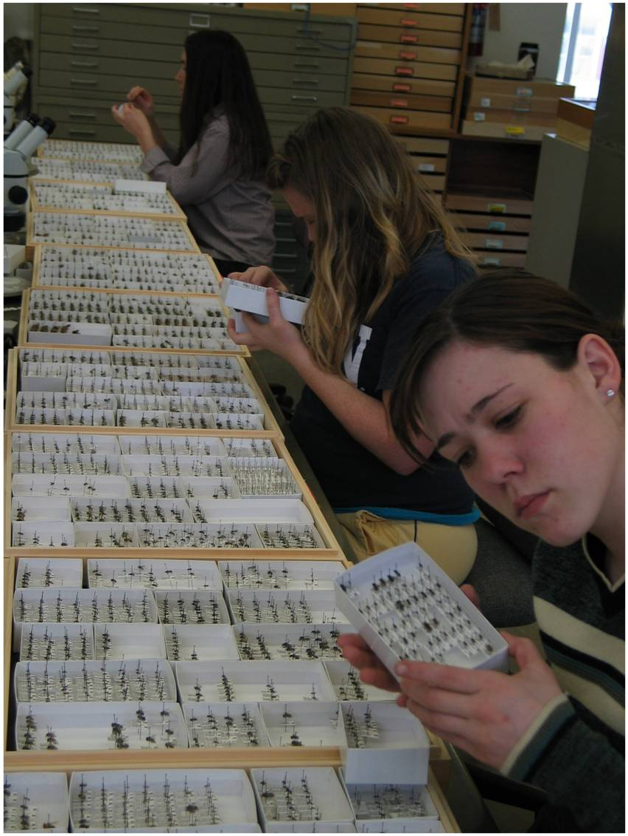
The Problem: Pollinators in Peril
Figure 2: Researchers examining an insect collection for historical information
Photo credit: USDA ARS
Over the past decade, reports of declining honey bee health have dominated news headlines and captured the attention of the public. Concern for pollinator well-being should also be expanded to include the nearly 4,500 other bee species in North America. Many of these valuable pollinators, including native bumble bees, may also be experiencing population declines.

So how do researchers go about determining if wild bee populations are increasing, decreasing, or remaining stable? The first step is identifying if historical monitoring data exists and accessing it. This may require researchers to examine well-curated insect collections to determine abundance and distribution of a species in previous years (Figure 2). If this information is unavailable or inaccessible, researchers will face the challenge of being unable to compare current bee counts with historical, baseline data. Rather than providing evidence of a population trending up or down, researchers may only be able to present a “snapshot” of the current population.
Bumble bee species examined
Populations suspected to be in decline | Populations suspected to be relatively stable
- Bombus affinis | - Bombus bifarius
- Bombus occidentalis | - Bombus vosnesenskii
- Bombus pensylvanicus | - Bombus bimaculatus
- Bombus terricola | - Bombus impatiens

Figure 3: Target species examined in 2007-2009 U.S. bumble bee survey from Cameron et al., 2011
In the mid-2000’s, researchers in pointed out the severe lack of data on pollinator abundance and distribution. In addition, existing bee surveys often relied on sampling methods which were not standardized or repeatable. To address this issue, various research groups worked together to conduct a large-scale, systematic bumble bee survey in the U.S. (Cameron et al., 2011). The aim was to gather data on abundance, species diversity, and distribution of eight target bumble bee species. All eight species were historically common, but anecdotal reports indicated that some species might be in decline. Of the eight species, four were suspected to be in decline while the remaining four were assumed to be relatively stable (Figure 3).

Using recent data and historical records, researchers could determine population trends by examining a species’ relative abundance compared to other bumble bee target species over time. Relative abundance can be calculated by dividing the number of individuals of the target species by the total number of other target species collected in the same region.

Relative abundance = $\frac{ \# of target species individuals}{total \# of all target species of interest in the region}$

For example, in this survey, only two of the target bee species (B. bifarius and B. occidentalis) are found in the global west region (including the states of AZ, CA, CO, ID, MT, NM, NV, OR, SD, UT, WA, and WY). To determine if the B. occidentalis population was in decline, researchers calculated the relative abundance for the historical period (1900-1999, black bars) and compared this to the relative abundance of the recent collection period (2007-2009, grey bars).
Relative Abundance
- What trend in the B. occidentalis population do you observe in this graph?
The relative abundance decreased (or declined over time.
- Approximately how much did the relative abundance of B. occidentalis change over time?
The relative abundance decreased from about 30% to <5%.
Figure 4 from Cameron et al., 2011: Black bars are 1900-1999, gray bars are 2007-2009.
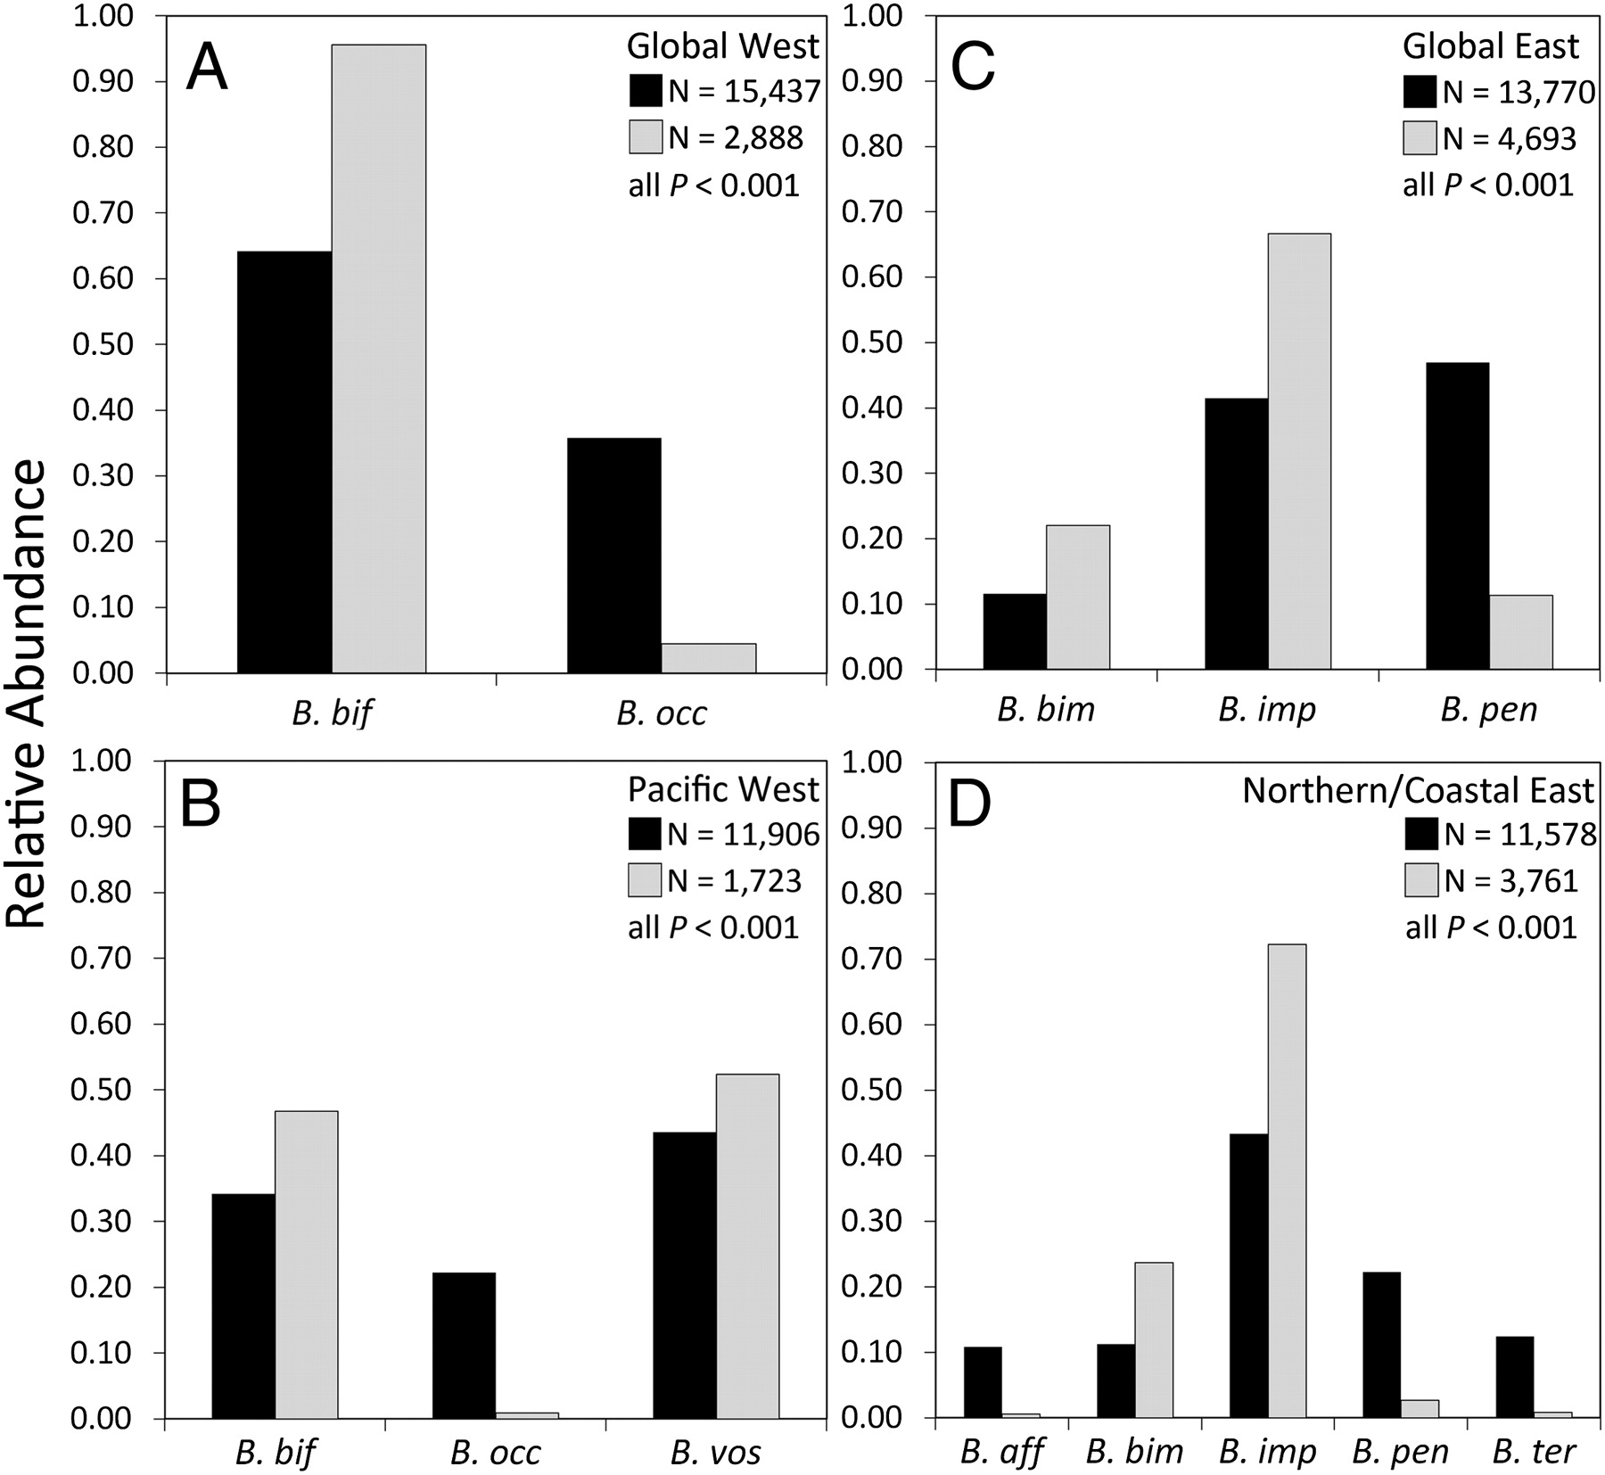
Figure 5 from Cameron et al., 2011. Black bars indicate 1900-1999. Grey bars indicate 2007-2009. Key to species names: B. aff = Bombus affinis; B. bif = Bombus bifarius; B. bim = Bombus bimaculatus; B. imp = Bombus impatiens; B. occ = Bombus occidentalis; B. pen = Bombus pensylvanicus; B. ter = Bombus terricola; B. vos = Bombus vosnesenskii.

Examine figure 5 above indicating relative abundance of eight bumble bee species in four U.S. regions.
- Compare the population trends of B. pensylvanicus in the Global East and Northern/Coastal East.
In both cases, B. pensylvanicus declined. However, in the Global East the relative abundance decreased from ~45% to ~10% and in the Northern/Coastal East it decreased from ~20% to ~2%.

- In each of the regions, which bumble bee species’ populations show evidence of decline?
Global West: Bombus occidentalis
Pacific West: Bombus occidentalis
Global East: B. pensylvanicus
Northern/Coastal East: B. affinis, B. pensylvanicus, B. terricola

- Which bee species are NOT experiencing decline in the Pacific West? How do you know?
Bombus bifarius and B. vosnesenskii do not appear to be declining because their relative abundance went up in the latest population survey in 2007-2009.

Part 2: Likely Culprits of Bumble Bee Decline?
Before we can begin to hypothesize reasons for the decrease in some bumble bee populations, we first need to consider what bumble bees need in order to survive.
Bumble bees need…
- High-quality habitat for nesting
- Plentiful food and water resources nearby throughout the spring, summer, and fall
- An environment relatively free of pests, parasites, pathogens, and pesticides

- What are three factors you think might have a negative impact on bumble bee populations?
Student answers will vary. Accept all reasonable answers.

- Which, if any, of these factors are related to human actions? Discuss these factors with a partner.
Student answers will vary. Accept all reasonable answers.

The selected excerpt below is from a Nature Conservancy blog post entitled “Plight of the Bumble Bee: Conserving Imperiled Native Pollinators” from Matt Miller. The post provides us with a glimpse of the potential factors playing a role in bumble bee declines.
Where Have All the Pollinators Gone?
An incident in an Oregon parking lot last summer dramatically illustrated the plight faced by native pollinators.
At a mall parking lot in Wilsonville, people began finding dead bumble bees – unbelievable numbers of dead bumble bees. It turned out to be the largest bumble bee die-off ever recorded, with more than 50,000 dead bees littering the area.
A wildlife mystery? Not quite.
It turns out that someone had sprayed 55 flowering trees with a pesticide known as a neonicotinoid, legal for use but deadly for insects, including beneficial ones like pollinators.
…
In addition to pesticides, bumble bees face a long list of other threats – habitat loss, climate change, competition from non-native bees, introduced diseases.
According to the Xerces Society, habitat loss in particular is having a profound effect on bumble bees (and other native pollinators).
Bumble bees need a mix of native plants to feed on as well as grassy areas to burrow. They once found this habitat in plenty on the edges of farms and yards, and even in roadside ditches. But there has been a tendency to “clean up” – to remove the wilder edges around human development.
That’s bad for bees and other pollinators.
A neatly trimmed grass lawn may be green but it’s not green – especially if it is sprayed with pesticides and all native plants are removed.
We often think of habitat loss as an irreversible problem, or one that can be solved only by intensive restoration activities. If a subdivision goes in and takes out part of a wolverine’s range, it is not like you can plant a few trees and bring back wolverines.
But with bumble bees, you can reverse habitat loss. Yards, ditches and abandoned lots can make a big difference. Your personal actions can save native pollinators – protecting not only cool critters but also vital ecosystem services.

- What are three factors that Matt suggests are threatening bumble bees and other pollinators?
Three of the following: Pesticide exposure, habitat loss, climate change, competition from non-native bees, introduced diseases.
Matt Miller states in his blog post “Yards, ditches and abandoned lots can make a big difference. Your personal actions can save native pollinators – protecting not only cool critters but also vital ecosystem services.”
- What actions might Matt be referring to in this post? What are three personal actions you could take to help conserve bumble bee species?
Student answers may vary. Reasonable answers may include planting of grasses for nesting habitat, planting of flowers for food/foraging resources, not spraying pesticides, reduced mowing of grasses or flowers in ditches or lots, planting of native flowers

Part 3: Taking a Closer Look at Habitat Loss
According to a review article by Goulson, Lye, and Darvill (2008) on decline and conservation of bumble bees, ”declines in bumble bee species in the past 60 years are well documented in Europe, where they are driven primarily by habitat loss and declines in floral abundance and diversity resulting from agricultural intensification.”
By comparing historical and current land use patterns, we can see more and more of our landscape has been transformed for agricultural use and urban development. This change in land use has led to a loss of adequate foraging and nesting habitat for bumble bees and other pollinators. In the U.S., for example, 85% of Iowa’s land area was once prairie grassland, providing abundant habitat for bumble bees. However, Iowa’s prairies have been reduced to 0.1% of all land area with most land now largely covered in monoculture crops and urban areas (Goulson et al., 2008).
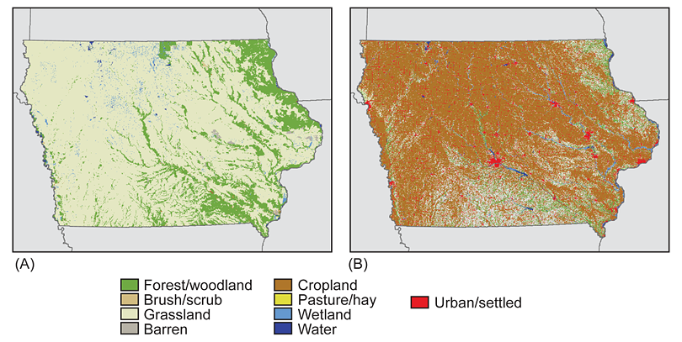
Figure 6 from Gallant, Sadinski, Roth, & Rewa, 2011: Iowa’s land cover in mid-1800's (A) and 2001 (B)

In an attempt to reverse this loss of habitat and protect biodiversity, the U.S. and Europe have enacted agricultural policies that reward growers for enacting various land management techniques which minimize environmental impact. Each management technique has a different objective and therefore, results in differing levels of successful conservation of threatened bumble bee species.

For example, some land management techniques aim to increase nesting habitat by planting grasses in field margins. Another technique may encourage growers to limit their use of pesticides. Other approaches may encourage the planting of pollen- and nectar-producing flowers to improve bumble bees’ access to quality foraging resources across all seasons.
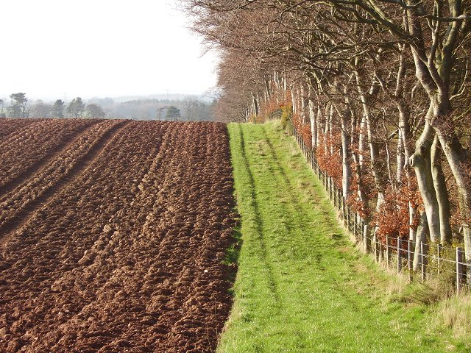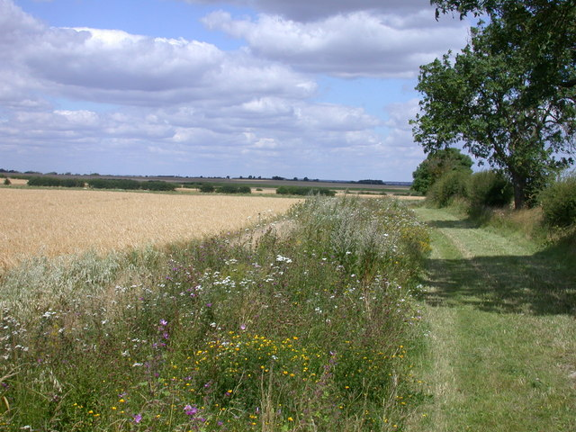
Figure 7: Crop field margins provide potential habitat or foraging resources for bees. Photo credits: Left, Richard Webb - Creative Commons; Right, Keith Edkins - Creative Commons
With so many different land management techniques to choose from, researchers in the United Kingdom (UK) decided to examine the effect each approach had on abundance and diversity of bumble bee species.
- If you were a researcher comparing the effect of several land management techniques, how might you set up an experiment to compare their conservation success?
  - What would your independent and dependent variables be?
  - What would be your control treatment?
  - How would you replicate your experiment?
  - What confounding factors should you consider?
Student answers will vary. Accept all reasonable answers.
Independent variables: type of land management technique

Dependent variable: Might be bumble bee abundance, number of different species of bumble bees

A control treatment may include a conventional (not conservation) land management, such as planting of the crop in the field margin.

A confounding factor could be flowers or grasses available in adjacent fields (bumble bees can forage up to a mile from their nest).
Examining the Effectiveness of Conservation Strategies
A research study conducted by Carvell, Meek, Pywell, Goulson, & Nowakowski (2007) compared bee abundance in field margins in the UK with seven different land management techniques. Researchers compared the following treatments:
- Crop (Crop): field margin planted with a cereal crop; conventional or standard practice
- Conservation headland (Cons head): field margin includes cereal crop with restricted application of herbicide and insecticide; encourages broad-leaf plants
- Natural regeneration (Nat regen): field margin includes no crop; no herbicide, pesticide, or fertilizer; encourages rare annual plants
- Tussocky grass mixture (Grass): field margin includes five grass species; no herbicide, pesticide, or fertilizer; provides nesting habitat
- Wildflower mixture (Wildflower): field margin sown with 21 native wildflower species and four fine grass species; no herbicide, pesticide or fertilizer; provides foraging and nesting habitat
- Pollen and nectar mixture (Pollen & nectar): field margin sown with four agricultural legume (bean) species and four fine grass species: no herbicide, pesticide or fertilizer; provides foraging and nesting habitat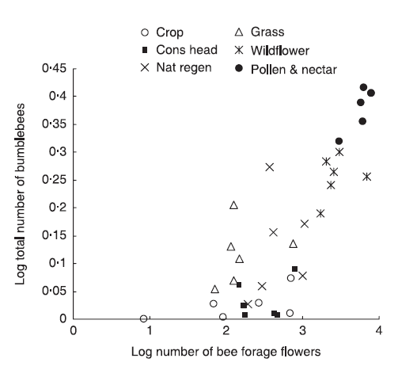
Figure 8 from Carvell et al., 2007: The relationship between flower abundance of bee forage species and total bee abundance on different field margin land management techniques. Values represent the log-transformed mean number of bees per plot at each site, averaged over 3 years.

Examine figure 8 on the previous page. Answer the following questions.
- What patterns in number of bee forage flowers do you observe in the data?
Student answers will vary. Accept all reasonable answers.
Cropland (the control) and tussocky grass mixture had consistently low numbers of bee forage flowers. Natural regeneration and conservation headland had moderate but variable numbers of flowers. Wildflower mixture and pollen and nectar mixtures showed a consistently high number of bee forage flowers.

- What patterns in bee abundance do you observe in the data?
Cropland and conservation headland appeared to have the lowest number of bees, followed by a moderate number of bumble bees (and more variation) in the tussocky grass mixture and natural regeneration. Lastly, the wildflower mixture and pollen and grass mixtures had consistently high numbers of bumble bees.

- Describe the relationship between the number of bee forage flowers and the number of bumblebees.
There was a positive relationship between the number of bee forage flowers and number of bumble bees. (This is not surprising considering the relationship between bees and flowers.)

- Which land management strategy would you recommend to a grower interested in conservation of bumble bees? Why?
Students should advise growers to plant the pollen & nectar mixture to attract the greatest number of bumble bees and minimize or eliminate pesticides and herbicide sprays in the field margins to avoid off-target exposure with bumble bees.

Reflection
- How might this information be used to inform conservation strategies in agroecosystems?
Student answers may vary. At the least, students should comment on the following:
This data provides evidence that greater numbers of bee forage flowers attracts and supports a greater number of bumble bees. When agricultural policy is written, it should provide the greatest support for land management strategies that promote more bee forage flowers (such as the wildflower mixture or pollen and nectar mixture).

This work could support future studies which examine the type of flowers that support the greatest number of bumble bee species, amount of area needed to see a conservation benefit, which plantings support rare bumble bee species, etc.

References
Calderone, N. W. (2012). Insect Pollinated Crops, Insect Pollinators and US Agriculture: Trend Analysis of Aggregate Data for the Period 1992–2009. PLoS ONE, 7(5), e37235. http://doi.org/10.1371/journal.pone.0037235
Cameron, S. A., Lozier, J. D., Strange, J. P., Koch, J. B., Cordes, N., Solter, L. F., & Griswold, T. L. (2011). Patterns of widespread decline in North American bumble bees. Proceedings of the National Academy of Sciences, 108(2), 662–667.
Carvell, C., Meek, W. R., Pywell, R. F., Goulson, D., & Nowakowski, M. (2007). Comparing the efficacy of agri-environment schemes to enhance bumble bee abundance and diversity on arable field margins. Journal of Applied Ecology, 44(1), 29–40.
Colla, S. R., Otterstatter, M. C., Gegear, R. J., & Thomson, J. D. (2006). Plight of the bumble bee: pathogen spillover from commercial to wild populations. Biological Conservation, 129(4), 461–467.
Gallant, A. L., Sadinski, W., Roth, M. F., & Rewa, C. A. (2011). Changes in historical Iowa land cover as context for assessing the environmental benefits of current and future conservation efforts on agricultural lands. Journal of Soil and Water Conservation, 66(3), 67A–77A. http://doi.org/10.2489/jswc.66.3.67A
Goulson, D., Lye, G. C., & Darvill, B. (2008). Decline and conservation of bumble bees. Annu. Rev. Entomol., 53, 191–208.

