Conserving Bumble Bees

Student Name _________________________________________
Part 1: Value of Pollinators
Insects are responsible for the pollination of approximately 80% of all flowering plants including both wild plants and agricultural crops. With adequate pollination, plants produce fruits, nuts, and berries which are consumed by humans and other animals. Proper pollination also produces seed allowing for plant reproduction in the wild and continued agricultural crop propagation.

According to a Cornell University study, honey bees and other insect pollinators in the U.S. contribute an estimated $29 billion dollars annually in farm income (Calderone, 2012). U.S. agriculture gains approximately $15 billion of this total value from honey bee pollination alone, but often overlooked are the specialized pollination services provided by bumble bees.

Bumble bees exhibit a unique behavior known as “buzz pollination,” in which the bee hangs upside down on a flower and vibrates her wing muscles causing the release of large amounts of pollen. Buzz pollination is especially valued by growers of tomatoes, peppers, and cranberries because it leads to better fruit set than pollination by honey bees. In addition, bumble bees are some of the only species which function effectively in greenhouse settings where crops such as tomatoes, sweet peppers, and strawberries are grown.
Figure 1: Bumble bee on red clover
Photo credit: Erin Ingram

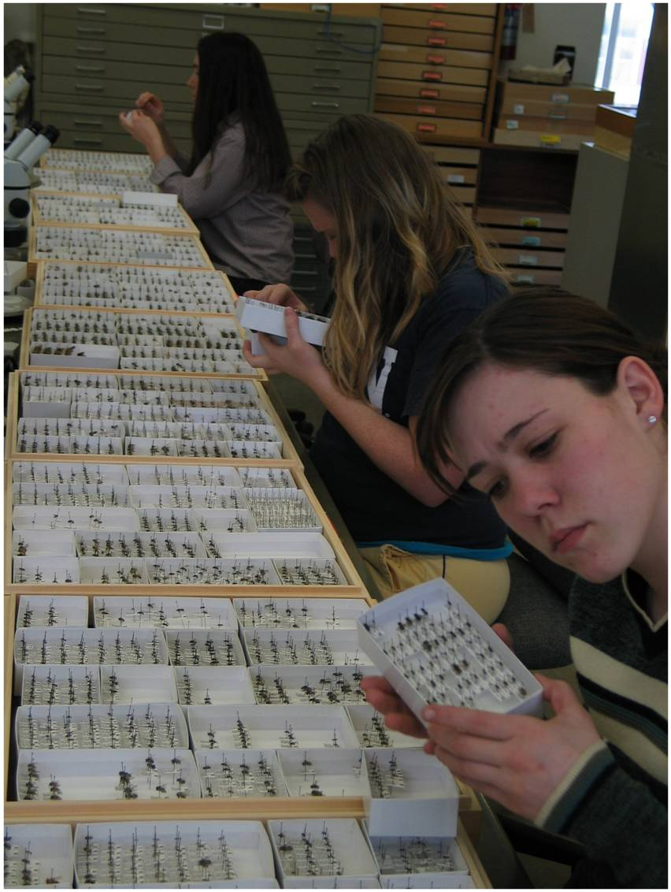
The Problem: Pollinators in Peril
Figure 2: Researchers examining an insect collection for historical information
Photo credit: USDA ARS
Over the past decade, reports of declining honey bee health have dominated news headlines and captured the attention of the public. Concern for pollinator well-being should also be expanded to include the nearly 4,500 other bee species in North America. Many of these valuable pollinators, including native bumble bees, may also be experiencing population declines.

So how do researchers go about determining if wild bee populations are increasing, decreasing, or remaining stable? The first step is identifying if historical monitoring data exists and accessing it. This may require researchers to examine well-curated insect collections to determine abundance and distribution of a species in previous years (Figure 2). If this information is unavailable or inaccessible, researchers will face the challenge of being unable to compare current bee counts with historical, baseline data. Rather than providing evidence of a population trending up or down, researchers may only be able to present a “snapshot” of the current population.

Figure 3: Target species examined in 2007-2009 U.S. bumble bee survey from Cameron et al., 2011
Bumble bee species examined
Populations suspected to be in decline | Populations suspected to be relatively stable
- Bombus affinis | - Bombus bifarius
- Bombus occidentalis | - Bombus vosnesenskii
- Bombus pensylvanicus | - Bombus bimaculatus
- Bombus terricola | - Bombus impatiens
In the mid-2000’s, researchers in pointed out the severe lack of data on pollinator abundance and distribution. In addition, existing bee surveys often relied on sampling methods which were not standardized or repeatable. To address this issue, various research groups worked together to conduct a large-scale, systematic bumble bee survey in the U.S. (Cameron et al., 2011). The aim was to gather data on abundance, species diversity, and distribution of eight target bumble bee species. All eight species were historically common, but anecdotal reports indicated that some species might be in decline. Of the eight species, four were suspected to be in decline while the remaining four were assumed to be relatively stable (Figure 3).

Using recent data and historical records, researchers could determine population trends by examining a species’ relative abundance compared to other bumble bee target species over time. Relative abundance can be calculated by dividing the number of individuals of the target species by the total number of other target species collected in the same region.

Relative abundance = $\frac{ \# of target species individuals}{total \# of all target species of interest in the region}$

For example, in this survey, only two of the target bee species (B. bifarius and B. occidentalis) are found in the global west region (including the states of AZ, CA, CO, ID, MT, NM, NV, OR, SD, UT, WA, and WY). To determine if the B. occidentalis population was in decline, researchers calculated the relative abundance for the historical period (1900-1999, black bars) and compared this to the relative abundance of the recent collection period (2007-2009, grey bars).
Relative Abundance
- What trend in the B. occidentalis population do you observe in this graph?

- Approximately how much did the relative abundance of B. occidentalis change over time?
Figure 4 from Cameron et al., 2011: Black bars are 1900-1999, gray bars are 2007-2009.

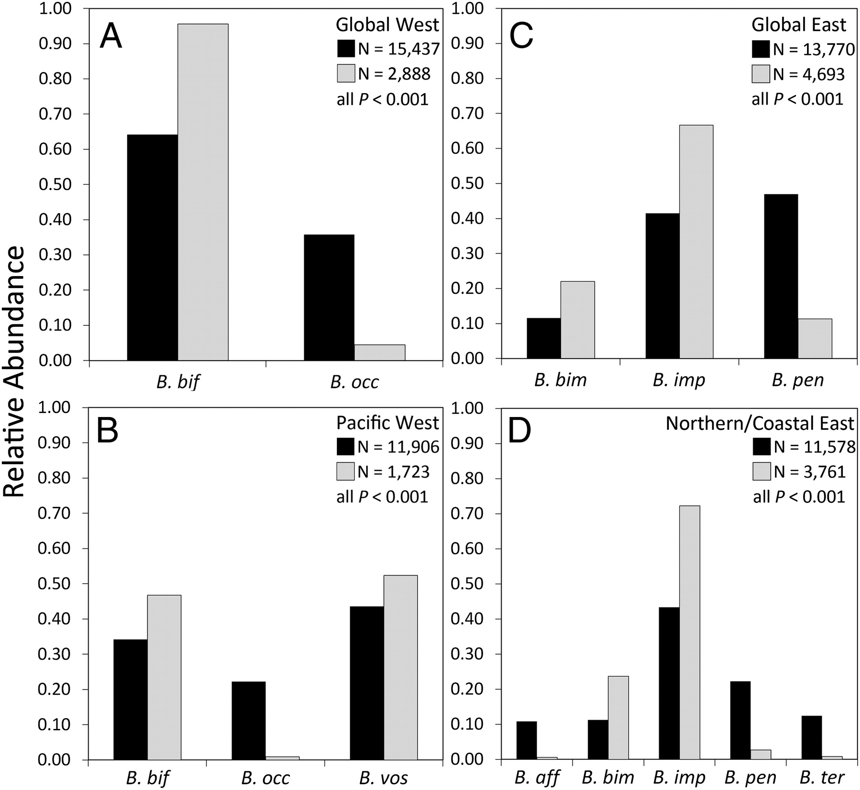
Figure 5 from Cameron et al., 2011. Black bars indicate 1900-1999. Grey bars indicate 2007-2009. Key to species names: B. aff = Bombus affinis; B. bif = Bombus bifarius; B. bim = Bombus bimaculatus; B. imp = Bombus impatiens; B. occ = Bombus occidentalis; B. pen = Bombus pensylvanicus; B. ter = Bombus terricola; B. vos = Bombus vosnesenskii.

Examine figure 5 above indicating relative abundance of eight bumble bee species in four U.S. regions.
- Compare the population trends of B. pensylvanicus in the Global East and Northern/Coastal East.

- In each of the regions, which bumble bee species’ populations show evidence of decline?

- Which bee species are NOT experiencing decline in the Pacific West? How do you know?

Part 2: Likely Culprits of Bumble Bee Decline?
Before we can begin to hypothesize reasons for the decrease in some bumble bee populations, we first need to consider what bumble bees need in order to survive.
Bumble bees need…
- High-quality habitat for nesting
- Plentiful food and water resources nearby throughout the spring, summer, and fall
- An environment relatively free of pests, parasites, pathogens, and pesticides

- What are three factors you think might have a negative impact on bumble bee populations?

- Which, if any, of these factors are related to human actions? Discuss these factors with a partner.

The selected excerpt below is from a Nature Conservancy blog post entitled “Plight of the Bumble Bee: Conserving Imperiled Native Pollinators” from Matt Miller. The post provides us with a glimpse of the potential factors playing a role in bumble bee declines.
Where Have All the Pollinators Gone?
An incident in an Oregon parking lot last summer dramatically illustrated the plight faced by native pollinators.
At a mall parking lot in Wilsonville, people began finding dead bumble bees – unbelievable numbers of dead bumble bees. It turned out to be the largest bumble bee die-off ever recorded, with more than 50,000 dead bees littering the area.
A wildlife mystery? Not quite.
It turns out that someone had sprayed 55 flowering trees with a pesticide known as a neonicotinoid, legal for use but deadly for insects, including beneficial ones like pollinators.
…
In addition to pesticides, bumble bees face a long list of other threats – habitat loss, climate change, competition from non-native bees, introduced diseases.
According to the Xerces Society, habitat loss in particular is having a profound effect on bumble bees (and other native pollinators).
Bumble bees need a mix of native plants to feed on as well as grassy areas to burrow. They once found this habitat in plenty on the edges of farms and yards, and even in roadside ditches. But there has been a tendency to “clean up” – to remove the wilder edges around human development.
That’s bad for bees and other pollinators.
A neatly trimmed grass lawn may be green but it’s not green – especially if it is sprayed with pesticides and all native plants are removed.
We often think of habitat loss as an irreversible problem, or one that can be solved only by intensive restoration activities. If a subdivision goes in and takes out part of a wolverine’s range, it is not like you can plant a few trees and bring back wolverines.
But with bumble bees, you can reverse habitat loss. Yards, ditches and abandoned lots can make a big difference. Your personal actions can save native pollinators – protecting not only cool critters but also vital ecosystem services.

- What are three factors that Matt suggests are threatening bumble bees and other pollinators?

Matt Miller states in his blog post “Yards, ditches and abandoned lots can make a big difference. Your personal actions can save native pollinators – protecting not only cool critters but also vital ecosystem services.”
- What actions might Matt be referring to in this post? What are three personal actions you could take to help conserve bumble bee species?

Part 3: Taking a Closer Look at Habitat Loss
According to a review article by Goulson, Lye, and Darvill (2008) on decline and conservation of bumble bees, ”declines in bumble bee species in the past 60 years are well documented in Europe, where they are driven primarily by habitat loss and declines in floral abundance and diversity resulting from agricultural intensification.”
By comparing historical and current land use patterns, we can see more and more of our landscape has been transformed for agricultural use and urban development. This change in land use has led to a loss of adequate foraging and nesting habitat for bumble bees and other pollinators. In the U.S., for example, 85% of Iowa’s land area was once prairie grassland, providing abundant habitat for bumble bees. However, Iowa’s prairies have been reduced to 0.1% of all land area with most land now largely covered in monoculture crops and urban areas (Goulson et al., 2008).
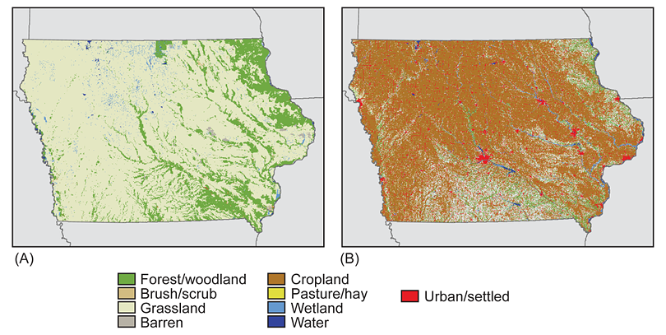
Figure 6 from Gallant, Sadinski, Roth, & Rewa, 2011: Iowa’s land cover in mid-1800's (A) and 2001 (B)

In an attempt to reverse this loss of habitat and protect biodiversity, the U.S. and Europe have enacted agricultural policies that reward growers for enacting various land management techniques which minimize environmental impact. Each management technique has a different objective and therefore, results in differing levels of successful conservation of threatened bumble bee species.

For example, some land management techniques aim to increase nesting habitat by planting grasses in field margins. Another technique may encourage growers to limit their use of pesticides. Other approaches may encourage the planting of pollen- and nectar-producing flowers to improve bumble bees’ access to quality foraging resources across all seasons.
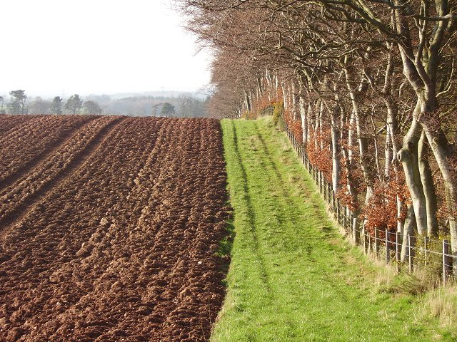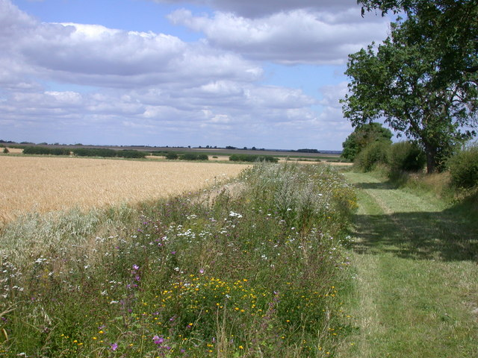
Figure 7: Crop field margins provide potential habitat or foraging resources for bees. Photo credits: Left, Richard Webb - Creative Commons; Right, Keith Edkins - Creative Commons
With so many different land management techniques to choose from, researchers in the United Kingdom (UK) decided to examine the effect each approach had on abundance and diversity of bumble bee species.
- If you were a researcher comparing the effect of several land management techniques, how might you set up an experiment to compare their conservation success?
  - What would your independent and dependent variables be?
  - What would be your control treatment?
  - How would you replicate your experiment?
  - What confounding factors should you consider?

Examining the Effectiveness of Conservation Strategies
A research study conducted by Carvell, Meek, Pywell, Goulson, & Nowakowski (2007) compared bee abundance in field margins in the UK with seven different land management techniques. Researchers compared the following treatments:
- Crop (Crop): field margin planted with a cereal crop; conventional or standard practice
- Conservation headland (Cons head): field margin includes cereal crop with restricted application of herbicide and insecticide; encourages broad-leaf plants
- Natural regeneration (Nat regen): field margin includes no crop; no herbicide, pesticide, or fertilizer; encourages rare annual plants
- Tussocky grass mixture (Grass): field margin includes five grass species; no herbicide, pesticide, or fertilizer; provides nesting habitat
- Wildflower mixture (Wildflower): field margin sown with 21 native wildflower species and four fine grass species; no herbicide, pesticide or fertilizer; provides foraging and nesting habitat
- Pollen and nectar mixture (Pollen & nectar): field margin sown with four agricultural legume (bean) species and four fine grass species: no herbicide, pesticide or fertilizer; provides foraging and nesting habitat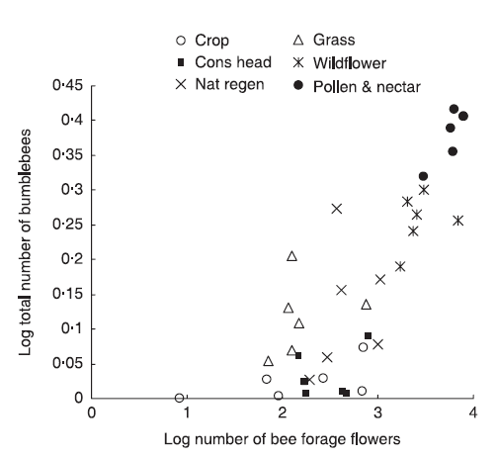
Figure 8 from Carvell et al., 2007: The relationship between flower abundance of bee forage species and total bee abundance on different field margin land management techniques. Values represent the log-transformed mean number of bees per plot at each site, averaged over 3 years.

Examine figure 8 on the previous page. Answer the following questions.
- What patterns in number of bee forage flowers do you observe in the data?

- What patterns in bee abundance do you observe in the data?

- Describe the relationship between the number of bee forage flowers and the number of bumblebees.

- Which land management strategy would you recommend to a grower interested in conservation of bumble bees? Why?

Reflection
- How might this information be used to inform conservation strategies in agroecosystems?

References
Calderone, N. W. (2012). Insect Pollinated Crops, Insect Pollinators and US Agriculture: Trend Analysis of Aggregate Data for the Period 1992–2009. PLoS ONE, 7(5), e37235. http://doi.org/10.1371/journal.pone.0037235
Cameron, S. A., Lozier, J. D., Strange, J. P., Koch, J. B., Cordes, N., Solter, L. F., & Griswold, T. L. (2011). Patterns of widespread decline in North American bumble bees. Proceedings of the National Academy of Sciences, 108(2), 662–667.
Carvell, C., Meek, W. R., Pywell, R. F., Goulson, D., & Nowakowski, M. (2007). Comparing the efficacy of agri-environment schemes to enhance bumble bee abundance and diversity on arable field margins. Journal of Applied Ecology, 44(1), 29–40.
Colla, S. R., Otterstatter, M. C., Gegear, R. J., & Thomson, J. D. (2006). Plight of the bumble bee: pathogen spillover from commercial to wild populations. Biological Conservation, 129(4), 461–467.
Gallant, A. L., Sadinski, W., Roth, M. F., & Rewa, C. A. (2011). Changes in historical Iowa land cover as context for assessing the environmental benefits of current and future conservation efforts on agricultural lands. Journal of Soil and Water Conservation, 66(3), 67A–77A. http://doi.org/10.2489/jswc.66.3.67A
Goulson, D., Lye, G. C., & Darvill, B. (2008). Decline and conservation of bumble bees. Annu. Rev. Entomol., 53, 191–208.

