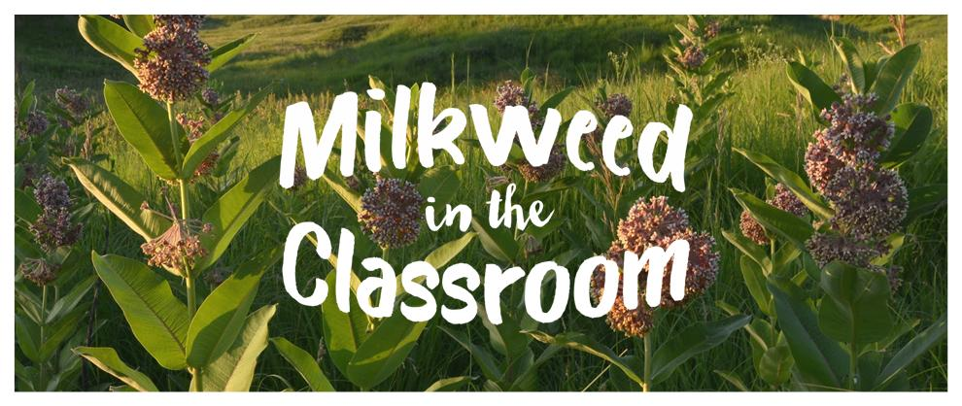
Table of Contents
Background and Introduction 3
Meeting Next Generation Science Standards 4
Additional Monarch Butterfly Resources 5
Engaging in Argument from Evidence 6
Claim-Evidence-Reasoning 6
Growing Milkweed in the Classroom 8
Pace Map 9
Anchoring Phenomena: How has the monarch butterfly migration changed over time and why? 10
Lesson 1: What is migration and why do monarch butterflies migrate? 10
Lesson 2: Is the Monarch butterfly migration getting easier? 12
Lesson 3: What does good habitat look like for monarch butterflies? 16
Lesson 4: What is a prairie and who lives there? 19
Lesson 5: How can images of a person or place over time help us to see changes? 25
Lesson 6: How have Tallgrass prairies changed over time? 27
Lesson 7: How can we use what we learned to make an argument for how the monarch migration is changing and why? 30
Lesson 8: How can humans help the monarchs as they migrate? 34

Milkweed in the Classroom Team

Doug Golick  Erin Ingram  Jenny Keshwani  Tom Weissling | Sarah Bailey | Drew Larsen  Anna Swerczek  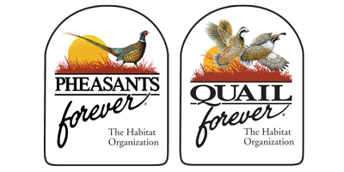

Grant funding provided by:

Background and Introduction
The Monarch butterfly migration is one of the most spectacular natural phenomena on Earth. Each fall, Monarch butterflies leave their breeding grounds in the northern U.S. and Canada to travel south (up to 3,000 miles!) to their overwintering home in central Mexico. As conditions become unsuitable for their survival in northern latitudes, monarchs leave behind their feeding and breeding areas and fly south to look for a safe place to spend the winter. Millions of monarchs will spend the winter huddled together on the branches of oyamel fir trees high in the mountains of central Mexico. In the spring, surviving Monarch butterflies will begin heading north once again, but the journey north does not belong to a single generation of monarchs. As they travel, they will mate and lay eggs on milkweed plants. These eggs will hatch and the emerging larvae will gorge themselves on milkweed plants before pupating and transforming into adult butterflies. As the life cycle repeats, new generations of monarchs will gradually move north. As many as four to five generations of butterflies will be needed to reach their final destination in the northern U.S. and Canada.
Monarchs face daunting challenges as they migrate.
During this long and difficult journey, monarchs face numerous challenges including predators, poor weather, and changes to the landscape that impact their ability to find suitable habitat. Monarchs mainly rely on prairies, meadows, roadsides, and grasslands to survive. Intact prairies provide monarch populations with necessary habitat to survive including nectar-producing wildflowers for adult monarchs to feed upon and various milkweed species to lay their eggs upon and feed their young. Without healthy prairie habitat, the monarch migration faces an uncertain future.
Habitat restoration is essential to secure monarch migrations for future generations.
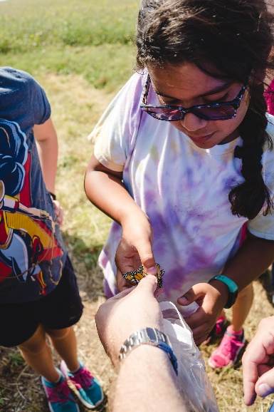
Once native prairie covered almost 40% of the U.S. and provided ample habitat for monarchs and other prairie wildlife, but today, prairie ecosystems are some of the most endangered ecosystems in the world. While large scale habitat restoration and conservation projects are generally undertaken by government agencies and conservation organizations, small scale efforts are also important. Backyards and schoolyards can provide small, but essential pockets of prairie to support monarchs on their migration.
How can you and your students get involved?
Milkweed in the Classroom is collaborative Nebraska Environmental Trust grant-funded project lead the University of Nebraska-Lincoln, Prairie Plains Resource Institute, and Pheasants Forever, Inc. that supports teachers and students in growing milkweed in the classroom and assisting in local restoration efforts.
For more information, contact us!
Erin Ingram, eingram3@unl.edu
Doug Golick, dgolick2@unl.edu

Meeting Next Generation Science Standards
A Framework for K-12 Science Education (NRC, 2012) sets forth a vision for science education in which students engage in “fundamental questions about the world and with how scientists have investigated and found answers to those questions”. This approach views science as more than simply what we know (a body of knowledge), it is also how we have come to know it (a set of practices). In this new approach, students will experience three-dimensional learning in which they engage in scientific and engineering practices and apply cross-cutting concepts to deepen their understanding of the disciplinary core ideas in key science areas.
The Milkweed in the Classroom lessons are designed to help students investigate a real-world phenomenon that is connected with students’ interests and experiences. In this unit, the monarch migration will act as the anchoring phenomenon and students will investigate the guiding question, “How has the monarch migration has changed over time and why?”
Milkweed in the Classroom Lessons mapped to A Framework for K-12 Science Education.
 | Lessons
Science Practices | 1 | 2 | 3 | 4 | 5 | 6 | 7 | 8
Asking questions and defining problems |  | X |  |  |  | X
Analyzing and interpreting data |  | X |  |  | X | X |  | X
Constructing explanations and designing solutions |  |  |  |  |  |  |  | X
Engaging in argument from evidence |  | X |  |  | X |  | X
Obtaining, evaluating, and communicating information | X |  | X | X |  | X |  | X
Cross-cutting concepts | 1 | 2 | 3 | 4 | 5 | 6 | 7 | 8
Patterns |  | X |  | X | X | X
Cause-and-Effect | X |  | X |  |  |  | X | X
Systems and System Models |  |  |  |  |  |  |  | X
Stability and Change |  | X |  |  | X | X | X
Disciplinary Core Ideas | 1 | 2 | 3 | 4 | 5 | 6 | 7 | 8
Ecosystems: Interactions, Energy, and Dynamics | X | X | X | X | X | X | X | X
Engineering Design |  |  |  |  |  |  |  | X

Next Generation Science Standards Performance Indicator Bundle
3-LS4-3 Construct an argument with evidence that in a particular habitat some organisms can survive well, some survive less well, and some cannot survive at all.
3-LS4-4 Make a claim about the merit of a solution to a problem caused when the environment changes and the types of plants and animals that live there may change.

Additional Monarch Butterfly Resources
A variety of organizations provide additional lesson and resources related to the monarch butterfly life cycle, monarch butterfly migration route, and conservation actions that help monarch butterflies. We have included links to these resources for your convenience.
Monarch Joint Venture: https://monarchjointventure.org/mjvprograms/education/monarch-education-resources
U.S. Fish and Wildlife: https://www.fws.gov/savethemonarch/
Nebraska Game and Parks’ Monarchs on a Mission: http://outdoornebraska.gov/monarchsonamission/
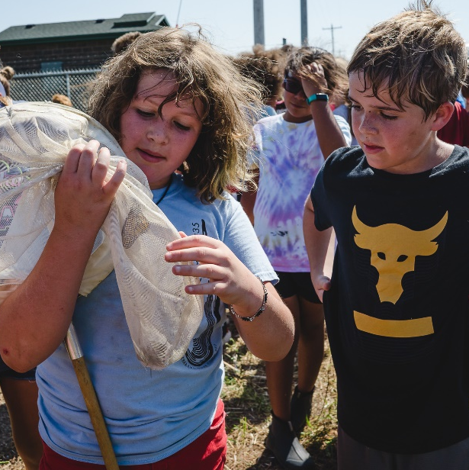

Engaging in Argument from Evidence
When you hear the word “argumentation”, it may bring to mind ideas of fighting, anger, or being attacked. However, scientific arguments are a bit different. Scientific argumentation is a social process in which students build, question and critique claims using evidence about the natural world. This is a key practice both in the Next Generation Science Standards and the Common Core State Standards for English Language Arts and Literacy.

If teaching about scientific argumentation is unfamiliar to you, consider exploring the short PD playlist below from STEM Teaching Tools to become more familiar with this scientific practice and how you can support it in your classroom. The playlist below is a crash course in supporting scientific argumentation in your classroom and will take ~2 hours to complete.
- PD Playlist: Incorporating Scientific Argumentation into Your Classroom: http://stemteachingtools.org/pd/playlist-argumentation

Claim-Evidence-Reasoning
This unit calls on students to engage in argument from evidence. Students who are engaging in scientific argumentation will likely need help in 4 different areas:
- Claims - Considering multiple competing claims
- Evidence - Using high-quality evidence
- Reasoning
  - Focusing on being convincing
  - Making reasoning clear

The following strategies may prove helpful in scaffolding students to use the Claim-Evidence-Reasoning structure to construct their scientific argument.

- Help students to understand the difference between respectful scientific arguments and confrontational or competitive arguments.
  - In a scientific argument, we can disagree about an idea, but we are not disagreeing with a person.
  - The purpose of a scientific argument is not to “win”, but rather to come to a point of mutual understanding or consensus.
- Make time for science talk.
  - Students will need practice and feedback as they learn to construct scientific arguments. You can help guide them by modeling a Claim-Evidence-Reasoning conversation as a whole class.
    - Watch CER conversations in action:
      - With 5th grade students: https://www.teachingchannel.org/video/support-claims-with-evidence-getty
      - With 2nd grade students: https://www.teachingchannel.org/video/t-charts-nsf
    - Start with a non-science example. For example, this teacher uses a popular Doritos commercial to introduce a collaborative CER discussion: https://www.modelteaching.com/education-articles/writing-instruction/claim-evidence-reasoning-cer
- Scaffold students’ use of CER in their writing.
  - Post short definitions of CER in your classroom.
  - Provide graphic organizers, sentence starters, or writing prompts.
Claim: Answers the key question. It tells us what you learned through your research or investigation.
Evidence: Backs up your claim. It tells us about the observations of patterns or details from your research or investigation.
Reasoning: Uses scientific terms or principles to explain the evidence.

Claim:
My claim is…
I think…
Evidence:
I observed/read/found….
My evidence is…
My proof is…
Reasoning:
I know this is true because…
This happened because…
The reason for this is…

Growing Milkweed in the Classroom
If students will be growing milkweed in the classroom, Pheasants Forever offers a Milkweed in the Classroom Kit for purchase.
- Kit includes milkweed seeds, soil, planting containers, grow light, and spray bottle for watering.
- Order form found here: https://www.pheasantsforever.org/Conservation/Habitat-Education/Milkweed-in-the-Classroom/Kit-Order-Form.aspx.

Milkweed Planting Timeline

More detailed growing instructions can be found here:
- Milkweed Planting Guide (pdf)
- Grow Milkweed tutorial videos:
  - Starting Milkweed Seeds
  - Transplanting Seedlings to Larger Containers
  - Transplanting Plants Outside

Pace Map
Please note that each lesson will likely take more than 1 day to implement in your classroom based on the following estimated time allotment.

Lesson 1 30 min
Lesson 2 30-45 min
Lesson 3 45-60 min
Lesson 4 45-60 min
Lesson 5 30-45 min
Lesson 6 30 min
Lesson 7 30-45 min
Lesson 8 60-90 min

To help you plan for implementation, we have provided two sample pace maps below. Based on an estimated instructional time of 300-405 min (5-6.75 hours), the unit will take 15-21 days of instruction if you teach science for 20 minutes per day and 10-15 days of instruction if you teach science for 30 minutes per day.

Sample Pace Maps
If teaching science 20 minutes per day = 15-21 days
 | Day 1 | Day 2 | Day 3 | Day 4 | Day 5
Week 1 | Lesson 1 | Lesson 1 | Lesson 2 | Lesson 2 | Lesson 3
Week 2 | Lesson 3 | Lesson 3 | Lesson 4 | Lesson 4 | Lesson 4
Week 3 | Lesson 5 | Lesson 5 | Lesson 6 | Lesson 6 | Lesson 7
Week 4 | Lesson 7 | Lesson 8 | Lesson 8 | Lesson 8 | Lesson 8

If teaching science 30 minutes per day = 10-15 days
 | Day 1 | Day 2 | Day 3 | Day 4 | Day 5
Week 1 | Lesson 1 | Lesson 2 | Lesson 2 | Lesson 3 | Lesson 3
Week 2 | Lesson 4 | Lesson 4 | Lesson 5 | Lesson 5 | Lesson 6
Week 3 | Lesson 7 | Lesson 7 | Lesson 8 | Lesson 8 | Lesson 8

Anchoring Phenomena: How has the monarch butterfly migration changed over time and why?

Lesson 1: What is migration and why do monarch butterflies migrate?

Objectives
- Identify challenges facing monarch butterflies during their migration
- Recognize that the purpose of animal migration is to move from one place to another to make survive and reproduction possible.

Materials
- Monarch butterfly life cycle stage pictures: https://go.unl.edu/monarchlifecycle
- Book: When Butterflies Cross the Sky: The Monarch Butterfly Migration by Sharon Katz Cooper
- (Optional) Interactive monarch butterfly migration storymap: https://cgee-hamline.org/MonarchJV-Migration/
- (Optional) Monarch migration maps for download:
  - 11” x 17” http://outdoornebraska.gov/wp-content/uploads/2016/09/Monarch-Migration-11x-17.pdf
  - 16” x 20” http://outdoornebraska.gov/wp-content/uploads/2016/09/Monarch-Migration-16x20.pdf
- (Optional) Monarch migration map (18”x24”) for purchase: https://shop.monarchwatch.org/product/Monarch-Migration-Map/138528

Time required
- 30 minutes

Vocabulary
- Migration: movement from one place to another; seasonal movement of animals from one place to another.
- Life Cycle: the sequence of stages that all living organisms can go through including birth, growth, reproduction, and death

Engage
- Engage students’ prior knowledge of the Monarch butterfly.
Show students a picture of the monarch.
Ask:
  - Who has seen a butterfly like this before?
  - Does anyone know the name of this butterfly?
  - This is a monarch butterfly. What do you know about the monarch butterfly?

- Introduce the word “migration”.
Display the word “migration” on the board. Read the word aloud. Read it as a class.
Ask:
- Who has heard the word “migration” before?
- What do you think migration means?
Post a definition of migration in the classroom. Explain that migration means moving from one place to another and that some animals migrate from one area to another depending on the season.

- Read a story about the monarch butterfly migration.
Explain that monarch butterflies are one example of an animal that migrates, or moves from one place to another depending on the season. Read the story, When Butterflies Cross the Sky: The Monarch Butterfly Migration by Sharon Katz Cooper.

- (Optional) In pairs, small groups, or as a whole class, have students explore the monarch butterfly migration using the interactive storymap or downloadable maps provided in the materials.

- Discuss the challenges monarch butterflies face along their migration.
  - In the story, what challenges did monarch butterflies face when they are migrating?
    - Not enough food to eat
    - Become too tired to finish the trip
    - Birds and other animals may try to eat them
    - Bad weather (rain or cold) may make flying difficult or impossible

- Discuss the purpose of the monarch butterfly migration: survival and reproduction
  - The Monarch migration seems pretty dangerous. With all of the dangers they face, why do they do it?
    - Monarch butterflies move from one place to another to get what they need to survive and reproduce (have babies).
    - In the spring, the butterflies move north to eat food resources as they become available with warmer weather. Along the way, the butterflies reproduce and the next generation of butterflies is born. Four to five generations of monarch butterflies are born on the spring migration.
    - In the fall, a single generation of monarch butterflies move south as weather gets colder and food resources become scarce.
  - Why is it important for monarch butterflies to migrate to their overwintering home each fall?
    - They move to safe overwintering sites to rest before starting the migration process again.

Lesson 2: Is the Monarch butterfly migration getting easier?

Objectives
- Analyze a graph of overwintering monarch butterfly counts
- Recognize that the number of monarch butterflies at the overwintering site in Mexico is declining over time

Materials
- Monarch migration worksheet showing graph of overwintering monarch butterfly counts from 1997-2012 (1 per student)

Time required
- 30-45 minutes

Vocabulary
- Claim: The first part of a scientific argument. Answers the key question. It tells us what you learned through your research or investigation.
- Evidence: The second part of a scientific argument. Backs up your claim. It tells us about the observations of patterns or details from your research or investigation.
Explore
- Introduce the anchoring phenomena.
  - In this unit, we are going to explore how the monarch migration has changed over and why and what impact humans can have on this amazing journey!

- Review challenges that monarch butterflies face as they migrate.
    - Not enough food to eat
    - Become too tired to finish the trip
    - Birds and other animals may try to eat them
    - Bad weather (rain or cold) may make flying difficult or impossible

- Take a class poll.
  - Do you think the monarch migration has gotten easier, harder, or stayed the same over time?
Have students indicate their answer with a thumbs up (easier), thumbs down (harder), or thumbs to the side (stayed the same).

Discuss:
  - What information might be helpful in deciding if things are getting easier, harder, or staying the same for Monarchs?
Discuss students’ ideas a whole class.

- Provide students with a graph of overwintering counts of monarch butterflies in Mexico and make observations.
Show students the monarch butterfly count graph. Explain to students what the graph is showing. Scientists counted the number of monarch butterflies at their overwintering home in Mexico. They did this every year from 1997 through 2012.

Ask
  - What patterns do you notice?
  - What do you wonder?

Discuss what they are observing in the data:
  - Numbers of monarch butterflies have gone up and down over the years, but overall, numbers have gone down.

- Gather students wondering questions on a discussion question board.
  - Examples:
    - I wonder why monarch numbers are going down.
    - I wonder what changes happened along the migration route after 1997.
    - I wonder if humans are involved.
Explain
- Take the class poll again.
  - Based on what you learned from the graph, do you think the monarch migration has gotten easier, harder, or stayed the same over time?

This time, help students to practice using data as evidence to support a claim. Discuss how we can be more confident in our answer if we have data to support our claim.
  - If the migration is getting easier, would we expect to see the number of monarchs at the overwintering sites getting bigger or smaller? Why?
  - What if the migration is harder? What pattern should we see in the data?
  - What if the migration difficulty stayed the same?
  - Which claim does our data support?

- Highlight students’ previous observations that fewer monarchs are successfully migrating based on a decreasing pattern in the data.
  - We can use the decreasing monarch populations in the data as evidence to support the claim that the migration is getting harder over time, because fewer monarchs are surviving the migration and making it back to the overwintering site.
  - This data does not tell us WHY monarch populations are lower.
Wrap-up
- Reflect and Discuss
  - Based on the data and our claim that the migration is getting harder, why do you think it might be getting harder for Monarchs to survive their migration?
    - Have students write a written reflection or discuss with a partner.

Is the Monarch migration getting easier? Name ___________________________
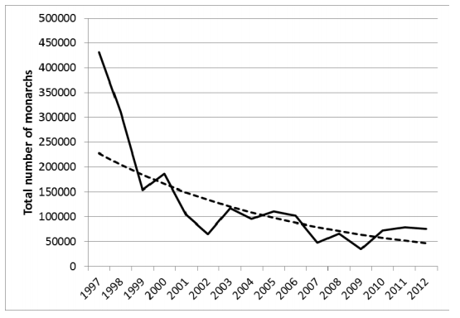
Look at the graph above showing the total number of monarch butterflies counted by scientists at their overwintering home in Mexico every year from 1997 through 2012. Answer the questions below. Discuss your answers with a neighbor.
What do you notice? | What do you wonder?

Lesson 3: What does good habitat look like for monarch butterflies?

Objectives
- Research monarch butterfly survival needs
- Draw a picture of a suitable monarch habitat

Materials
- Monarch butterfly research materials (books, websites, magazines, etc.)
Suggested resources:
  - Monarch Life Cycle and Natural History from Nebraska Game and Parks: http://outdoornebraska.gov/lifecycle/
  - Monarch Butterfly from National Geographic Kids: https://kids.nationalgeographic.com/animals/invertebrates/insects/monarch-butterfly/
  - Monarch Habitat Needs: https://monarchjointventure.org/monarch-biology/habitat-needs
  - Types of Monarch Habitat: https://monarchjointventure.org/monarch-biology/habitat-needs/types-of-monarch-habitat
  - Monarch Butterfly by Gail Gibbons
- Paper and drawing utensils

Time required
- 45-60 minutes

Vocabulary
- Habitat: The home of an animal or a plant; includes food/sunlight, water, space, and shelter
- Habitat Loss: When the necessary food, water, shelter, or space needed for a species’s population to survive goes away.
- At-risk: A species whose population is declining, but it is not yet to the point of being classified as threatened
- Threatened: a species whose population is declining and if it continues to decline, it will be endangered
- Endangered: a species whose population has declined to a point that it cannot recover on its own and must have help through conservation efforts
- Extinct: A species whose population no longer exists on Earth
Engage
- Review prior learning about monarch migration:
  - Monarch butterflies take part in dangerous migration through Mexico, the U.S., and Canada.
  - Based on the data, we argued that their migration is getting more difficult because fewer monarchs are found at their overwintering home in Mexico.
  - We ended by brainstorming ideas for what might be changing that is making it harder for Monarchs to survive their migration.
Ask volunteers to share out their ideas. Explain that in this lesson, we are going to learn more about what monarchs need to survive on their migration.

- Introduce the monarch butterfly as a species at-risk.
Discuss what it means when a species of animal of at-risk, threatened, endangered or extinct.
Ask students to remember back to the graph of the declining monarch butterfly numbers. The population was declining, or going down.

Explain that in 2014, a group of conservation organizations wrote a petition asking that the Monarch butterfly be added to the threatened or endangered species list. They gathered information to show that monarch butterflies were having trouble surviving and they identified that one of the major threats to monarch migration is habitat loss.

- Introduce the idea of habitat and the impacts of habitat loss on monarch butterflies.
Write “Habitat” on the board or chart paper. Review students’ understanding of habitat and habitat loss.
- Discuss habitat:
  - What is habitat?
    - All animals have a habitat made up of food, water, shelter, and space. These four things must be accessible to the animal when they need it (for example, if a water source dries up during the hot summer this may not provide adequate habitat for animals who depend on it).
- Discuss habitat loss:
    - When the necessary food, water, shelter, or space needed for a population to survive goes away, we call that habitat loss.
    - What might happen when an animal can no longer get the necessary food, water, shelter, or space they need to live?
      - When a habitat changes, some animals can survive well, some survive less well, and some cannot survive at all.
Explore
- Introduce the lesson objective: To research monarch butterfly habitat and survival needs.
Explain that research is an important part of protecting and saving at-risk, threatened, or endangered species. By learning more about their natural history (life cycle, reproduction, food requirements, etc.), their habitat requirements, and the factors causing this species to be threatened or endangered, we can do more to provide these species what they need.

Using print and online resources, have students research what Monarch butterflies need to survive and what their habitat looks like.

Questions to think about:
  - What does a monarch butterfly’s home look like? Where do they live?
  - What food do monarch butterflies eat? Do young caterpillars eat the same food as adult butterflies?
  - Where do monarch butterflies lay their eggs?

- Have students collect and organize their research findings in a graphic organizer (example below).

 | Habitat
 | Food | Water | Shelter | Space
Monarch butterfly (Adult)
Monarch caterpillar (Baby)

Key information students should collect:
    - Monarchs live mainly in prairies, meadows, roadsides, and grasslands.
    - As caterpillars, they feed exclusively on milkweed.
    - Adults are generalists and feed on a variety of blooming plants (containing great amounts of sugar). Female monarchs often lay their eggs on the underside of milkweed leaves.
    - Adult monarchs are seen flying through the Midwest U.S. from June through the fall, so having plants that bloom throughout the summer and fall are needed for the adults to thrive.
Explain
- Draw a Monarch Habitat.
Provide students with paper, writing utensils, and crayons or markers.
Ask: If you were to design a habitat for monarch butterflies, what would you include?
Have students draw a picture and write a paragraph explaining their habitat design and how it meets the habitat needs of monarchs.
Wrap-up
- Ask volunteers to share with a partner the features of their monarch habitat drawing and explain how these features would support monarch survival.

Lesson 4: What is a prairie and who lives there?

Objectives
  - Recognize features shared by different prairie ecosystems

Materials
  - Computer with internet access
  - Ecosystem cards (1 set per 3-4 students)
  - Paper and drawing utensils

Time required
  - 60 minutes

Vocabulary
  - Prairie: An ecosystem full of grasses and wildflowers, with few trees, and little water
Prior to the lesson
- Print and cut apart ecosystem cards (1 set per 3-4 students). Fold and tape to create cards that contain picture on front and information on the back.
Engage
- Review prior learning about monarch habitat.
  - Monarchs live mainly in prairies, meadows, roadsides, and grasslands.
  - Monarch caterpillars feed on the leaves of milkweed plants.
  - Monarch butterflies feed on the nectar (sugars) of many different wildflowers.

- Engage students’ prior knowledge of prairies.
Display the word, Prairie, on the board or chart paper. Give each student a piece of paper, pencil, and markers or crayons and ask students to draw a picture of a perfect prairie.
Questions to think about:
  - We learned that monarchs live mainly in prairies. What do you think a prairie looks like? What makes it a prairie?
  - What plants and animals do you think live in a prairie?
Ask volunteers to share out their drawings with the class and point out the features of the prairie and the plants and animals they drew.
- Introduce the lesson objective: To research prairies and how they provide habitat for monarchs
  - Today, we are going to do something that scientists do- we are going to conduct research. We know that monarchs migrate through the U.S. on their journey from Mexico to Canada and back. Our goal is to learn more about what prairie is like and how it provides habitat for monarchs.
Explore
- Compare features of prairie/grassland/shrubland ecosystems to other types of ecosystems.
Divide students into small groups, give each group a set of the ecosystem cards (provided)
Ask:
- What patterns do you notice in all of the prairies?
- What similarities and differences did you observe when you compare the prairie ecosystems to the other ecosystems (ocean, forest, and desert)?

Have students share their ideas. As a whole class, come to a consensus about several features that all prairies share:
- Prairies have lots of grass, lots of sun, few trees, few water features

- Help students to explore the diversity of plants and animals (beyond grasses) that live in prairies.
Play a video of photographs taken by Chris Helzer, director of science for the Nature Conservancy in Nebraska: https://youtu.be/xsk5TdnVg0U. This video shows just a fraction of diversity of wildflowers and animals that are important components of prairies.
Ask students to focus on observing all the living and non-living things Chris saw in a square meter of prairie in Nebraska.
- Based on the videos and pictures they have viewed, have students create a list of living and non-living things found in the prairie.
  - Discuss:
    - Was the prairie only full of grasses? What else did you observe?
      - The prairie is full of colors and wildlife. The video showed animals and lots of wildflowers also called forbs.
    - Why do you think you saw so many insects in the prairie?
      - The prairie can be a good habitat for many insects. It provides necessary food, space, shelter, and water for these animals.
Explain
- Ask students to revise or draw another picture of a prairie based on what they have learned.
Discuss:
  - Look back at your drawing of the perfect prairie. Would you change anything about your drawing?
  - Are there any plants or animals you would like to add?

Give students time to revise or redraw their perfect prairie adding plants and animals that they may have missed in their first drawing.

Reflect: How did your drawing change? What did you add to your perfect prairie?
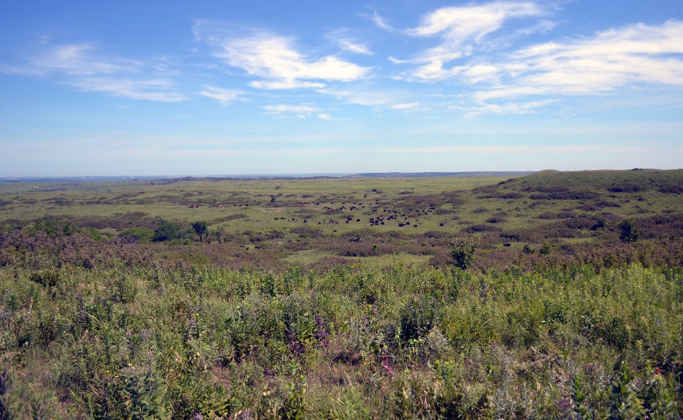  Tallgrass Prairie | 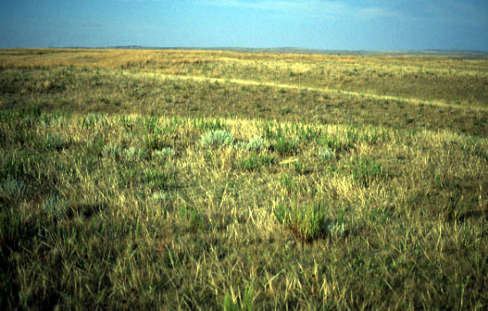  Shortgrass Prairie
Tallgrass Prairie  Temperatures: Hot summers, cold winters  Average Rainfall: 25-36 inches per year  Plants: Few trees, many tallgrasses grow here  Did you know? Many of the grasses found here can grow to be 6 feet tall! | Shortgrass Prairie  Temperatures: Hot summers, cold winters  Average Rainfall: 12-17 inches per year  Plants: Mostly shortgrass plant species, but also has patches of mixed grasses and areas of wet meadows and tree-filled woodlands along rivers and creeks  Did you know? The shortgrass prairie is home to a state endangered species, Swift Fox.
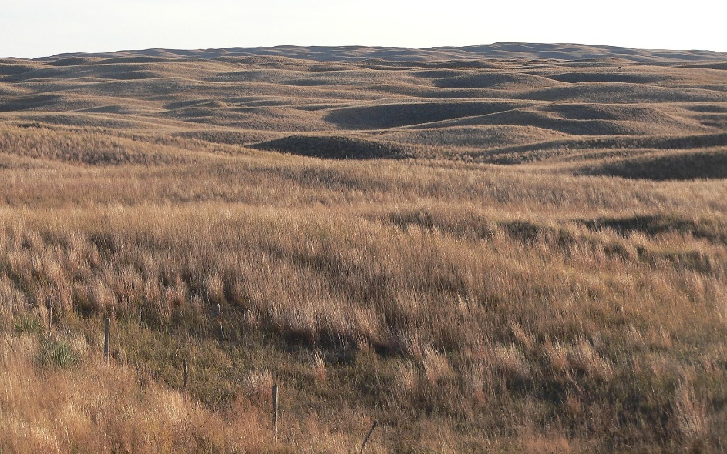  Sandhills Prairie | 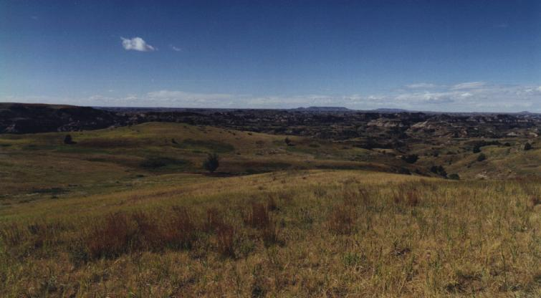  Mixedgrass Prairie
Sandhills Prairie  Temperatures: Hot summers, cold winters  Average Rainfall: 17-23 inches per year  Plants: Mix of tallgrass and shortgrass plants. It also has wetland plant species which live in the wetlands and near small lakes dotting the ecoregion  Did you know? The Sandhills Prairie in Nebraska is a unique landscape that can be found nowhere else on Earth! The irregular dunes (hills of loose sand) and sandy soils set this ecoregion apart from other similar prairies. | Mixedgrass Prairie  Temperatures: Hot summers, cold winters  Average Rainfall: 20-28 inches per year  Plants: Few trees, mix of tallgrass and shortgrass plants  Did you know? Each spring migratory cranes (including the endangered Whooping Crane) fly through the mixedgrass prairie.
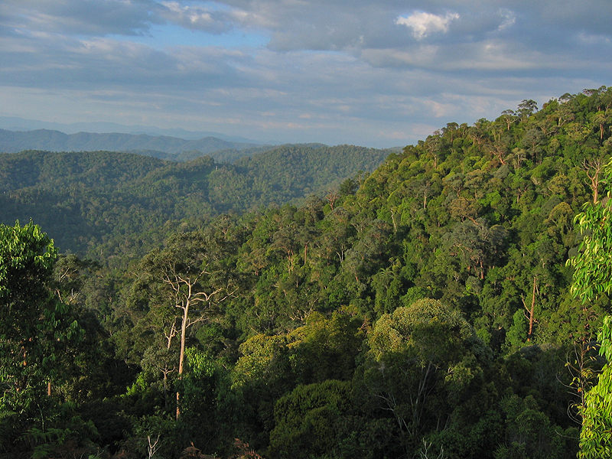  Tropical Rainforest | 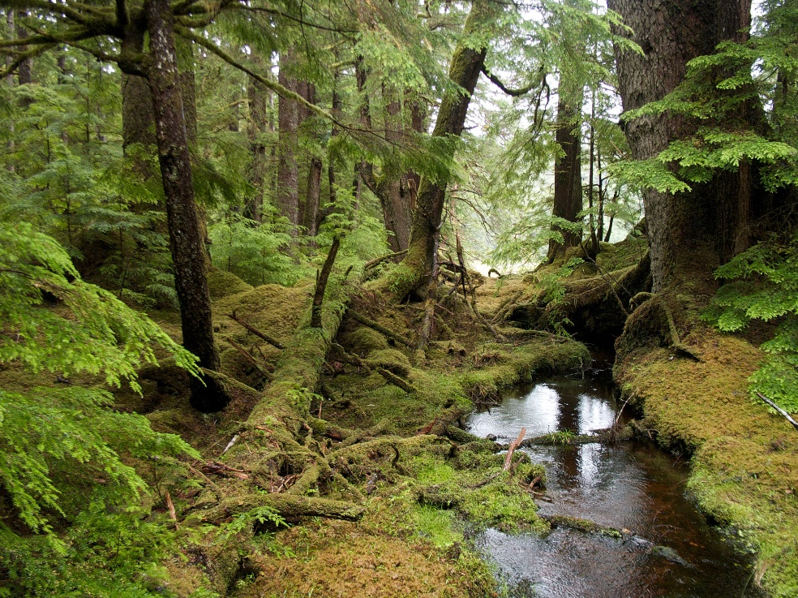  Temperate Forest
Tropical Rainforest  Temperatures: Hot year round  Average Rainfall: 79-394 inches per year  Plants: Incredible number of different and fast-growing trees, ferns, leafy plants.  Did you know? It is not uncommon to find 1,000 different tree species in a single square kilometer. | Temperate Forest  Temperatures: Hot summers, cold winters  Average Rainfall: 60-200 inches per year  Plants: Trees, mosses, ferns, shrubs  Did you know? Redwood trees in the temperate rainforests and giant sequoias in the Sierra Nevada mountain range in California can grow to massive proportions, as tall as 115 meters and 9 meters in diameter.
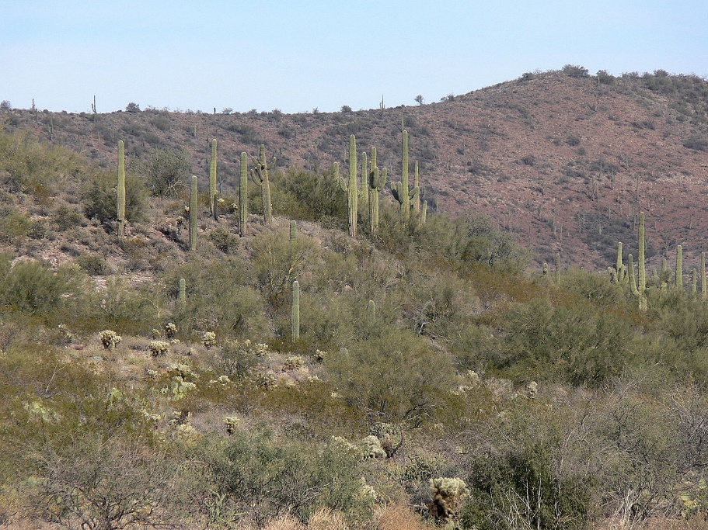  Desert | 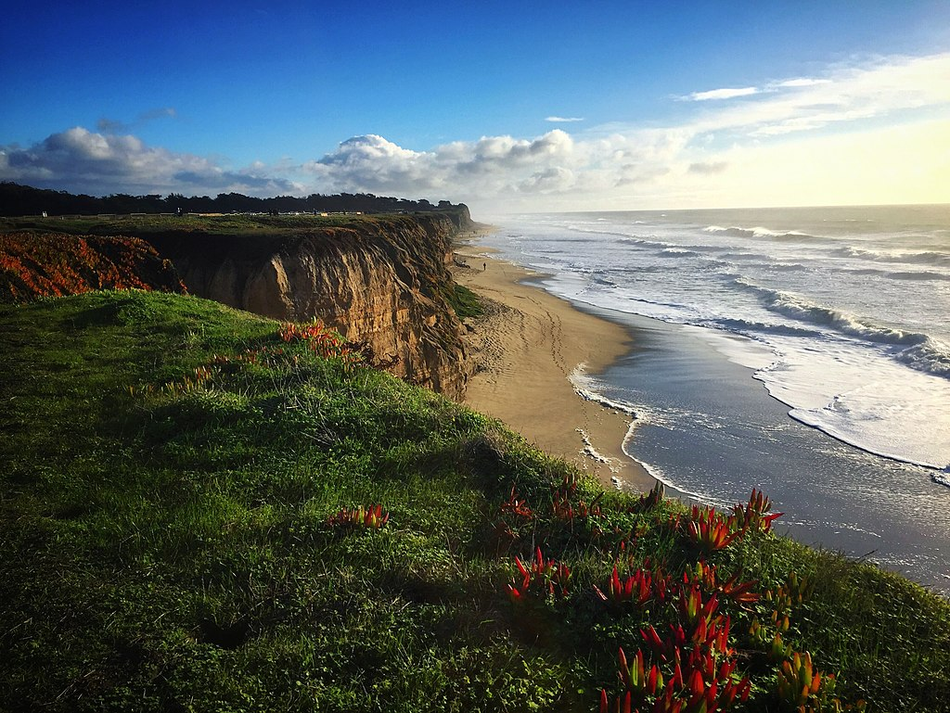  Ocean
Desert  Average Rainfall: Less than 10 inches per year  Plants: Few trees; Cacti and Desertscrub grows here. Scrub is a mixture of plants including shrubs, succulents, herbs, and few grasses.  Did you know? Many flowering plants in the desert emerge when environmental conditions are just right and then disappear just as quickly, often not returning again for years at a time. | Ocean  Average Rainfall: 60-250 inches per year  Plants: Kelp, seaweed, and algae (known as phytoplankton)  Did you know? While about 3% of all insects on Earth are aquatic (live in water), there are no insects that live their entire lives in the ocean.

Lesson 5: How can images of a person or place over time help us to see changes?

Objectives
  - Identify patterns of developed and undeveloped land use in satellite images

Materials
  - Computer with internet access
  - White board or chart paper, markers

Time required
  - 30-45 minutes

Vocabulary
  - Patterns: observable repeating or recurring events, relationships, or forms
Engage
- Discuss how pictures can be used to see changes over time.
Ask:
Who remembers having their school picture taken? If you look at your previous school pictures, can you see how you have changed over time?

Have students share if they have noticed that they have changed a little or a lot over time by comparing their school pictures over time.

Explain:
Just like school pictures are taken every year and you can see how you change over time by comparing the pictures, the Earth also gets its picture taken every year too and we can see how the Earth has changed over time by comparing these pictures.

Explore
- Introduce Google Earth Engine.
Navigate to the Google Earth Engine website- https://earthengine.google.com/timelapse/.

Explain to students that they can use the Google Earth Engine to see pictures of how the Earth looks from above. Have students stand up, look down at their feet, and pretend to take a picture. Explain that the pictures taken of Earth are called satellite images and they are taken by cameras that are looking down at the Earth. These pictures have been taken every year (sort of like how school pictures are taken each year) for the past 35 years! By comparing how these pictures look year after year, we can see how the Earth has changed over time.

- As a class, make observations and identify patterns in natural and developed areas.
Using Google Earth Engine, explore an area that has experienced major changes from 1984-2018. You may want to explore a local area such as your town or school. If not much change has happened in your area, you may want to show an area from the left column which has experienced major changes.

Good examples include:
- Deforestation in Nuflo de Chavez, Bolivia to see changes that emerge when land is cleared for agriculture production.
- Urban growth in Las Vegas, Nevada to see changes that emerge when land is cleared for urban development.

Ask:
  - What do you notice about how the land changes or stays the same?

Have students write down their answers or discuss what they notice with a partner. Discuss observations as a whole class.

Make two columns labelled Big Changes and No (or Little) Change on a whiteboard or chart paper. Record and discuss the patterns that students observe when land has experienced big changes and the surrounding area that looks unchanged.

Big Changes | No Change
Examples:  Changes shape- lots of squares or circles rather than squiggly, natural shapes  Changes color- Land changes color (green to tan) | Examples:  No shape change  No color change- Land stays the same color

Lesson 6: How have Tallgrass prairies changed over time?

Objectives
  - Make observations of historic vs. current tallgrass prairie land cover
  - Identify pattern of declining tallgrass prairie land cover

Materials
  - 25 post-it notes
  - Computer with internet access
  - White board or chart paper, markers
  - Worksheet showing historic vs. current Tallgrass prairie range

Time required
  - 30 minutes

Engage
- Conduct a Disappearing Tallgrass Prairie activity with your students
Place 25 post-it notes on the board in a 5x5 square.
    - Explain to students that a long time ago in the U.S. (before European settlers arrived) that there was a lot of tallgrass prairie (about 170 million acres!) and that this is represented by the 25 post-it notes shown here.

Start to remove post-it notes until only one (1) is left on the board.
    - However, over the years since European settlers arrived, this land started to be changed. People built cities and towns full of roads, streets, homes, businesses, and schools. We call this urban development. The land was also changed to grow crops and raise livestock. We call this agricultural development.

Point to the one (1) post-it that is left.
    - Explain that today there are about 6-7 million acres of tallgrass prairie left.

- View a map of historic vs. current Tallgrass prairie range.
Explain:
When we observed the satellite images, we could only see how the Earth has changed over the past 35 years, but researchers can use satellite pictures and other sources of information to compare how land has changed over much longer periods of time. They can compare how land used to look before people settled here and what it looks like now.

Show students the map, Tallgrass Prairie Ecosystems: Then and Now. Explain that the light green color is the Tallgrass prairie before people settled in Nebraska and the dark green color shows where Tallgrass prairie is found now.

If students are struggling to understand the map, refer back to the Disappearing Tallgrass Prairie activity. Explain that the light green color is like the original 25 post-it notes and the dark green color is like the last remaining post-it note. The dark green is all the tallgrass prairie that is left.

Use the Notice and Wonder strategy to help students make observations and ask questions about their observations.
- What do you notice?
- What do you wonder?
Have students take a few minutes to write down their answers. Divide students into partners or small groups and ask students to share their observations and describe what patterns they see in data.
Ask students what they think the map might be showing. Record students’ ideas.
Explain that maps can be useful in showing how an area has changed over time. Discuss what the map is showing—the range of tallgrass prairie before settlers moved into the area (light green) and the range of tallgrass prairie currently (dark green).
Wrap Up
Lead a discussion to wrap up and reflect on what they learned about how the amount of tallgrass prairie has changed over time.

Exploring changing land cover in the Tallgrass Prairie Ecosystem Name: _________________
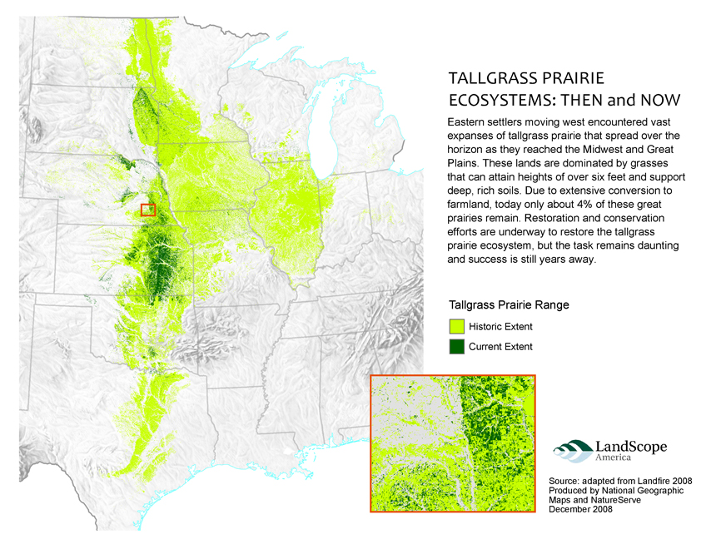
Look at the map shown above. Answer the questions below. Discuss your answers with a neighbor.
What do you notice? | What do you wonder?

Lesson 7: How can we use what we learned to make an argument for how the monarch migration is changing and why?

Objectives
  - Construct a scientific argument to explain how and why the monarch butterfly migration has changed over time

Materials
  - Computer with internet access
  - White board or chart paper, markers
  - Writing utensils
  - Claim-Evidence-Reasoning graphic organizer worksheet

Time required
  - 45-60 minutes

Vocabulary
  - Scientific Argument:
  - Claim: Answers the key question. It tells us what you learned through your research or investigation.
  - Evidence: Backs up your claim. It tells us about the observations of patterns or details from your research or investigation.
  - Reasoning: Uses scientific terms or principles to explain the evidence.

Explain
- Introduce scientific argumentation and establish norms for argumentation.
Explain how scientific argumentation is different than an argument or a fight.

Help students to understand the difference between respectful scientific arguments and confrontational or competitive arguments.
  - In a scientific argument, we can disagree about an idea, but we are not disagreeing with a person.
  - The purpose of a scientific argument is not to “win”, but rather to come to a point of mutual understanding or consensus.

Discuss with students that in the process of argumentation…
- It is okay to be wrong or change your mind.
- It is okay to not be sure of your answer and still contribute by presenting ideas.
- There isn’t always a right answer and even if there is, sometimes the process to get there is messy. Our process won’t be to focus on getting the “right” answer, it will be on having productive conversation with one another.
- It is expected that there will be disagreements along the way.

- Model a claim-evidence-reasoning (CER) conversation as a whole class using a non-science example. For example, you might follow this teacher’s example and use a popular Doritos commercial to introduce a collaborative CER discussion:

  - Play the Doritos commercial: https://youtu.be/r2EcgNfK3PA

  - Show students the definitions of claim, evidence, and reasoning. Introduce each one at a time as you answer the question, “What happened to the cat?”

  - Have students work in pairs to write the claim (their opinion about what happened to the cat) and provide evidence (details from the video that support their opinion).

Possible answers:
Student Claim Example: The dog killed the cat.
Student Evidence Example: There is a cat missing poster. The dog is seen burying pet tags. The dog hands the man a bag of Doritos that says “You didn’t see nuthin’.”

  - As a whole class, add ideas to create a class reasoning. (The reasoning part of CER is difficult and will take a lot of practice.)
Student Reasoning Example: There was a missing poster posted of the cat which means the cat was missing. The cat was missing because the dog killed the cat and is covering up the murder. The dog is seen digging in dirt and covering up pet tags to hide the body of the cat. When someone is murdered, the body is usually hidden to hide the murder. If there are witnesses to the crime, they are often bribed to keep quiet about the crime. The man saw the dog burying the cat so he bribed the man with Doritos to keep him quiet about witnessing seeing the dog disposing of the cat’s body. This approach to introduce CER into your classroom provides the framework students will need to start writing CER responses in the lab setting.

- Apply CER to the question of how monarch migration has changed over time and why.
Explain to students that now that they have practiced CER, they will apply the same argumentation process to answer the question: How has the monarch migration changed over time and why do you think this is?

Ask students to gather together all of the information they have been gathering. This should include:
- Monarch butterfly habitat research
- Prairie research
- Observations of the Tallgrass Prairie map

Have students make a claim about how Monarch migration changed. Do they think it is easier, harder, or the same?

Now have students think about HOW they know this. Ask students to think back on the evidence they have gathered so far- the graph of monarchs at their overwintering site, what they learned about monarch habitat and prairie, their observations of change over time, and the Tallgrass prairie map.

Finally, guide students to think about scientific terms or principles they can use to explain the evidence. Hint: This might be things they learned about habitat and survival needs (what all living things need to survive).

Work individually, in pairs, or as a class to write an argument using the provided template.

- Student Example Claim: The monarch migration has gotten harder over time.

- Student Example Evidence: The number of monarch butterflies is going down. Monarch butterflies need good habitat to survive and reproduce (make more babies). The prairie that provides good habitat is disappearing.

- Student Example Reasoning: When living things can’t get the food, water, shelter, and space they need to survive, they may die. The prairie that provides good habitat (food, water, shelter, and space) for monarch butterflies is changing because it is disappearing. Monarch butterflies may not be able to get the things they need to survive from the changing habitat (where they live). Because of these changes, their journey is getting harder and more of them are dying as a result.

- Guide students in discussing their claims, presenting their evidence, and defending their reasoning. If possible, have students point out those arguments that make a strong case and WHY.
Claim-Evidence-Reasoning Conversation Name ________________________________
How has the monarch butterfly migration changed over time and why?
Use the evidence you gathered from…
Claim: Answers the key question. It tells us what you learned through your research or investigation.
My claim is…
I think…
Evidence: Backs up your claim. It tells us about the observations of patterns or details from your research or investigation.
I observed/read/found….
My evidence is…
My proof is…
Reasoning: Uses scientific terms or principles to explain the evidence.
I know this is true because…
This happened because…
The reason for this is…

- Your monarch butterfly habitat research
- Your prairie research
- Your observations of the Tallgrass Prairie map
Construct a scientific argument supported by your evidence about how has monarch butterfly migration changed over time and why.

Claim: I think the monarch butterfly migration … __________________________________________________________________________________________________________________________________________________________________________
Evidence: _______________________________________________________________________________________________________________________________________________________________________________________________________________________________________________________________
Reasoning:
_______________________________________________________________________________________________________________________________________________________________________________________________________________________________________________________________

Lesson 8: How can humans help the monarchs as they migrate?

Objectives
  - Analyze maps of monarch migration from Journey North to determine when monarchs fly through the U.S. and need access to milkweed and wildflowers
  - Identify how planting prairie flowers provide habitat (food, water, space, or shelter) for prairie animals
  - Write a recommendation (make a claim) about actions humans can take to help monarch butterflies on their migration

Materials
  - Book: Plant a Pocket of Prairie by Phyllis Root
  - White board or chart paper, markers
  - Paper and writing utensils

Time required
  - 60-90 minutes

Vocabulary
- Habitat: The home of an animal or a plant; includes food/sunlight, water, space, and shelter
Engage
- Engage students’ prior knowledge of healthy foods and we need to have the right kinds of foods and the right amount of food to stay healthy.
Discuss:
  - I want you to think about making a meal for yourself that is healthy. What foods would you include?
  - What if you went to the grocery store to buy food and there is only broccoli? Could you survive if you had to eat only broccoli for every meal?
    - Yes, you could probably survive, but you might not feel very good and you might get sick. Broccoli is a healthy food, but it isn’t healthy to eat only broccoli and nothing else.
  - What about if you went back the week after that and there was no food at all on the shelf? Could you survive if there is no food to eat?
    - No, humans need food to survive.

Explain that all living things need the right types of food and in the right amount to be healthy.

- Review what we have learned about monarch habitat and how it is changing.
  - Think back about what we learned about what monarch caterpillars and butterflies need to survive. What did we learn?
    - Monarch caterpillars eat only milkweed leaves.
    - Adult monarch butterflies eat nectar (sugars) from many different types of wildflowers.
  - We also learned that monarchs live in prairies and that prairies are changing.

- Introduce the lesson objective
  - We have been learning about how monarch habitat is changing and this is affecting their ability to survive on their migration. Now we need to look at ways that humans can help monarchs during their migration.
Explore
- When do monarchs need food? When are monarchs migrating through the U.S. in your area?
Show students maps of adult monarch sightings by citizen scientists from Journey North. Explain that each dot represents an adult monarch being seen by someone as the monarchs are migrating north in the spring and south in the fall. The different colors represent when the monarch was seen.
  - Moving north in the spring: https://maps.journeynorth.org/map/?year=2019&map=monarch-adult-spring
  - Moving south in the fall: https://maps.journeynorth.org/map/?map=monarch-adult-fall&year=2019

Discuss
  - What do you notice?
  - Based on the maps, when are monarchs passing through your area?
  - What does this tell us about when food needs to be available?

- Read a story about how planting prairie plants can provide a way to improve habitat not only for monarchs, but for other animals.

Read Plant a Pocket of Prairie by Phyllis Root
  - As you read the story, ask students to look for ways that planting prairie flowers provides each of the four elements of habitat- food, water, space, and shelter- for prairie animals.

Individually or as a group, ask students place a mark next to each habitat element that is provided for prairie animals. This can be done individually in science notebooks or on small white boards, or as a whole class.
Food | Water | Space | Shelter
| | | | | | | | | | | | | |

- Learn from several experts from the Milkweed in the Classroom team as they take you on a tour of a prairie in Aurora, Nebraska and discuss how planting prairie plants can improve habitat for monarchs and other wildlife.

Watch videos featuring the following Milkweed in the Classroom team members:
- Anna Swerczek, Pheasants Forever, Inc.: https://go.unl.edu/milkweed1
- Sarah Bailey, Prairie Plains Resource Institute: https://go.unl.edu/milkweed2
- Doug Golick, University of Nebraska-Lincoln, Department of Entomology: https://go.unl.edu/milkweed3
Explain
- Reflect and Discuss
  - Do you think planting prairie plants is a good way to improve habitat for monarch butterflies? Why or why not?
    - Yes, planting prairie can provide Monarchs and other animals with many habitat elements that are needed for survival.
Elaborate
- Write a recommendation for ways that humans can help protect Monarch butterflies through prairie conservation.
  - Based on what you have learned, design an information pamphlet about prairie conservation for parents, the public, or businesses that outlines prairie conservation steps that can be taken.

Questions to think about:
  - Why do monarchs need our help?
  - How do we create quality habitat for monarchs?
  - When do food resources need to be available?

Extension Activities
For longer or more in-depth prairie conservation activities, consider one or more of the following:
  - Grow milkweed plants in the classroom to be transplanted outside later using growing guides, videos, and other resources found on the Milkweed in the Classroom website.
  - Examine existing milkweed plants (if available) to record the animals living on or visiting them.
  - Design a high-quality prairie plant seed mix that you think would help improve local wildlife habitat.
  - Design a prairie garden that can be planted at or near the school. Students submit designs that include:
    - Types of plants should be selected to match their location
    - Additional wildlife habitat supports (bird houses, native bee hotels etc.)
  - Plan a trip to a prairie or habitat restoration site

